13.56 MHz RF Power Supply

RF Generator Board

Notes, Assembly and Adjustment

© 2012 Christian Klippel <c.klippel@gmx.de>

This document describes the basic operation priciple, assembly steps and required adjustment for a 13.56 MHz RF power supply. Such a supply can be used with soldering handpieces, cartridges, tweezers, etc. from the OKI/Metcal and Thermaltronics soldering systems designed to operate at this frequency.

With this project you should be able to build your own power supply unit for these systems. Please note that this is not a direct copy of the existing power supply designs. While it is based on the same principle, the design itself was created from ground up by myself. There are quite some differencies in this design compared to the existing ones, mainly in an attempt to hopefully make the whole circuitry simpler.

The supply is basically a RF generator at a fixed frequency, 13.56 MHz in this case, where the feedback loop of the DC supply of the final stage includes the actual RF output/reflected measurement to ensure that the output stage is not damaged when a mismatch occurs. The cartridges work by RF induction into a special alloy which, at a fixed temperature, looses its ability to have energy induced magnetically. When that Curie point is reached, a mismatch of the RF load (the cartridge) will occur, and most of the RF energy is reflected back into the output stage. With fixed-power output stages this would lead to the destruction of the output stage. However, in these units here the RF power is reduced as soon as the mismatch occurs to prevent this from happening.

IC1 on this board is the DC/DC buck converter that provides the DC voltage to the output stage. Between L4 and L5 the peak voltage of the RF signal is picked up by the circuitry on the lower-left on page 3 of the circuit diagrams. That circuitry is just a simple peak detector. It's output is bufferd by one of IC3's Op-Amps, and then fed back, through a series resistor, into the feedback pin of IC1. So what this combination does is effectively trying to provide a constant peak voltage at the junction between L4 and L5. At power up pretty much all the RF energy is consumed by the tip cartridge. Once it reaches its design temperature, that RF energy is reflected back into the supply. This will lead to an increasing peak voltage seen by the peak-detector. In the end, the output of the OpAmp rises as well, causing a higher voltage at IC1's feedback input. This in turn will cause IC1 to decrese its output voltage, and thus the voltage seen by the peak detector: the feedback loop is complete.

Another important part of the circuit is the detection of the tip cartridge. This is accomplished by the circuitry in the lower-right of page 3 of the circuit diagrams. The tip cartridge has a very low DC resistance. This part of the circuit sends a small DC current through the tip, which will effectively pull the gate of Q1 to ground, thus Q1 is switched off. If the tip is removed Q1 is now switched on by the pullup resistor R21. L6 basically blocks the RF AC voltage, R20/C41 provide a low-pass filter that adds a tiny delay into that detection to debounce the resulting signal.

A useful extra in this circuit is the SWR bridge. This provides a detection of the forward and reflected RF energies which in turn can be evaluated by external circuitry to provide finer control of the system. However, this part is somewhat optional and not required for the basic operation of the supply.

The circuit is designed to include some failsafe and protection points. For example, i included a bunch of 5.6 volt zener diodes. Normally they would do nothing. But in case something fails, they should provide some basic protection against overvoltage at the inputs of the parts on the 5 volt rail, mainly the OpAmp and whatever circuitry follows that.

Another difference to the original units is the driver part of the output FET. While the originals use another FET as driver, i decided to use the ISL55110 FET driver chip from Intersil. It is a tiny chip, designed to drive a FET with sufficient current, at high frequencies. I also created a much smaller and simpler oscillator circuit. The originals, at least the older ones, use a full 7404 chip and crystal to form the oscillator. However, there is the SN74LVC1GX04 available from Texas Instruments, which is basically just a '04, but condensed down into a small SOT23-6 package and internally wired for operation as oscillator. To this i connected a small 5.0x3.2mm SMD crystal with 13.56 MHz, plus the required feedback and series resistor as well as the load capacitances for the crystal.

Generally i tried to use parts that are easy to solder by hand. Passives are not smaller than 0805, for example. As for the part values and tolerances, for some parts it is important to have the exact same specs that i will give in the part lists, for others there is quite some leeway. For example the voltage rating of the bulk capacitor at the input of the DC/DC buck converter. This obviously depends on what you decide to use to power it with. I used 50V spec'd stuff there, just to be on the safe side. But you are welcome to change that, if you must.

I will mark the important parts with a *, to indicate that the specs of those parts are important. I will also add some commentary about what parts are optional. For example, if you dont need the SWR bridge stuff, you can leave those parts out. However, in that case a low-ohm resistor should be connected between the OpAmp inputs and GND instead of the small capacitors.

Considering this, i will not give a single, complete part list for the whole board. Instead i will provide partial part lists with each section that will be explained in the instructions below, together with some comments on those parts.

Alright then, so lets start building it!
To build and test this circuit you need a few tools at hand. One is a suitable power supply. The values i give in this document refer to +30 volts for the DC input to the buck converter. You also need a +5V and +12V supply for the OpAmp, oscillator and FET driver.

There are a few toroids that need to be wound coils onto, so you need magnet wire (that is, enameled copper wire) withething between 0.7 and 0.8 mm in diameter.

A normal multimeter should be OK to successfully build this circuit, but having a scope available surely won't hurt in case something does not work out as expected.

You also need a 50 ohms, non-inductive dummy load. It should be a 50 watts type, one of these things that is used by HAM's, for example. This we will use to provide a basic load to the buck converter during assembly, as well as load to the RF output later on.

You need a decent soldering iron with tips suitable for SMD soldering, plus a larger hoof tip to solder the buck regulator thermal-pad to the PCB.

And of course the usual tools like pliers, etc.

The first section to assemble is the DC/DC buck converter section as seen in the graphic below.

Part # | Value | Size | Notes
C1, C7, C8 | 100µ / 50V* | 10.0 x 10.8 mm* | Low-ESR electrolytic
C2, C3, C4 | 10µ / 50V* | SMD 1210* | X7R, at least C2, others optional
C5 | 100n / 50V* | SMD 0805* | X7R
C6 | 10n / 50V* | SMD 1206* | X7R
R1 | 22k | SMD 0805 | PullDown, 22k minimum
R2 | 18k* | SMD 0805* | 1% or better
R3 | 2k2* | SMD 0805* | 1% or better
R4 | 2k* | SMD 0805*
R11 | 4k7 | SMD 0805 | Can be omitted, see text
R32 | 1k* | SMD 3364W | Or any other that fits footprint
D1 | 60V / 5A | SMB | Schottky, for example SK56B R4
L1, L2 | 22µ*, 4A min. | SSR1260 | Or any other that fits footprint  SSR1260-220M from Bourns for example
IC1 | LM22676* | TJ7A* | TO-263 Thin package
SV1 | 2 x 8* | 0.1“* | SMD pin- or socket-header, see text

In this section we have one optional part. This is resistor R11. If you want your controller to be able to temporarily increase or decrease the output voltage, you need to install this resistor here. The value of 4k7 is just a rough guide, it actually depends on how you control this functionality later on (that is, what voltage levels you inject and how).

What gender the connector SV1 has is up to you. You can use a pinheader here and plug a flat-ribbon cable plus connector onto it, or you can use a socketheader and plug in the controlling board into that, in case you want to stack the two boards. The reason to use a socketheader (female) in case of a stacked configuration is because you can get long THT pinheaders, but not long socketheaders.

The very first part to solder in is IC1, using a large hoof tip. This is because we need to solder its thermal pad as well, and other parts would be in the way otherwise. First we need to fill the vias on the PCB in the area that the thermal pad should be soldered to. Also we tin the thermal pad of IC1 a bit. Here are two images of the areas of interrest, one before and one after tinning/filling:

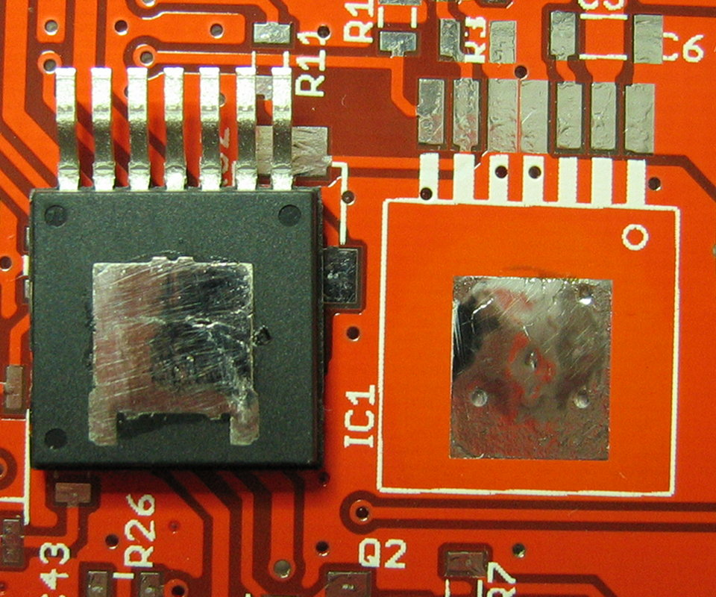
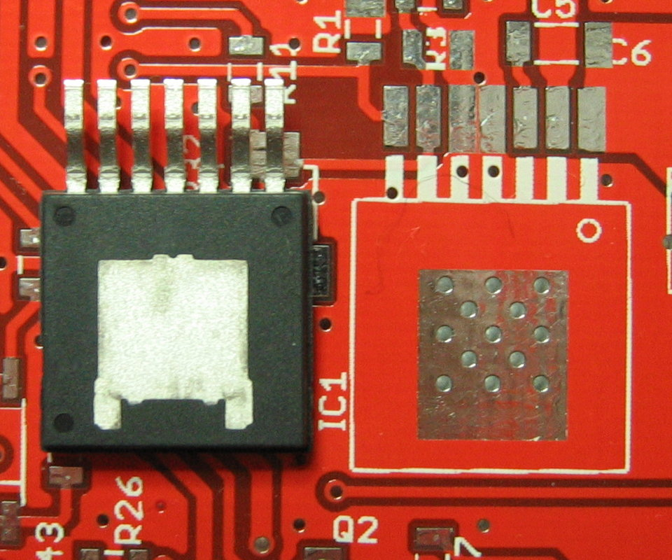

Add enough solder to the area on the PCB so that it slightly bulges, then clean off the flux residues on the PCB and the chip. The idea here is that when the chip is placed, it will be slightly tilted when from the side. We also tack-on the chip at the two outmost pins:

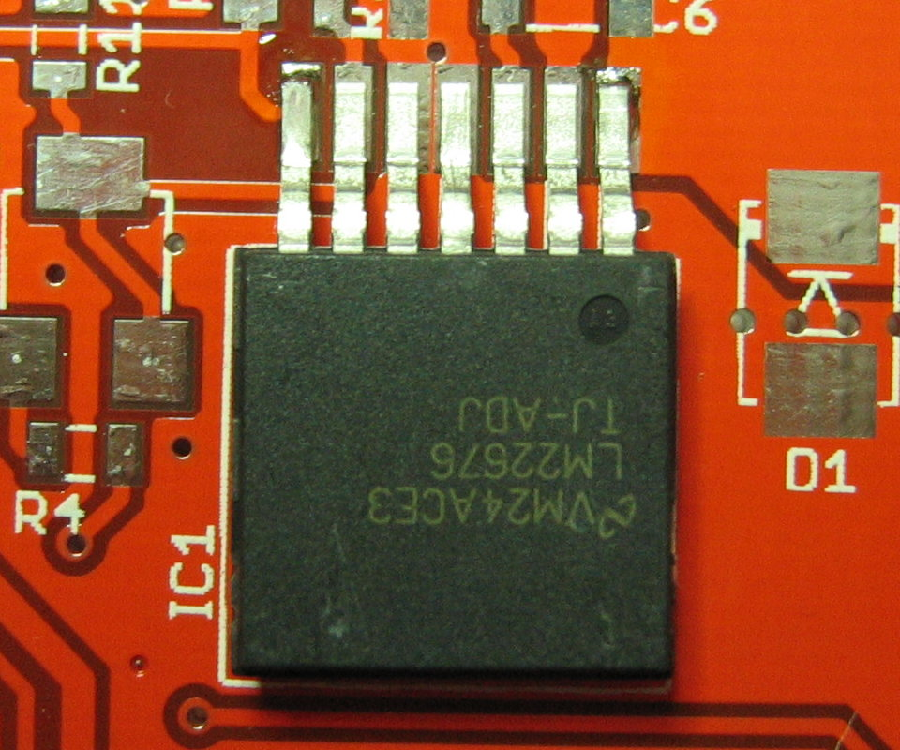
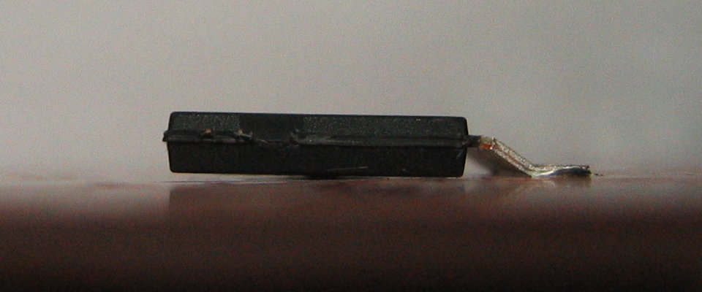

Now flip over the PCB, preferably on a hard surface. Add plenty of solder to the area where the thermal vias are. Now apply pressure with your fingers, above and below that area. With the other hand put the hoof tip into the tinned area. Move the tip around over the whole area for a while. The idea is that the vias, filled with solder, will conduct the heat to the other side and melt the solder there. Due to the applied pressure it will then solder IC1 flat on, giving a good thermal contact between its thermal pad and the copper of the PCB. Check from the side that the chip is really flat on. If needed repeat the procedure. Ance all is OK, use some desolder wick and remove excess solder, so that you have virtuall no bulging in that area anymore. Then clean off the flux residues, flip the board over again and solder on the remaining pins:

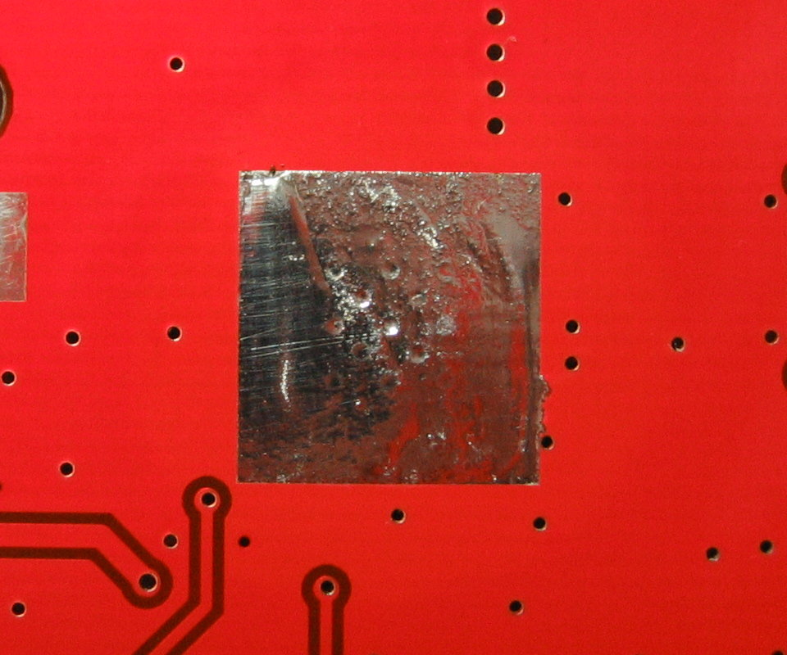
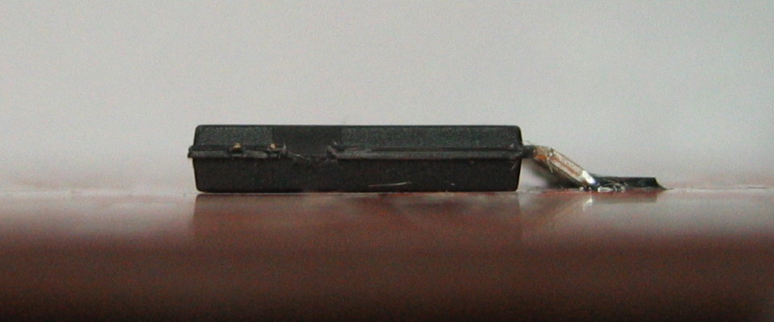

Now solder in the remaining parts, L1 and L2 first because their pads would be hard to reach later on. Add C7 and C8 next. Now all the small SMD passives around IC1, followed by C1. Finally solder the connector SV1 in place.

Now its time for the first test. You need a +30V and a +5V supply, as well as the 50 ohms dummy load. Connect the dummy load between the output side of L2 (which goes into XFMR1) and GND. For that you can temporarily solder it to the GND pad of FET1 and the proper pad of XFMR1. Solder some temporary wiring to the following pads of SV1: 10/12 for GND, 14/16 for +30V and 1 for +5V. First apply the +30V and meassure at the output of L2. There should be no voltage, since IC1'2 enable pin is pulled low. Now apply +5V to pin 1 of SV1. This will enable IC1, and you should see around 11.7 volts at the output of L2. Leave the dummy load connected for now, we need it again in the next step.

If all that works out OK the next section can be assembled. If not, recheck your solder work, the part values, etc.

The next section is the OpAmp and it's surroundings, shown in the image below:

Part # | Value | Size | Notes
C42 | 100n / 16V | SMD 0805
C43 | 100n / 16V | SMD 0805 | Optional, see text
C36 | 10n / 16V | SMD 0805 | Optional, see text
R23 | 2k2* | SMD 0805* | See text
R24 | 22k* | SMD 0805*
R33, R34 | 2k2 | SMD 0805 | Alternatively R25, see text
R25 | 5k* | S64Y* | Alternatively R33/R34, see text
R26 | 4k7* | SMD 0805* | Optional, see text
R27 | 1k* | SMD 0805* | Optional, see text
R28, R29, R30 | 1k | SMD 0805 | Optional, see text
R16 | 100R | SMD 0805 | Optional, see text
R17 | 22k | SMD 0805 | Optional, see text
R19 | 5k* | S64Y*
D4, D5, D10 | Zener 5.6V* | LL34 | Optional, see text
IC3 | TLV2374 | SOIC-14 | Or any other rail-to-rail capable OpAmp

This section is mainly for the RF energy feedback loop of IC1, but also for buffering the forward/reflected RF energy levels coming from the SWR bridge, as well as providing an output voltage proportional to the buck converters output, to be used by some external circuitry if wanted.

At a bare minimum IC3, R19, R23, R24, C42 and either the combination R33/R34 or the trimpot R25 are needed. These parts generate the feedback voltage that is fed into buck converter in accordance with the peak detectors output. The OpAmp used in this stage has a voltage offset defined by R33/R34 or R25. Usually half the supply voltage of IC3 is OK, as provided with R34/R35. But if you want to play around a bit with the feedback loops behaviour, go for the adjustable version using R25 instead.

The trimpots used are multiturn, and normally THT parts. To make them SMD parts just bend out the pins accordingly, and shorten them. R23/R24 define the gain of this stage. If want to experiment you can tweak these values to get a more or less aggressive regulation.

R26/R27 are a voltage divider to sense the output of the buck converter. It is smoothed a bit by C43, and limited to 5.6V by Zener D10. This section is optional. It is useful if you want to detect load changes, or generally want to have that info available to the controller circuit. R28 decouples the output a bit in case of capacitive loads there. If you place a 100n capacitor to GND on the controller board there, it will provide a small low-pass filtering to give a more stable reading.

R16/R17/C36/D5 precondition the signal of the reflected RF energy as detected by the SWR bridge. R30 is a again at the output of the OpAmp for the same reasons as R28 is.

If you do not want the voltage reading and/or the SWR functionality, terminate the then unused OpAmp inputs to GND. You can do that by replacing C43 with a low-ohm resistor for the voltage reading, and doing the same with C36 for the reflected output of the SWR bridge, and C35 from the next section for the forward output of the bridge.

Once you soldered in all the parts for this section, turn R19 fully counter-clockwise and in case you use R25, adjust it to the middle position (that is, when powered by +5V it should give you 2.5V output at the center pin). Now apply the +30V again, as described in the previous section, and at the same time apply +5V to pins 1 and 5 of SV1.

Now adjust the trimpot R32, next to IC1, so that you get about 22 volts at the output of L2. This sets the maximum possible output voltage that IC1 can generate, except for the case where you externally feed in some voltage level through the optional R11 described in the previous section. If all works fine, continue with the next section.

This section will provide the RF peak detector, plus some parts of the SWR bridge. Again, here is an image of the parts used in this section:

Part # | Value | Size | Notes
C37, C38, C39 | 56p / 500V* | SMD 1206* | C0G, ceramics
C33 | 100n / 16V | SMD 0805 | Optional, see text
C35 | 10n / 16V | SMD 0805 | Optional, see text
R13, R14 | 100R* | SMD 0805 | Optional, see text
R15 | 22k | SMD 0805 | Optional, see text
R18 | 120k* | SMD 0805*
D8 | Zener 5.6V* | LL34*
D6, D7 | LL4148* | LL34* | Simple 1N4148 diode in SMD
D2 | LL4148 | LL34 | Optional, see text

All the non-optional parts form the peak detector. The optional parts are for the foward detection of the SWR bridge.

The 56p/500V caps are the same that will be used in the output filter section later on.

Nothing to test here, so just recheck that everything soldered correctly and proceed to the next section.

This section contains the the tip-detection circuitry, as well as a few parts for the optional SWR bridge. These are the parts in question:

Part # | Value | Size | Notes
L6 | 47µ | SMD 2424 | Can be bigger in value. Current handling of only a few mA, and whatever footprint fits.
C40 |  |  | Not used, ignore
C41 | 2µ2 / 16V | SMD 1206 | Can be bigger in value
C34 | 100n / 16V | SMD 0805 | Optional, see text
R20 | 100R | SMD 0805
R21 | 1k | SMD 0805
R22 | 22k | SMD 0805
R12 | 100R | SMD 0805 | Optional, see text
D3 | LL4148 | LL34 | Optional, see text
D9 | Zener 5.6V* | LL34*
Q1 | 2N7002 | SOT23-3 | Or equivalent

The tip-detection is implemented by sending a small DC current through the tip. Since the tip has a very low DC resistance, this will effectively pull the gate of Q1 to GND, turning it off. L6 filters out the RF AC voltage of the RF output, R20/C41 provide a low-pass filtering. If no tip is connected, R21 pulls the gate of Q1 high, turning it on.

R12/C34/D3 are part of the SWR bridge for the reflected power detection. These can be omitted if you do not want that feature.

To test the tip detection connect a LED plus suitable current limiting resistor between pin 5 (+5V) and pin 8 (tip detection output, open drain to GND) of SV1. Apply +5V to pin 5 (and GND on either of the pins 9, 10, 11, 12 of SV1). The LED should now light up. Shorten the two pads of the RF output, the LED should now turn off.

If things work out as wanted, proceed with the next section.

Now it's time to assemble the section that provides the 13.56 MHz oscillator and the FET driver chip. As usual, here is an image of that section:

Part # | Value | Size | Notes
C44, C45 | 22p* | SMD 0805* | Load capacitors for the crystal
C9, C10, C11 | 100n / 16V | SMD 0805 | Decoupling
C12 | 4µ7 / 16V | SMD 1206 | Can be bigger in value
R5 | 2M* | SMD 0805*
R6 | 1k* | SMD 0805*
R7, R10, R31 | 22k | SMD 0805
R8, R9 | 10R | SMD 1206
Q2 | 2N7002 | SOT23-3 | Or equivalent
IC4 | SN74LVC1GX04 | SOT32-6 (DBV) | Texas Instruments
IC2 | ISL55110 | TSSOP-8 | Intersil
XTAL1 | 13.56 MHz | SMD 5.0 x 3.3 mm

This is a basic oscillator circuit, nothing special. It provides the 13.56 MHz signal. The ISL55110 is used as the driver for the FET output stage. Be aware that there is the 55111 as well. That one, however, has one output inverted. So make sure to get the proper one.

Unfortunately the enable/power-down signal of the driver has inverted polarity to what the buck converter uses. For that reason this signal is inverted by R7, R31 and Q2.

R8/R9 are in series between the drivers outputs and the FET gate. This limits the current used to drive the FET and also spreads the load over the two outputs that the ISL provides. R10 is a safeguard that turns off the output FET in case IC2 fails. However, does not prevent havoc if IC2 fails with the outputs high.

R5 is the feedback resistance needed by the oscillator chip IC4, R6 is a limiting resistor to not overdrive the crystal. C44/C45 provide the load capacitance of the crystal. 22P is a suitable value most of the times, but if in doubt check the specs of the crystal you want to use.

Testing this section requires a scope or at least a frequency counter. Provide +5V to SV1 pins 1 and 5, and +12V to SV1 pin 7. The 12 volts are used by the driver. Of course don't forget GND. You should see the 13.56 MHz at R8/R9, as well as pins 3 and 4 of the driver.

Since the driver is so small, but has to deliver quite some current (albeit only for rather short spikes), it would be a good idea to provide at least a minimal thermal coupling to the PCB. Unfortunately this package does not have a thermal pad. Anyways, i placed a small dab of thermal compound at the place where IC2 is located. Then push down the chip and solder it in place. Don't use too much compund, it should not be squeezed out onto the pads. In any case, use non-conductive compund.

Alright, now that this is done we go to the next section, the RF output filter.

Now the second last section, RF output transformer and filter. And of course again an image of that section:

Part # | Value | Size | Notes
C13 | 330n* / 250V* | SMD 1210* | X7R*, probably better to use 3 x 100n / 250V 1206 in parallel
C14-C19 | 47n* / 250V* | SMD 1206* | X7R*
C20-C32 | 56p* / 500V* | SMD 1206 | C0G*, actually we use 2 less, see text
XFMR1 | 2 x 13 turns* | FT82-61* | Amidon ferrite toroid, bifilar wound, 80 cm magnet wire 0.7 to 0.8 mm diameter
L3 | 1 x 11 turns* | T80-6* | Amidon iron powder toroid, 35 cm magnet wire 0.7 to 0.8 mm diameter
L4 | 1 x 14 turns* | T50-6* | Amidon iron powder toroid, 30 cm magnet wire 0.7 to 0.8 mm diameter
L5 | 1 x 10 turns* | T50-6* | Amidon iron powder toroid, 25 cm magnet wire 0.7 to 0.8 mm diameter

Now let's start by winding the output transformer and the filter coils onto the toroids. This is a bit nasty, since the coreas are rather small, and if you are unused to this kind of work it will be quite a starin on your fingers.

First we will wind the output transformer. It has a bifilar winding of 13 turns (which actually makes it two windings of 13 turns each). For this you need about 80 cm of magnet wire with 0.7 to 0.8 mm diameter. Stretch the wire a bit to even out any kinks it may have. Now fold it in the middle. Next is to twist these two strands. You should aim for 2-3 twists per cm. It is important that it is really twisted, and not one wire wound around the straight other. Here is an image of how the twisting should look like:

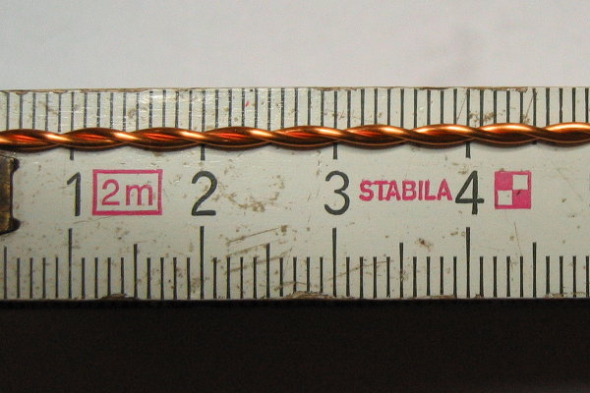

Now take the FT82-61 ferrite core and place a first, tight winding on it, like this:

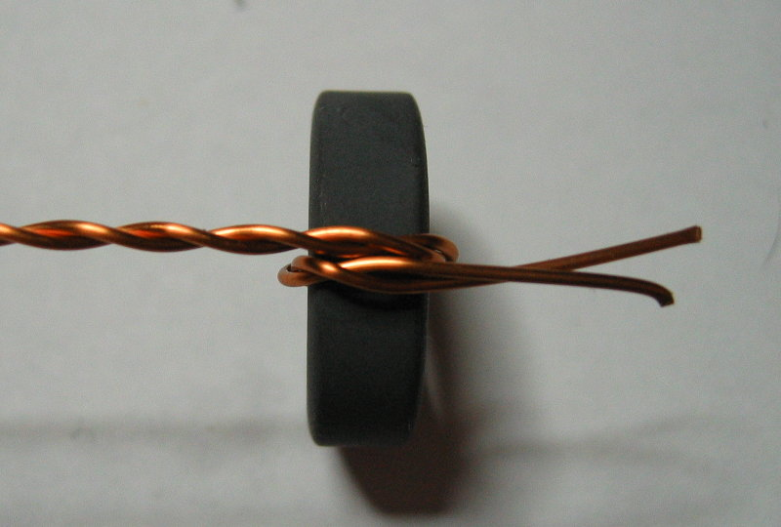
Next place the toroid between your thumb and index finger, so that your fingers are placed on the outer rim and the center of the core is open, with the thumb pressing the first turn against the toroid. Now thread the longer end of the twisted wire through the opening of the core and firmly pull on it to have it tightly wound around the core. Rotate the core a bit so that your thumb is now placed onto the new winding.

Repeat these steps until you have placed 13 turns onto the core. Try to have them roughly even-spaced. Bend the ends of the wire so that they go straight down. On the outer rim you should now count 13 turns. You can move around the winding a bit to get them more evenly spaced. The end result should look like this:

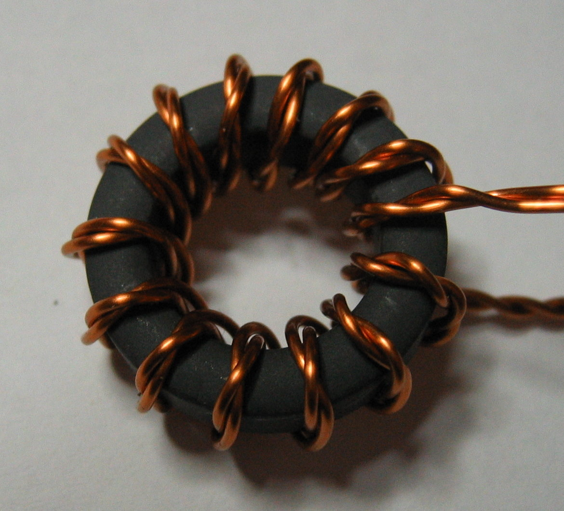

Now cut the longer end to the same length as the smaller end, and untwist both up to the toroid. Remove the isolation at the last 5 or 10 mm of the wire ends, it's ok to have it removed on only one „side“ of the wire, no need yet to remove it all around.

Take a multimeter and find out which ends belong to which winding. The end of one winding needs to be twisted together with the beginning of the second one, this will become the center-tap. Here is an image where i have placed some markers:

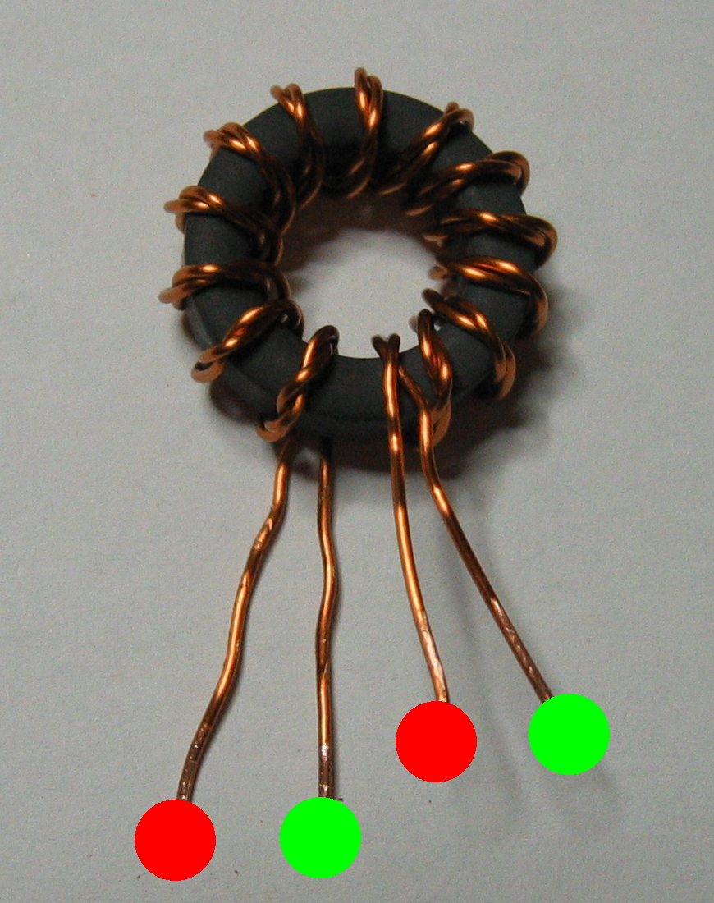

The leftmost wire from the bottom is the start of one winding, it's end on the leftmost side of the top. Same with the second winding. This is the arrangement you should prepare. It may be needed to „untwist“ on end half a turn, chanches are 50:50 to get it right on spot on the first measurement ;)

Now bend the beginning of the second winding (green dot on the left) and end of the second (red dot on the right) upward, and the end of the first winding (green dot on the right) downward. Remove the insulation of these four wires all around now. I use a sharp knife to do so. The result should look like this when viewed from the bottom:

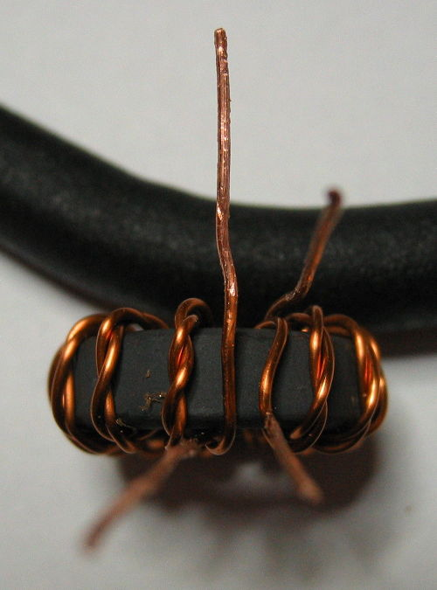

Twist together the upper two wires. Then tin the twisted pair as well as the other two single wires. Cut them to the proper length, and bend them in the required way. You should now end up with something that looks like this:

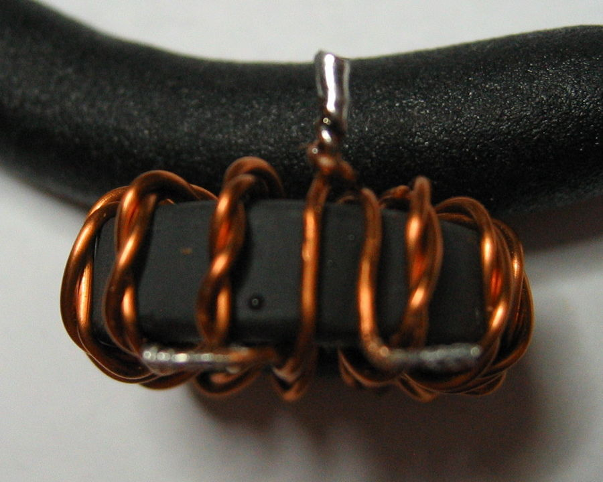

Next the filter coils are wound onto their toroids. The winding method is the same as for the transformer, only that a single wire is used now instead of a twisted one.

L3 is 11 turns on the T80-6 toroid. This means you should end up with counting 13 windings on the outer rim of the core. L4 is 14 turns on a T50-6 toroid, and L5 is 10 turns on another T50-6 toroid. Again, remove the insulation at the ends, tin them and bend them in the proper way.

Here is an image of how these toroids should look like in the end, From left to right is L3, L4 and L5:

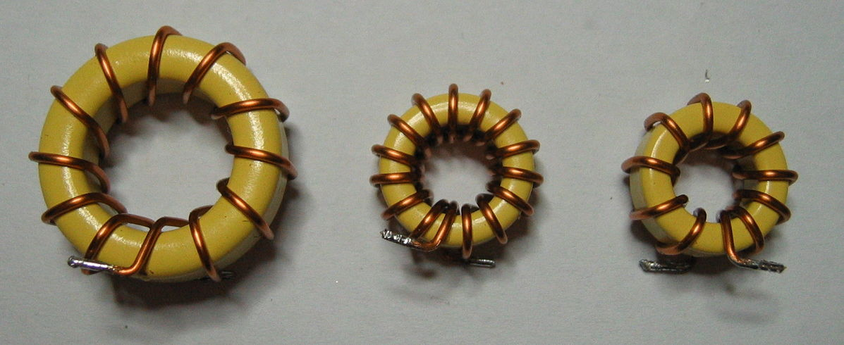

Here is a nother shot showing the coild from the bottom:

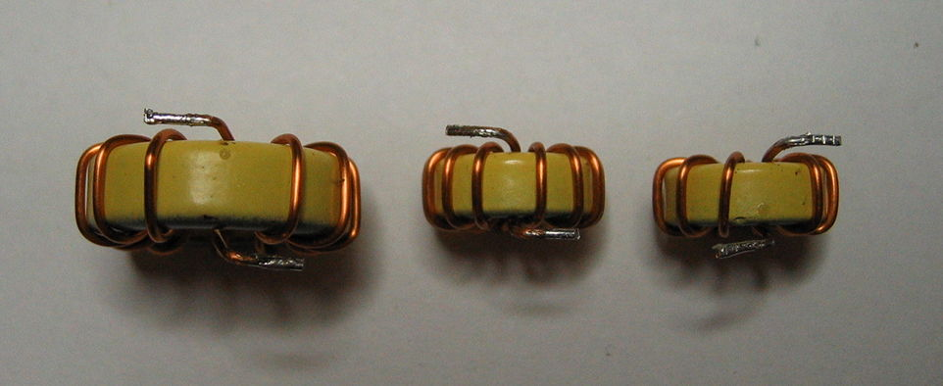

Now that the transformer and the coils are ready this section can be soldered. Start by soldering in the capacitors first. In the part list i mentioned that two of the 56p capacitors are omitted. That would be C20 and C30. Just leave them out. Then solder in the transformer and the coils. If the wires are a bit too long simply shorten them. If they are too short, start over with the coils ;)

The coils and the transformer should probably be glued down with some dabs of epoxy glue or similar. You don't really need to if you don't plan on moving the unit around or dropping it. However, if they are not glued down you risk tearing them off in case of a shock or lots of vibration.

Now to the final part of the assembly, putting in the IRF510 FET. The original idea was to mount the whole PCB flat centered onto a 100mm x 100mm heatsink. So that is what i describe here.

Drill 2.5mm holes at the proper places in the heatsink and cut 3mm threads into them. If, like me, you don't really trust the long-term stability of the solder-stop, you may want to use some very thin adhesive film and stick that over the few traces that exists on the bottom side of the PCB. Alternatively you could also use a heat-transfer pad over the whole area. In that case you don't need to use the mica disc, thermal compound and isolating washer to mount the FET.

Now mount the PCB onto the heatsink, but first put a dab of thermal compound where the buck regulator and FET driver is (if you don't use the tranfer-pad, that is). What you use to mount it depends on what you want to use to control it. You can use simple M3 screws, or use 25mm long hex standoffs in case you want to build it sandwich-like, as i did. Those standoffs have a outer thread on one end, and a inner thread on the other. If you plan to use my supply/contoller board design and place the bulk capacitors there at the bottom side, use 30mm long standoffs instead.

Now shorten the legs of the FET about 2mm, and bend the ends downward a bit. The pins are to be soldered onto the pads onto the PCB, with the FET itself placed in the square opening. Add a thin layer of thermal compund on the exposed part of the heatsink in that square. Put a mica disk for a TO220 package there. Then add a thin film of thermal compound on the backside of the FET. Put it in place and put a isolating washer, used to mount TO220 packages, into the FET's mounting hole. Now screw it down tightly with a M3 screw. Solder the pins onto their respective pads.

Next step is doing the adjustment of the output stage. To do so connect the 50 ohms dummy load to the RF output. The dummy load really must be non-inductive. You can not use a big wirewound resistor for this! It should be able to handle up to 50 watts for a while. If you don't have access to a suitable dummy load, for example through a friend who is into CB or HAM radio, you have to build one yourself. Just search the net, there are plenty of instructions on how to cheaply make such a dummy load.
Now you need to apply all three voltages at once onto SV1. +5V to pin 5, +12V to pin 7, GND to pins 9, 10, 11 and 12, and +30V to pins 13, 14, 15 and 16. The 5V rail only needs a few mA, it only drives the oscillator, the input side of the driver, the OpAmp, voltage divider and some pullup resistors. The 12V rail needs a few hundred mA, since it is used by the driver to drive the FET. For the +30 volts you need a few amperes, but not more than 3 ampere total. Apply these voltages at once, but leave pin 1 of SV1 unconnected.

A word of caution: Voltages well in excess of 100 volts will appear in the output filter stage, and at the RF output it will go over 100 volts as well. Be very careful here!

Verify that all the voltages are OK. Turn R19 to all the way clockwise until the end. Now connect pin 1 of SV1 to +5V. This will now enable the buck regulator and the driver. A few hundred miliamperes should be drawn on the +30V rail now. Adjust R19 counter-clockwise so that the output voltage at L2, which goes into XFMR1, comes up to about 21 volts.

If you can not reach that point, you have to check and double check that all the soldering is OK, that you used the right parts in the right places, that the coils and the transformer are wound correctly, and that they are soldered well to the board. Also check that the FET is OK and not damaged (for example accidentally due to static discharge). A scope will be helpful to check the various stages from oscillator to RF output.

If everything works, congratulations! You now have a usable RF power supply. Switch of all the DC power supplies and disconnect the dummy load from the RF output. Instead connect a F type socket at the output, using a short length of RG58 coax cable between the RF output pads on the PCB and the F type socket. If you want just a basic supply with no fancy stuff added, connect pin 8 of SV1 to pin 1 of the same connector. Also add a pullup to +5V of no more than 1k to pin 8. This is for the tip detection and will disable the driver and buck regulator when no cartridge is connected. It will automatically re-enable them once a cartridge is inserted.

That's it. Connect your handpiece or tweezers, or whatever suitable, to the F type socket. Insert the cartridge you want and turn it on. After a few seconds you are ready to solder. Of course it can't hurt to put the whole thing into a metal enclosure. Make sure it is well shielded!

The follow up part on all this will be about the supply/controller board i designed for this unit. However, that one is optional, you can use whatever you want to control this board and generate the required voltages.

Have fun,

Chris

