

**Ahsanullah University of Science and Technology**

***LAB REPORT***

Course No: *EEE3110*

Course Name: *Numerical Technique Laboratory*

*Exp No:02*

*Exp Name: Applications of MATLAB*

* Name: *Md. Idrak Efaz*
* ID: *190205121*
* Year: 3 , Semester: 1
* Section: B-2
* Department of *EEE*.

Exercise1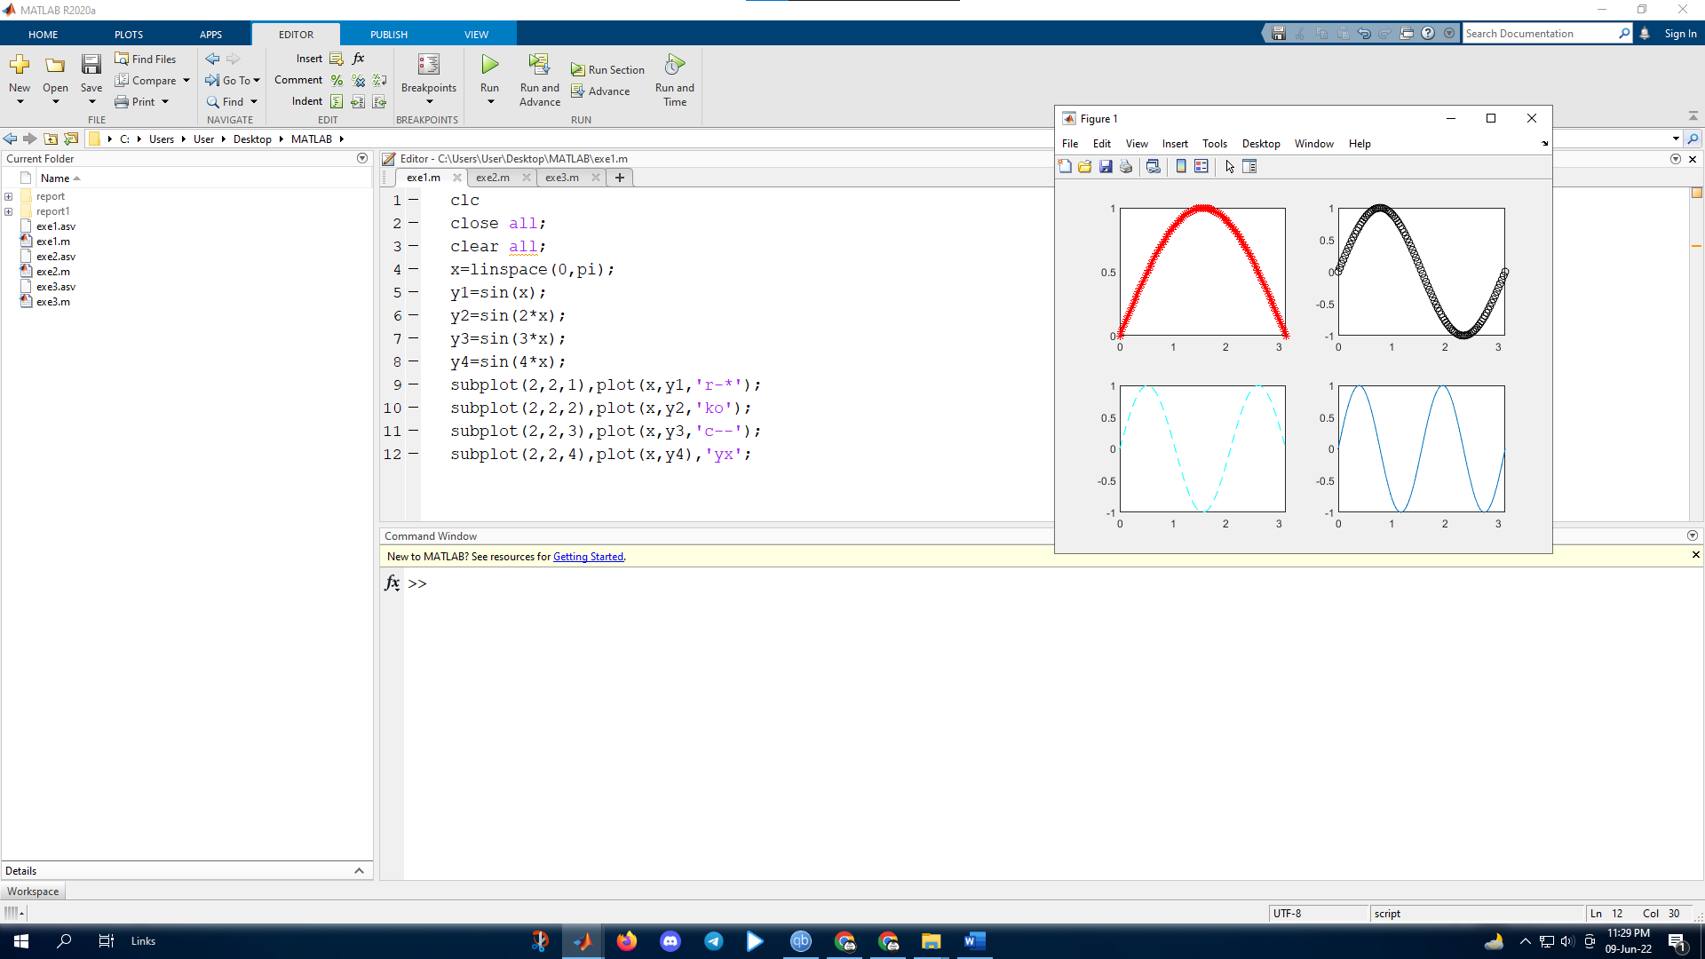

Exercise2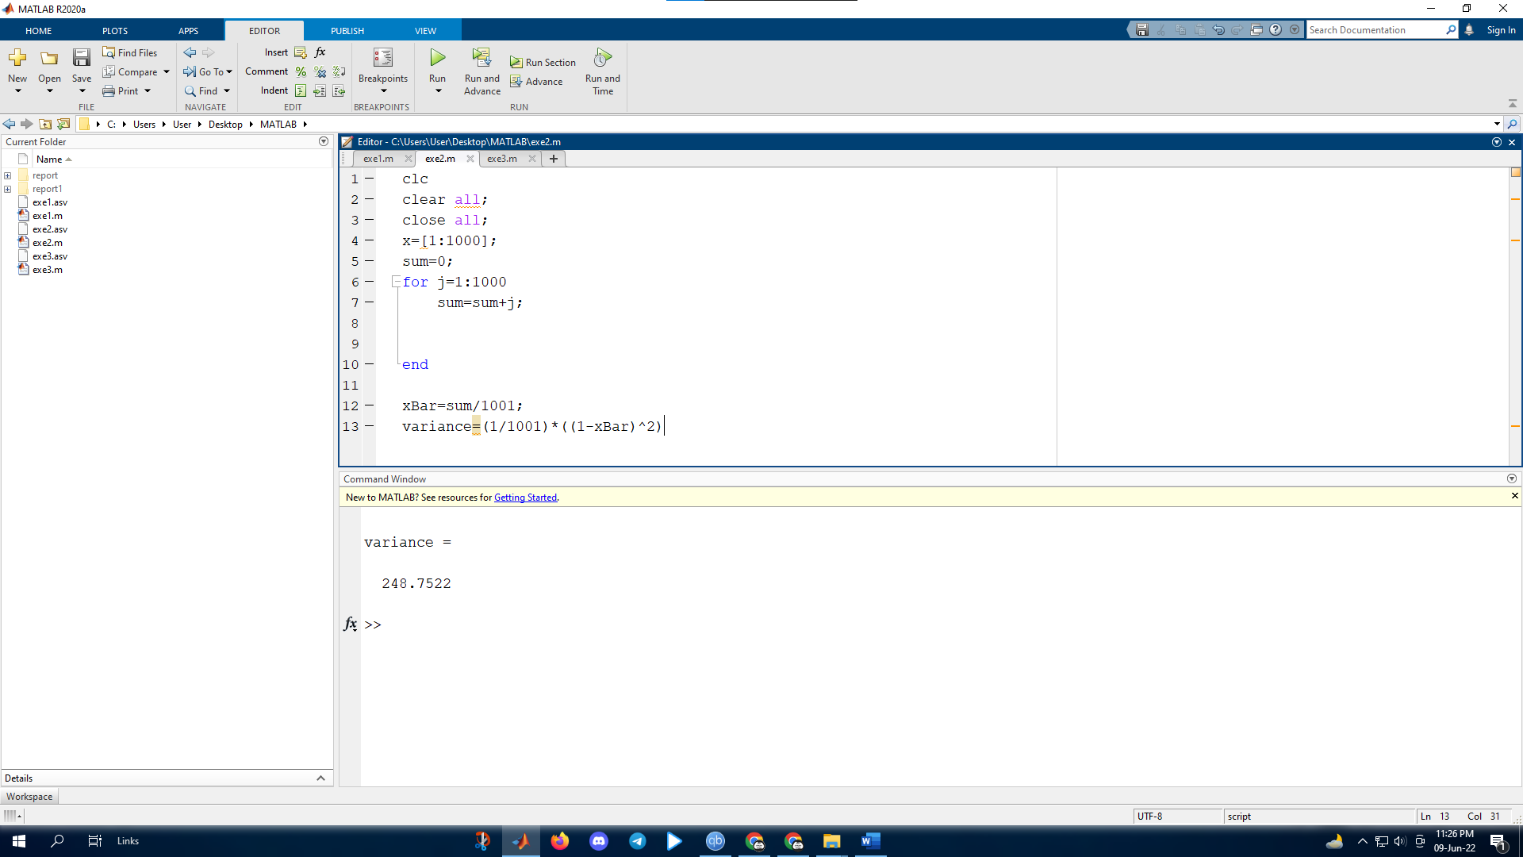

Exerxise3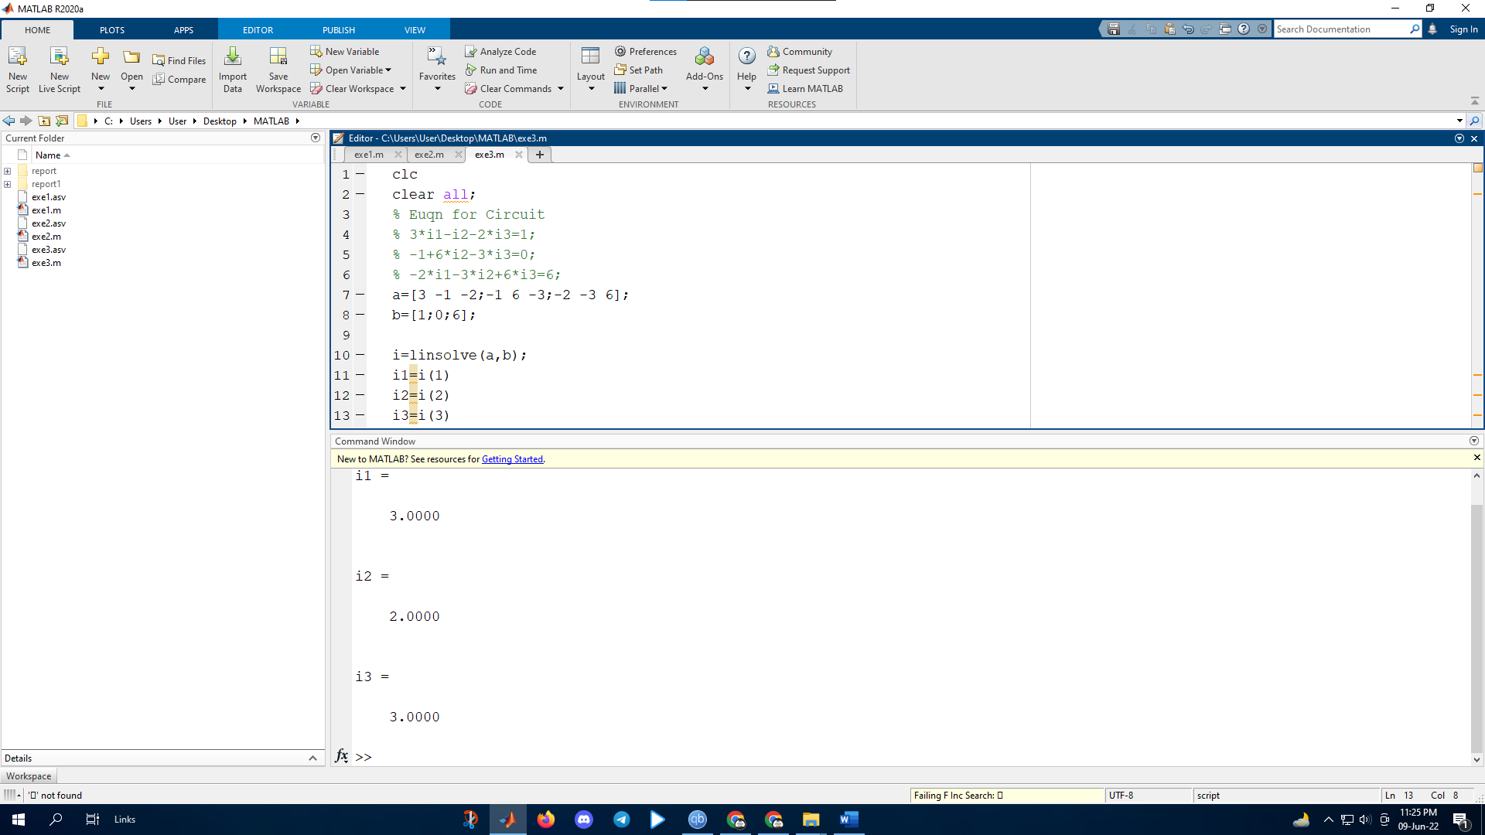

Extra 