Backend Course
File structure
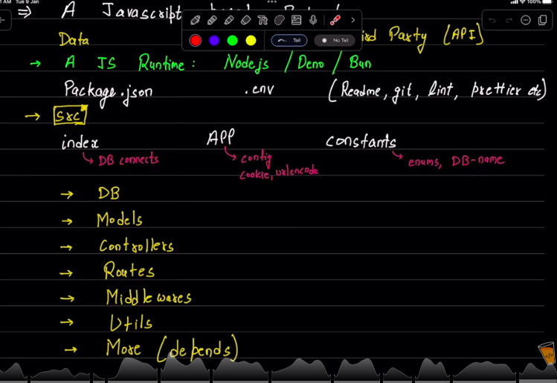

Express: ( a package)
It listens to the Request and send Response to the frontend

CORS
Cors issue can be solved using proxies in the vite.config.js or you have to go to server and whitlist your frontend domain

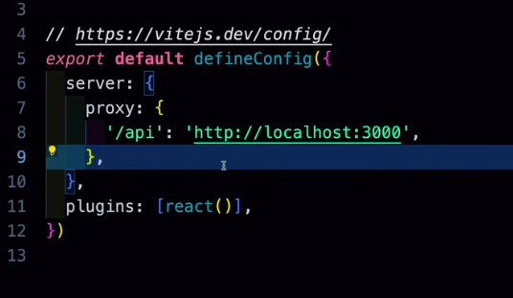

Database Design
Initially this is the work for Database specialist/Administrator
We can use moon modler for making models and their ERD’s and it will then generate the code for mongoose for us to use

Production Ready folder structure for Node Backend
