**LHD Share Day 5**

# Mail: idreesarif111@gmail.com

Write the program for maximum of three numbers.

**Step 1** Declare the three variables.

**Step 2** Check if A is greater than B and C.

**Step 3** If so print A is greater.

**Step 4** Else check if B is greater than C.

**Step 5** If so print B is greater.

**Step 6** Else print C is greater.

# CODE:

**echo "Enter Num1"**

**read num1**

**echo "Enter Num2"**

**read num2**

**echo "Enter Num3"**

**read num3**

**if [ $num1 -gt $num2 ] && [ $num1 -gt $num3 ]**

**then**

**echo "$num1 is the greatest"**

**elif [ $num2 -gt $num1 ] && [ $num2 -gt $num3 ]**

**then**

**echo "$num2 is the greatest"**

**else**

**echo "$num4 is the greatest"**

**fi**

**~**

**~**

**~**

# OUTPUT:

a program using Case statement in which user enter two operands and one operator (+,-,*, /). Both operands perform according to operator

# !/bin/bash

# Take user Input

echo "Enter Two numbers : " read a

read b

# Input type of operation echo "Enter Choice :" echo "1. Addition"

echo "2. Subtraction"

echo "3. Multiplication"

echo "4. Division" read ch

# Switch Case to perform # calulator operations case $ch in

1. res=`echo $a + $b | bc`

;;

1. res=`echo $a - $b | bc`

;;

1. res=`echo $a \* $b | bc`

;;

1. res=`echo "scale=2; $a / $b" | bc`

;;

esac

echo "Result : $res"

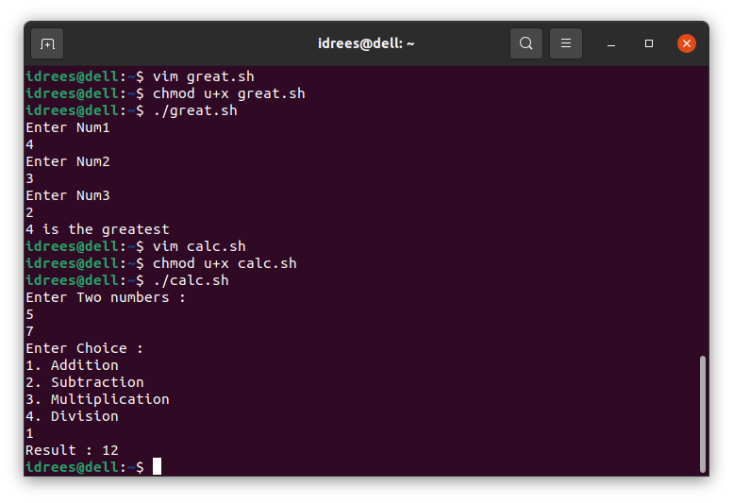

**a program which add first 5 prime numbers;**

**program(Introduction to Arrays)**

#!/bin/bash

arr_name=(“Aasd” “Kamal” “OS-LAB” “CS” “5B” ) echo “First Index : ” ${arr_name[0]}

echo “Second Index : ” ${arr_name[1]} echo “Third Index : ” ${arr_name[2]} echo “Fourth Index : ” ${arr_name[3]}

# OUTPUT

