MEDICAL CLINIC DATABASE PROJECT
Version Control And Lab Submission
Group Members | Idrees Zazai, Farman Afridi
Class | BSSE Group A
Instructor | Sir. Ali Hassan
Github Link | https://github.com/idreeszazai657-hash/Medical_Clinic_Project

Milestone 1: First ERD Diagram & Schema
Project Title: Medical Clinic Database System
Group Members: Idrees Zazai, Farman Afridi
Instructor: Ali Hassan

Version 1.1 (Updated)

ER Diagram:
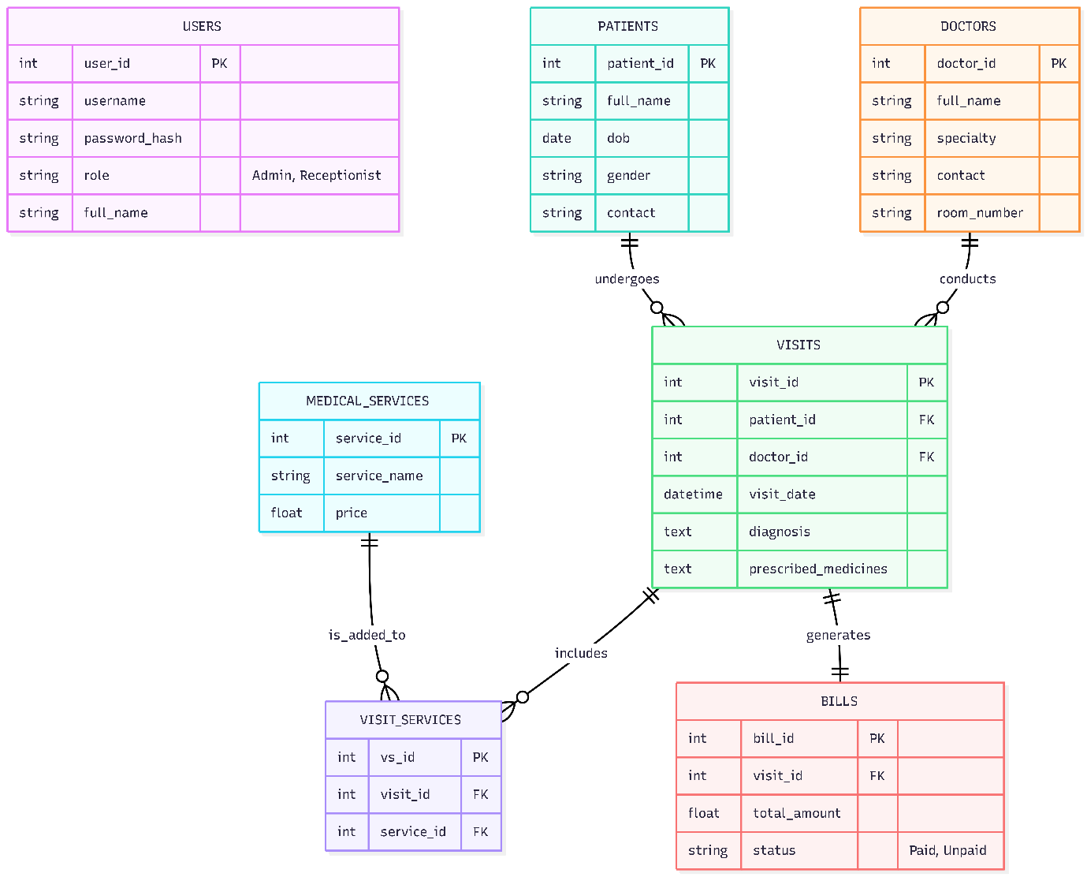

Data Flowchart:

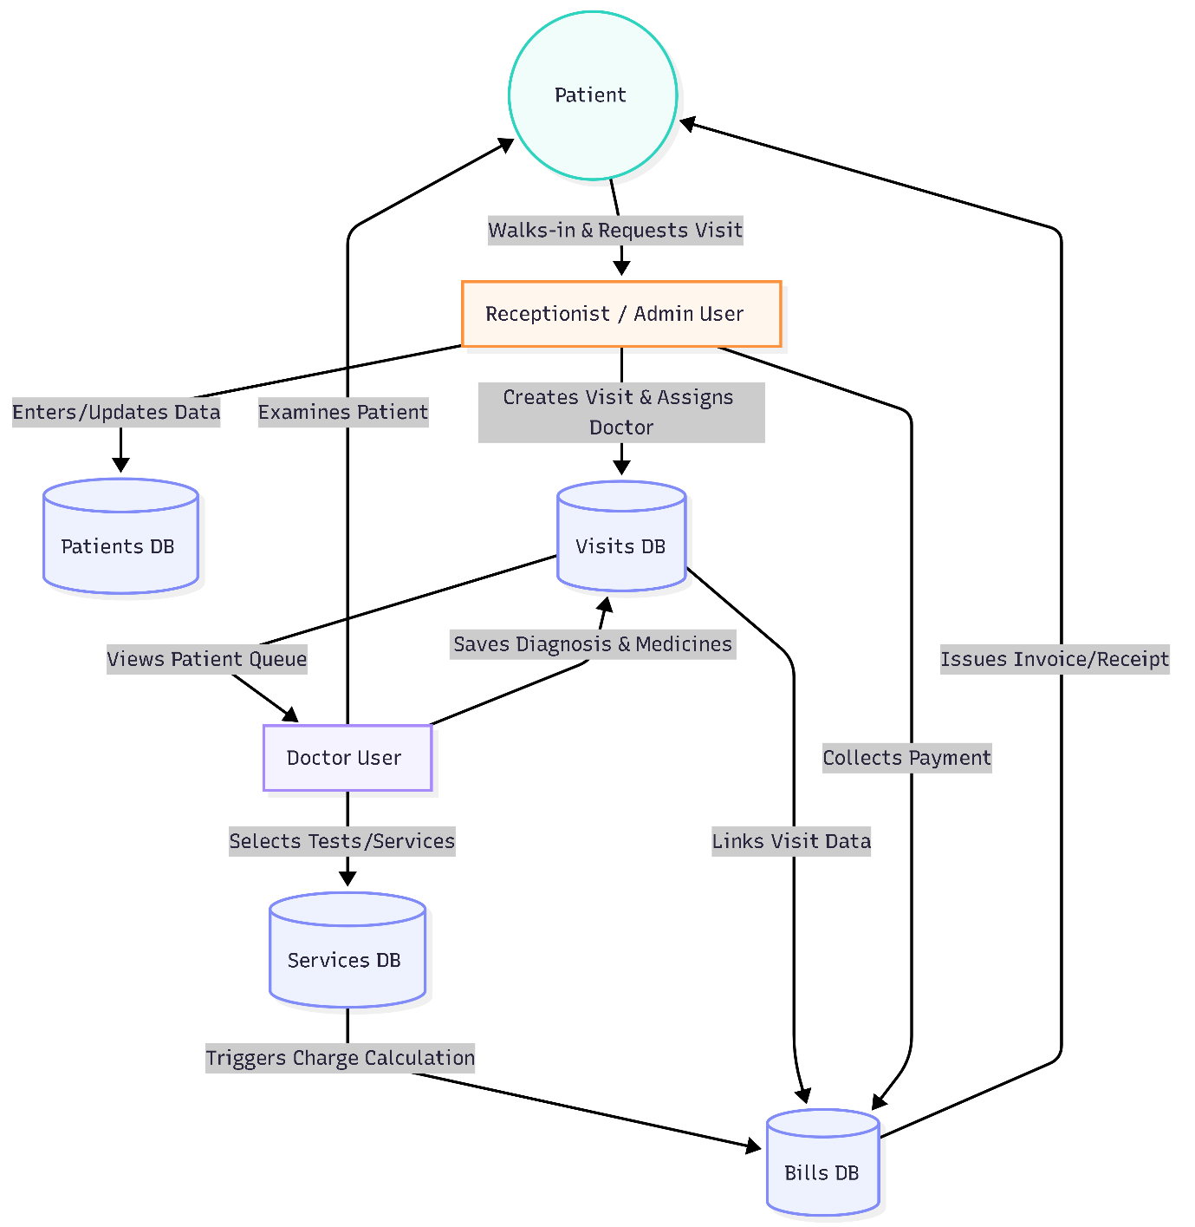

Database Schema:
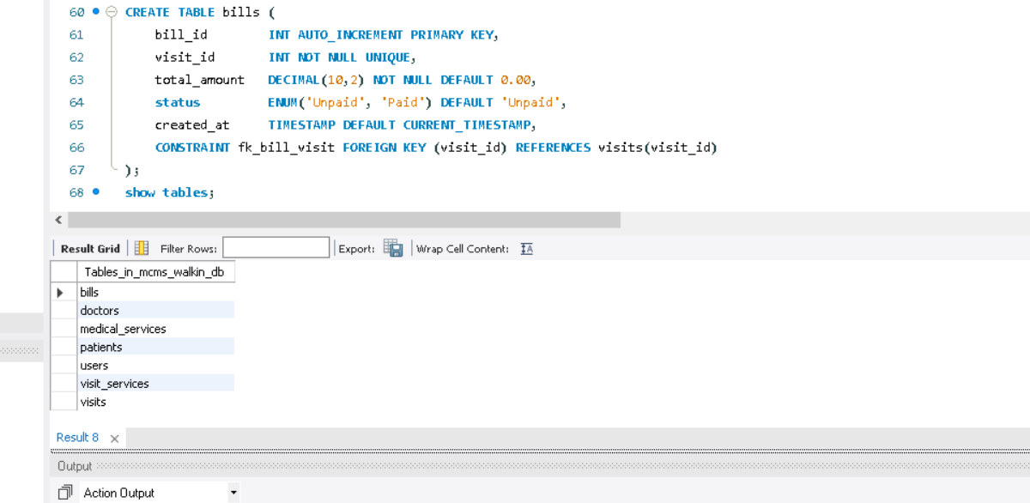

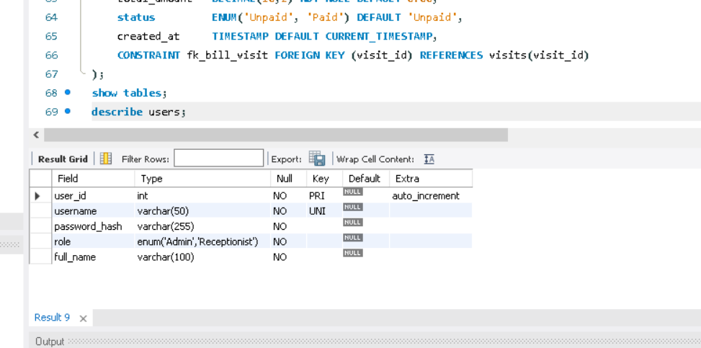
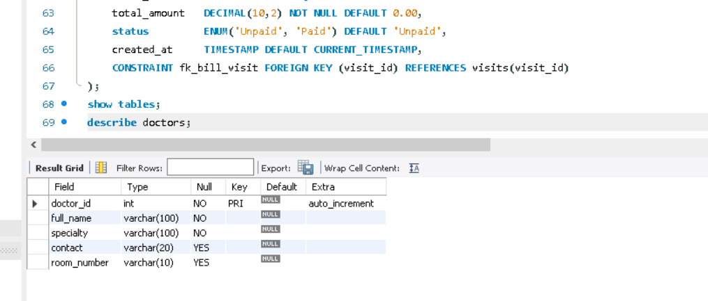

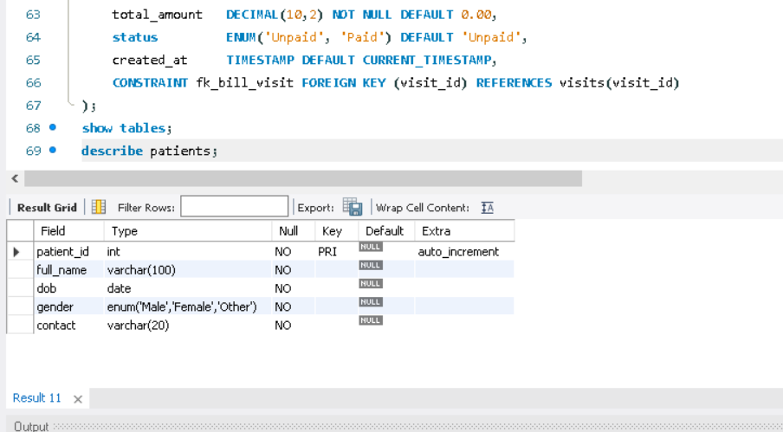

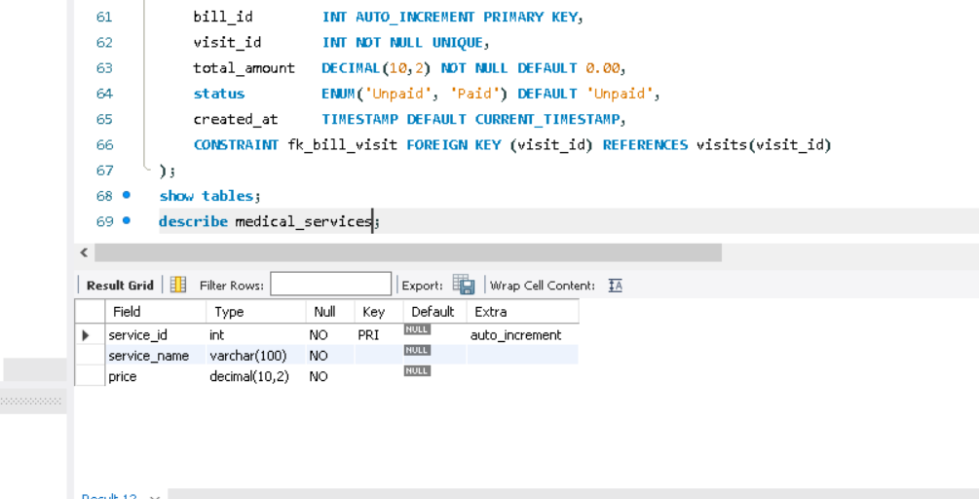
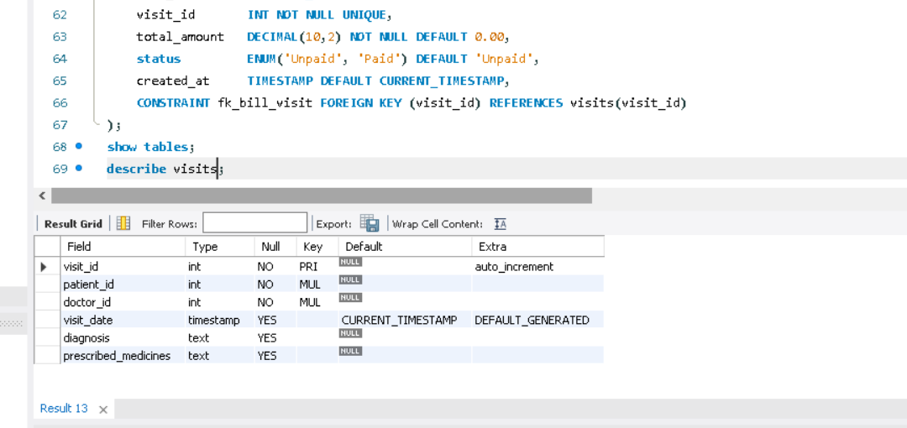
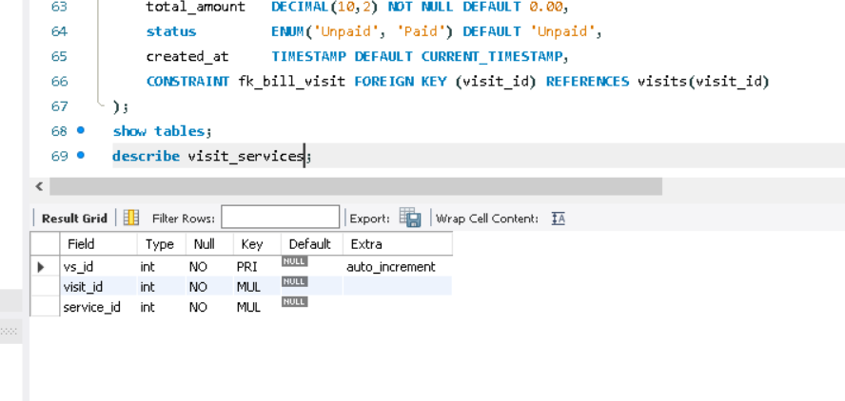

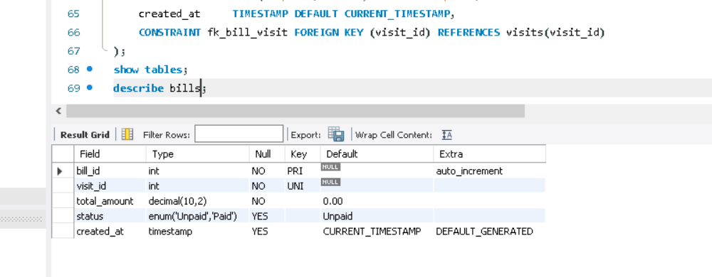

Milestone 2: ERD Design & Normalization
Project Title: Medical Clinic Database System
Group Members: Idrees Zazai, Farman Afridi
Instructor: Ali Hassan

Step 1 & 2 — Apply Normalization & Remove Duplicates

1NF (First Normal Form)
Issue Found: The full_name fields in USERS, PATIENTS, and DOCTORS were not atomic. The prescribed_medicines field in VISITS contained multiple medicines.
Changes Made: Split full_name into first_name and last_name across all relevant tables. Removed prescribed_medicines from VISITS and created a new PRESCRIPTIONS table.
Why: To comply with 1NF, every column must hold a single, indivisible value.

2NF (Second Normal Form)
Issue Found: None.
Changes Made: None.
Why: Partial dependencies only exist with composite primary keys. All tables use single-column surrogate primary keys. Thus, being in 1NF guarantees 2NF.

3NF (Third Normal Form)
Issue Found: None.
Changes Made: None.
Why: All attributes depend strictly on the primary key, avoiding transitive dependencies. The schema is successfully in 3NF.

Step 3 — Updated ERD
The ER Diagram has been updated to reflect the new PRESCRIPTIONS table and atomic name fields. Please refer to the updated_erd.png image in the ERD directory.
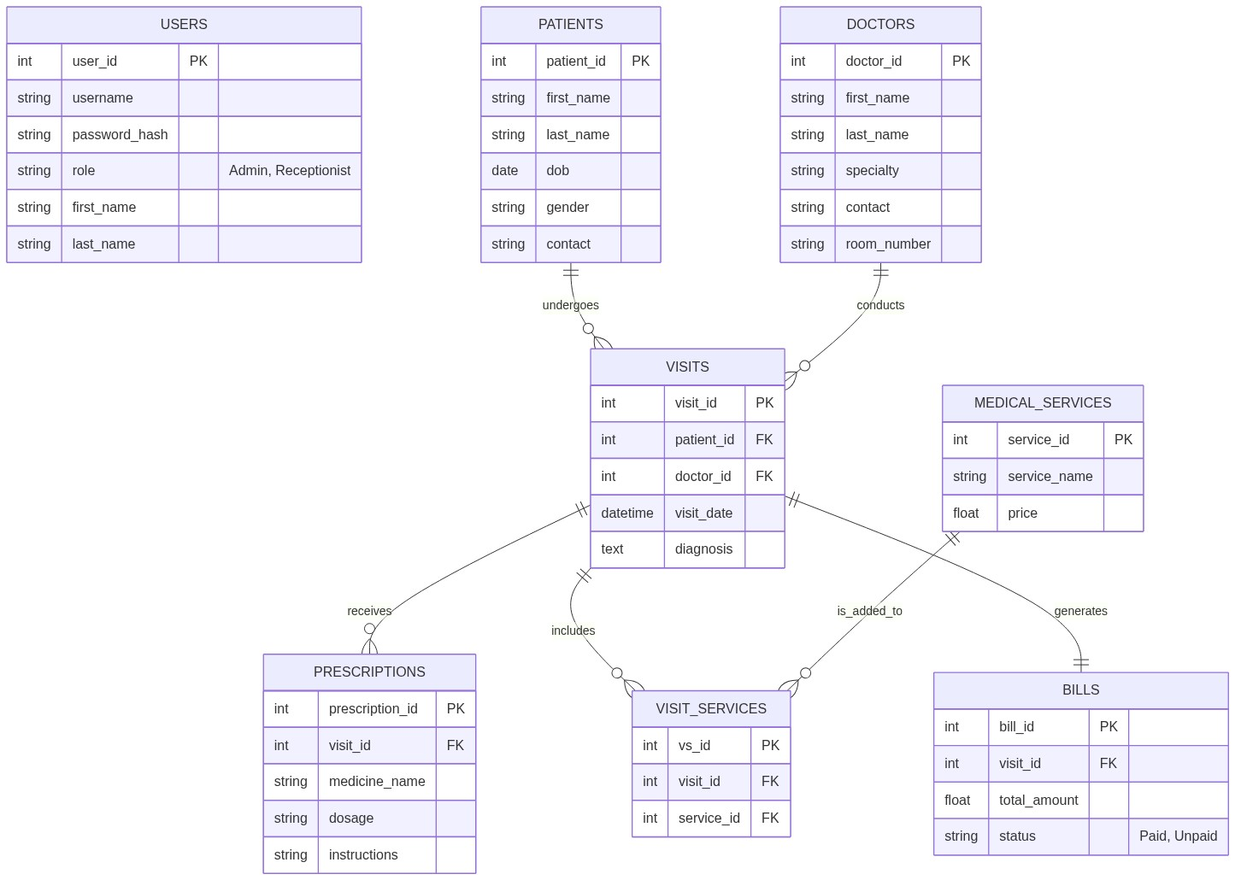

Milestone 3: Dataset Preprocessing
Project Title: Medical Clinic Database System
Group Members: Idrees Zazai, Farman Afridi
Instructor: Ali Hassan

Step 1 — Prepare Your Dataset
A Python script was utilized to generate a realistic and structured synthetic dataset. We generated exactly 60 rows of data for all 8 core tables (USERS, PATIENTS, DOCTORS, MEDICAL_SERVICES, VISITS, PRESCRIPTIONS, VISIT_SERVICES, BILLS) using randomized names, dates, and medical terminology.

Step 2 — Define Your Dataflow
1. Data Entry Point: The receptionist registers new patients in the PATIENTS table.
2. Core Operational Flow: The receptionist schedules a visit by connecting PATIENTS to DOCTORS within the VISITS table.
3. Dependent Streams: From VISITS, doctors issue PRESCRIPTIONS and order MEDICAL_SERVICES (tracked in VISIT_SERVICES).
4. Financial Processing: All services linked to a visit calculate a total_amount, stored in the BILLS table.
5. Outputs: The system generates Patient Invoices, Medical History Reports, and Operational Reports.

Step 3 — Export Clean CSV Files
The generated dataset was successfully exported as 8 clean CSV files into the Data directory.

Milestone 4: Database Setup (DDL)
Project Title: Medical Clinic Database System
Group Members: Idrees Zazai, Farman Afridi
Instructor: Ali Hassan

DDL Scripts and Constraints
The schema.sql script was created mapping our normalized schema to MySQL. It includes:
- AUTO_INCREMENT PRIMARY KEY constraints on all tables.
- FOREIGN KEY constraints linking all relationships with ON DELETE CASCADE.
- NOT NULL applied to essential fields.
- UNIQUE constraint on username.
- CHECK constraints ensuring data validity (e.g., price >= 0, gender IN ('Male', 'Female', 'Other'), role IN ('Admin', 'Receptionist')).

Indexes for Performance
We implemented CREATE INDEX statements on all foreign key columns to ensure foreign key lookups are optimized. Additional indexes were placed on frequently queried columns such as patient last_name, doctor specialty, and visit_date.

EER Diagram Verification
The DDL script has been written such that MySQL Workbench's Reverse Engineer feature perfectly generates the final EER Diagram.

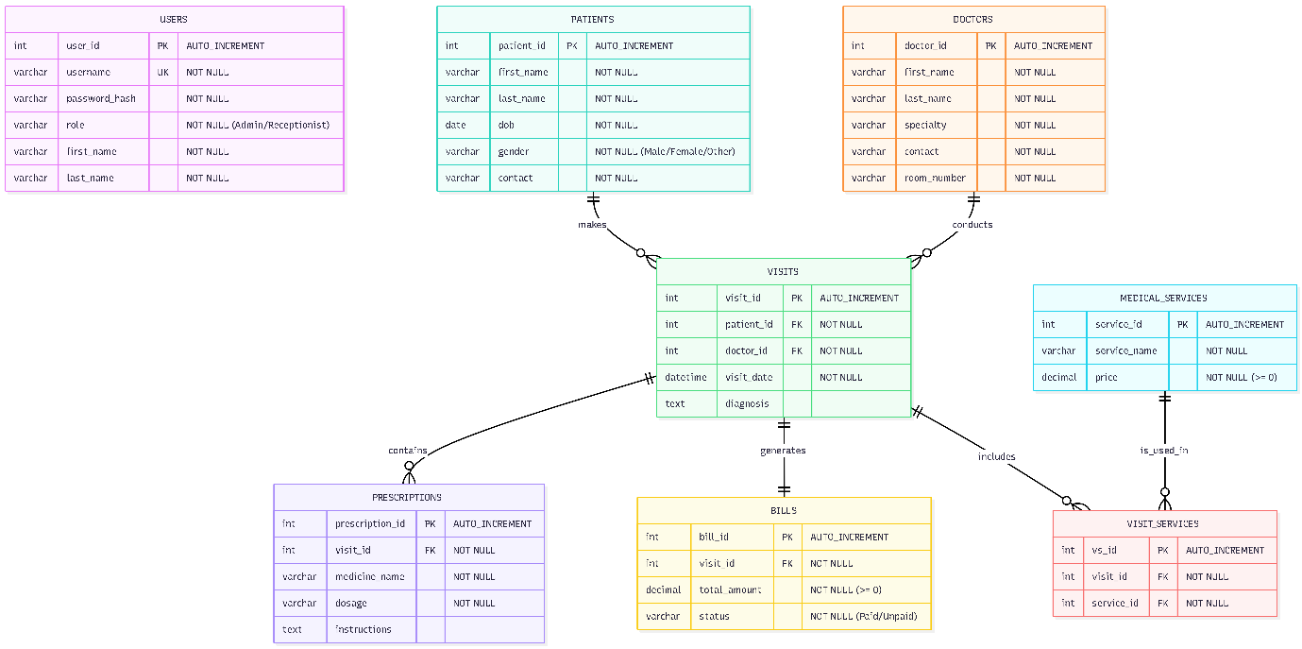

Milestone 5: Data Population (DML)
Project Title: Medical Clinic Database System
Group Members: Idrees Zazai, Farman Afridi
Instructor: Ali Hassan

Data Population Strategy
Instead of LOAD DATA INFILE, a custom Python script converted our 8 CSV files into a comprehensive insert_data.sql script. This file contains over 400 lines of pure INSERT INTO statements to safely populate the database without triggering MySQL file permission restrictions.

Validation Queries
A validation_queries.sql script was developed to fulfill all final assignment requirements:
1. UPDATE Operation: Updated a bill's status to 'Paid' using a WHERE clause.
2. DELETE Operation: Deleted an old visit using a WHERE clause.
3. Row Count: A UNION ALL query executing COUNT(*) across all 8 tables.
4. NULL Checks: Queries targeting first_name, visit_date, and total_amount to ensure data completeness.
5. JOIN-Based FK Integrity: A LEFT JOIN query checking for orphaned records, guaranteeing foreign key constraints are fully intact.

-- ==========================================
-- 1. DATA MODIFICATION DEMONSTRATION
-- ==========================================

-- Demonstrating an UPDATE operation with a WHERE condition
-- Updating the status of a specific bill to 'Paid'
UPDATE BILLS
SET status = 'Paid'
WHERE bill_id = 5 AND status = 'Unpaid';

-- Demonstrating a DELETE operation with a WHERE condition
-- Deleting a specific old visit (Since we have ON DELETE CASCADE, this will safely remove linked records in VISIT_SERVICES and PRESCRIPTIONS)
DELETE FROM VISITS
WHERE visit_id = 60;

-- ==========================================
-- 2. VALIDATION QUERIES
-- ==========================================

-- A. COUNT(*) for each table to confirm row counts
SELECT 'USERS' AS Table_Name, COUNT(*) AS Row_Count FROM USERS
UNION ALL
SELECT 'PATIENTS', COUNT(*) FROM PATIENTS
UNION ALL
SELECT 'DOCTORS', COUNT(*) FROM DOCTORS
UNION ALL
SELECT 'MEDICAL_SERVICES', COUNT(*) FROM MEDICAL_SERVICES
UNION ALL
SELECT 'VISITS', COUNT(*) FROM VISITS
UNION ALL
SELECT 'PRESCRIPTIONS', COUNT(*) FROM PRESCRIPTIONS
UNION ALL
SELECT 'VISIT_SERVICES', COUNT(*) FROM VISIT_SERVICES
UNION ALL
SELECT 'BILLS', COUNT(*) FROM BILLS;

-- B. NULL check on key columns
-- This should return 0 rows if our NOT NULL constraints and data population worked correctly
SELECT 'Missing Patient Name' AS Issue_Type, COUNT(*) AS Count FROM PATIENTS WHERE first_name IS NULL
UNION ALL
SELECT 'Missing Visit Date', COUNT(*) FROM VISITS WHERE visit_date IS NULL
UNION ALL
SELECT 'Missing Bill Total', COUNT(*) FROM BILLS WHERE total_amount IS NULL;

-- C. JOIN-based check to confirm foreign key integrity
-- This checks if there are any VISITS assigned to a patient_id that DOES NOT exist in the PATIENTS table.
-- Because of our Foreign Key constraints, this MUST return 0 rows.
SELECT
v.visit_id,
v.patient_id AS Orphaned_Patient_ID
FROM
VISITS v
LEFT JOIN
PATIENTS p ON v.patient_id = p.patient_id
WHERE
p.patient_id IS NULL;

select* from patients;

