**X-Curve: A Decision-Invariant Framework for Machine Learning**

**Mission: Support end-to-end Training Solutions for Decision Invariant Models**

Recently, machine learning and deep learning technologies have been successfully employed in many complicated **high-stake decision-making** applications such as disease prediction, fraud detection, outlier detection, and criminal justice sentencing. All these applications share a common trait known as **risk-aversion** in economics and finance terminologies. In other words, the decision-makers tend to have an **extremely low risk tolerance**. Under this context, decision-making parameters will significantly affect the performance of models. For example, in binary classification problems, we use the so-called classification threshold as the decision parameter. In the following examples, we see that changing the threshold leads to significantly different model performances. 图形用户界面, 应用程序, Teams

In risk-aversion problems, the decision parameters change dynamically in deployment time. Hence, the goal of X-curve learning is to learn high-quality models that can adapt to different decision conditions. Inspired by the fundamental principle of the well-known AUC optimization, our library provides a systematic solution to optimize the area under different kinds of performance curves. To be more specific, the performance curve is formed by a plot of two performance functions $x(\lambda), y(\lambda)$ of decision parameter $\lambda$. The area under a performance curve becomes the integral of the performance over all possible choices of different decision conditions. In this way, the learning systems are only required to optimize a decision-invariant metric to avoid the risk aversion issue.

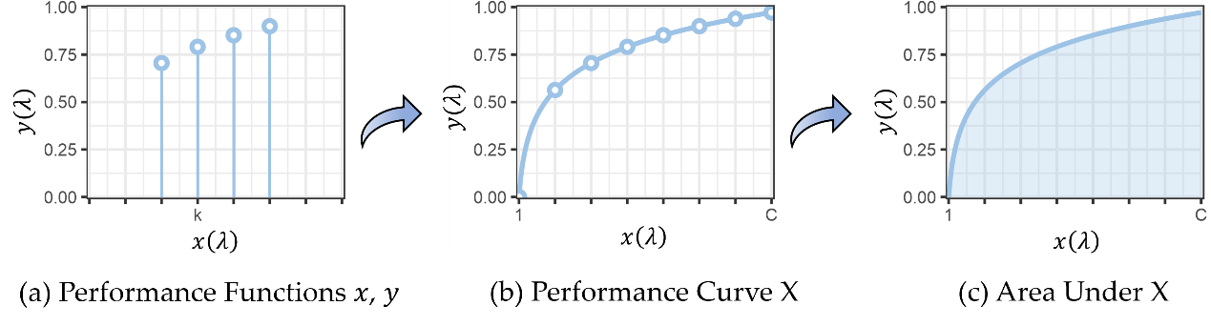

XCurve now supports four kinds of performance curves including AUROC for Long-tail Recognition, AUPRC for Imbalanced Retrieval, AUTKC for Classification under Ambiguity, and OpenAUC for Open-Set Recognition.

Outline

