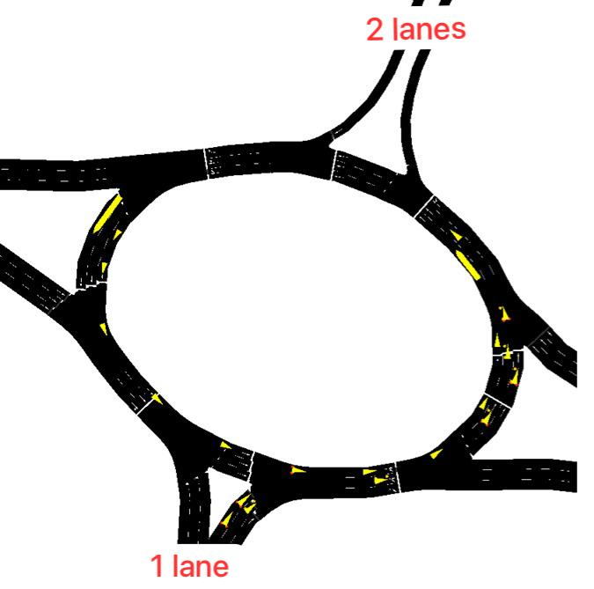
Fig. 1: Highlighting 2 lanes and 1 lane
First, can you reverse the number of lanes between Al Qasr and Al Maabilah? This will be constant for both the first and second scenarios.

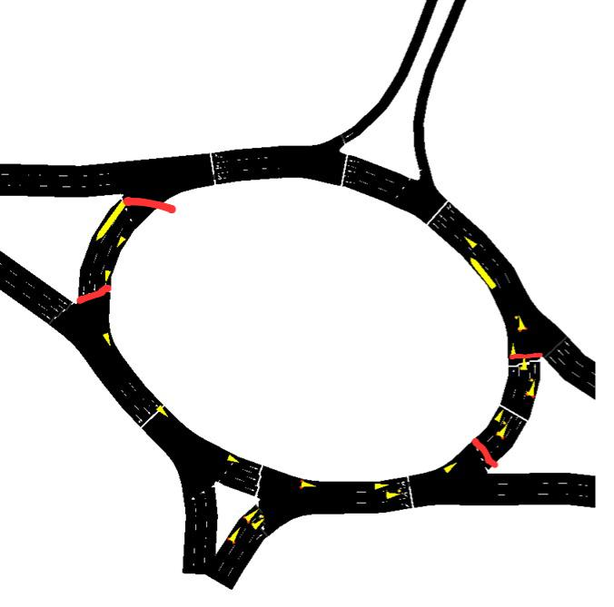
Fig. 2: Next requirement
After adjusting the number of lanes, the second scenario will be closing the roundabout and making reversing traffic with a barrier, like the red line

