RANSAC – A random sampling technique used to remove outliers and make the homography matrix more accurate (Primsingh 2023). It generates a hypothesize from random samples and verifies it into data (Choi et al. 2009) Brought into the image processing field by Fischler and Bolles (1981) in opposition to Least Squares. From the data, it selects a sub-set and the smallest number of points required at random (ie. 2 in our case). It then counts the number of inliers with a given threshold (delta), which is related to the inlier noise statistics, for a number of iterations (n), for a given probability (p) for finding the maximum number of inliers (Argyros 2024).

Simply and robust, without the need for complex algorithms or large amounts of memory, as it only uses a subset of the data(Choi et al. 2009)An issue with RANSAC, is that it the local matching is not modelled. Can be seen as a black box, generating tentative correspondences (Chum and Matas 2005). Additionally in Robotics, RANSAC may cause difficulty in processing real-time data due to its random nature, which makes it proportional to the accuracy (Jeon et al. 2015).

PROSAC (Progressive Sample Consensus) builds on RANSAC by leveraging ranked correspondences. It starts with high-confidence matches and progressively includes lower-confidence ones, optimizing computational efficiency and improving model accuracy (Chum and Matas 2005). The paper by Chum and Matas (2005), showed a 2 magnitude increase in solving non-trivial problems and an identical worst case behaviour between RANSAC and PROSAC.

It has been promoted as a strong alternative to RANSAC for use in Robotics (Jeon et al. 2015). In the code, when we create the matches, each one has an attribute distance which we can use to sort the matches.

2 images in a scene are related by homography, a transformation that matches corresponding points of one image onto another (Datahacker 2020).
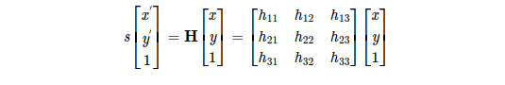Figure 1: H-matrix from Gava and Bleser (2017)

From this matrix, we can see that there are 8 points (the last being a fixed unity value of 1). In our code we have-

[[ 4.03548440e-01 -1.86198824e-02 3.29151196e+03]
[-1.44030512e-01 1.02744241e+00 -2.75241198e+02]
[-1.88131297e-04 4.77777867e-05 1.00000000e+00]]

There are 8 unknowns, which means we need 4 inlier pairs to compute the matrix, as each of them gives 2 equations (Zoghlami et al. 1997).

Model estimation:
Using sampled points we need a minimum of 4 points to compute a homography matrix. - (x and x’ are corresponding points) ( is 3x3 transformation matrix)
Inlier Counting:

After obtaining the homography matrix, it is then used to convert one image’s coordinate system to another (Premsingh 2023).

Homography slide 5

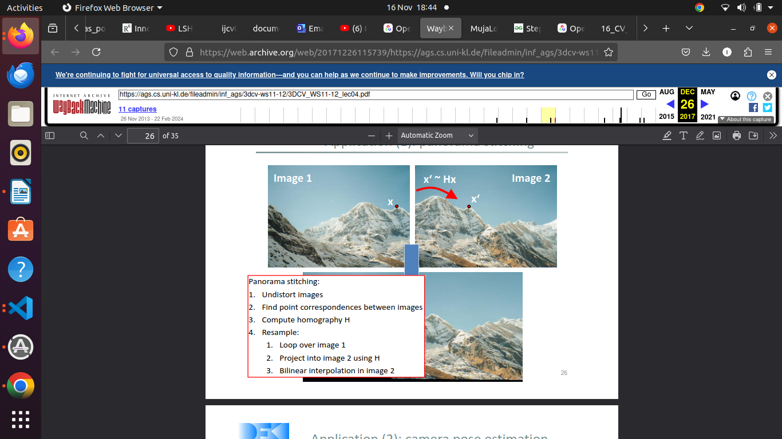Figure 2: H-matrix applied to 2 images. From Gava and Bleser(2017).

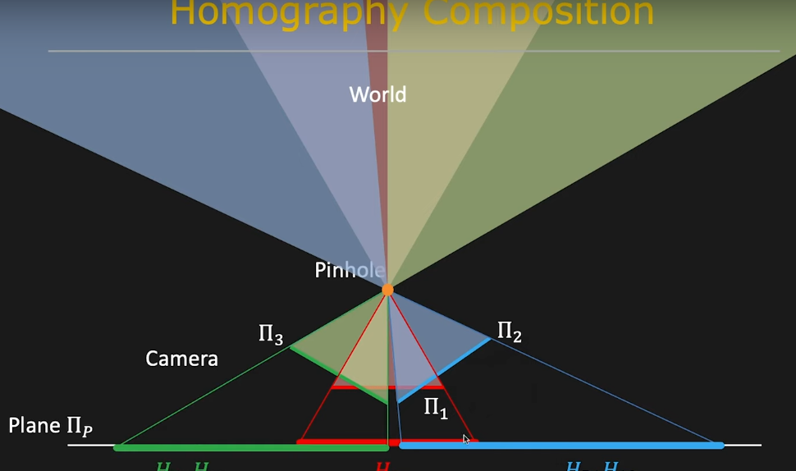Figure 3: How Homographic planes converge into a stitch image. Plane 1 is transformed onto plane p via the transform Hp1. Plane 2’s transform is Hp1H12. First principles of computer science (2021)

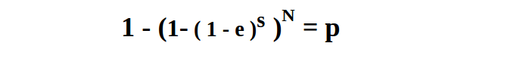Figure 4: From Argyros (2024)

e – probability that a point is an outlier.
s – number of sample points
N – number of samples
p – desired probability
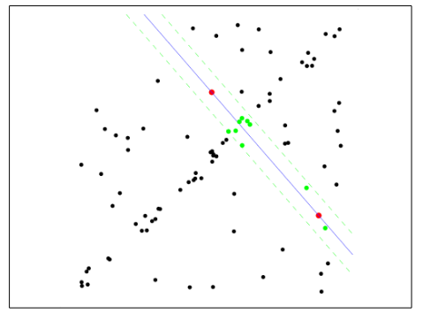Figure 5: Sampling in RANSAC from Argyros(2024)

Here 2 points are drawn and fitted. A number is determined is a sampled line is a good fit. This is then repeated n times and the best fit from the collection is used(Argyros 2024).

Fischler, A., M.,Bolles, C., R. 1981. Random sample consensus: a paradigm for model fitting with applications to image analysis and automated cartography. Commun. ACM 24, 6 (June 1981), 381–395.

Chum, O., Matas, J. (2005). Matching with PROSAC - progressive sample consensus. Proc. of CVPR. 1. 220 - 226 vol. 1.

Nam, D.,Aouf, N. (2017) "Automated mosaicing for improving vehicle situational awareness in real time," 2017 IEEE Intelligent Vehicles Symposium (IV), Los Angeles, CA, USA,pp. 1146-1151.

Choi, S. Kim, T. Yu., W. (2009) Performance Evaluation of RANSAC Family. BMVA. Paper 355.
The first point of call was the documentation, which gave a clear overview.

Jeon, K., H. Jeong, M., J. Lee, Y., K. 2015 An implementation of the real-time panoramic image stitching using ORB and PROSAC. International SoC Design Conference (ISOCC), Gyeongju, Korea (South), 2015, pp. 91-92.

Argyros, A. (2024) Slides from Lecture 16. Online resource: http://users.ics.forth.gr/~argyros/cs472_spring24/16_CV_RANSAC_LMEDS_2903.pdf
Accessed on: 20/11/2024.

Primsingh, P., (2023) Image Stitching using OpenCV — A Step-by-Step Tutorial. Online resource: https://medium.com/@paulsonpremsingh7/image-stitching-using-opencv-a-step-by-step-tutorial-9214aa4255ec. Accessed on: 12/11/2024

Zoghlami, I. Faugeras, O. Deriche, R, (1997) Using geometric corners
to build a 2D mosaic from a set of images, in Proc. EEE Computer
Society Conference on Computer Vision and Pattern Recognition, San
Juan, Puerto Rico, USA. pp. 420-425

Gava, C. Bleser, G. (2017) 2D projective transformations (homographies). Online resource:
https://web.archive.org/web/20171226115739/https://ags.cs.uni-kl.de/fileadmin/inf_ags/3dcv-ws11-12/3DCV_WS11-12_lec04.pdf
Accessed on: 08/11/2024

Datahacker. (2020) How to create a panorama image using OpenCV with Python. Online resource: https://datahacker.rs/005-how-to-create-a-panorama-image-using-opencv-with-python/
Accessed on: 15/11/2024

