Nama : Ahmad Idris Dzulfikar

NIM : A11.2021.13418

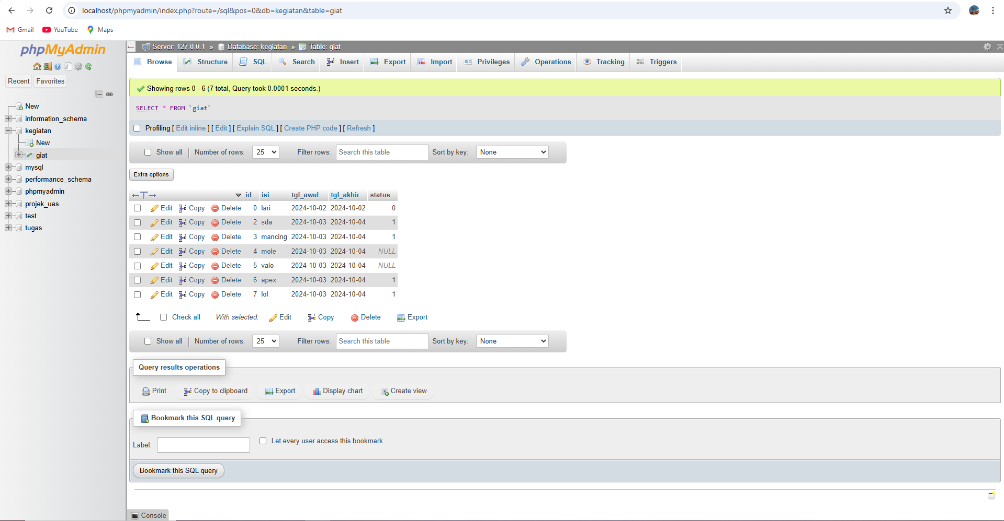

Database saya simpan dengan nama Giat

Berisi bebrapa data yang sudah di buat

<?php

// Database connection settings

$databaseHost = 'localhost';

$databaseName = 'kegiatan';

$databaseUsername = 'root';

$databasePassword = '';

// Create a connection

$mysqli = mysqli_connect($databaseHost, $databaseUsername, $databasePassword, $databaseName);

// Check the connection

if (!$mysqli) {

    die("Connection failed: " . mysqli_connect_error());

}

?>

Coding untuk koneksi

<!DOCTYPE html>

<html lang="en">

<head>

    <meta charset="UTF-8">

    <meta name="viewport" content="width=device-width, initial-scale=1.0">

    <link rel="stylesheet" href="assets/css/bootstrap.css">

    <link href="https://cdn.jsdelivr.net/npm/bootstrap@5.0.2/dist/css/bootstrap.min.css"

          rel="stylesheet"

          integrity="sha384-EVSTQN3/azprG1Anm3QDgpJLIm9Nao0Yz1ztcQTwFspd3yD65VohhpuuCOmLASjC"

          crossorigin="anonymous">

    <title>To Do List</title>

</head>

<body>

<h3>

    To Do List

    <small class="text-muted">Catat semua hal yang akan kamu kerjakan disini.</small>

</h3>

<hr>

Base code

<form class="form row" method="POST" action="" name="myForm">

    <?php

    $isi = '';

    $tgl_awal = '';

    $tgl_akhir = '';

    if (isset($_GET['id'])) {

        $ambil = mysqli_query($mysqli, "SELECT * FROM giat WHERE id='" . $_GET['id'] . "'");

        while ($row = mysqli_fetch_array($ambil)) {

            $isi = $row['isi'];

            $tgl_awal = $row['tgl_awal'];

            $tgl_akhir = $row['tgl_akhir'];

        }

    ?>

        <input type="hidden" name="id" value="<?php echo $_GET['id'] ?>">

    <?php } ?>

    <div class="col">

        <label for="inputIsi" class="form-label fw-bold">Kegiatan</label>

        <input type="text" class="form-control" name="isi" id="inputIsi" placeholder="Kegiatan" value="<?php echo $isi ?>">

    </div>

    <div class="col">

        <label for="inputTanggalAwal" class="form-label fw-bold">Tanggal Awal</label>

        <input type="date" class="form-control" name="tgl_awal" id="inputTanggalAwal" placeholder="Tanggal Awal" value="<?php echo $tgl_awal ?>">

    </div>

    <div class="col mb-2">

        <label for="inputTanggalAkhir" class="form-label fw-bold">Tanggal Akhir</label>

        <input type="date" class="form-control" name="tgl_akhir" id="inputTanggalAkhir" placeholder="Tanggal Akhir" value="<?php echo $tgl_akhir ?>">

    </div>

    <div class="col">

        <button type="submit" class="btn btn-primary rounded-pill px-3" name="simpan">Simpan</button>

    </div>

</form>

Code untuk form input data

<table class="table table-hover">

    <thead>

        <tr>

            <th scope="col">#</th>

            <th scope="col">Kegiatan</th>

            <th scope="col">Awal</th>

            <th scope="col">Akhir</th>

            <th scope="col">Status</th>

            <th scope="col">Aksi</th>

        </tr>

    </thead>

    <tbody>

    <?php

// Menjalankan query dan menangani error jika terjadi

$result = mysqli_query($mysqli, "SELECT * FROM giat ORDER BY status, tgl_awal");

// Mengecek apakah query berhasil

if (!$result) {

    // Jika query gagal, tampilkan pesan error dari MySQL

    die("Query Error: " . mysqli_error($mysqli));

}

$no = 1;

while ($data = mysqli_fetch_array($result)) {

?>

    <tr>

        <th scope="row"><?php echo $no++ ?></th>

        <td><?php echo $data['isi'] ?></td>

        <td><?php echo $data['tgl_awal'] ?></td>

        <td><?php echo $data['tgl_akhir'] ?></td>

        <td>

            <?php if ($data['status'] == '1') { ?>

                <a class="btn btn-success rounded-pill px-3" type="button" href="index.php?id=<?php echo $data['id'] ?>&aksi=ubah_status&status=0">Sudah</a>

            <?php } else { ?>

                <a class="btn btn-warning rounded-pill px-3" type="button" href="index.php?id=<?php echo $data['id'] ?>&aksi=ubah_status&status=1">Belum</a>

            <?php } ?>

        </td>

        <td>

            <a class="btn btn-info rounded-pill px-3" href="index.php?id=<?php echo $data['id'] ?>">Ubah</a>

            <a class="btn btn-danger rounded-pill px-3" href="index.php?id=<?php echo $data['id'] ?>&aksi=hapus">Hapus</a>

        </td>

    </tr>

<?php } ?>

        <?php

        if (isset($_POST['simpan'])) {

            if (isset($_POST['id'])) {

                $ubah = mysqli_query($mysqli, "UPDATE giat SET isi = '" . $_POST['isi'] . "', tgl_awal = '" . $_POST['tgl_awal'] . "', tgl_akhir = '" . $_POST['tgl_akhir'] . "' WHERE id = '" . $_POST['id'] . "'");

            } else {

                $tambah = mysqli_query($mysqli, "INSERT INTO giat(isi, tgl_awal, tgl_akhir, status) VALUES ('" . $_POST['isi'] . "', '" . $_POST['tgl_awal'] . "', '" . $_POST['tgl_akhir'] . "', '0')");

            }

            echo "<script>document.location='index.php';</script>";

        }

        if (isset($_GET['aksi'])) {

            if ($_GET['aksi'] == 'hapus') {

                $hapus = mysqli_query($mysqli, "DELETE FROM giat WHERE id = '" . $_GET['id'] . "'");

            } else if ($_GET['aksi'] == 'ubah_status') {

                $ubahstatus = mysqli_query($mysqli, "UPDATE giat SET status = '" . $_GET['status'] . "' WHERE id = '" . $_GET['id'] . "'");

            }

            echo "<script>document.location='index.php';</script>";

        }

        ?>

    </tbody>

</table>

code untuk table dan button

link git

https://gitlab.com/ahmadidris1220/todolist/-/blob/main/index.php