PPC-125 /200N(Clinical Chemistry Analyzer)

ASTM - Host Interface Document

Version: 2.0

INDEX

Sr.No. | TOPIC | Page No.
1 | Overview | 6
2 | Interconnection Diagram | 7
3 | OSI (Open System Interconnection) Layers | 8
4 | Physical Layer | 9
5 | Modifying HOST Settings, | 11
6 | ASTM Lower Level Communication Methodology | 15
7 | Data Flow Diagram | 16
8 | Checksum Calculation | 23
9 | Special Function Character Table | 24
10 | ASTM Higher Level Concept | 25
11 | ASTM Records
 | Message Header Record | 26
 | Patient Record | 27
 | Test Order Record | 29
 | Result Record | 31
 | Comment Record | 33
 | Request Information Record | 34
 | Message Terminator Record | 35
12 | Data Transfer from ASTM to LIMS | 36
13 | Data Transfer from LIMS to ASTM | 37
14 | ASTM and LIMS Communication Examples | 39
15 | ASTM and LIMS Testing Scenarios | 51

OVERVIEW:

Purpose:

This Document details the specifications for ASTM Host Interconnection and communication for Clinical Chemistry analyzer.

Scope:

Detailed information on operation of the system is beyond the scope of this document. The information offered here is strictly to aid programmers in grasping very basic operational features of the analyzer.

Conventions:

This document consists primarily of a series of examples that show the information needed to successfully interface to the system. The basic concept of data transfer in this interface is the exchange of data and control frames between the host system and the analyzer.

Primary Reference:

E1381 – 02
Low-Level Protocol to Transfer Messages between Clinical Laboratory Instruments and Computer Systems.

E1394 – 97

Transferring Information Between Clinical Instruments and Computer Systems.

INTERCONNECTION DIAGRAM:
Analyzer
Analyzer PC
LIMS Computer System
ASTM Communication Packets

Serial RS-232 or TCP/IP


Fig (2.0) ASTM Interconnection with LIMS Computer System

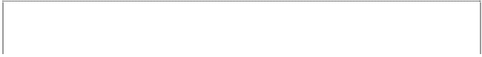
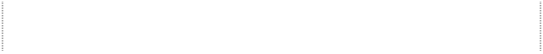
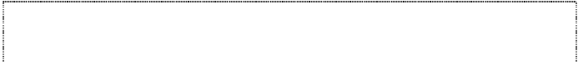
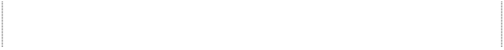


OSI (Open System Interconnection) Layers:
Application Software
MsComm (VBA Component) or TCP/IP (Win socket)
ANSI X3.4-1986 standards. / IEEE 802.3 standards.
Frame Structure:
<STX> FN text <ETX> C1 C2 <CR><LF>: End Frame Or
<STX> FN text <ETB> C1 C2 <CR><LF>: Intermediate frame. (For messages greater than 1024 characters) FN = Frame No.
RS232 / Fast Ethernet (TCP/IP)
Electrical Characteristics: EIA-232-D-1986 standards. Serial: 9600 BAUD, 8-bit, No Parity, 1 Stop Bit.
TCP/IP: 10MBPs
Connectors: DB9 / DB25 or RJ45.

Application Layer
Presentation Layer
Session Layer
Transport Layer
Network Layer
DataLink Layer
Physical Layer

PHYSICAL LAYER:

1. ASTM provides an option of RS232C : Serial Communication for the user to connect with LIMS Computer System.

RS232C (Serial Communication)

Communication Specifications:

Transmission Method | RS232C asynchronous, half duplex.
Transmission Rate | 1200, 2400, 4800, 9600, 19200 bps
Transmission Code | ASCII
Data Length | 7 bits, 8 bits
Parity | Even, Odd, None
Stop Bit | 1 bit, 2 bit

Connections:
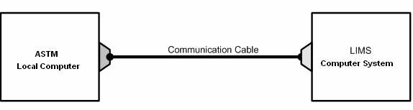
Connector:

D-SUB 9-Pin Connector (Male) on Standard PC
D-SUB 9-Pin Connector (Female): for Communication Cable.

Pin Assignment: Communication Cable

D-SUB 9-Pin |  |  | D-SUB 9-Pin
Frame GND | 1 |  | 1 | Frame GND
Receive Data | 2 | ⇐ | 3 | Transmit Data
Transmit Data | 3 | ⇒ | 2 | Receive Data
Data Terminal Ready | 4 | ⇐ | 6 | Data Set Ready
Signal GND | 5 | ⇔ | 5 | Signal GND
Data Set Ready | 6 | ⇒ | 4 | Data Terminal Ready
Request to Send | 7 | ⇒ | 8 | Data Set Ready
Data Set Ready | 8 | ⇐ | 7 | Request to Send
NC | 9 |  | 9 | NC

NOTE: For 25-Pin Connector consider following Pin details:

Pin |  | Description
1 |  | Frame GND
2 | TXD | Transmit Data
3 | RXD | Receive Data
4 | RTS | Request to Send
5 | CTS | Clear to Send
6 | DSR | Data Set Ready
7 | GND | Signal GND
20 | DTR | Data Terminal Ready

MODIFYING HOST SETTINGS:

Go to [Service maintenance]---[Parameters setting]
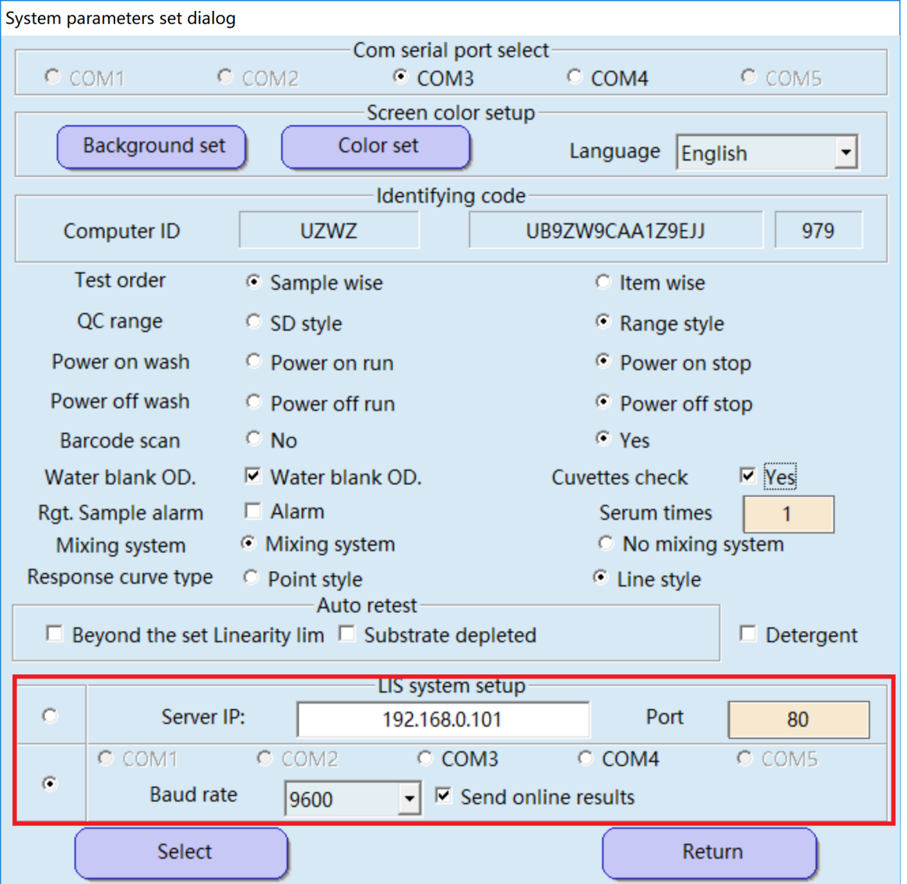

Go to Host Setting. Select TCP/IP mode or COM mode.

- RS232 for Serial Communication

Select COM Option for Serial Communication.
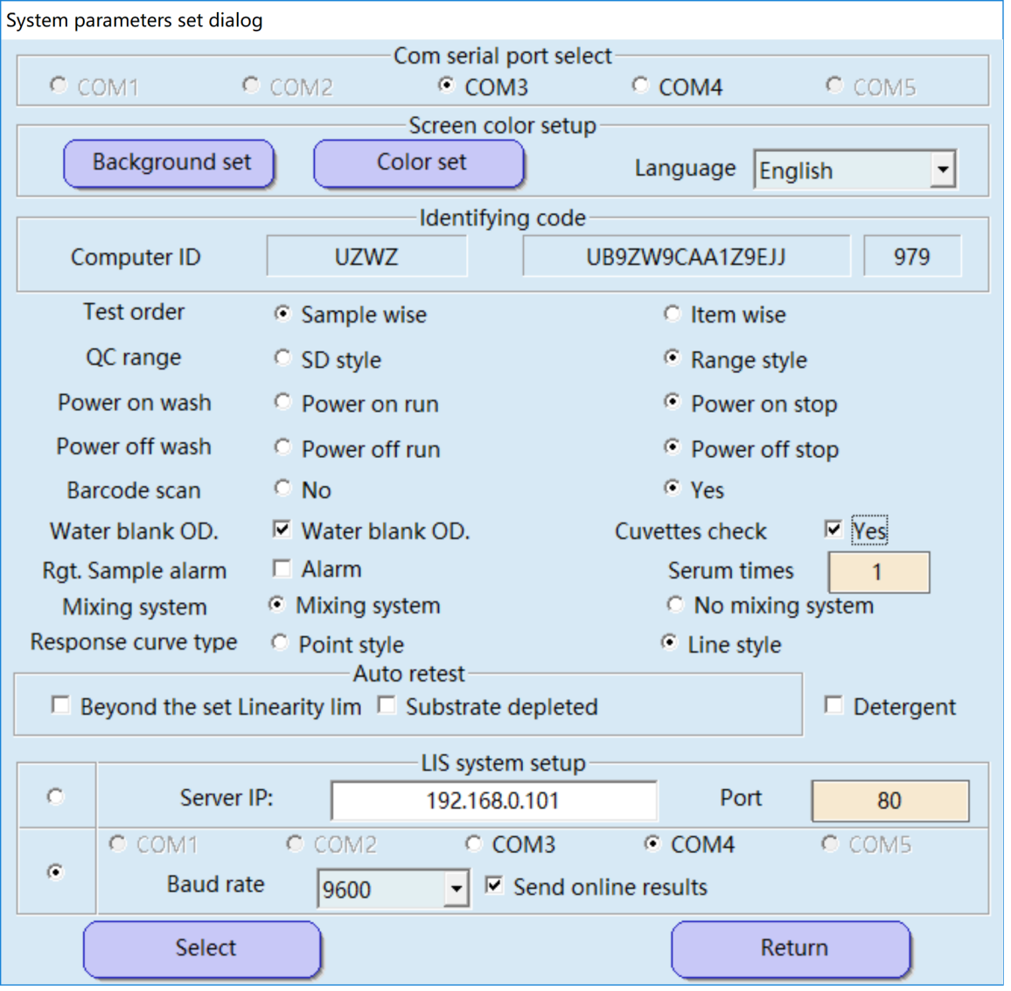

- TCP/IP
Select IP Option for TCP/IP Communication. Enter the IP address and port of the machine in which LIMS is running.

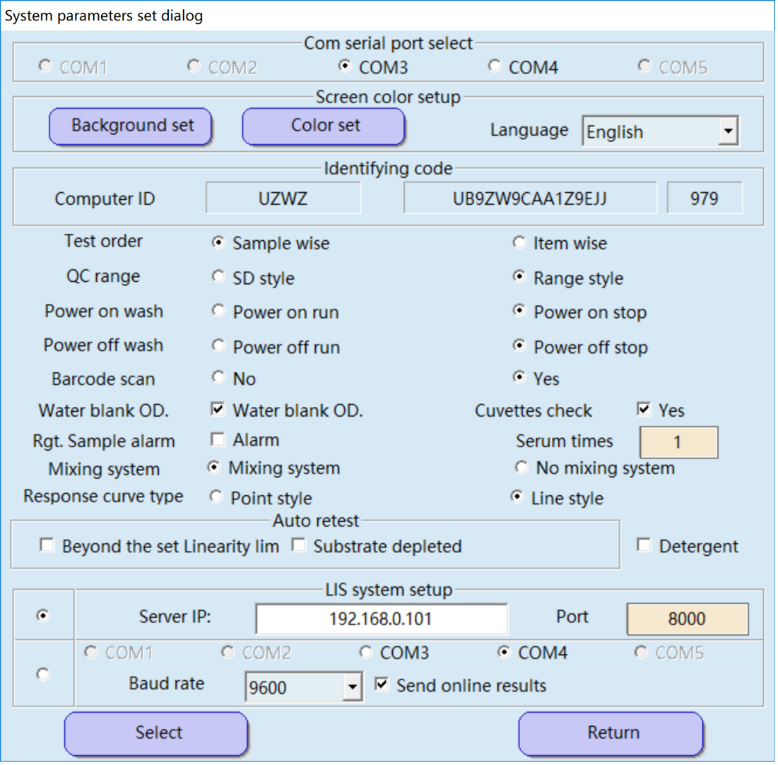

ASTM Lower Level Communication Methodology:

Item | Method | Explanation
Frame Configurations | For Middle Frame  <STX> FN text <ETB> C1 C2 <CR><LF>  For Last Frame  <STX> FN text <ETX> C1 C2 <CR><LF> | Control character (characters enclosed in <>):  <STX> is control character (HEX 02)  <ETB> is control character (HEX 17)  <CR> is control character (HEX 0D)  <LF> is control character (HEX 0A)  <ETX> is control character (HEX 03)  FN: FN is a single ASCII number. FN indicates the sequence number for a frame (the frame number modulus 8). Frames of a single transmission phase are consecutively numbered beginning with 1, so FN runs from 1 to 7, then continues with 0, 1, and so on.  Text: the data content of a frame (maximum 1024 characters). Records are sub-divided into intermediate (middle) frames with 1024 or fewer characters. Text is part of a split message.  C1 and C2: When 1 byte resulting from adding each byte, FN to <ETB> for the middle frame and FN to  <EXT> for the last frame, is expressed in hexadecimal, the upper character (161) is C1 and the lower character  (160) is C2. Characters used are ‘0’ to ‘9’ or ‘A’ to ‘F’
Frame Character Configuration of Text | Characters other than  <SOH><STX><ETX>  <EOT><ENQ><ACK>  <DLE><NAK><SYN>  <ETB><LF><DC1>  <DC2><DC3><DC4> | <SOH> is control character (HEX 01)  <EOT> is control character (HEX 04)  <ENQ> is control character (HEX 05)  <ACK> is control character (HEX 06)  <DLE> is control character (HEX 10)  <NAK> is control character (HEX 15)  <SYN> is control character (HEX 16)  <DC1> ~ <DC4> is control character (HEX 11 ~ 14)
Maximum Length of the Frame | 1024 characters | For one frame, maximum of 1024 characters for text, 7 characters for frame control characters.  Messages equal to or less than 1024 characters are transmitted as one final frame. Messages greater than 1024 characters are split into frames that have character lengths that fall within the 1024-character limit. The only or final remaining frame becomes the last frame and is indicated by <ETX>. All others are intermediate (middle) frames and are indicated by <ETB>.

Data Flow Diagram:

Transmitting Message:

Case 1: Ideal Transmit Data.
Termination
NEUTRAL
<EOT>
Termination
NEUTRAL
<ACK>
STRING_ACK_INTERVAL
·
<STX> Last Frame <ETX> C1 C2 <CR> <LF>
Continue Sending next frames
<ACK>
STRING_ACK_INTERVAL
·
Receive
STRING_ACK_INTERVAL

<ACK>

<STX> Frame 2 <ETB> C1 C2 <CR> <LF>
·
Transmit
<STX> Frame 1 <ETB> C1 C2 <CR> <LF>
Transfer
<ACK>
Transfer
<ENQ>
ENQ_ACK_INTERVAL
·
NEUTRAL
Establishment
NEUTRAL
Establishment
LIMS
ASTM
(Analyzer)

Case 2: <NAK> Received
NEUTRAL
NEUTRAL
Termination
<EOT>
Termination
Continue sending next frames
<ACK>
·
Receive
<NAK>

RETRY
<STX> Frame 1 <ETB> C1 C2 <CR> <LF>
STRING_ACK_INTERVAL
STRING_ACK_INTERVAL
·
<STX> Frame 1 <ETB> C1 C2 <CR> <LF>
Transmit
Transfer
<ACK>
Transfer
ENQ_ACK_INTERVAL
·
NEUTRAL
Establishment
<ENQ>
NEUTRAL
Establishment
LIMS
ASTM
(Analyzer)

Case 3: <NAK> Received for more than 6 times.
Transfer
Transfer
·
ASTM
(Analyzer)
NEUTRAL
Establishment
<ENQ>
ENQ_ACK_INTERVAL
<ACK>
LIMS
NEUTRAL
Establishment
Transmit
<STX> Frame 1 <ETB> C1 C2 <CR> <LF>

·
STRING_ACK_INTERVAL
·
<NAK>
RETRY # 1
<STX> Frame 1 <ETB> <CR> <LF>
STRING_ACK_INTERVAL

·
<NAK>
RETRY # 2
<STX> Frame 1 <ETB> C1 C2 <CR> <LF>
STRING_ACK_INTERVAL

·
<NAK>
RETRY # 3
<STX> Frame 1 <ETB> C1 C2 <CR> <LF>
STRING_ACK_INTERVAL
Receive

·
<NAK>
RETRY # 4
<STX> Frame 1 <ETB> C1 C2 <CR> <LF>
STRING_ACK_INTERVAL

·
<NAK>
RETRY # 5
<STX> Frame 1 <ETB> C1 C2 <CR> <LF>
STRING_ACK_INTERVAL

·
<NAK>
RETRY # 6
<STX> Frame 1 <ETB> C1 C2 <CR> <LF>
STRING_ACK_INTERVAL

<NAK>
Termination <EOT>
NEUTRAL
Termination
NEUTRAL

Case 4: Time out after sending frame.

Termination
NEUTRAL
<EOT>
STRING_ACK_INTERVAL
·
Terminal
NEUTRAL
Receive
<STX> Frame 1 <ETB> C1 C2 <CR> <LF>
STRING_ACK_INTERVAL
·
Transmit
Transfer
<ACK>
Transfer
ENQ_ACK_INTERVAL
·
LIMS
NEUTRAL
Establishment
<ENQ>
ASTM
(Analyzer)
NEUTRAL
Establishment
➢ TimeOut

Receiving Message:

Case 1: Ideal Receive Data
Termination
NEUTRAL
NEUTRAL
<EOT>
Termination
Continue receiving Frames
Transmit
<STX> Frame 2 <ETB> C1 C2 <CR> <LF>
<ACK>
ACK_EOT_INTERVAL
·
<STX> Frame 1 <ETB> C1 C2 <CR> <LF>
<ACK>
ACK_EOT_INTERVAL
·
Receive
Transfer
<ACK>
ACK_EOT_INTERVAL
·
Transfer
LIMS
NEUTRAL
Establishment
<ENQ>
ASTM
(Analyzer)
NEUTRAL
Establishment

Case 2: Checksum Mismatch
Termination
NEUTRAL
<EOT>
Termination
NEUTRAL
Continue receiving next frame
Receive
RETRY
<STX> Frame 1 <ETB> C1 C2 <CR> <LF>
<ACK>
ACK_EOT_INTERVAL
·
<STX> Frame 1 <ETB> C1 C2 <CR> <LF>
Checksum mismatch
<NAK>
ACK_EOT_INTERVAL
·
Transmit
Transfer
Transfer
Transfer <ACK>
<ENQ>
ACK_EOT_INTERVAL
·
NEUTRAL
Establishment
NEUTRAL
Establishment
LIMS
ASTM
(Analyzer)

Case 3: Time Out after sending <ACK>
NEUTRAL
Termination
NEUTRAL
Transmit
<STX> Frame 1 <ETB> C1 C2 <CR> <LF>
<ACK>
ACK_EOT_INTERVAL
·
Receive
<ENQ>
<ACK>
ACK_EOT_INTERVAL
·
NEUTRAL
Establishment
Transfer
NEUTRAL
Establishment
Transfer
LIMS
ASTM
(Analyzer)
➢ TimeOut

CHECKSUM CALCULATION:

Consider a message Frame to be transmitted:

<STX> FN Text Message <ETB> C1 C2 <CR> <LF>

Where:

  - C1 & C2 Represents the high nibble (= most significant 4 bit) respectively, the low nibble (=least significant 4 bit) of the 8-bit checksum.
  - C1 and C2 are represented as two digits of hex numbers.
  - The checksum is the modulus 8 of the sum of ASCII values of the frame characters starting with and including ‘FN’ and completing with <ETX> respectively <ETB>.

Sample VB Code to calculate Checksum:

“strString” = FN Text Message <ETB>
strString consists of entire message string starting from Frame Number “FN” up till <ETB> or <ETB>.

For i = 1 To Len(strString)
Checksum = Checksum + Asc(Mid$(strString, i, 1))
Next i

strCksm = Right$(Hex$(Checksum), 2) If Len(strCksm) < 2 Then
For i = Len(strCksm) To 1 strCksm = "0" + strCksm
Next i End If

strCksm now holds the two byte checksum to be transmitted.

ASTM HIGHER LEVEL CONCEPT:

ASTM data is sent or received in terms of packets. Packet starts with the Header (H) and ends with the Terminator (L). Packet without header and terminator is treated as invalid and will be ignored.

ASTM Record Types :
Seq No. | Record Type | Convention | Used
1 | Message Header Record | H | Y
2 | Patient Information Record | P | Y
3 | Test Order Record | O | Y
4 | Result Record | R | Y
5 | Comment Record | C | Y
6 | Request Information Record | Q | Y
7 | Scientific Record | S | N
8 | Manufacturer Information Record | M | N
9 | Message Terminator Record | L | Y

Example :
H|`^&||Password1|Micro1|||||LSI1||P|139-94|19890501074500<CR> P|1||52483291<CR>
O|1|5762^01||^^^BC ^^POSCOMBO|||||||||||BL||||||||||F<CR> R|1|^^^ORG#|103^Group D Entero<CR> R|2|^^^AM^MIC|>16<CR> R|3|^^^AM^INTERP1|++<CR> R|4|^^^AM^DOSAGE1|PO 250.500 mg Q6h<CR>
.
.
.
R|90|^^^BIOTYPE|102-34021<CR> L|1<CR>

Each record type has predefined fields. If any field has no data, it should be separated with delimiter. All the delimiters are defined in header.

This message is then passed to ASTM Lower level to be further spitted in to frames of specified lengths and transmitted to LIMS.

ASTM RECORDS:
* Fields mentioned in bold are mandatory.
1 | Message Header Record
 | Fields | String format
1 | Record Type ID | H
2 | Delimiter Definition | |`^&
3 | Message Control ID | Unique Number
4 | Access Password | ******
5 | Sender Name Or ID | Manufacturer^Instrument1^Software or firmware version`Instrument2
6 | Sender Street Address | Street Address^City^State^Zip^Country Code
7 | Reserved Field
8 | Sender Telephone Number | Phone1`Phone2`Phone3 (It may contain  areacode ,countrycode,beeper number,hours to call) e.g.  +912212345678`+912212345679
9 | Characteristics of sender | Contains Parity,Chechsums,operational protocols
10 | Receiver ID | The name or Id of receiver
11 | Comment /Special Instructions
12 | Processing ID | P/T/D/Q (At a time only one , default P)
13 | Version No. | ASTM version No. 1394-97
14 | Date and Time of message | current datetime YYYYMMDDHHMMSS
15 | Carriage Return | <CR> End of the string
H|`^&||PSWD|Harper Labs|2937 Southwestern Avenue^Buffalo^NY^73205||319 412- 9722||||P|1394-97|19890314<CR>

About Processing ID :
P–Production: Treat message as an active message to be completed according to standard processing.
T–Training: Message is initiated by a trainer and should not have an effect on the system.
D–Debugging: Message is initiated for the purpose of a debugging program. Q–Quality Control: Message is initiated for the purpose of transmitting quality control/quality assurance or regulatory data.

About Delimiters :
- Default Delimiters in Header (Point 2)
| | Field Delimeter (Alt + 124)
` | Repeat Delimeter (Alt + 96)
^ | Component Delimeter (Alt + 94)
& | Escape Delimeter (Alt + 38)
♪ | <CR> (Alt + 13)
- Delimiters can be changed .
- Allowed characters for delimiters. Alt + (7,9,11,12,13,32-126,128-254)
- Disallowed characters for delimiters : 0 - 6 ,8,10, 14 - 31 , 127 ,255
- 13 is reserved for a record terminator (CR) and can not be used for any other purpose.
- All delimiters should have different values.
viii) Alphanumeric characters should not be used as delimiters.

2 | Patient Record
 | Fields | String format
1 | Patient Record Number | P
2 | Sequence Number | Frame Number (only 1 digit)
3 | Practice Assigned Patient ID | Patient ID
4 | Laboratory Assigned Patient Id
5 | PatId3
6 | Patient Name | Name of the Patient (Last Name^First Name^Middle Name^Title )
7 | Mother's maiden Name | Required to distinguish between patients with same birthdate and last name. This will be represented only with mother's maiden's surname
8 | BirthDate | YYYYMMDDHHMMSS
9 | Patient Sex | M/F/U (Male/Femal/Other)
10 | Patient Race - Ethnic Origin | W`B`O`NA`H
11 | Patient Address | Street Address^City^State^Zip^Country Code
12 | ReservedField
13 | Patient Telephone No. | Phone1`Phone2`Phone3 (It may contain  areacode ,countrycode,beeper number,hours to call) e.g.  +912212345678`+912212345679
14 | Attending Physician ID | (Ordering Physician`Attending Physician`Referring Physician)
 |  | Physician IDNumber^Code (401- 0^Merchant^Darshak^V`401-0^Mehta^Kantilal^^Shri)
15 | SpecialField1
16 | SpecialField2
17 | Height | Height/Weight and Unit are separated by component delimiter. 1.2^mtr (default unit is cms for ht and for wt kg). Unit (mtr/kg) is optional , if the value is in default unit.
18 | Weight
19 | Patient's known or Suspected Diagnosis | Either ICD -9 code or free text. Multiple diagnoses are separated by repeat delimiter.
20 | Patient's Active Medications | Generic name can be used.
21 | Patient's Diet | Free text. Indicate conditions that affect results of testing.
22 | Practice Field No. 1
23 | Practice Field No. 2
24 | Admission and Discharge dates | Separated by repeat delimiter
25 | Admission Status | OP/PA/IP/ER (Only 1 is allowed)
26 | Location | Clinic location /Nursing Unit /Ward /Bed
27 | Nature of Alternative Diagnostic Code and Classifiers | Identifies the class code
28 | Alternative Diagnostic Code and Classification | Separated by Repeat delimiter
29 | Patient Religion | P/C/M/J/L/H (Only 1)
30 | Marital Status | M/S/D/W/A (Only 1)
31 | Isolation Status | ARP/BP/ENP/NP/PWP/RI/SE/SI/WSP (Only 1)

32 | Language | Patient's primary language
33 | HospitalService | Both Code and text seperated by component delimiter
34 | HospitalInstitution
35 | DosageCategory | A/P1/P2 (Only 1)
36 | Carriage Return | <CR>
P|1|2462|158|287-17-2791|POHL^ALLEN^M|Samules|9600401|M|W|4526 C
street^Fresno^CA^92304 ||(402)782-342X242|542^Dr.Brown|||72^in|175^lb||Penicillin|||| 19890428 |IP|Ward1|||C|M|WSP||ERR|PC ^ Prompt Care<CR>

About Admission Status :
OP (outpatient)
PA (preadmit)
IP (inpatient)
ER (emergency room).

About Patient Origin :
W white
B black
- asian/pacific islander
NA native american/alaskan native H Hispanic

About Patient Religion :
- Protestant
C Catholic
M Church of the Latter Day Saints (Mormon) J Jewish
L Lutheran
H Hindu

About Marital Status :
M married
S single
D divorced
W widowed
A separated

About Isolation Status :
ARP antibiotic resistance precautions BP Blood and needle precautions
ENP Enteric precautions
NP Precautions for neutropenic patient PWP Precautions for pregnant women RI Respiratory isolation
SE Secretion/excretion precautions SI Strict isolation
WSP Wound and skin precautions

About Dosage Category :
A–ADULT
P1–PEDIATRIC (1–6 months)
P2–PEDIATRIC (6 months–3 years).

3 | Test Order Record
 | Fields | String format
1 | Test Order Identifier | O
2 | Sequence Number | Frame No.
3 | Speciman ID | Sample ID^Container No. (Samp1^01)
4 | Instrument Speciman ID | Unique identifier assigned by the instrument
5 | Universal Test ID | Test Name (^^^ALB`^^^ALP`^^^LIVER)
6 | Priority | S`A`R`C`P
 |  | S : Stat (Immediate)
 |  | A : As soon as possible
 |  | R : Routine
 |  | C : Callback
 |  | P : PreOperative
7 | Requested/Ordered Date And Time | Denote the date and time , the test order should be considered ordered. Future time is recorded here. (YYYYMMDDHHMMSS)
8 | Speciman collection Date and Time | Actual date and time , the sample was collected (YYYYMMDDHHMMSS)
9 | Collection End Time | End date and time of a timed speciman collection (YYYYMMDDHHMMSS)
10 | Collection Volume | Sample Volume^Unit (default in ml)
11 | Collector ID | The person and facility which collected the speciman
12 | Action Code | C : Cancel request for the battery or tests named (Delete Test)
 |  | A : Add the requested tests or batteries to the existing sample
 |  | N : New requests accompanying a new sample
 |  | P : Pending sample (Add but don't schedule)
 |  | L : Reserved (Not in use)
 |  | X : Sample or test already in process
 |  | Q : Treat a sample as a Q/C test sample
13 | Danger Code | Represents by either test or code , indicating any special hazard associated with the sample
14 | Relevant clinical information | Additional information about the sample
15 | Date/ Time Speciman Received | Date and Time recorded by laboratory
16 | Speciman Descriptor | Sample Type ^ Sample Source
 |  | Sample Type : Blood , Urine , Serum
 |  | Sample Source : Sample source body site (left arm ,left hand , right lung)
17 | Ordering Physician | Physician IDNumber^Code (401-0 ^ Thomas ^ John^V`401-0^Mehta^Kantilal^^Shri)

18 | Physician's Telephone Number | Phone1`Phone2`Phone3 (It may contain area  code ,country code, beeper number, hours to call) e.g.  +912212345678`+912212345679
19 | User Field No.1
20 | User Field No.2
21 | Laboratory Field No.1
22 | Laboratory Field No.2
23 | Date/ Time Result reported or Last modified
24 | Instrument charge to computer system | Accounting reference by the instrument for the tests performed
25 | Instrument Section ID | In the case where the multiple instruments are on a single line or a test was moved from one instrument to another ,  this field will show which instrument or section of an instrument performed the test
26 | Report Types | O : Order Record , User asking analysis be performed
 |  | C : Correction of previously transmitted results (When sending results from Result Reprint)
 |  | P : Preliminary results (Before Rerun)
 |  | F : Final Results
 |  | X : Order Cancelled (When order can not be performed)
 |  | I : In Instrument Pending
 |  | Y : No order on Record for this test (in response to query)
 |  | Z : No record of this patient (In response to query
 |  | Q : Response to a request-information query
27 | Reserved Field
28 | Location or Ward of Speciman Collection | Ward of sample collection
29 | Nosocomial Infection Flag | Hospital acquired infection
30 | Speciman Service | Specific service responsible for the sample collection
31 | Speciman Institution | Institution of sample collection
32 | Carriage Return | <CR>

O|1|5762^01||^^^BC^BloodCulture^POSCOMBO|R|19890501530|198905020700|||456^Fam sworth|N|||198905021130|BL^Blood|123^Dr.Wirth||||||||Instrument#1|||ERR|N<CR>

4 | Result Record
 | Fields | String format
1 | Result Record Identifier | R
2 | Sequence Number | Frame No.
3 | Universal Test ID | Test Name (^^^ALB) or (^^^LIVER^ALB)
4 | Data or Measurement Value | Result value
5 | Units | ISO 2955
6 | Reference Ranges | Lower limit to Upper limit
7 | Result Abnormal Flags | L: Below Low Normal
 |  | H: Above High Normal
 |  | LL: Below Panic Normal
 |  | HH: Above Panic High
 |  | <:Below absolute low
 |  | >:Above absolute high
 |  | N: Normal
 |  | A: AbNormal
 |  | U: Significant Change Up
 |  | D: Significant Change Down
 |  | B: Better, Use when direction not relevant or not defined
 |  | W: Worse, Use when direction not relevant or not defined
8 | Nature of Abnormality Testing | A :Age based population
 |  | S :Sex based population
 |  | R :Race based population
 |  | N :Generic Normal Range was applied to all patients
9 | Result Status | C : Correction of previously transmitted results (Patient Report)
 |  | P : Preliminary results (Before Rerun)
 |  | F : Final Results
 |  | X : Order Cancelled (When test can not be preformed)
 |  | I : In Instrument Pending
 |  | S : Partial Results
 |  | M : MIC Level Results
 |  | R : Result was previously transmitted
 |  | N : This result contains necessary information to run a new order
 |  | Q : Response to a request-information query
 |  | V: Operator verified / approved result
 |  | W: Validity is questionable
10 | Date of change in instrument Normative Values or Units

11 | Operator Identification | 1st Component : Instrument Operator who performed the test
 |  | 2nd Component : Verifier for the test
12 | Date / Time Test Started | YYYYMMDDHHMMSS
13 | Date / Time Test Completed (Result Date) | YYYYMMDDHHMMSS
14 | Instrument Identification | Identifies instrument or section of instrument that performed the test
15 | Carriage Return | <CR>

R|1|^^^ALB|2.3|mg/dl<CR>

5 | Comment Record
 | Fields | String format
1 | Comment Record Identifier | C
2 | Sequence Number | Frame No.
3 | Comment Source | Comment Origination Point
 |  | P : Practice
 |  | L : Computer System (LIS)
 |  | I : Instrument (ASTM)
4 | Comment Text | Code ^Comment Text
5 | Comment Type | G : Generic/Free text comment
 |  | T: Test Name comment
 |  | P: Positive Test Comment
 |  | N: Negative Test comment
 |  | I: Instrument Flag Comment
6 | Carriage Return | <CR>

C|1|L|Notify IDC if tests positive|G<CR>

6 | Request Information Record
 | Fields | String format
1 | Request Record Identifier | Q
2 | Sequence Number | Frame No.
3 | Starting Range ID Number | PatID^SampleID1`SampleID2^Manufacturer defined Battery No. OR ALL . Use Repeat delimiter for multiple samples
4 | Ending Range ID Number | PatID^SampleID
5 | Universal Test ID | ^^^ALB`^^^ALP / ALL
6 | Nature of Request Time Limits | S : Sample Collection Date
 |  | R : Result Test Date
7 | Beginning Request Results Date And Time | This field represent either a beginning date and time for which results are being requested or a single date and time.
 |  | YYYYMMDDHHMMSS`YYYYMMDDHHMMSS`YYYYMM DDHHMMSS
8 | Ending Request Results Date And Time | If not null, specifies the ending or latest date and time for which results are being requested. If beginning date  consists of multiple dates , then ending date should be null. (YYYYMMDDHHMMSS)
9 | Requesting Physician Name | Physician IDNumber^Code (401-0 ^ Merchant ^ Darshak^V`401-0^Mehta^Kantilal^^Shri)
10 | Requesting Physician Telephone Number | Phone1`Phone2`Phone3 (It may contain area  code ,country code, beeper number, hours to call) e.g.  +912212345678`+912212345679
11 | User Field No. 1
12 | User Field No. 2
13 | Request Information Status Codes | C : Correction of Previously transmitted results (Patient Report)
 |  | P : Preliminary Results (PreRerun results , for tests gone for Rerun)
 |  | F : Final Result
 |  | X : Request can not be done , request cancelled
 |  | I : Results pending in instrument
 |  | S : Request Partial / UnFinalized results
 |  | M : Result is a MIC Level
 |  | R : This Result was previously transmitted
 |  | A : Abort/cancel last request criteria (allows a new request to follow)
N : requesting new or edited results only (Modified from patient report or online/offline results but not transmitted to
LIMS)
 |  | O : Requesting test orders and demographics only
 |  | D : Requesting demographics only (Patient record)
15 | Carriage Return | <CR>

Q|1|032989326||ALL<CR>

7 | Message Terminator Record
 | Fields | String format
1 | Message Terminator Record Identifier | L
2 | Sequence Number | 1
3 | Termination Code | Nil
 |  | N : Normal Termination
 |  | T : Sender Aborted
 |  | R : Receiver Requested Abort
 |  | E : Unknown System Error
 |  | Q : Error in Last request for information
 |  | I : No Information available from last query
 |  | F : Last request for information processed

L|1|N<CR>

Data transferred from ASTM to LIMS :

- Result Record :
Only photometric and ISE tests for patient sample and controls will be sent to LIMS. Standard and Blank results will not be sent to LIMS.
In following cases results will be sent to LIMS
  - Online : When Run is on.
  - Offline : From Offline Entry module.
  - Result Reprint : From Result Reprint module.
  - Patient Report : Only modified results from Patient Report will be
sent to LIMS.

- Request Information Record :
After sample barcode scan, the sampleID will be checked in Application Software. If the sampleID is not available then, the request will be sent to LIMS.

- Comment Record (Optional) :
This is free text, where user can write any extra information about the record, in his/her own language.

In following cases comment will be sent to LIMS
  - Invalid Test : IF test sent from LIMS , is not available in
Application Software, comment saying test name XXX not available in instrument, will be sent to LIMS.
  - Invalid Result Flag : ASTM has some predefined flags. If Application software flag is not matched with ASTM flag, then the actual flag generated from Application software will be sent to LIMS

- Patient and Test Order Record :
Normally this information comes from the LIMS. But there is provision in Application software, to make entry for patient and sample. This information will be sent from ASTM to LIMS.

Data transferred from LIMS to ASTM :

- Patient Record :
All the patient history.

- Test Order Record :
The sample information along with the tests schedules / not scheduled.

- Request Information Record :
  - Results
  - Patient and Test Order, for which, the entry is made in Application software.

- Comment Record (Optional) :
  - Patient Information
  - Any other information

Examples of each record type :

Example 1 : Patient Order Data Header
Patient Information Record A Comment Record for Patient A Order Information Record A1 Order Information Record A2
Patient Information Record B
Order Information Record B1 Order Information Record B2 Order Information Record B3
Message Terminator

Example 2 : Result Data Header
Patient Information Record A Comment Record for Patient A Order Information Record A1
Result Information Record A11 Comment Record For Result A11
Result Information Record A12 Result Information Record A13
Order Information Record A2
Result Information Record A21 Result Information Record A22
Patient Information Record B
Order Information Record B1
Result Information Record B11 Result Information Record B12
Comment Record For Result B12

Order Information Record B2
Result Information Record B21 Result Information Record B22
Order Information Record B3
Result Information Record B31
Message Terminator

Example 3 : Request Information Data Header
Request Information Record A Message Terminator

While Sending / Receiving the string…

- Every packet should start with header (H) and end with terminator (L).
- All delimiters should be defined in Header (H).
- Each string in the packet should be max 1024* characters in length.
- Each string should start with record type (H / P / O / Q / C / L) and terminate with <CR>.
- The record type ID (H / P / O / Q / C / L) is case sensitive.
- Each string should contain the Record Sequence Number.
- There should not be <CR> in between the string.
- Delimiters should not be included for trailing null fields.
Example: P|1|Pat1||||<CR> should be written as P|1|Pat1<CR>
- Fields should be arranged in the positional order specified.
- The sending system can use null values to indicate no change. This null value should not overwrite existing data in the receiving system.
- A field containing only a pair of double quotes (Alt + 34) should be treated as an instruction to the receiver that the existing contents pertaining to that field should be deleted.
- All dates should be in the format of YYYYMMDDHHMMSS.
- Measurement units should be expressed with ISO 2955.
*Handled by ASTM Lower Level.

Ref No. | Sr No. | Check in System Settings
6.1.1 | 1 | Allowed characters (Delimiters) : 7,9,11,12,13,32-126,128-254
6.1.1 | 2 | Disallowed characters (Delimiters) : 0 - 6 ,8,10, 14 - 31 , 127 ,255
6.1.1 | 3 | 13 is reserved for a record terminator.
6.2 | 4 | All fields are variable in length .But clinical instrument can decide the max length of field.
6.4.1 | 5 | Alphanumeric characters should not be used as delimiters.
 | 6 | Any special characters should not be used in clinical instrument application.
6.4 | 7 | All delimiters should have different values.
 | 8 | System settings should be disabled , when communication is on. (Set Flag when communication is on)
Ref No. | Sr No. | Check while building the string
 | 1 | Every packet should start with header (H) and end with terminator (L) .
6.4.7 | 2 | All delimiters should be defined in Header (H)
 | 3 | Each string in the packet should be max 64000 characters in length.
6.5 | 4 | Each string should start with record type (H / P / O / Q / C / L) and terminate with <CR>
6.5 | 5 | The record type ID is case sensitive

6.6.7 | 6 | Each string should contain the Record Sequence Number.
 | 7 | There should not be <Enter> pressed inbetween the string.
6.4.8 | 8 | Delimiters are not included for trailing null fields.
6.4.9 | 9 | Transmitted records may include more fields than are required by a receiving system. When processing a message , the receiving system may ignore any field it does not require.
6.4.9 | 10 | Fields always be transmitted in the positional order specified.
6.4.10.1 | 11 | The sending system can use null values to indicate no change .This null value should not overwrite existing data in the receiving system.
6.4.10.2
6.4.10.3 | 12 | A field containing only a pair of double quotes (Alt + 34) should be treated as an instruction to the receiver that the existing contents pertaining to that field should be deleted.
6.6.2 | 13 | All dates should be in the format of YYYYMMDDHHMMSS
6.6.4 | 14 | Measurement units should be expressed with ISO 2955 . (Define 2D Array)

ASTM and LIMS Communication :

Sr # | Instrument Software | ASTM | LIMS
1 | Scan the Barcode. | Get the barcode detail from instrument and send to  LIMS. ⇒ | Receive the sample request from ASTM.  ⇓
 |  |  | ⇓
 | With the Patient entry option, view the same data. | Receive test order data from LIMS and send to  instrument software. | Send the sample order data to ASTM.  ⇐
2 | Run the Sample. | Get the results from instrument application and send to LIMS. | Receive the result from the ASTM.
3 | Send the results through Result Reprint option to ASTM
4 | Modify result through Patient Report and send to ASTM.
5 | Make offline entry

  - Scan the barcode and send request to the LIMS
    - Schedule the patient.
    - Click [Sample scan], click [Scan barcode], after finished, click [Save]
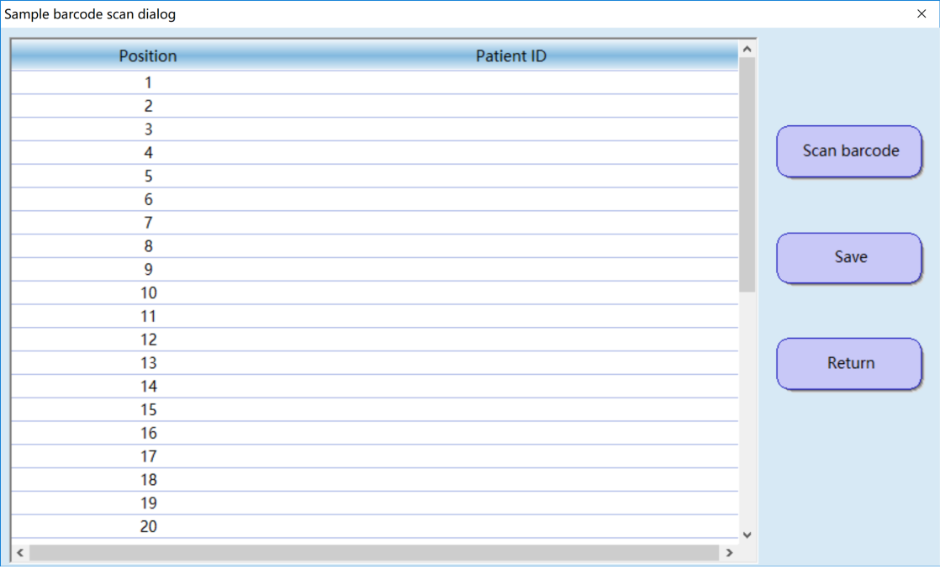
    - Click [Return]
    - Click [LIS], and click [Receive]
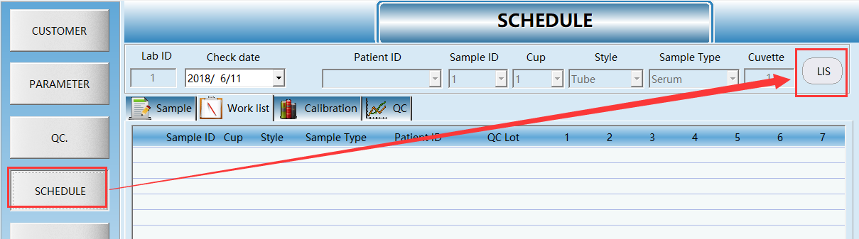
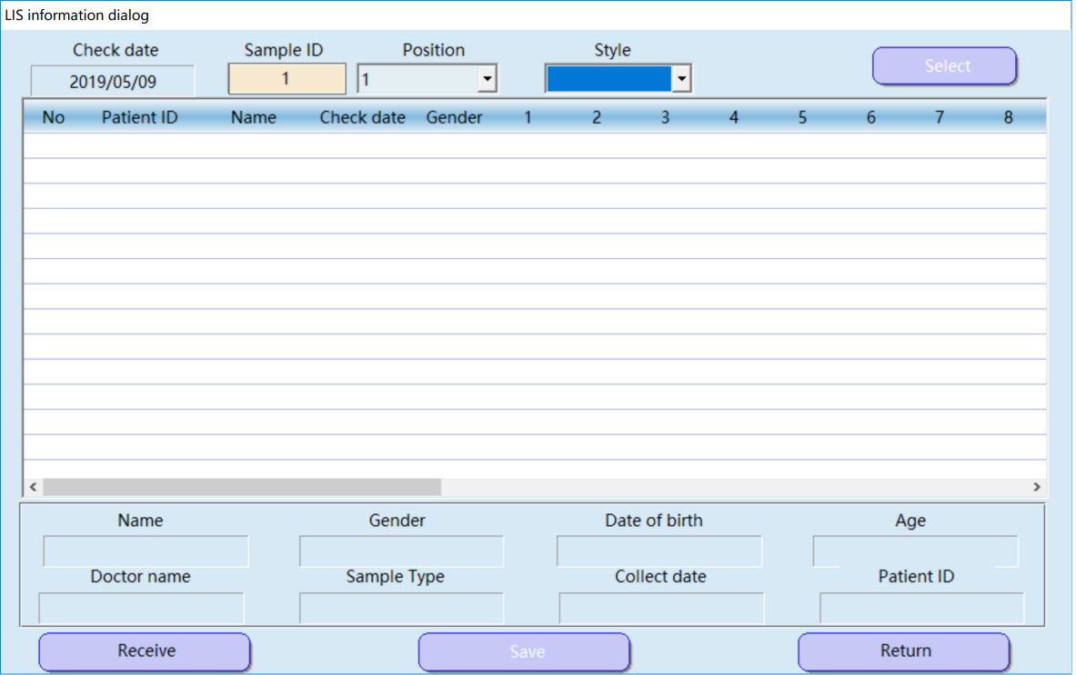
    - Send request for new samples to LIMS in batch of 5.

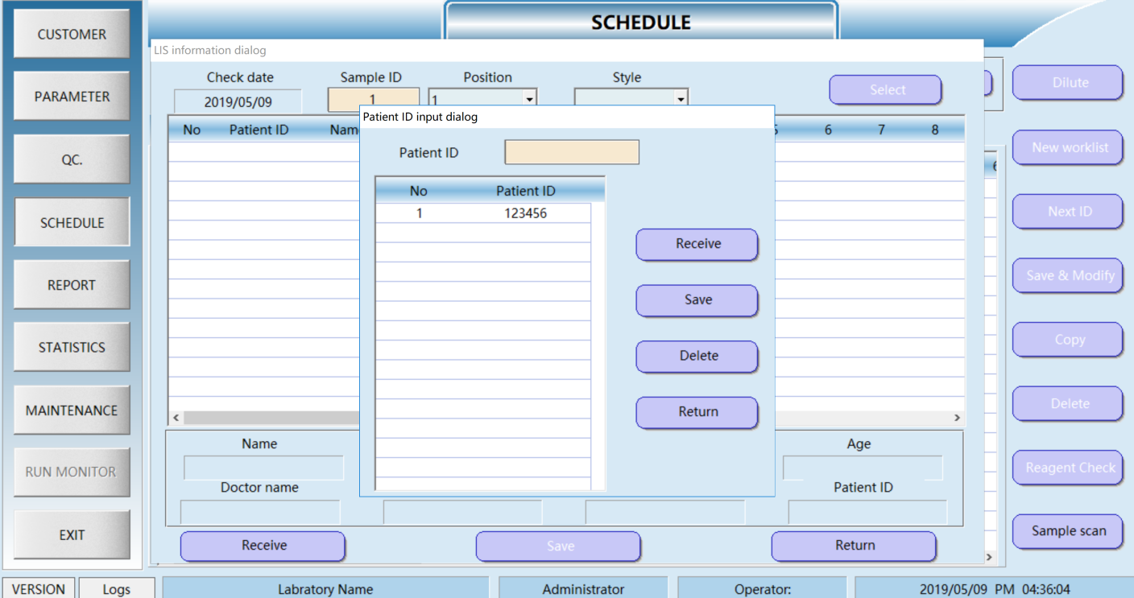

Request received by LIMS
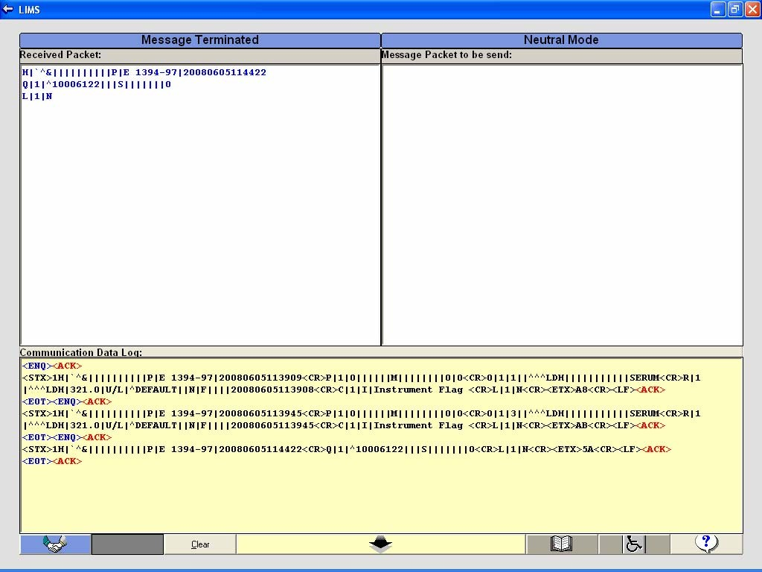

H|`^&||||||||||P|E 1394-97|20080605114422 Q|1|^10006122|||S|||||||O
L|1|N

    - In Response to this Query LIMS sends “Patient Information” and “Test Order” data for respective SampleID.

  - Patient and Order data sent from LIMS to ASTM.

- Patient and Order data entered in LIMS, with new sampleID.

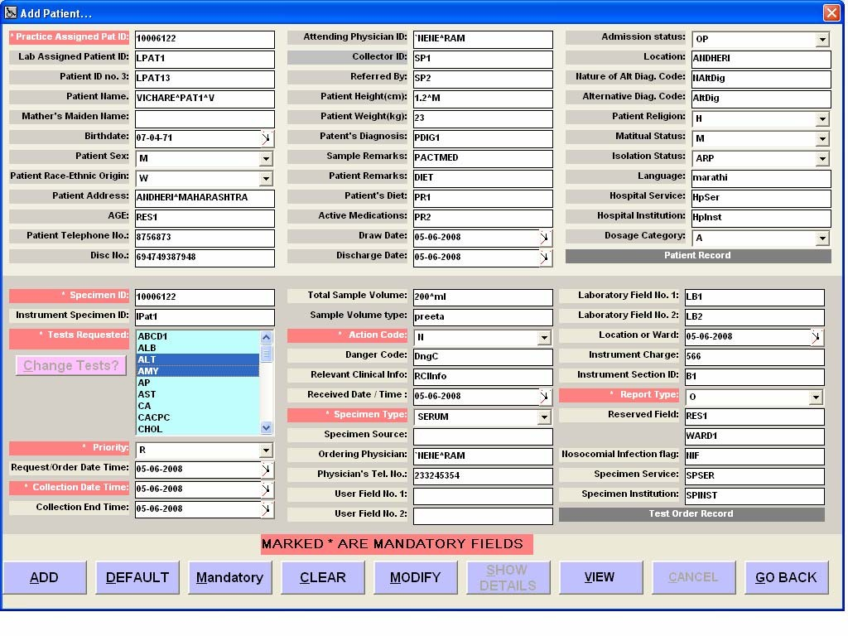

- String generated after clicking on (+) button.
<ENQ><ACK>
<STX>1H|`^&||****|TBM-LIMS|Seepz||||||E-1394- 97|20080605114926<CR>P|1|10006122|LPAT1|LPAT13|VICHARE^PAT1^V|
|19710704|M|W|ANDHERI^MAHARASHTRA|RES1|8756873`694749387948|`N ENE^RAM|SP1|SP2|1.2^M|23|PDIG1|PACTMED|DIET|PR1|PR2|20080506`2
0080506|OP|ANDHERI|NAltDig|AltDig|H|M|ARP|marathi|HpSer|HpInst
|A<CR>C|1|L|Patient Information|G<CR>O|1|10006122|IPat1|^^^ALT`^^^AMY`^^^LPS|R|200 80506|20080506|20080506|200^ml|preeta|N|DngC|RCIInfo|20080506| SERUM|`NENE^RAM|233245354|||LB1|LB2|20080506|566|B1|O|RES1|WAR D1|NIF|SPSER|SPINST<CR>L|1|N<CR><ETX>6F<CR><LF><ACK>
<EOT>

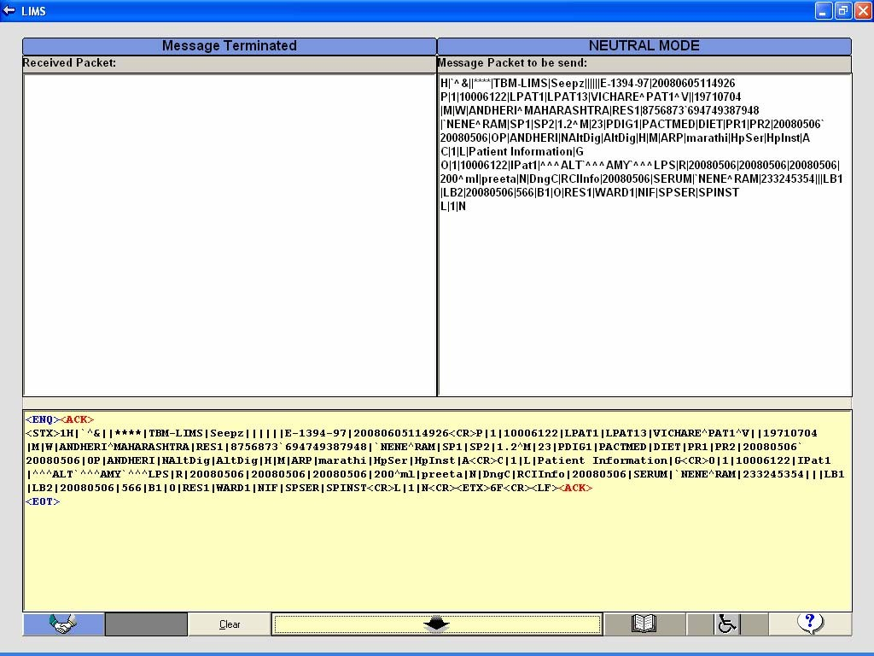

- String received by the ASTM and stored in the instrument software.

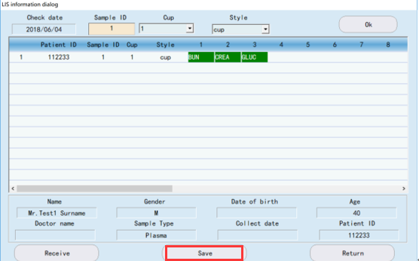

  - Results sent from ASTM to LIMS
    - Online

Result sent to LIMS
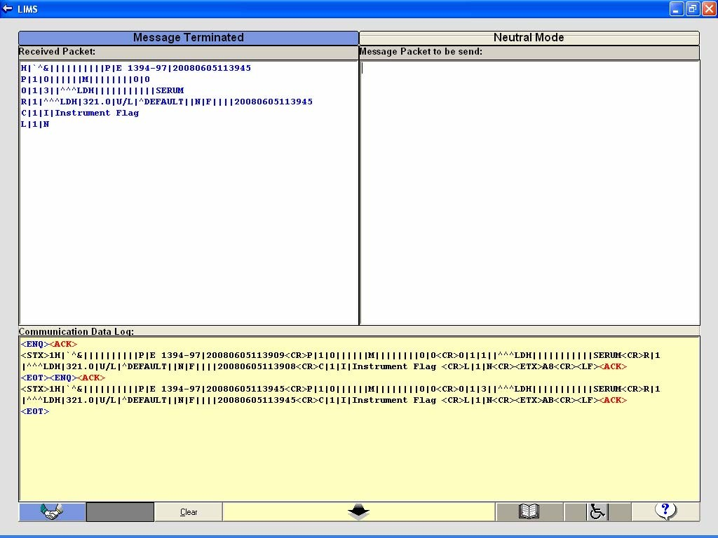

H|`^&||||||||||P|E 1394-97|20080605115331 P|1|0||||||||||||||0|0 O|1|1||^^^LDH|||||||||||SERUM R|1|^^^LDH|321|U/L|||N|F||||20080605120000 C|1|I|Instrument Flag
L|1|N

    - Offline
Result sent from Result Reprint
- Select the results to be sent to LIMS
- Click on Send To Host
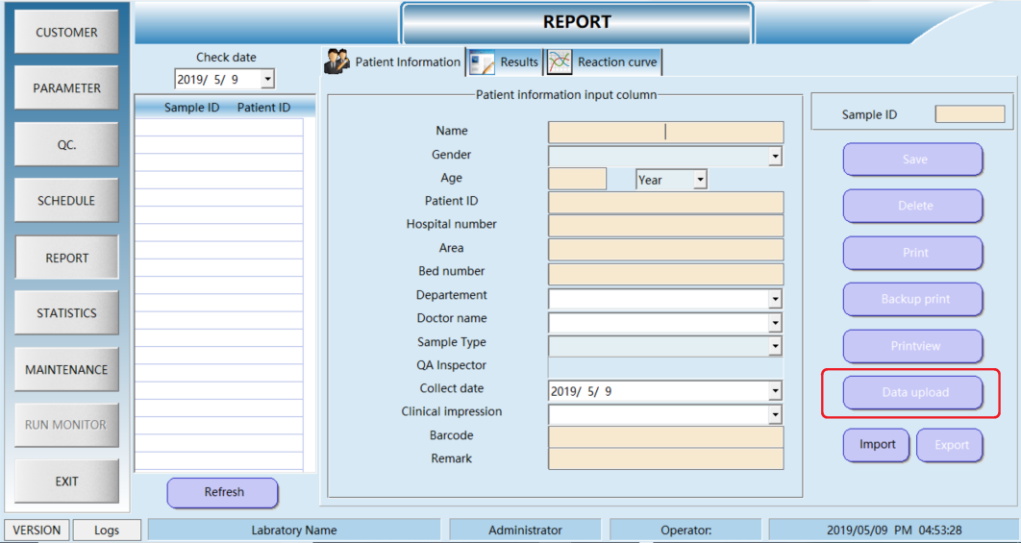

Results received by LIMS
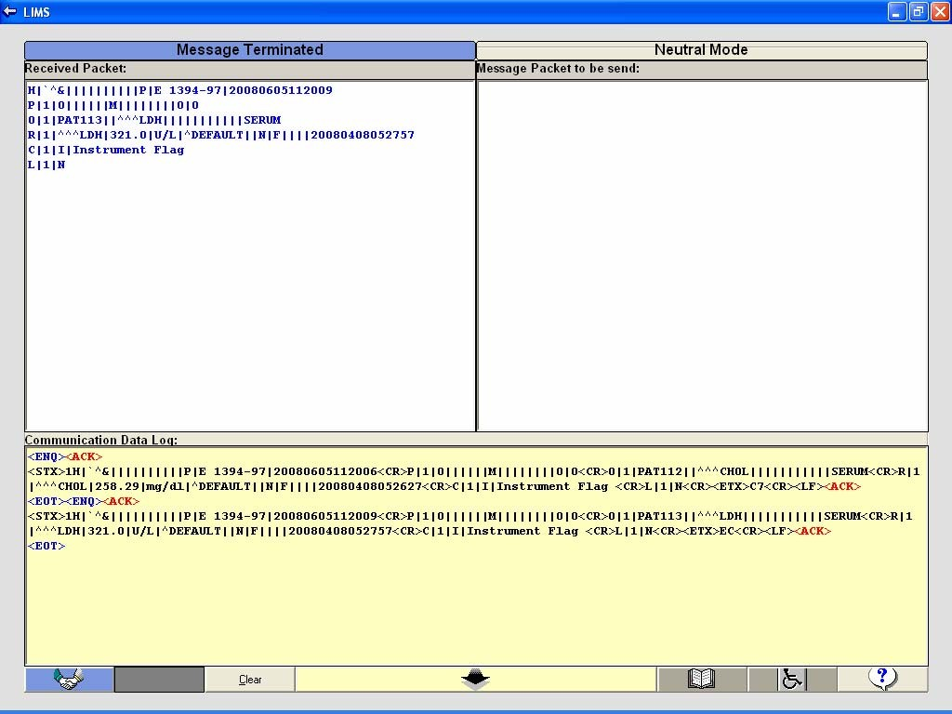

<ENQ><ACK>
<STX>1H|`^&||||||||||P|E 1394- 97|20080605112006<CR>P|1|0||||||M||||||||0|0<CR>O|1|PAT112||^^^CHOL||||
|||||||SERUM<CR>R|1|^^^CHOL|258.29|mg/dl|^DEFAULT||N|F||||2008040805262 7<CR>C|1|I|Instrument Flag <CR>L|1|N<CR><ETX>C7<CR><LF><ACK>
<EOT><ENQ><ACK>
<STX>1H|`^&||||||||||P|E 1394- 97|20080605112009<CR>P|1|0||||||M||||||||0|0<CR>O|1|PAT113||^^^LDH|||||
||||||SERUM<CR>R|1|^^^LDH|321.0|U/L|^DEFAULT||N|F||||20080408052757<CR> C|1|I|Instrument Flag <CR>L|1|N<CR><ETX>EC<CR><LF><ACK>
<EOT>

Sample BarcodeScan Testing :

(B- Barcoded ; NB- Non Barcoded)
Before Barcode Scan |  |  | After Barcode Scan
SamplePos | SampleID | Tests
2 (NB) | 10077127037056  (sample id of pos 6) | CKN(NP),CALC1( ALB,AMY) | Pos replaced by 6 and tests appended as ALP and ISE
8 (B) SAMP123414 | SAMP123414 | ALB(NP), AMY(NP) ,ISE | ALP appended to same sampleid
10 (B) SAMPLE1147 | SAMP10 | CKMB,CKN | SampleID changed to SAMPLE1147 (actual barcode)
11 (B)  SAMPLE12345 | SAMPLE1157 (sample  id of pos 15) | ALP,CKN | Sampleid replaced with  SAMPLE12345

MultiXL – ASTM Testing (During Run)
Case 1 : During ‘Run’ the scheduled sample is replaced with the other one.
  - Old sample scheduling is in progress. Results are not yet out.
Test Case | Expected Result | Actual Result | Status
Program ‘SAMP21’ at pos 21. | Position 21 should not be replaced by new sample. | Position 21 remains unchanged. | OK
Start the Run. When scheduling starts , click on
‘Sample Added’
Replace sample on pos 21 by
the other sample, manually.
Wait till the LIS sends the
requested sample information.
  - Scheduling over and results are out.
Test Case | Expected Result | Actual Result | Status
Program ‘SAMP21’ at pos 21. | Position 21 should be replaced by the new sample. | Position 21 is replaced by new sample. | OK
Start the Run. Wait till schedule gets over.
Once the results are out , click on ‘Sample Added’.
Replace sample on pos 21 by the other sample, manually.
Wait till the LIS sends the requested sample information.

Case 2 : Add new tests for the existing sample , from LIS.
Test Case | Expected Result | Actual Result | Status
Program CODE12812 at | Existing test should not be | When testorder data is | OK
position 6, with tests ALB,CRE. | scheduled again. | received from LIS , ALB is
Scan the barcode. | But new tests should be | ignored and ALP, BIT are
Send few more tests say | added to the existing | added to the sample
ALB,ALP,BIT from LIS for the | sample and get scheduled. | CODE12812.
same sample.

Case 3 : During Run, emergency sample sent from LIS.
Test Case | Expected Result | Actual Result | Status
Program sample manually. | Emergency sample should | Emergency sample gets | OK
Start the RUN. | be given high priority. | scheduled as soon as the
Send emergency sample from |  | current sample scheduling is
LIS. |  | over.

Case 4 : Fill all the positions in the sample tray , with the barcoded samples .Then query to LIS and chk if LIS sends sample information to all queried samples.
Test Case | Expected Result | Actual Result | Status
Fill whole sample tray with the barcodeed samples. | ASTM should query for the scanned barcodes and LIS in response should send the patient and testorder information. | ASTM sent query to the LIS for all the scanned samples. And LIS replied with the patient and testorder data, for all the queried samples. | OK
Programme all the samples in LIS
Scan the barcode.

Case 5 : Blank / Standard results should not get transferred to the LIS. Control Results if selected in Host Setting , then only get transferred to the LIS.

Test Case | Expected Result | Actual Result | Status
Programme all blank, std, control and patient in the  application. | Blank , Standard results should not get  transferred to the LIS. | Blank , Standard results are ignored in all cases. | OK
In Host setting screen, set ‘Send Control Results’ to  false. | Only patient results should be sent to the LIS. | Only patient results are sent to the LIS. | OK
In Host setting screen, set ‘Send Control Results’ to true. | Only patient and control results should be sent to the LIS. | Patient and control both results are sent to LIS. | OK

Case 6 : ISE results should get transferred to ASTM , only if , in system parameter ‘ISE’ is on.
Test Case | Expected Result | Actual Result | Status
Programme one sample in application. |  |  | OK
Send ISE tests from LIS to ASTM.
a) In System Parameter, put ISE module ‘Off’. | ISE tests should not get  programmed in application. | ISE tests are not programmed.
b) In System Parameter, put ISE module ‘On’. | ISE tests should get  programmed as other photometric tests. | ISE tests got programmed.

Case 7 : Cancel the test from LIMS.
Test Case | Expected Result | Actual Result | Status
Programme sample  SAMP123450 with tests ALB,ALP and CRE |  |  | OK
Send from LIS , same  sampleid with test ALB and actioncode as ‘C’ | ALB test should be  removed from sample SAMP123450 | Schedule for test ‘ALB’ is  removed for the sample SAMP123450.

Case 8 : Don’t send Results with specific Flags (as per selection in Host Settings) to LIS.
Test Case | Expected Result | Actual Result | Status
In host setting , select the  flags , for which we want to send the results to LIS |  |  | OK
In test parameters , make
the appropriate changes to generate those flags.
Start the RUN.
Wait till results are out. | Only the selected flag results should get transferred to LIS | Only the selected flag results got transferred to LIS

