People’s Democratic Republic of Algeria

Ministry of Higher Education and Scientific Research

National Higher School of Artificial Intelligence

SUBJECT:

Data bases lab2 report

Done by: Mohamed Idris Hamadi HAMAIDI

Section and Group: S1G4

Instructor: Dr. S.Belkacem

Q1:

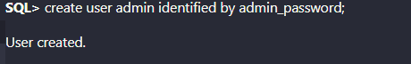

Q2:couldn’t logain,need to create a session

Q3:

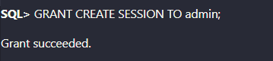

Q4:

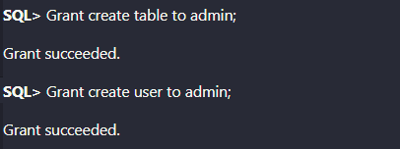

Q5: error no right for admin on that table

Q6:

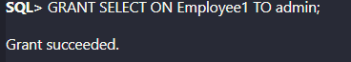

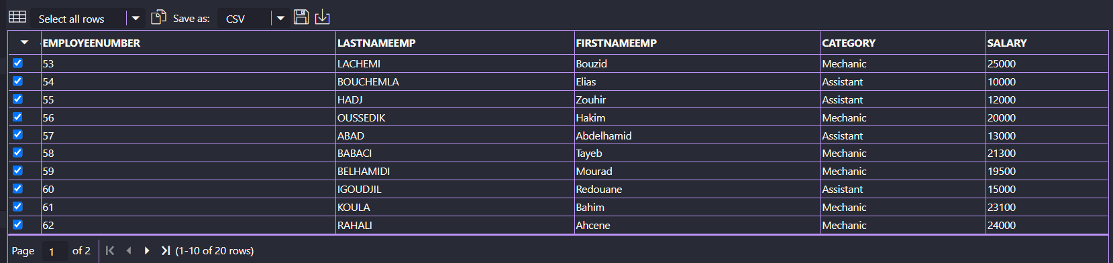

Q7:

UPDATE DBAINTERVENTION.EMPLOYEE SET SALARY = SALARY + 3000

WHERE EMPLOYEENUMBER IN ( SELECT EN FROM

             (SELECT EN, COUNT(PI) AS CPI

             FROM (SELECT EMPLOYEE.EMPLOYEENUMBER AS EN, PARTICIPANTS.INTERVENTIONNUMBER AS PI

             FROM DBAINTERVENTION.EMPLOYEE INNER JOIN DBAINTERVENTION.PARTICIPANTS ON EMPLOYEE.EMPLOYEENUMBER = PARTICIPANTS.EMPLOYEENUMBER)

             GROUP BY EN

             HAVING COUNT(PI) >= 4));

Q8:

grant select,UPDATE on PARTICIPANTS1 to admin;

grant UPDATE on EMPLOYEE1 to admin;

Q9:

create index LASTNAMEEMP_IX on DBAINTERVENTION.EMPLOYEE( LASTNAMEEMP); --

didn't create an index cause admin don't have the right

Q10:





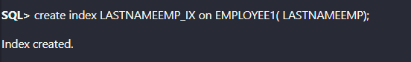

Q11:



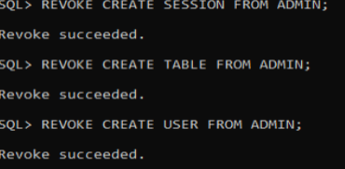

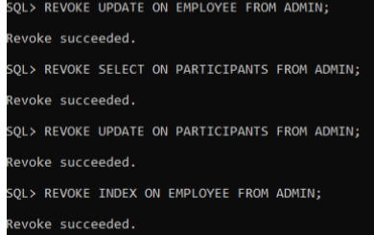

Q12:

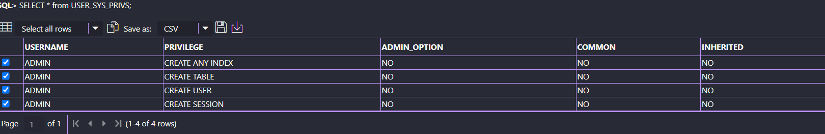

Q13:

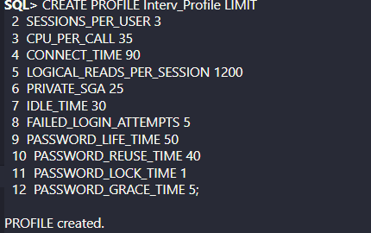

Q14:

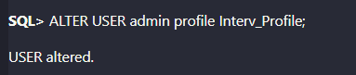

Q15:

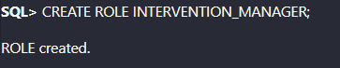

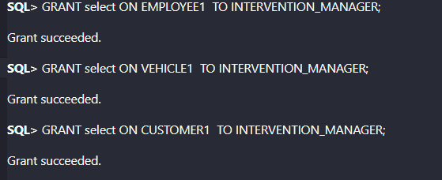

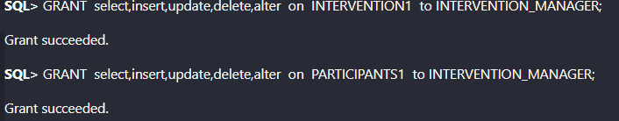

Q16:

