People’s Democratic Republic of Algeria

Ministry of Higher Education and Scientific Research

National Higher School of Artificial Intelligence

SUBJECT:

Data bases lab3 report

Done by: Mohamed Idris Hamadi HAMAIDI

Section and Group: S1G4

Instructor: Dr. S.Belkacem

Q1:

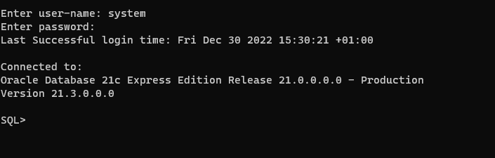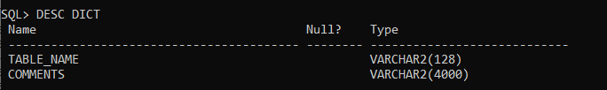

Q2:

ALL TAB

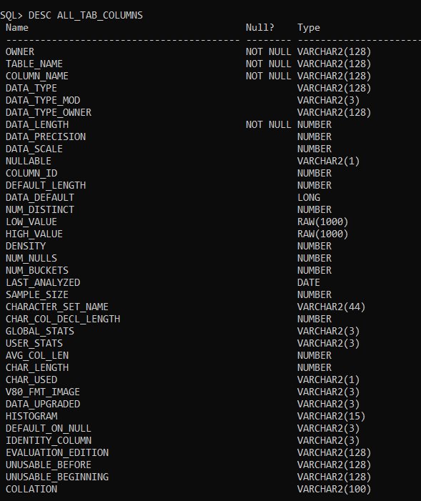

ALL CONSTRAINTS

USER TAB

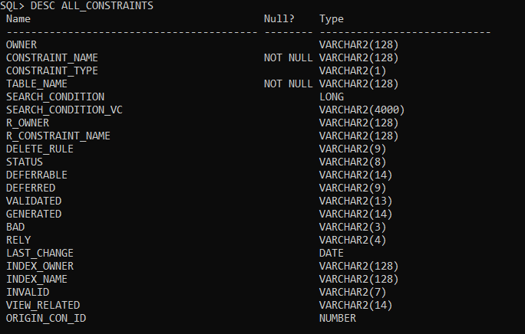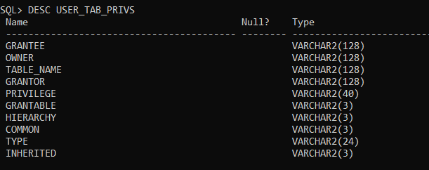

USER USERS

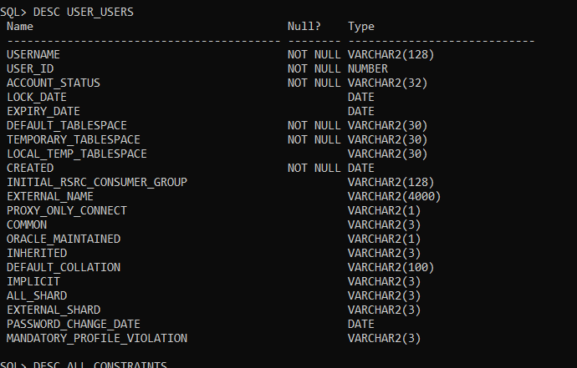

Q3:

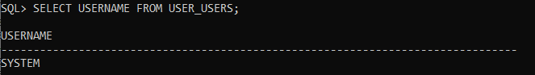

Q4:

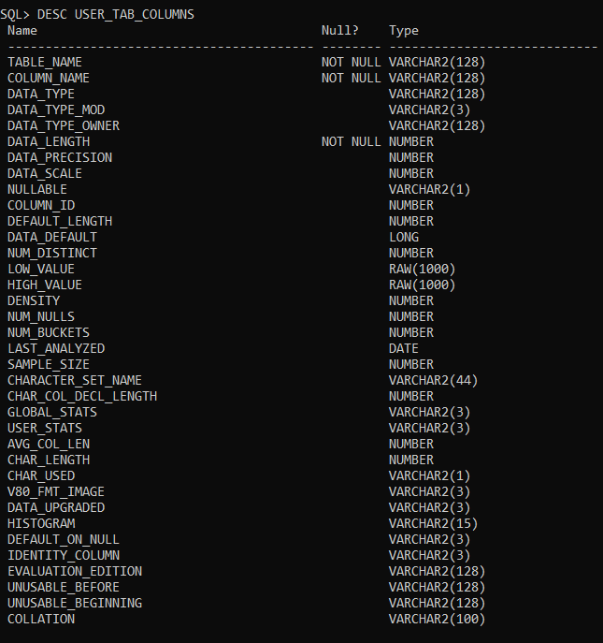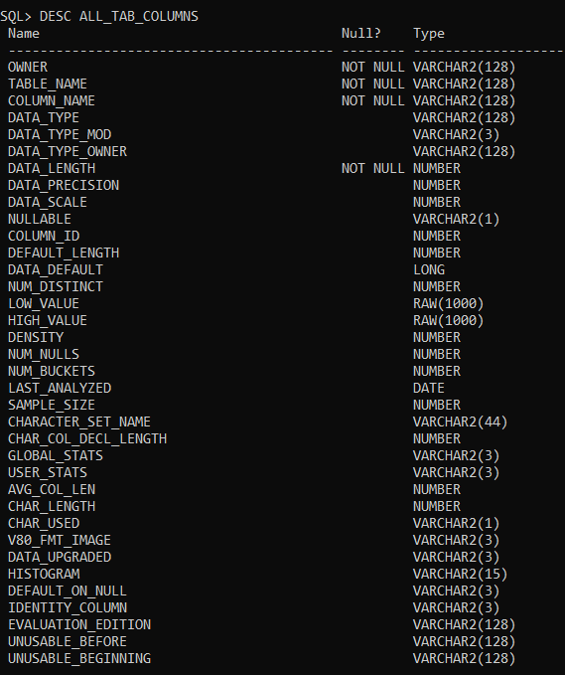

Q5:

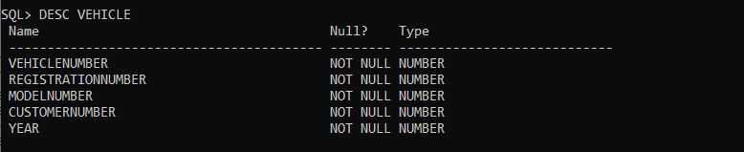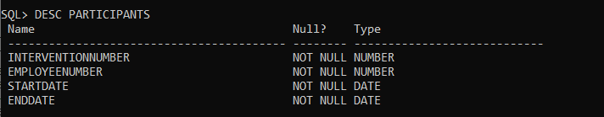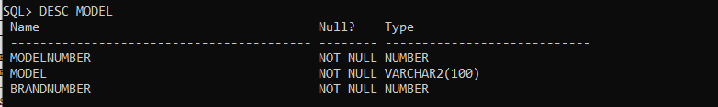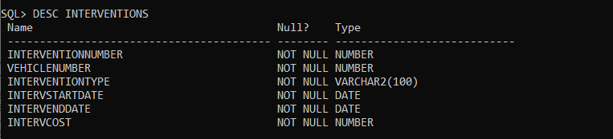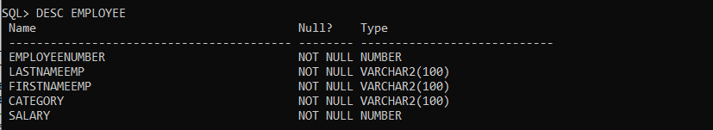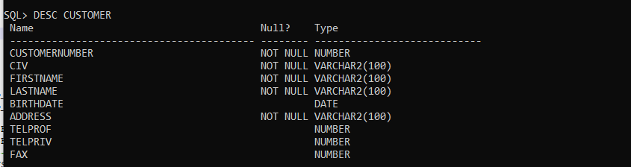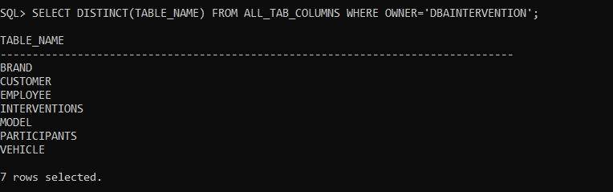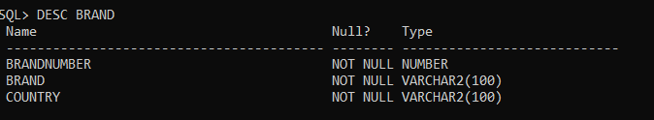

Q6: system has 152 rows selected,while dbaintervention has 7 rows selected (from question 5)



Q7:

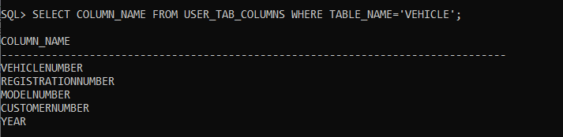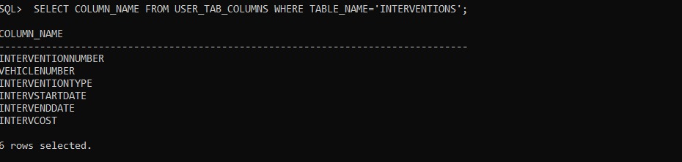

Q8:

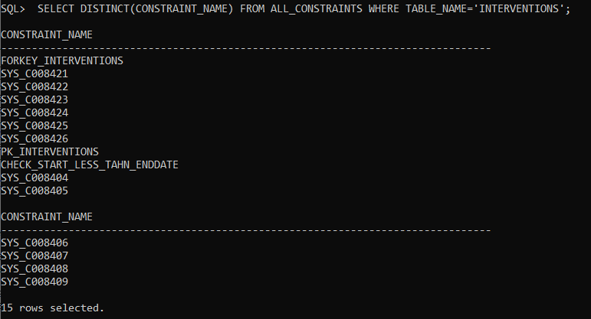

Q9:

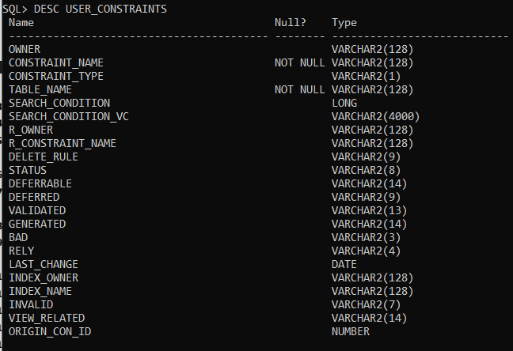C:\Users\moham\Desktop\lab3screenshotsandcode\QUESTION9_CONSTRAINTS_BY_SYSTEM.PNG

Q10:

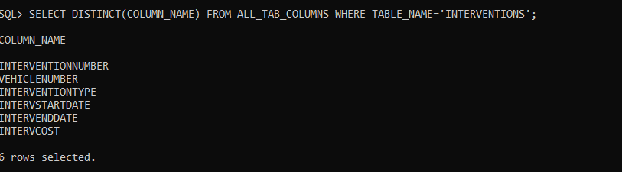

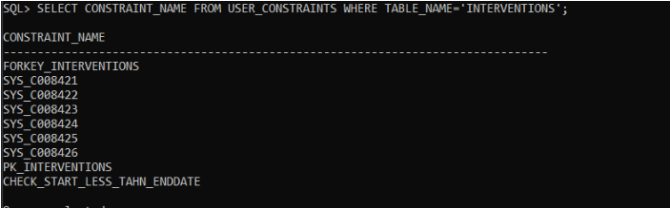

Q11:

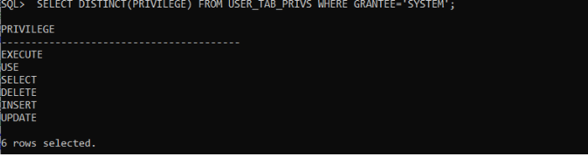

Q12:

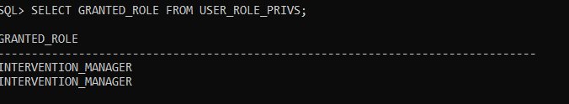

Q13:

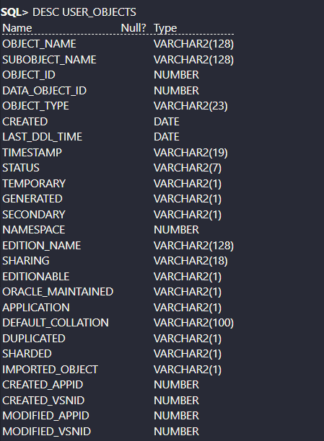

Q14:

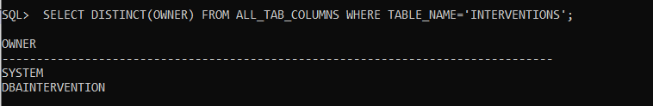

Q15:

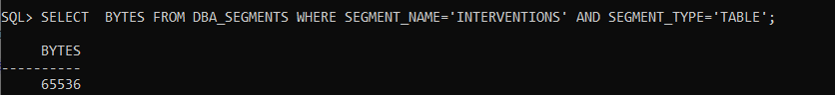

Q16: