Basic Networking Skills for Digital Forensics

Idriss Muhammad Abdullahi
2025/FWSD/11475

Fellowship in Web Application Security & Digital Forensics
Aminu Idris

05/09/2026

- Folder structure creation
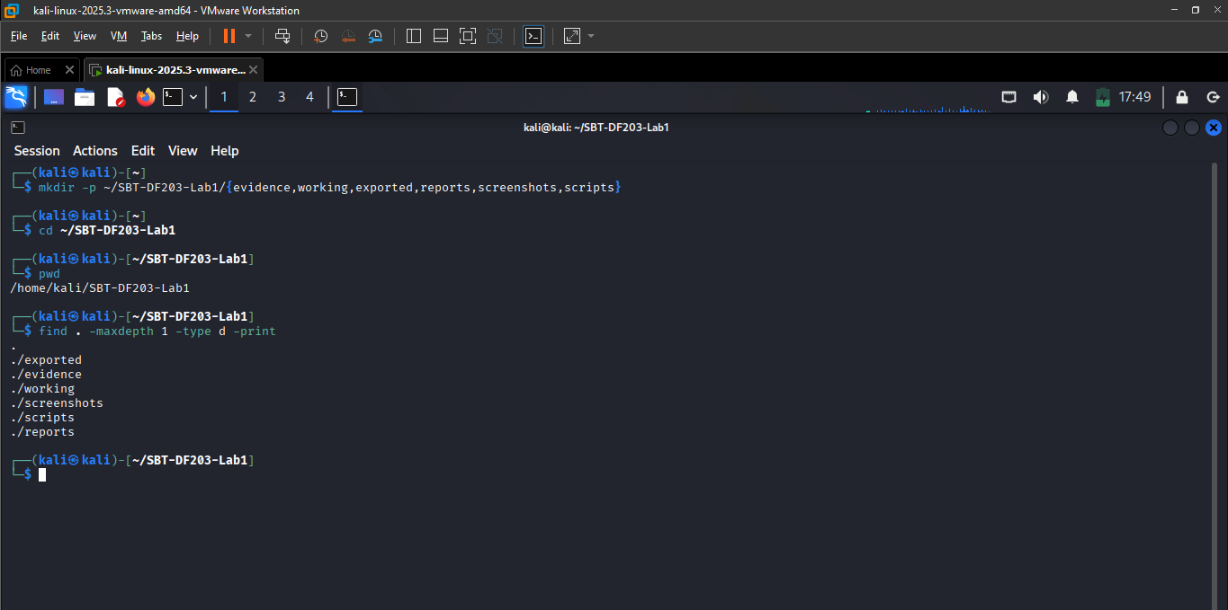

- Html successfully created
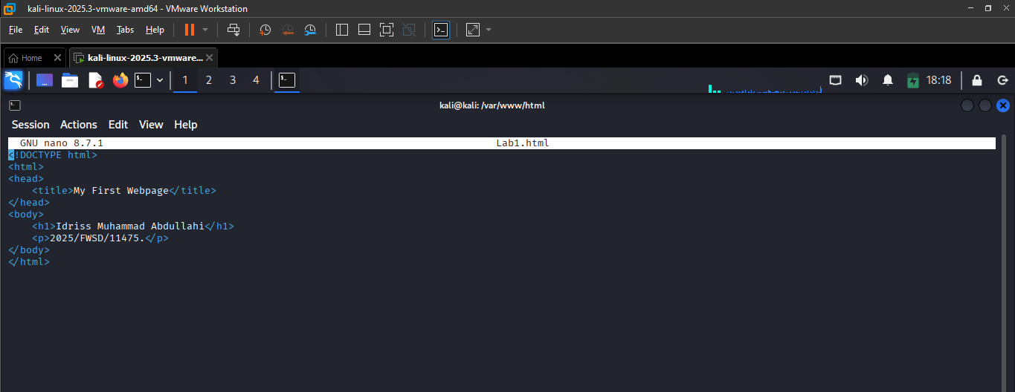

- Apache started and the on a successful status
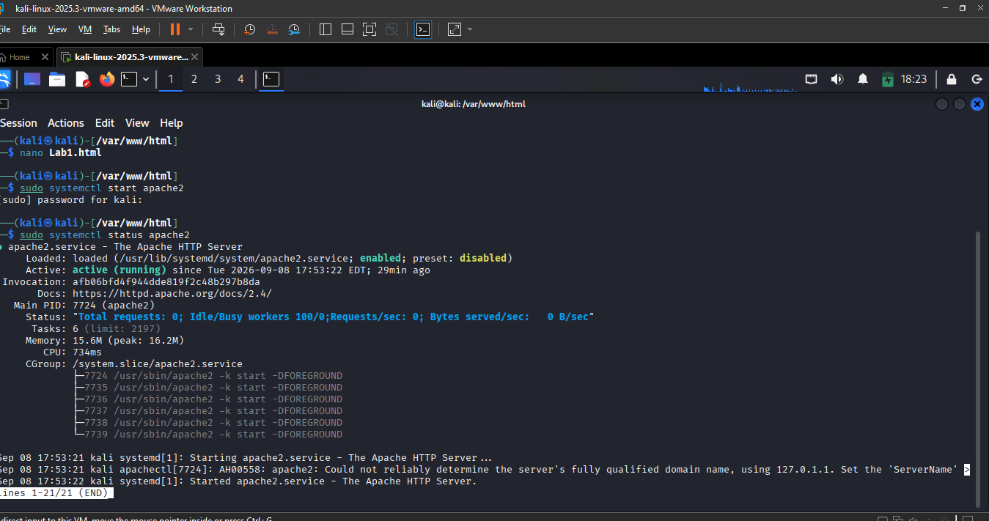
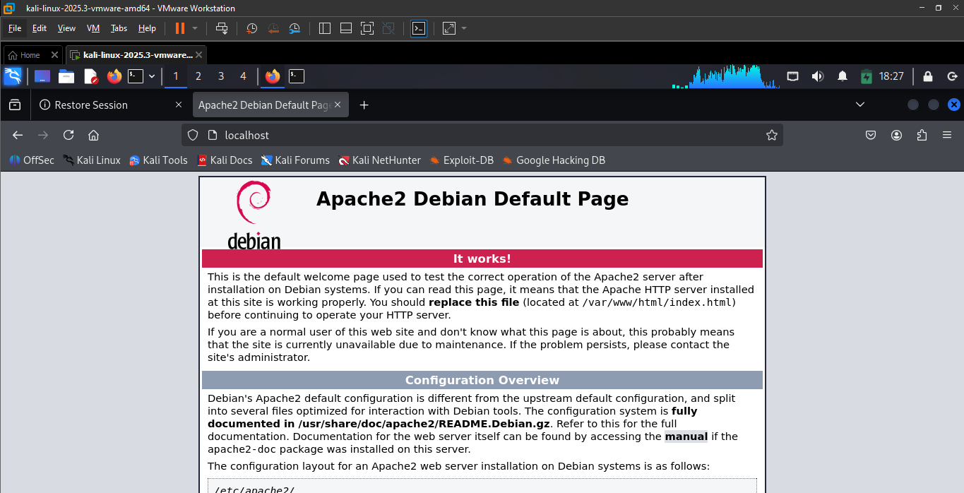
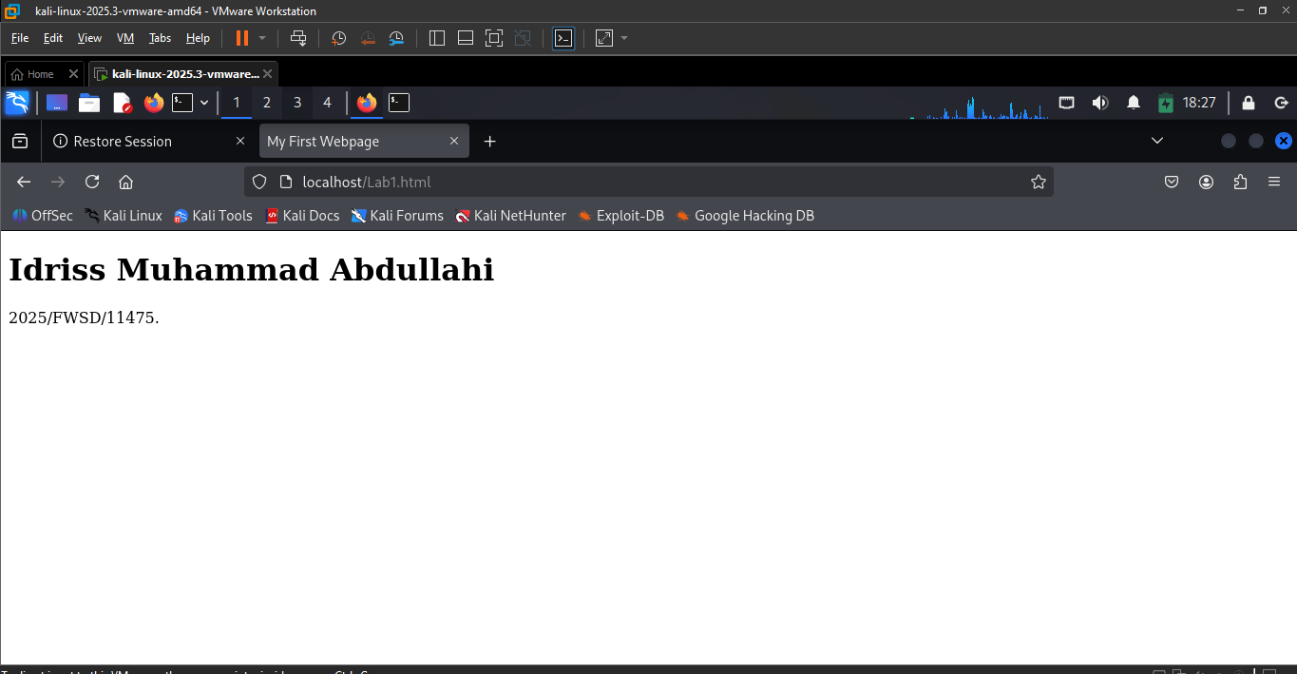
The service started successfully and served the webpage without errors.

- Launching Wireshark
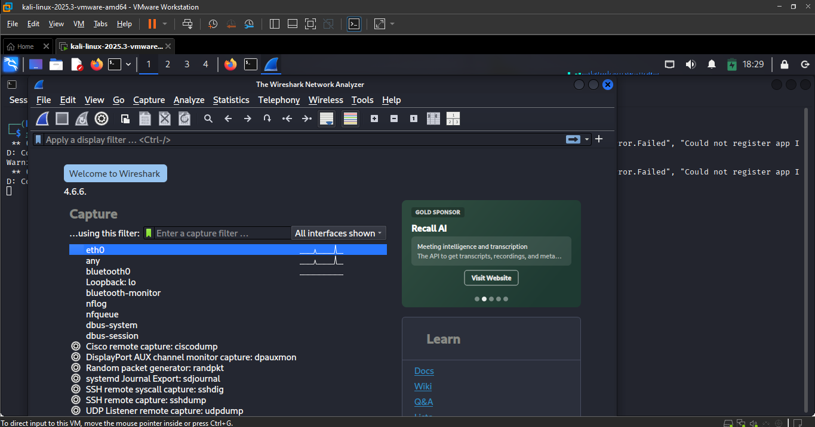
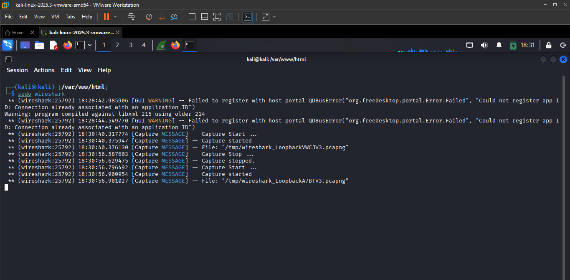
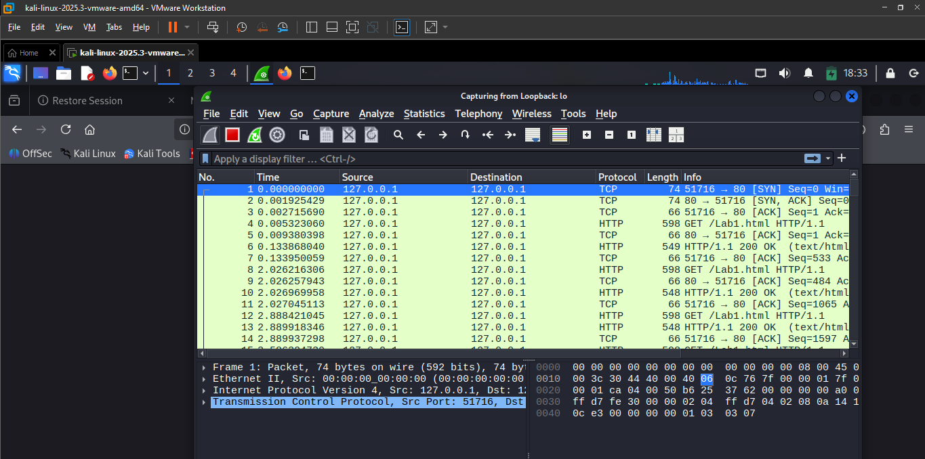
Wireshark successfully launched and Lo host monitoring successfully

- Filtering HTTP packets
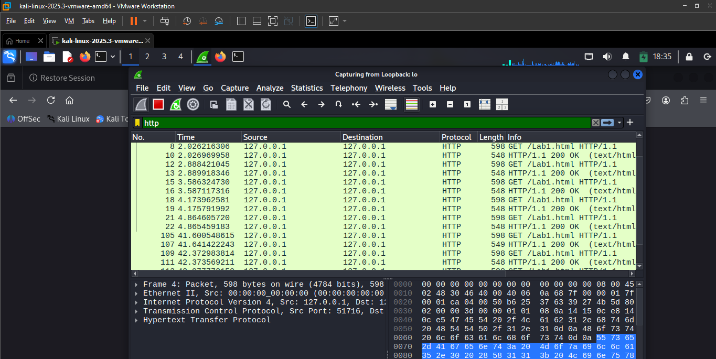

- Identifying TCP three-way handshake
- Packet 1 (SYN)
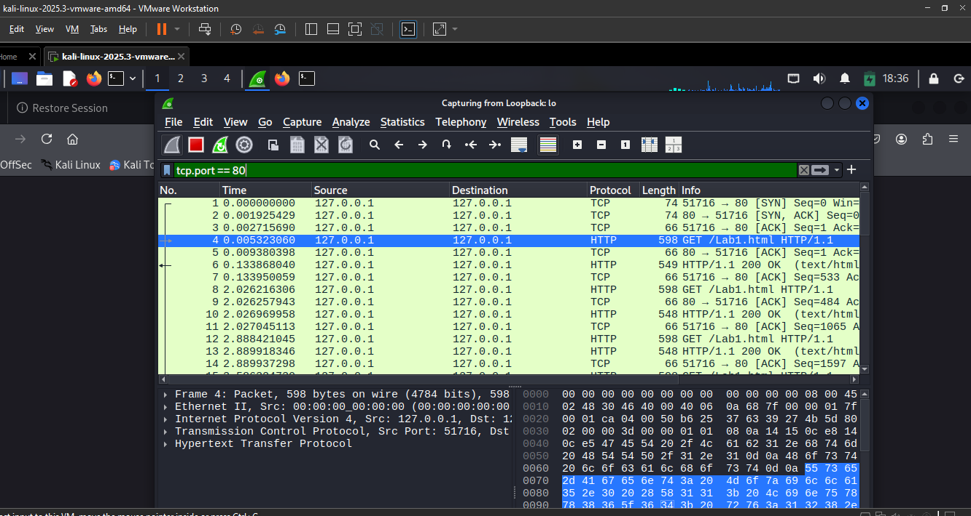

- Packet 2 (ACK)
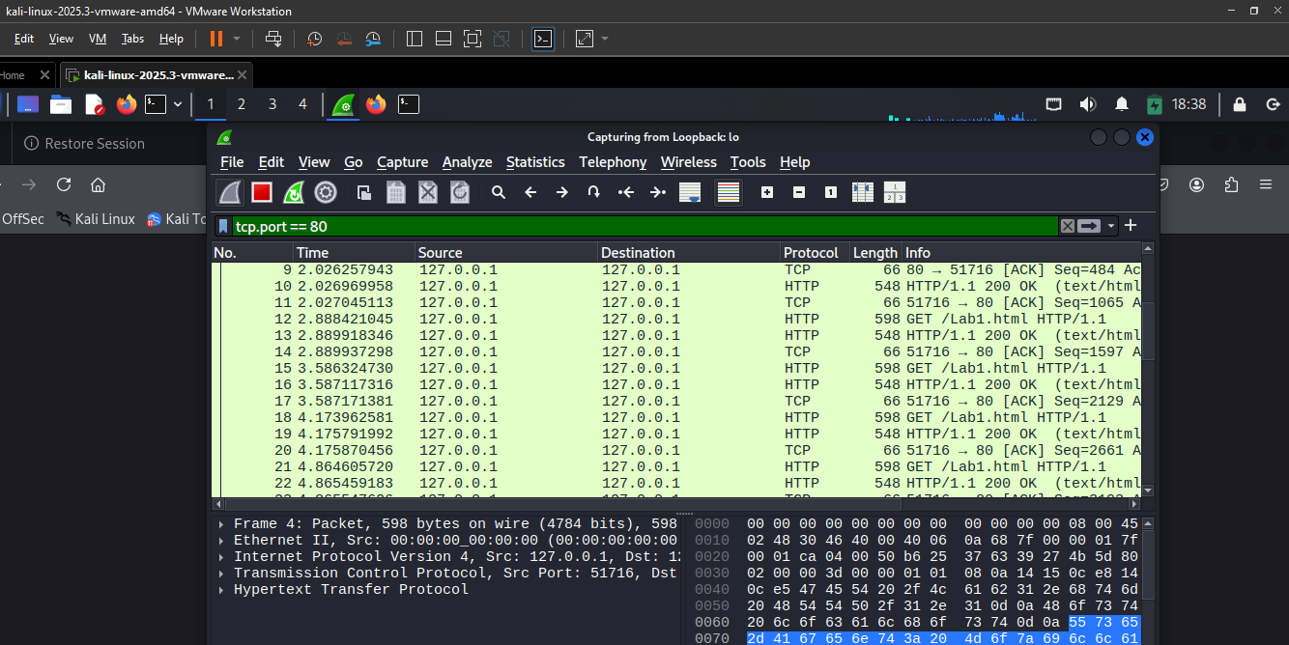

- Following TCP Stream
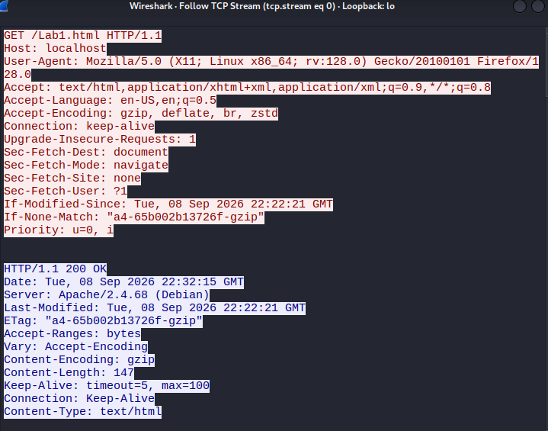
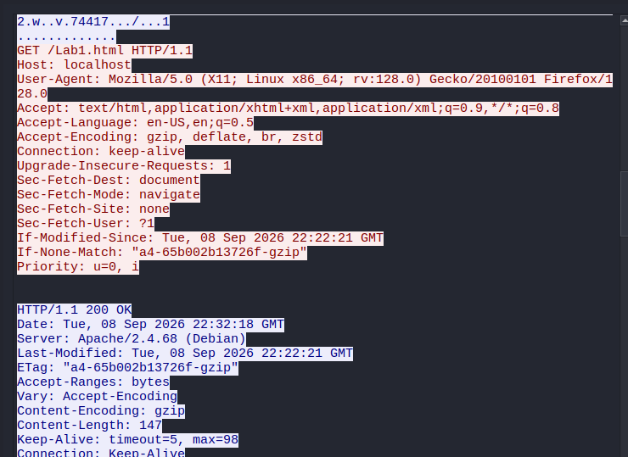

- Extracting HTTP Request Information
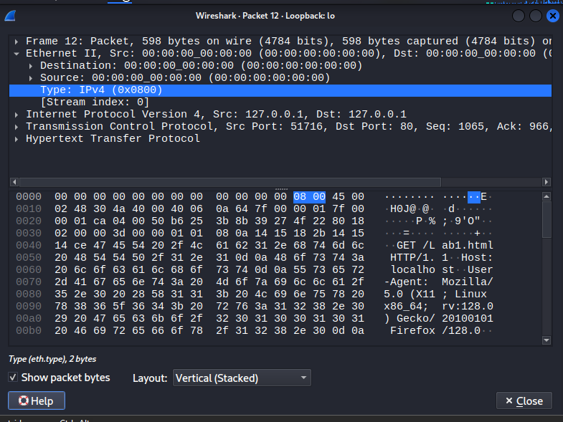

- Extracting IP Information
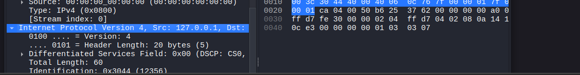

Summary
This practical was successfully completed by creating and hosting a simple HTML webpage on Apache, generating HTTP traffic, and capturing the communication using network forensic tools. The captured traffic was analyzed to identify the TCP three-way handshake, HTTP request, and HTTP response.
Key Findings
- Apache web service was running successfully on port 80.
- The webpage was accessed successfully through HTTP.
- TCP connection establishment (SYN, SYN-ACK, ACK) was observed.
- An HTTP GET request and HTTP 200 OK response were identified.
- Source and destination IP addresses, ports, timestamps, and protocol headers were successfully examined.
- The capture was performed on the loopback interface; therefore, normal Ethernet MAC addresses were not present.
Evidence Submitted
Screenshots documenting:
- Folder structure
- Apache service status
- Hosted webpage
- Packet capture process
- TCP handshake
- HTTP request and response
Conclusion
The practical successfully demonstrated HTTP traffic generation, packet capture, and basic network forensic analysis while maintaining evidence integrity through proper evidence handling and hashing procedures.

