The STEER document set · 2 of 3

STEER Framework
What the structure is: the artifact chain, the plays, the gates, and the metrics
Idriss Enayat · Framework v3.0 · August 2026
This document defines STEER's structure: the layers, the artifact chain that forms the lifecycle's backbone, the eight plays, the three gates, and the measurement system. The Methodology document states why; the Operating Model document defines who decides and how organizations run it.

Three Layers

The framework layer holds principles, accountabilities, gates, and metrics, and changes rarely. The lifecycle layer holds the eight plays across seven operational states, and is the daily rhythm. The platform layer holds agents, evidence, automation, and telemetry as bindings behind seams, so any tool swaps like a feature rather than a migration. Written artifacts are the interface between all three: the entire process ships as files in a repository, versioned like code.
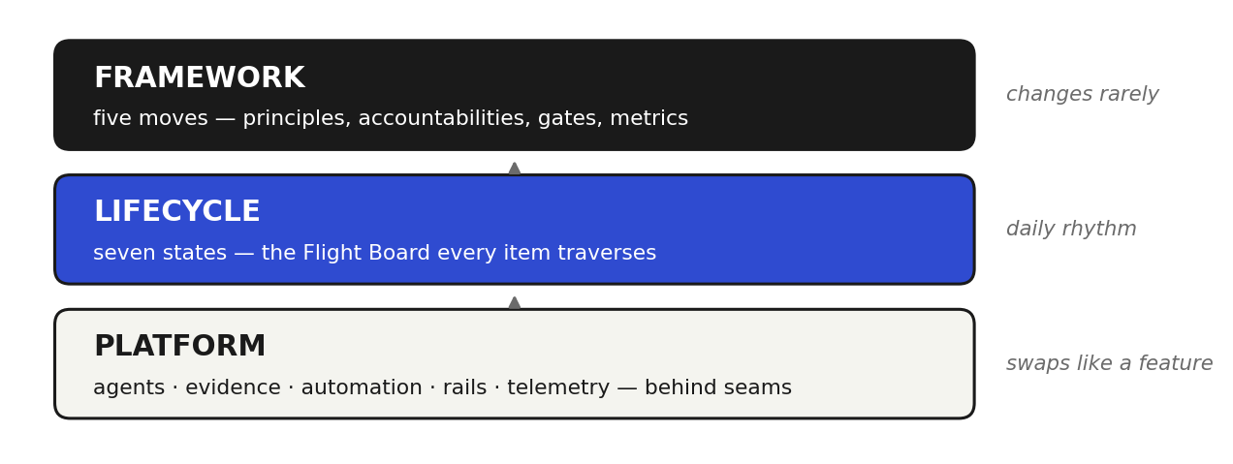
Three layers: the framework changes rarely; the platform swaps like a feature.

The Artifact Chain

Every play ends by committing an artifact to version control, and the next play begins by reading it. The chain is the audit trail: who asked for what, what the agents produced, what the evidence showed, and who approved it.
BRIEF → SPEC → EXAM → PLAN → diff + evidence → review findings + signatures → release record → band log → learning decision → next BRIEF
The brief states intent, its measurable outcome contract, and the risk domains it touches (it is a superset of emerging intent-file conventions, so STEER interoperates with intent-driven toolchains). The spec is the design pass. The exam, STEER's addition to the industry chain, is the binding definition of provably done: acceptance tests, evals, and guardrails, authored independently of the builders. The plan is the implementation route an agent proposes in a read-only pass. Then the diff with its evidence, the review findings with their signatures, the release record, the production band log, and the versioned learning decision complete the turn. A breached control band writes the next brief, so the loop can start itself.
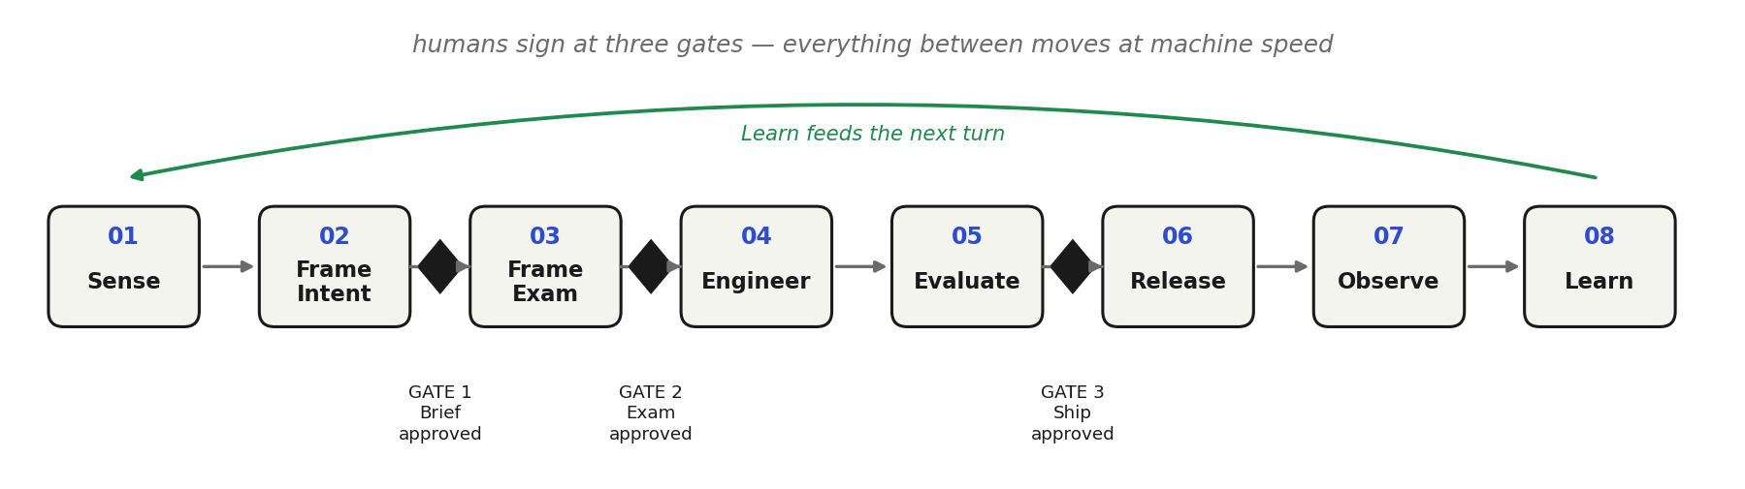
The Flight Board: eight plays, seven states, three gates on the chain.

The Eight Plays

Play | Commits | What happens | Measure (leading · lagging)
01 Sense | draft BRIEF | Signals, tickets, and band breaches become draft briefs; the Product Lead pulls work into flight deliberately (WIP is human framing capacity) | signal-to-brief time · brief survival rate
02 Frame · Intent | BRIEF + SPEC, Gate 1 | Intent accepted with a measurable outcome contract and domain tags; design pass with concerns flagged to policy owners | draft-to-accepted time · rework after build starts
03 Frame · Exam | EXAM, Gate 2 | Test agent drafts the exam; a fresh-context critic attacks it; timing tiers with risk; builders can never edit it | spec-to-exam time · escaped defects per item
04 Engineer | PLAN, then diff + evidence | Read-only planning pass, then builders implement in isolation; every claim ships with its proof; sessions verify their own work | first-pass rate · rework cycles
05 Evaluate | PR + findings, Gate 3 | The gauntlet runs the full exam; a fresh-context critic reviews in ranked passes; humans judge intent, quality, consequence | time to first review · caught vs escaped
06 Release | release record | Flag, canary slice, thresholds, rollback armed; autonomy tiers by environment; production requires a named authorization | gate wait time · change failure rate
07 Observe | band config + breach log | Deterministic control bands with tiered response: log, diagnose read-only, propose through a gated route | breach-to-brief time · repeat incidents
08 Learn | learning decision | Versioned decision (adapt, continue, scale, rollback, stop); incidents become permanent evals; changes to the operating system are eval-gated | incident-to-eval time · human hours per item

The Three Gates

Flow stops for a human signature at exactly three points; everything between them moves at machine speed. Gate 1: what are we building, and why. Gate 2: what does provably done look like. Gate 3: does the evidence support release. Each signature is an authenticated approval binding an identity, a sequence position, and an artifact revision, and gates are enforced in tooling (hooks, branch protection, required checks) wherever agents act. Gates tier by risk domain, decided up front: default-open domains ship on green checks; default-closed domains (security, privacy, money, irreversible operations) block until a human signs. One invariant never tiers: the agents that build can never edit the exam.

Measurement

Activity metrics are retired: velocity, story points, and utilization measure typing, and typing is no longer scarce. Four numbers run the framework, each paired so it cannot be gamed in isolation: outcome impact against the brief's contract (with baseline, denominator, and observation window); first-pass verification rate, read only alongside escaped defects; escaped defects, each one becoming a guardrail; and the north star, human hours per shipped item, trending down release over release while outcomes and guardrails hold. Every play also carries one leading and one lagging indicator, so the loop is measured everywhere it can drift.
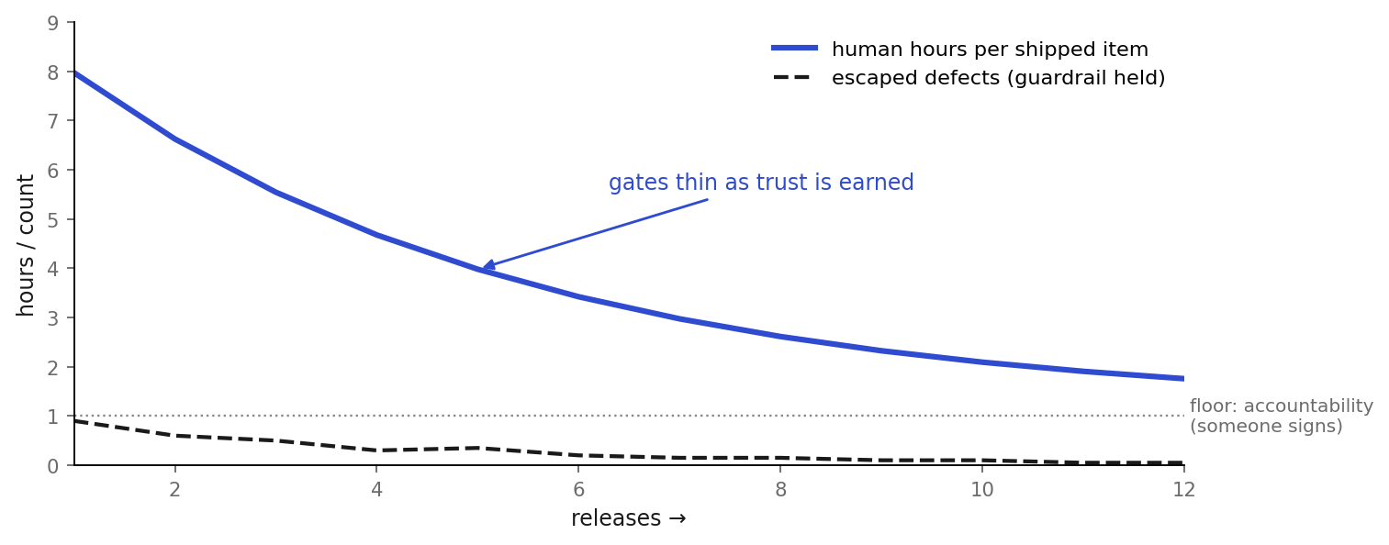
Human hours per item trend to the accountability floor while guardrails hold.
The STEER document set
- STEER Methodology · Why: the constraint shift, the values, the principles that govern every decision
- STEER Framework (this document) · What: the structure, the artifact chain, the plays, the gates, the metrics
- STEER Operating Model · How: accountabilities, decision rights, trust policy, culture, and scale
The Guidebook is the complete reference; the Whitepaper is the shareable overview.

