The STEER document set · 3 of 3

STEER Operating Model
How organizations run it: accountabilities, decision rights, trust, culture, and scale
Idriss Enayat · Framework v3.0 · August 2026
This document defines how an organization runs STEER: who holds which decision, how autonomy is metered, what protects the human channel, and how one pod scales to a portfolio. The Methodology document states why; the Framework document defines the structure this model operates.

Four Accountabilities, Signature Semantics

Agents do the labor; four humans own the decisions. On small teams people wear several hats, and the accountabilities are real regardless. What never transfers to any agent: intent, dissent, and legally binding accountability. Someone signs.
Accountability | Owns | Signs
Product Lead | What and why: pulls work into flight, owns the outcome contract, paces the system (the WIP limit is this person's protected attention) | Gates 1 and 3
Product Designer | Design intent and the shipped experience | Gate 1; Gate 3 for user-facing change
Tech Lead | Correctness and the exam; judges what machines cannot | Gates 2 and 3
Platform Engineer | The agent fleet, its guardrails, its cost; keeps machine speed safe | Fleet and hook changes (eval-gated)
Specialists (security, accessibility, privacy, legal, reliability) plug in through three sockets rather than standing meetings: guardrails in the exam, a tuned domain agent, and a conditional gate seat that activates only for tagged domains, with written reviews under an SLA that escalates visibly rather than blocking silently.

Trust-Metered Autonomy

Autonomy is a policy, not a mood. Gates tier by risk domain and by environment (development freely, staging in the middle, production behind a named authorization), and the tiering moves on evidence: first-pass verification rate and escaped defects form a measured track record per domain, environment, and agent role. As the record strengthens, default-open expands, signer counts drop, and human judgment concentrates on fewer, higher-consequence decisions. Model updates reset the relevant record; versions are pinned and the fleet re-validated on change. The floor is accountability: regulators, courts, and contracts bind humans, so someone always signs. This is also the model's answer to its own obsolescence: it meters improving AI at the rate trust is earned, so it strengthens rather than expires.

Culture: The Human Channel

The model needs humans for judgment, dissent, and accountability, and it protects the channel that carries them in writing, because unwritten culture erodes at machine speed. Four commitments, shipped as a versioned culture file: two rooms by design (work rooms with agents are signed and on the record; every pod keeps a human-only room and one protected synchronous ritual; decisions on the record, doubts welcome off it); blameless by construction (the log audits artifacts and decisions, never individual fallibility, and no gate signature is ever used against its signer when the process was followed); cohesion as scheduled work (the huddle and the learning review are the team's social fabric, and the Product Lead's load is a named risk); and learning in public (judgment happens in shared rooms, which is how the next generation of decision owners grows).

Scale: Two Speeds

Business alignment happens at discussion speed; delivery runs at machine speed, and the two are deliberately decoupled. The portfolio issues quarterly mission briefs per pod, naming outcomes to move and guardrails to hold, and manages no items. Each pod is a complete STEER loop: four accountabilities, a fleet, a Flight Board, gates, and metrics. Versioned interface contracts protect the seams between pods; shared libraries carry design systems, guardrails, and agent patterns; a platform pod treats the agent platform as a product. There is no lead pod: pods grow by cell division, copying the operating system faithfully.
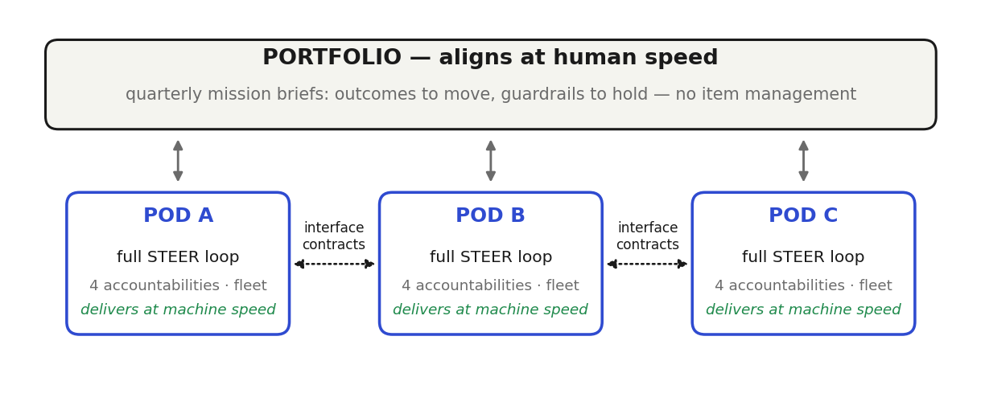
The portfolio aligns quarterly; pods deliver continuously behind interface contracts.

Portability and Governance

The model is vendor-neutral by construction: any capable model, any agent runtime, any code host, with every pick a binding behind a seam. Agent roles are hats on runtime primitives (interactive sessions, scoped subagents, non-interactive CI jobs), not separate products. In regulated environments one seam is mandatory: a managed, non-overridable policy layer (permissions, sandboxing, gate hooks) owned by the platform team. Governance is native rather than bolted on: the artifact chain is the audit record, and the mechanics map onto NIST AI RMF (gates and eval-gated change control implement Govern; briefs and outcome contracts, Map; the exam and paired metrics, Measure; guardrails, bands, and the learning review, Manage), giving ISO/IEC 42001 auditors a management system they can walk through. The Gate 3 signer owns the ship decision, and the fleet itself is treated as an attack surface: scoped credentials, sandboxed execution, dependency scrutiny, and model pinning with re-validation on change.

Adoption

Start with one pod and a strict pilot posture: ten to twenty real items through the loop, metrics recorded from item one, before any broad claim. Adopt plays in dependency order, not stage order: the intent home and context files first, the exam and feedback loop next, review and gates before any automation, and the self-feeding loop last, because automation must never accelerate work through a gate that does not yet exist. Legacy systems enter through an agent-ready on-ramp (characterization tests, seams, guardrails, telemetry) run as its own sequence of briefs, and where an existing tool already holds a record, one system is named the source of truth per artifact and the other links to it.
The STEER document set
- STEER Methodology · Why: the constraint shift, the values, the principles that govern every decision
- STEER Framework · What: the structure, the artifact chain, the plays, the gates, the metrics
- STEER Operating Model (this document) · How: accountabilities, decision rights, trust policy, culture, and scale
The Guidebook is the complete reference; the Whitepaper is the shareable overview.

