

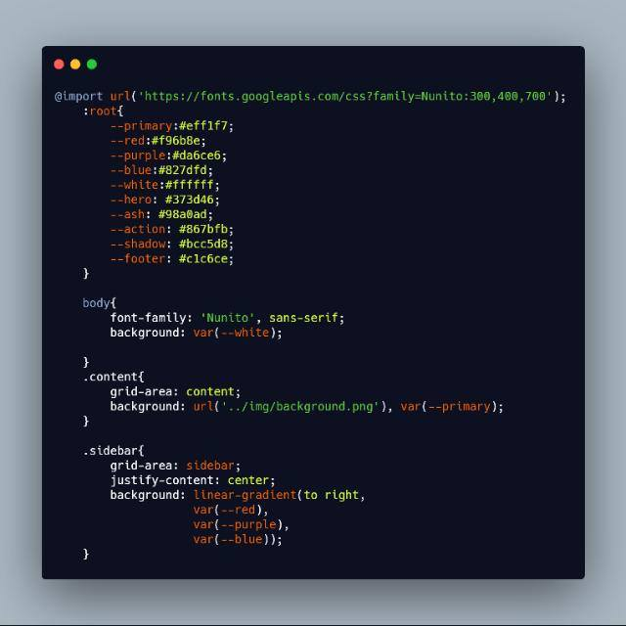

**KODAOLU IDRIS AREMU**

https://idrizzy.github.io/portfolio/

**Software Developer**

idrizzy29@gmail.com

Email

+234 7069141190

Phone

No. 60 Agbon Street Oru Station Oru-ijebu

Address

**CONTACT**

**SKILLS**

Communication

JavaScript

Html 5

Css3

Node Js

Laravel

Angular Js

Php

Teamwork

Creativity

**PROFILE**

Ogun State

State

Single

Birthday

Kodaolu Idris Aremu.

Name

Nigeria

Nationality

16 May 1993

**WORK EXPERIENCE**

**Tertiary Academic Management System (TAMS)**

Tai Solarin University Of education (2018-2019)

Was employed as a junior developer, where I work on the staff appointment, user and the registration part. I also fix, some bugs and write some other useful functions. The project is presently in the testing stage. I used HTML, CSS, BOOTSTRAP and Angular Js for the front-end development and PHP for the server side programming With Mysql database...

**Technocrat** (2017-2018)

This was a freelance Inventory Management system that keeps stock and appropriate record of goods in stock.

Technology used used HTML, CSS, BOOTSTRAP and Angular Js for the front-end development and PHP for the server side programming With Mysql database...

**Bankah (microfinance Banking Application)**

Al-hayat Microfinance bank. (2017-2018)

I worked as a front end designer. I designed part of the User interface for very good user experience

Technology used was HTML, JavaScript, JQuery and angular

**Education Title Here**

Learning Center Name Here (2010-2012)

Lorem ipsum dolor sit amet, consecteturelitaoadipiscingelit. Sedmattisnequeutodiosematvehicula, vitae rhoncussemamet.

**Education Title Here**

Learning Center Name Here (2010-2012)

Lorem ipsum dolor sit amet, consecteturelitaoadipiscingelit. Sedmattisnequeutodiosematvehicula, vitae rhoncussemamet.

**EDUCATION**

Relationship

Gender

Male

English, Yoruba

Language

**EDUCATION**

**Education Title Here**

Learning Center Name Here (2010-2012)

Lorem ipsum dolor sit amet, consecteturelitaoadipiscingelit. Sedmattisnequeutodiosematvehicula, vitae rhoncussemamet.

**Education Title Here**

Learning Center Name Here (2010-2012)

Lorem ipsum dolor sit amet, consecteturelitaoadipiscingelit. Sedmattisnequeutodiosematvehicula, vitae rhoncussemamet.

**EDUCATION**

**B.sc Computer Science**

National Open University Of Nigeria (NOUN)B.sc Computer Science

2014-2019

**West Africa Educational Council**

**(WAEC)**

First Foundation Comprehensive High School

2003-2009

**Objectives**

To render high quality in goal oriented and challenging working environment that enhance room for career development and where process control and assessment is prioritized.

 **Strength**

* I’m an adaptable and efficient team player with excellent communication skills at all levels. I’m looking for a role where I can develop my skills further, researching new technologies and reveling in new challenges.
* I’m a Website Developer looking to continue my career within agency side development.
* I have excellent design & coding skills, as well as an ability convert client requirements into exciting online applications.
* Strong team player, critical thinking and analytical skill developed through work in small and large groups.
* Get on well with people at all levels, easily making good working relation
* Seek out new responsibilities irrespective of reward and recognition.

**Patient Information registration Management System (PIRMS)**

National Open University Of Nigeria (2018)

This was my final Year Project. Where I designed a system based and focused on perfectly keeping of Patient’s information in the hospital. This has been a solution to the error in keeping record or mistakenly taken a patients records for another

Technology used was HTML, JavaScript, JQuery and Node Js for the back-end and MongoDB for the database

**First School Leaving Certificate**

Learning Ground Nursery and Primary School

1995-2003