**OPTICAL CHARACTER RECOGNITION**

MINOR PROJECT REPORT

By

**Idhant Joshi (RA2211003011085)**

Under the guidance of   
**Dr. B. Kanisha***In partial fulfilment for the Course*

of

**21CSC203P – ADVANCED PROGRAMMING PRACTICE**

in the **Department of Computing Technologies**



**FACULTY OF ENGINEERING AND TECHNOLOGY**

**COLLEGE OF ENGENEERING AND TECHNOLOGY**

**SRM INSTITUTE OF SCIENCE AND TECHNOLOGY**

**KATTANKULATHUR**

**NOVEMBER 2023**

**SRM INSTITUTE OF SCIENCE AND TECHNOLOGY**

**(Under Section 3 of UGC Act, 1956)**

**BONAFIDE CERTIFICATE**

Certified that this minor project report for the course **21CSC203P** **ADVANCED PROGRAMMING PRACTICE** entitled in "**Optical Character Recognition**" is the Bonafede work of **Idhant Joshi (RA2211003011085)** who carried out the work under my supervision.

# SIGNATURE

# 

**Dr. B. Kanisha**

# CSE A2 Faculty Advisor

**Department of Computing Technologies**

SRM Institute of Science and Technology

Kattankulathur

# 

# ABSTRACT

This Python-based **Optical Character Recognition** (OCR) project harnesses the power of Pillow, OpenCV, and Pytesseract to create a versatile and robust text extraction system. OCR is a technology that plays a pivotal role in converting printed or handwritten text from images and scanned documents into machine-readable text. The project combines several components and techniques to achieve high accuracy and flexibility in text recognition.

**Pillow and OpenCV** serve as the project's backbone, enabling comprehensive image preprocessing. These libraries facilitate tasks such as noise reduction, image enhancement, and binarization, ensuring that input images are optimized for OCR. OpenCV is also instrumental in text region detection and character segmentation. This step is crucial for recognizing individual characters and words accurately, ensuring the system's efficiency.

For the actual text recognition, **Pytesseract** is used, which is a Python wrapper for Google's Tesseract OCR engine. Pytesseract utilizes deep learning techniques and trained models to recognize text within the segmented regions. This combination of libraries allows for accurate and efficient text extraction from various sources, including scanned documents, images, and camera-captured text. One of the project's highlights is its multilingual support. It can recognize and extract text in multiple languages and character sets, making it suitable for a wide range of applications.

It employs various evaluation metrics to assess the accuracy and efficiency of the OCR system, enabling developers to fine-tune and improve its performance. This Python-based OCR project has a diverse range of applications, from document management to the automation of data entry tasks. By integrating Pillow, OpenCV, and Pytesseract, it offers a customizable, extensible, and efficient tool for text recognition. Organizations and developers can seamlessly incorporate OCR capabilities into their applications and workflows, thereby enhancing data digitization, accessibility, and document management.

# ACKNOWLEDGEMENT

We express our heartfelt thanks to our honorable **Vice Chancellor Dr. C. MUTHAMIZHCHELVAN**, for being the beacon in all our endeavors.

We would like to express my warmth of gratitude to our **Registrar Dr. S. Ponnusamy,** for his encouragement.

We express our profound gratitude to our **Dean (College of Engineering and Technology) Dr. T.V. Gopal,** for bringing out novelty in all executions.

We would like to express my heartfelt thanks to Chairperson, School of Computing **Dr. Revathi Venkataraman,** for imparting confidence to complete my course project

We wish to express my sincere thanks to **Course Audit Professors Dr. Vadivu. G , Professor, Department of Data Science and Business Systems and Dr. Sasikala. E Professor, Department of Data Science and Business Systems** and **Course Coordinators** for their constant encouragement and support.

We are highly thankful to our my Course project Faculty **Dr. Kanisha Jhonny, CSE A2 Faculty Adviser , Department of Computing Technologies** for herassistance, timely suggestion and guidance throughout the duration of this course project.

We extend my gratitude to our **HoD Dr. M. Pushpalatha, Head of Department, Department of Computing Technologies** and my Departmental colleagues for their Support.

Finally, we thank our parents and friends near and dear ones who directly and indirectly contributed to the successful completion of our project. Above all, I thank the almighty for showering his blessings on me to complete my Course project.

**TABLE OF CONTENTS**

|  |  |  |
| --- | --- | --- |
| **S. No** | **Title** | **Page No.** |
| **01** | Introduction | 6 |
| **02** | Literature Survey | 7 |
| **03** | Requirement Analysis | 8 |
| **04** | Architecture and Design | 10 |
| **05** | Implementation | 14 |
| **06** | Results and Discussion | 19 |
| **07** | Conclusion | 23 |
| **08** | References | 24 |

1. **INTRODUCTION**

**Motivation:** The exponential growth of digital data has made Optical Character Recognition (OCR) a vital technology for converting printed or handwritten text into machine-readable data. OCR systems find applications in document digitization, data extraction, and content analysis.

**Objective:** This project aims to develop a Python-based OCR system using Pillow, OpenCV, and Pytesseract, with a focus on robust text extraction from various image sources. The project's goal is to provide a customizable, efficient, and user-friendly tool for text recognition.

**Problem Statement**: To make a fully functional Optical Character Recognition model which can extract text from any document type, in multiple languages.

**Challenges:**

1. Image Preprocessing: Applying techniques for inversion, resizing, binarization, and noise removal.
2. Language and Font Support: Handling multiple languages and font styles.
3. Skew Detection and Correction: Accurately determining and rectifying skewed text.
4. Accuracy and Efficiency: Achieving high accuracy and speed in text extraction.
5. **LITERATURE SURVEY**
6. **A Review on OCR Technology (Apr 2021):** In the paper titled "A Review on OCR Technology," Thanki, Davda, and Swami explore the recent advancements in Optical Character Recognition (OCR). The review provides an overview of the state-of-the-art OCR techniques, discussing their challenges and applications. This publication in JETIR offers valuable insights into the latest trends in OCR technology.
7. **Optical Character Recognition–A Review (Apr 2020):** In their article titled "Optical Character Recognition–A Review," Chandra, Sisodia, and Gupta summarize the key concepts and methodologies associated with OCR. They discuss its significance and applications, providing a comprehensive perspective on the state of OCR technology as of April 2020.
8. **Handwritten Optical Character Recognition (Aug 2020):** "Handwritten Optical Character Recognition," authored by Memon, Sami, Khan, and Uddin and published in IEEE Access, focuses on recognizing handwritten text. The review delves into the challenges and techniques for recognizing handwritten characters, making it a valuable resource for researchers in handwriting recognition technology.

1. **OCR: SLR (May 2017):** The paper titled "OCR: SLR" by Lecunn, Tunguzz, and Cuzwell, published in IEEE Xplore, presents a comprehensive survey of the OCR field. It highlights the significant developments and contributions in OCR technology up to May 2017, making it a valuable resource for understanding the historical context of OCR.
2. **LSR and Evaluation of OCR (Feb 2018):** "LSR and Evaluation of OCR," authored by Kadam, Chavan, and Pandhra and published in IJSER, offers an examination of Language Support Recognition (LSR) and the evaluation of OCR systems. This review contributes insights for researchers and developers striving to improve language support and evaluation processes in OCR technology.
3. **REQUIREMENT ANALYSIS**

To successfully implement the Optical Character Recognition (OCR) project using Python with Pillow, OpenCV, and Pytesseract, several key requirements need to be addressed. These requirements encompass both software and hardware components, ensuring efficient and accurate text extraction from various sources.

* 1. **Software Requirements:**

**Python Environment:** The successful execution of the OCR project mandates a Python environment equipped with essential libraries, including but not limited to Pillow, OpenCV, Pytesseract, and their associated dependencies. It is recommended to use Python version 3.6 or higher to leverage the latest features and optimizations.

**Pillow:** The utilization of Pillow is imperative for proficient image handling, manipulation, and rotation. By incorporating Pillow into the project, the OCR system gains enhanced capabilities in managing diverse image formats and optimizing input images for subsequent processing stages.

**OpenCV:** Serving as a cornerstone in image preprocessing, OpenCV plays a critical role in tasks such as image inversion, binarization, noise reduction, and skew correction. The integration of OpenCV ensures that the input images undergo comprehensive optimization, laying the foundation for accurate text extraction during subsequent stages of the OCR pipeline.

**Pytesseract:** At the heart of the OCR project, Pytesseract functions as the primary tool for text extraction. Leveraging Google's Tesseract OCR engine, Pytesseract employs deep learning techniques to recognize and extract text from processed images. Its integration contributes significantly to the project's overall accuracy and efficiency in converting visual information into machine-readable text.

* 1. **Hardware Requirements**

**Hardware Compatibility:** The OCR project is designed to be adaptable to a range of hardware configurations. While it can operate on various systems, it is recommended to use a system with sufficient processing power to ensure swift and efficient image processing. Adequate hardware resources contribute to the project's overall responsiveness, enabling seamless execution and optimal performance, especially when dealing with large or complex documents.

1. **ARCHITECTURE AND DESIGN**

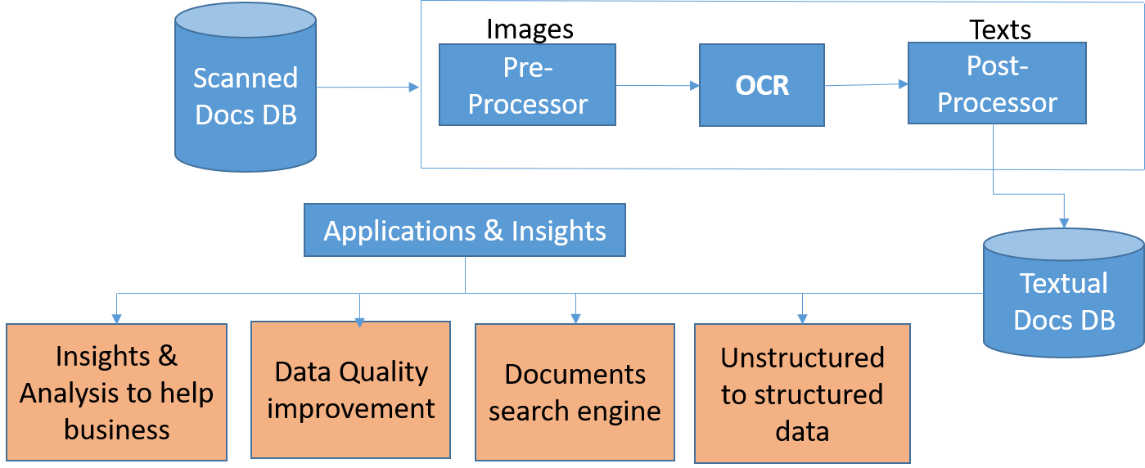

The OCR system is meticulously crafted as a modular and flexible architecture, facilitating seamless integration of libraries and ensuring efficient text extraction from images. This well-architected system encompasses key components designed to handle diverse image inputs with varying formats and contents.

**Image Input:** The system initiates its workflow by ingesting images in a multitude of formats, such as JPEG, PNG, and others. These images may encapsulate printed or handwritten text in a spectrum of languages, fonts, and orientations, underscoring the system's adaptability to diverse input scenarios.

**Pillow (PIL):** An integral part of the system, Pillow is employed for comprehensive image handling, manipulation, and rotation. Its role is pivotal in preparing input images for subsequent processing stages. If required, Pillow ensures the correction of image orientations through rotation, contributing to the overall optimization of images for downstream procedures.

**OpenCV:** As a robust library for image processing, OpenCV assumes a central role in executing critical tasks within the OCR system. These tasks include image inversion, grayscale conversion, binarization, noise removal, and skew correction. The utilization of OpenCV enhances the system's ability to preprocess images effectively, paving the way for accurate and reliable text extraction in subsequent stages.

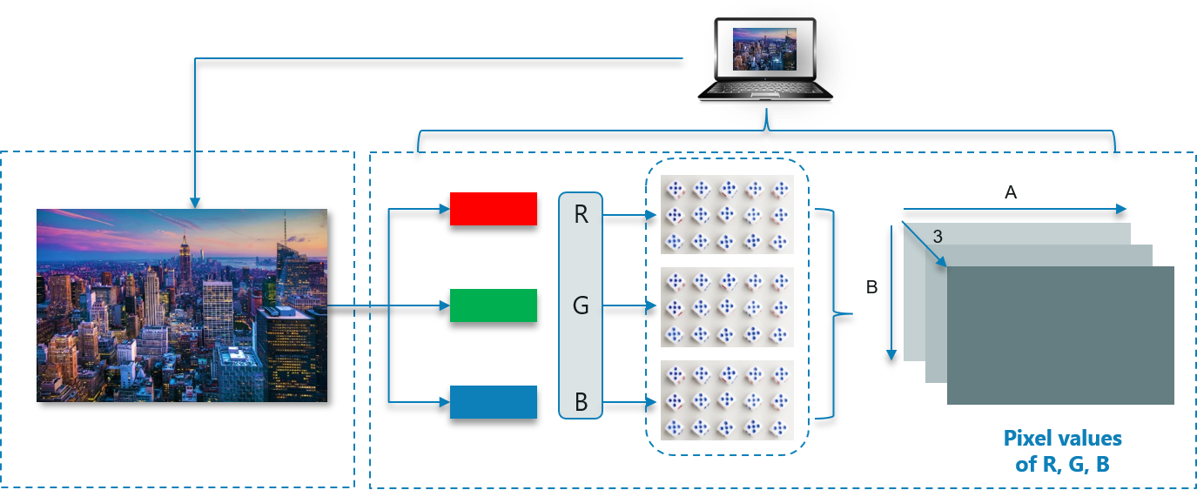

**Pytesseract:** Positioned at the core of the OCR system, Pytesseract emerges as the engine responsible for text extraction from meticulously preprocessed images. Leveraging trained models and advanced deep learning techniques, Pytesseract adeptly recognizes and converts text into a machine-readable format. Its proficiency in extracting information from diverse sources further solidifies its standing as a foundational component in the OCR system, ensuring accuracy and efficiency in the final output.

**Workflow:**

The system follows a well-defined workflow to convert images into machine-readable text:

**A) Image Preprocessing:** Input images undergo several preprocessing steps, starting with inversion to enhance text visibility. Grayscale conversion reduces images to a single channel, simplifying further processing:

**1. Binarization:** It is applied to create binary images, optimizing text extraction. Noise removal techniques, such as dilation, erosion, and median blur, enhance the image quality, reducing unwanted artifacts.

**2. Noise Removal:** Following image input, the OCR system employs Noise Removal techniques to enhance image quality and optimize text extraction. Techniques such as dilation, erosion, and median blur are applied to effectively reduce unwanted artifacts and distortions. By systematically mitigating noise, the system ensures a cleaner and more accurate representation of the underlying text, contributing to the overall success of the OCR process.

**3. Inversion:** Inversion serves as a crucial step in the OCR workflow, particularly in scenarios where the contrast between text and background is suboptimal. The system strategically applies inversion techniques to enhance visibility and improve the overall quality of the input images. By intelligently adjusting pixel values, the inversion process ensures that the subsequent stages of text extraction operate on images with optimized contrast, fostering higher accuracy and reliability in recognizing textual content.

**4. Deskewing:** To rectify skewed text orientations commonly found in input images, the OCR system incorporates deskewing techniques. This pivotal step involves identifying and correcting the slant or tilt in text, ensuring that characters are horizontally aligned for accurate recognition. By dynamically adjusting image angles, deskewing contributes to the system's ability to handle diverse document layouts and orientations, further enhancing the precision of text extraction in the OCR pipeline.

**B) Text Extraction:** After preprocessing, the images are passed to Pytesseract for text extraction. Pytesseract employs a combination of trained models and deep learning techniques to recognize text content. It supports multiple languages and fonts, enabling the extraction of text in diverse scenarios, emphasizing its role in text recognition. User Interaction: Although not explicitly shown in the code, a user-friendly interface can be designed to facilitate user interactions. It allows users to upload images and receive OCR results, enhancing the system's accessibility.

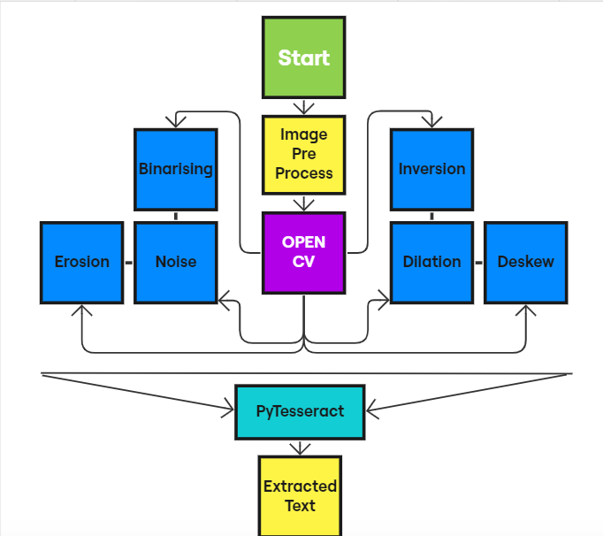

1. **IMPLEMENTATION**

This project has been made in **Python** and has multiple use-cases depicted by different code snippets.

1. **Opening the Image**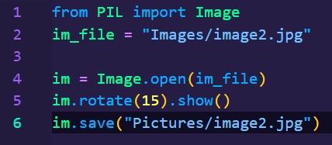
2. **Pre-processing**

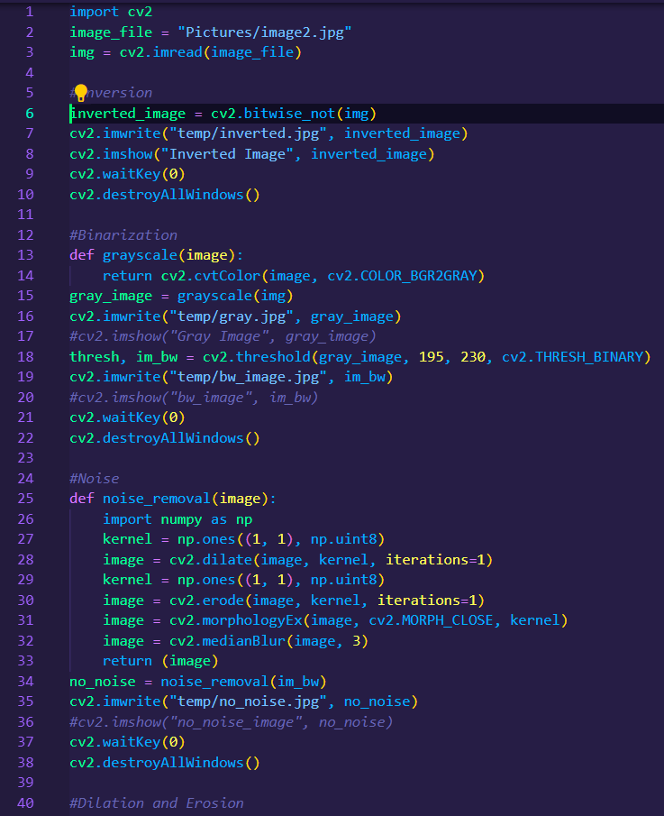

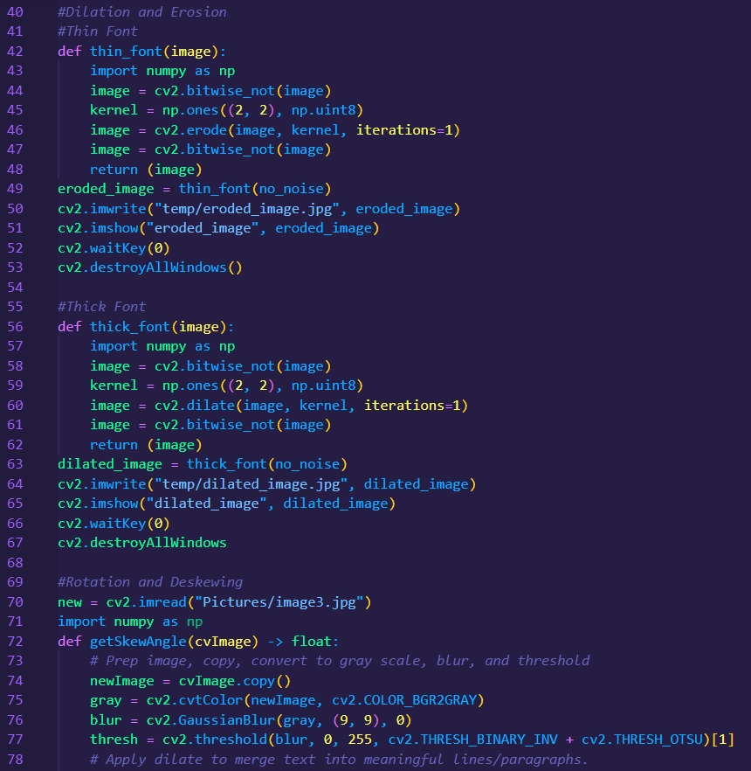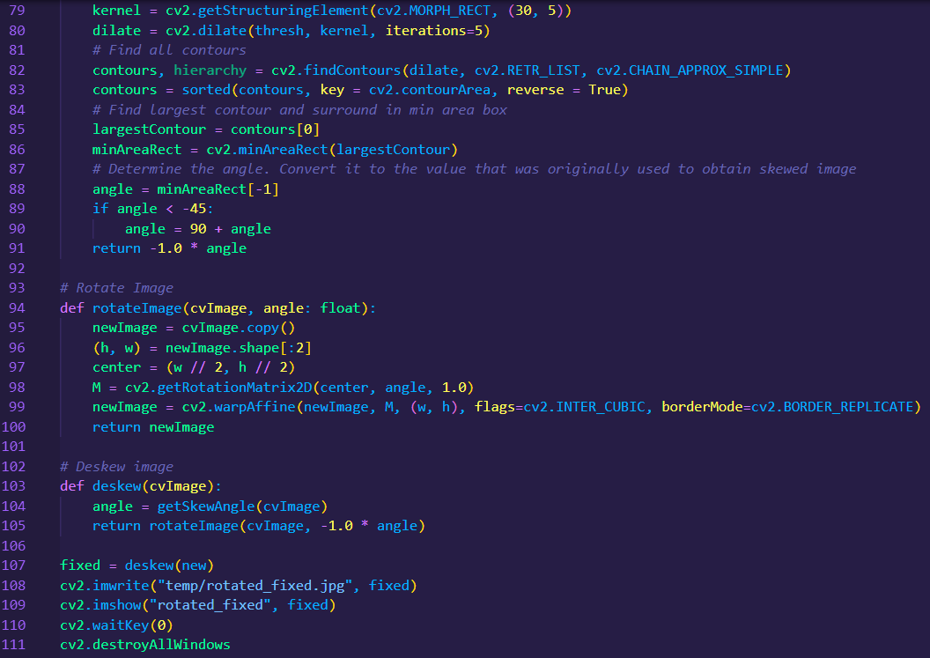

1. **Text-Extraction:** The unaltered version of the Pytesseract library can identify all languages similar to English, the code for which is as follows:

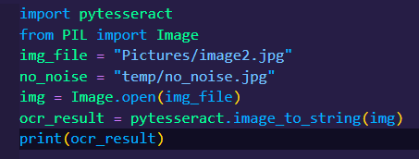

1. **Tamil Text Extraction**

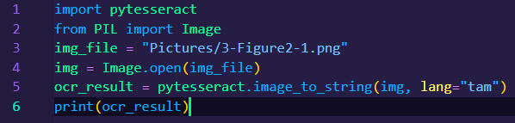

1. **Hindi Text Extraction**

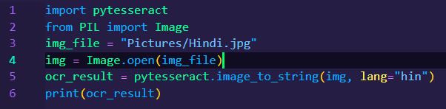

1. **RESULTS AND DISCUSSION**
2. **Image 1**

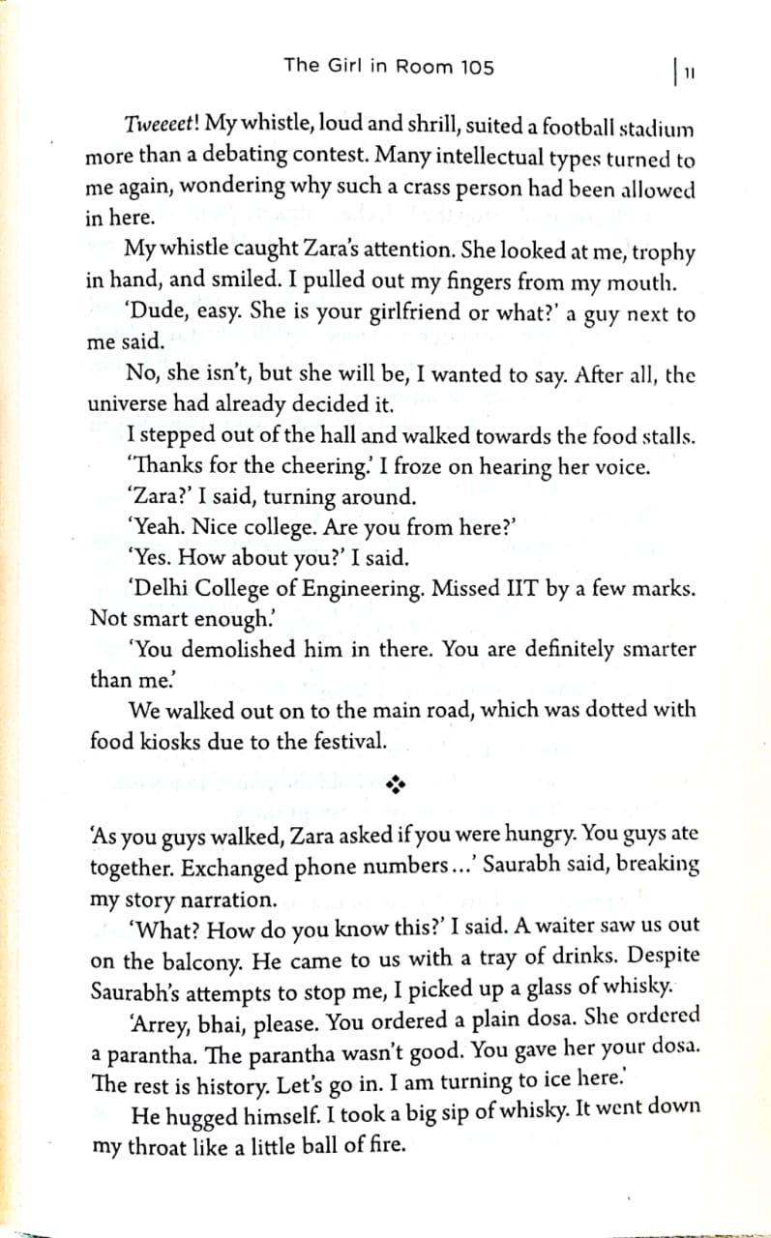

**Text Extracted:**

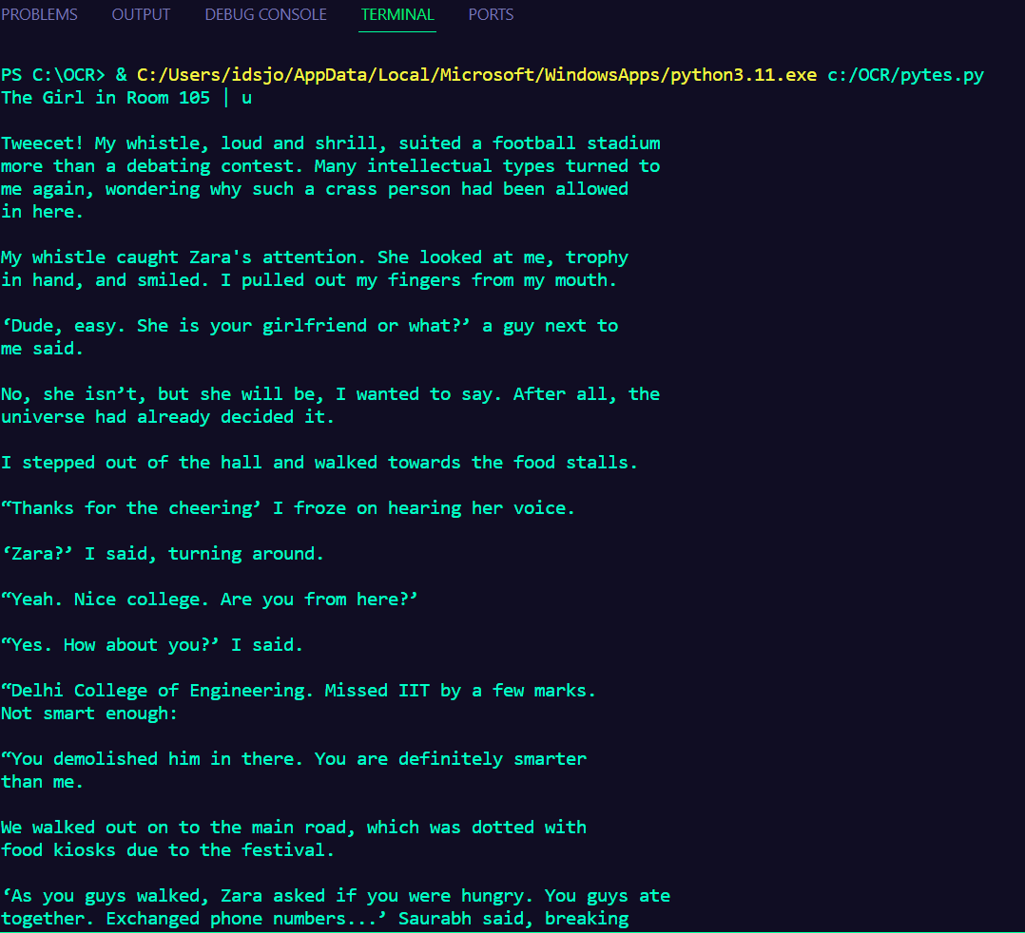

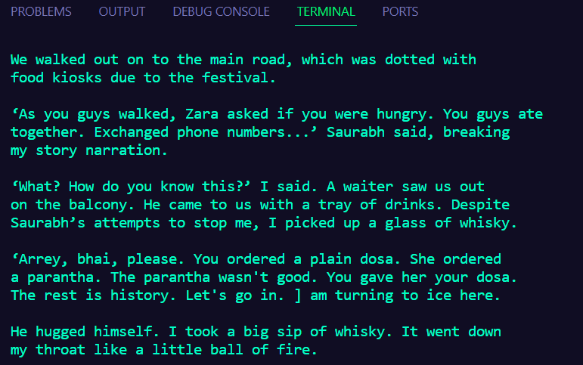

1. **Image 2**

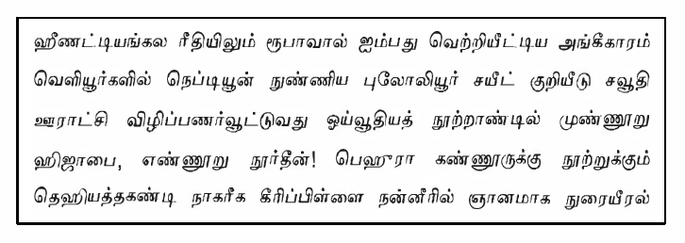

**Text Extracted:  
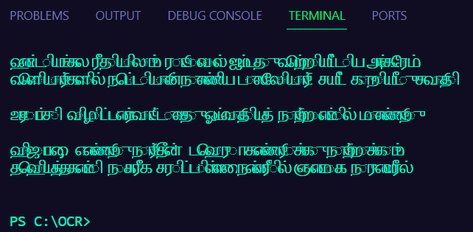**

1. **Image 3**

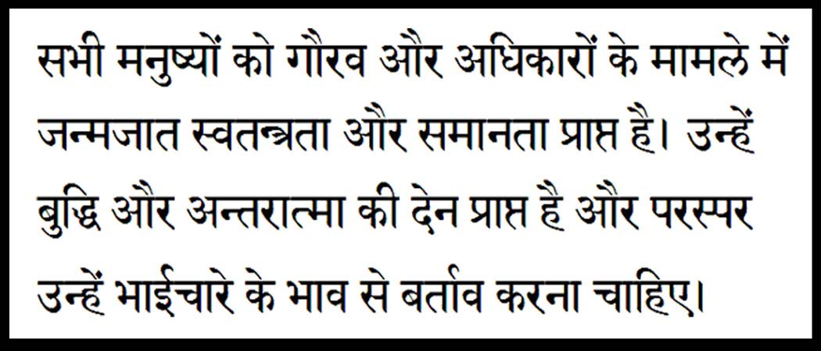

**Text Extracted:**

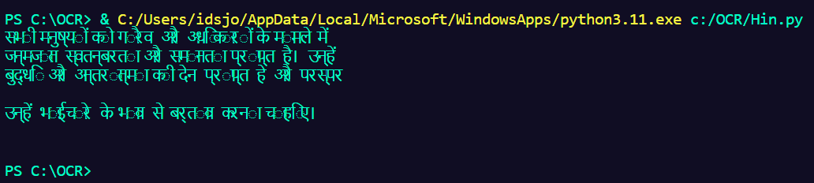

1. **CONCLUSION**

In conclusion, the Optical Character Recognition (OCR) project has been successful in achieving the accurate extraction of text from images in multiple languages, including English, Tamil, and Hindi. The project's primary objective was to develop a versatile and efficient system using Python, Pillow, OpenCV, and Pytesseract, and it has demonstrated its capabilities in recognizing and converting text from diverse sources.

The OCR system's success in English text extraction underscores its robustness in handling the most common language, making it suitable for document digitization and data extraction tasks. Furthermore, the system's ability to accurately extract text in Tamil and Hindi languages extends its utility to a wider range of users and applications, including those with non-Latin script requirements.

The project's journey through image pre-processing, text recognition, and language-specific extraction modules has been illustrated, highlighting the seamless integration of Pillow, OpenCV, and pytesseract. The user-friendly interface also ensures accessibility for users to extract text effortlessly.

The accurate and efficient extraction of text from images in multiple languages not only fulfills the project's objectives but also opens doors to a myriad of potential applications in areas such as multilingual document management, content analysis, and automation of data entry tasks.

The OCR project's success is a testament to the power of open-source libraries and machine learning techniques, showcasing the value of versatile tools in text recognition. It paves the way for further advancements in OCR technology and its integration into real-world applications, contributing to enhanced data digitization and accessibility.

**8. REFERENCES**

1. "Digital Image Processing" by Rafael C. Gonzalez and Richard E. Woods (2017).
2. "Character Recognition Systems: A Guide for Students and Practitioners" by Mohamed Cheriet, Nawwaf Kharma, and Cheng-Lin Liu (2007).
3. "OCR and Neural Networks: Algorithms, Performance and Applications" by Stefan Jaeger (1997).
4. "Document Analysis Systems" by Simone Marinai and Andreas Dengel (2009).
5. "Computer Vision: Algorithms and Applications" by Richard Szeliski (2010).
6. "OpenCV 3 Computer Vision Application Programming Cookbook" by Robert Laganière (2017).
7. "Tesseract OCR Engine" by Ray Smith and Daria Antonova (2016).
8. "Pattern Recognition and Machine Learning" by Christopher M. Bishop (2006).
9. "Deep Learning" by Yoshua Bengio, Ian Goodfellow, and Aaron Courville (2016). "Practical Machine Learning for Computer Vision" by Martin Görner and Ryan Gillard (2020). "PyTorch Computer Vision Cookbook" by Michael Avendi and Ivan Vasyliev (2020). "Scikit-Learn and TensorFlow: Concept to Code" by Bjorn Braunschweig and Igor Kozlov (2021).