

**Winter 2017 Contest**

**Black-box Testing Framework Version 2.0 Documentation**

**2017 February 17th**

**Team: Swifty X**

**Change History**

|  |  |  |  |
| --- | --- | --- | --- |
| **Version** | **Date** | **Change** | **Author** |
| 1.0 | December 15, 2016 | Initial Version | IDT |
| 2.0 | February 17, 2017 | 1. Changed the tone of the documentation and repurposed it for developers and testers in general. 2. Section 1: Added more source files and unit test files. 3. Section 2: Added information about dependencies, Gradle, and Maven. 4. Section 4: Added usage information for three new optional arguments. Replaced Run Configuration screenshot. 5. Section 5: Removed Extending the Framework section. Added Adding Test Cases to the Framework section. 6. Section 6: Added Building and Executing the Framework JAR section. 7. Section 7: Added Launching the Framework GUI section. 8. Section 8: Added Output File section. | Swifty X |
|  |  |  |  |
|  |  |  |  |



**Introduction**

IDT has developed a testing framework that will be used by developers and testers to test executable jars (Java). This document contains all of the documentation necessary for executing and extending the framework.

We would like to welcome you to the project. We are excited to work with your team to extend our testing framework to expose security vulnerabilities or weaknesses in the software under test.

**Contents**

**1. Framework and Supporting File Archive****s** **3**

**2. Framework Dependencie****s** **7**

**3. Importing the framework into Eclips****e** **9**

**4. Executing the framework in Eclips****e** **11**

**5. Adding Test Cases to the Framework** **15**

**6. Building and Executing the Framework JAR** **17**

**7. Launching the Framework GUI** **18**

**8. Output File** **20**

**1. Framework and Supporting File Archives**



IDT has two .zip files that contain our framework codebase and supporting files.

**com.idtus.contest.winter2017.framework.zip** –This is a compressed archive of the framework codebase. You willneed to unzip this archive on your development machines. **It does not matter where you ultimately put this** **codebase on your computer because you will be importing it into Eclipse and interacting with it though an IDE.**

Expanding compressed framework should reveal the following files that are part of a Maven Project for Eclipse:

**Program Source Files**

com.idtus.contest.winter2017.framework\.classpath

com.idtus.contest.winter2017.framework\.project

com.idtus.contest.winter2017.framework\build.gradle

com.idtus.contest.winter2017.framework\idt.bat

com.idtus.contest.winter2017.framework\idt.sh

com.idtus.contest.winter2017.framework\idt-ui.bat

com.idtus.contest.winter2017.framework\idt-ui.shcom.idtus.contest.winter2017.framework\pom.xml

com.idtus.contest.winter2017.framework\README.md

com.idtus.contest.winter2017.framework\src\main\java\contest\winter2017\Config.java

com.idtus.contest.winter2017.framework\src\main\java\contest\winter2017\ContinuousParameter.java

com.idtus.contest.winter2017.framework\src\main\java\contest\winter2017\DoubleParameter.java

com.idtus.contest.winter2017.framework\src\main\java\contest\winter2017\EnumerationParameter.java

com.idtus.contest.winter2017.framework\src\main\java\contest\winter2017\FormattedStringParameter.java

com.idtus.contest.winter2017.framework\src\main\java\contest\winter2017\Gui.java

com.idtus.contest.winter2017.framework\src\main\java\contest\winter2017\GuiLauncher.java

com.idtus.contest.winter2017.framework\src\main\java\contest\winter2017\IntegerParameter.java

com.idtus.contest.winter2017.framework\src\main\java\contest\winter2017\JsonParser.javacom.idtus.contest.winter2017.framework\src\main\java\contest\winter2017\Main.javacom.idtus.contest.winter2017.framework\src\main\java\contest\winter2017\Output.javacom.idtus.contest.winter2017.framework\src\main\java\contest\winter2017\Parameter.javacom.idtus.contest.winter2017.framework\src\main\java\contest\winter2017\ParameterFactory.java

com.idtus.contest.winter2017.framework\src\main\java\contest\winter2017\Parameters.java

com.idtus.contest.winter2017.framework\src\main\java\contest\winter2017\StdoutWrapper.java

com.idtus.contest.winter2017.framework\src\main\java\contest\winter2017\StringParameter.javacom.idtus.contest.winter2017.framework\src\main\java\contest\winter2017\Test.javacom.idtus.contest.winter2017.framework\src\main\java\contest\winter2017\Tester.java

com.idtus.contest.winter2017.framework\src\main\java\contest\winter2017\YamlReport.java

com.idtus.contest.winter2017.framework\src\main\java\contest\winter2017\parameter\BinaryAccessingIterator.java

com.idtus.contest.winter2017.framework\src\main\java\contest\winter2017\parameter\CharacterGenerator.java

com.idtus.contest.winter2017.framework\src\main\java\contest\winter2017\parameter\CharacterRangeIterator.java

com.idtus.contest.winter2017.framework\src\main\java\contest\winter2017\parameter\CharacterSet.java

com.idtus.contest.winter2017.framework\src\main\java\contest\winter2017\parameter\DoubleGenerator.java

com.idtus.contest.winter2017.framework\src\main\java\contest\winter2017\parameter\DoubleRangeIterator.java

com.idtus.contest.winter2017.framework\src\main\java\contest\winter2017\parameter\FormattedStringGenerator.java

com.idtus.contest.winter2017.framework\src\main\java\contest\winter2017\parameter\Generator.java

com.idtus.contest.winter2017.framework\src\main\java\contest\winter2017\parameter\InfiniteGenerator.java

com.idtus.contest.winter2017.framework\src\main\java\contest\winter2017\parameter\IntegerGenerator.java

com.idtus.contest.winter2017.framework\src\main\java\contest\winter2017\parameter\IntegerRangeIterator.java

com.idtus.contest.winter2017.framework\src\main\java\contest\winter2017\parameter\RegExprs.java

com.idtus.contest.winter2017.framework\src\main\java\contest\winter2017\parameter\StringGenerator.java

com.idtus.contest.winter2017.framework\src\main\java\contest\winter2017\util\NumberUtil.java

com.idtus.contest.winter2017.framework\src\main\java\contest\winter2017\util\PatternRecognizer.java

com.idtus.contest.winter2017.framework\src\main\resources\config.yaml

com.idtus.contest.winter2017.framework\src\main\resources\log4j.properties

com.idtus.contest.winter2017.framework\src\main\resources\icon\checkbox_off_blue.png

com.idtus.contest.winter2017.framework\src\main\resources\icon\checkbox_on_blue.png

com.idtus.contest.winter2017.framework\src\main\resources\icon\icon.pgn

com.idtus.contest.winter2017.framework\src\main\resources\icon\logo.png

com.idtus.contest.winter2017.framework\src\main\resources\json\CommandLineEncryption.json

com.idtus.contest.winter2017.framework\src\main\resources\json\LeetConverter.json

com.idtus.contest.winter2017.framework\src\main\resources\json\RegexPatternMatch.json

com.idtus.contest.winter2017.framework\src\main\resources\json\TesterTypeCheck.json

com.idtus.contest.winter2017.framework\src\main\resources\parameter\validReg.txt

**Unit Test Source Files**

com.idtus.contest.winter2017.framework\src\test\java\contest\winter2017\ConfigTest.java

com.idtus.contest.winter2017.framework\src\test\java\contest\winter2017\DoubleGeneratorTest.java

com.idtus.contest.winter2017.framework\src\test\java\contest\winter2017\FormattedStringGeneratorTest.java

com.idtus.contest.winter2017.framework\src\test\java\contest\winter2017\GeneratorsTest.java

com.idtus.contest.winter2017.framework\src\test\java\contest\winter2017\MainTest.java

com.idtus.contest.winter2017.framework\src\test\java\contest\winter2017\OutputTest.java

com.idtus.contest.winter2017.framework\src\test\java\contest\winter2017\StringGeneratorTest.java

com.idtus.contest.winter2017.framework\src\test\java\contest\winter2017\TesterTest.java

com.idtus.contest.winter2017.framework\src\test\java\contest\winter2017\YamlReportTest.java

com.idtus.contest.winter2017.framework\src\test\java\contest\winter2017\parameter\RegExprsTest.java

com.idtus.contest.winter2017.framework\src\test\java\contest\winter2017\util\NumberUtilTest.java

com.idtus.contest.winter2017.framework\src\test\java\contest\winter2017\util\PatternRecognizerTest.java

**com.idtus.contest.winter2017.supportingfiles.zip** –This is a compressed archive of the supporting files that you willneed to execute the framework. **The archive contains a directory called ‘idt_contest’ that we recommend putting** **directly into your C:\ directory (if you are using windows), the root directory (if you are using macOS), or your user’s directory (if you are using Linux).** You willultimately be referencing multiple files/directories as arguments for the framework, so we recommend you keep the paths short for convenience sake. This expanded structure should contain the following files:

idt_contest\jacoco\lib\jacocoagent.jar idt_contest\jars\CommandLineEncryption.jar idt_contest\jars\LeetConverter.jar idt_contest\jars\RegexPatternMatch.jar idt_contest\jars\TesterTypeCheck.jar

* this is the jacoco agent jar
  + this is an executable black-box jar that you will test
    - this is an executable black-box jar that you will test
    - this is an executable black-box jar that you will test
    - this is an executable **white-box** jar that you will test

**2. Framework Dependencies**



We intend for you to develop and execute the framework through Eclipse. There are a minimal set of dependencies that you will need to install in order to get the framework up and running.

1. **Java SE 1.7 or greater** - You will need to have Java installed and available as a command on the command line(added to your path). **The minimum acceptable Java version is 1.7**. The framework will be executing external

Java processes, and will require the command ‘java –jar’ to resolve correctly from the command line.

1. **Eclipse 4.4 or greater**- You will need to have Eclipse installed because the framework was created as a MavenProject for Eclipse. The project was originally created using Eclipse 4.4. (Luna), but there do not appear to be any requirements on a specific version of Eclipse. If you have a version prior to 4.4, you should be okay. Our recommendation is to use Luna (4.4), Mars (4.5), or Neon (4.6).  [http://www.eclipse.org/downloads](http://www.eclipse.org/downloads/)/
2. **Maven2Eclipse (m2e)** –You will need to make sure that you have Maven support in Eclipse installed to importand resolve dependencies associated with the framework project. One way to test if you already have this, is to go to File > Import, and look for Maven > Existing Maven Projects. If you do not have that option, you will need to install m2e from Help > Install New Software. Look for the site that uses the name of the version of Eclipse that you have installed (e.g. Luna, Mars, or Neon). You will find ‘m2e’ under the Collaboration entry. Install m2e and verify that you see the Maven options under File > Import.

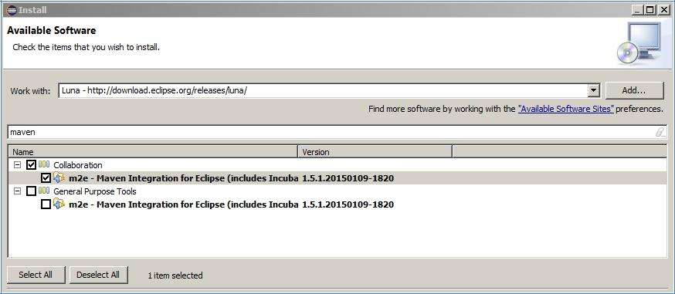

Installing Maven from Help > Install New Software in Eclipse Luna

Eclipse will use Maven to resolve the library dependencies for the framework automatically using the pom.xml file that is included with the framework project:

**(GROUP)** **(ARTIFACT IDs)**

org.jacoco jacoco-maven-plugin, org.jacoco.core, org.jacoco.agent, org.jacoco.report

org.ow2.asm asm-all

commons-cli commons-cli

com.google.guava guava

log4j log4j

org.slf4j slf4j-api, slf4j-log4j12

org.yaml snakeyaml

junit junit

com.google.truth truth

org.apache.commons commons-lang3

commons-collections commons-collections

com.fasterxml.jackson.core jackson-databind

1. **Gradle** – You will need to have Gradle for java build tool. It supports automatic download and configuration of dependencies and libraries. It compiles Java source code, runs unit tests, and create a JAR file, which can be distributed and run at command line. The current version is 3.3. You can download Gradle at <https://gradle.org/install>.
2. **Maven 3.x or greater** – Alternatively you can use Maven for java build tool. You can download Maven at http://maven.apache.org.

**3. Importing the framework into Eclipse**



Once you have Java, Eclipse, and Maven all installed, you can import the framework project into Eclipse.

1. **File** > **Import** will bring up a window with several options, select **Maven** > **Existing Maven Projects** and click onthe Next button at the bottom.

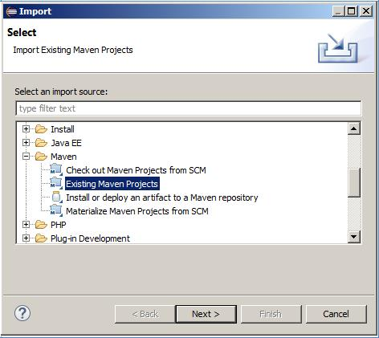

Selecting ‘Existing Maven Projects’ in Eclipse Import window

1. Use the Browse button on the Maven Projects page to select the path to the framework on your machine (it was unzipped from **com.idtus.contest.winter2017.framework.zip** somewhere on your system as part of step 1). The framework should be a folder called **com.idtus.contest.winter2017.framework**. When the framework is selected, click on the Finish button at the bottom.

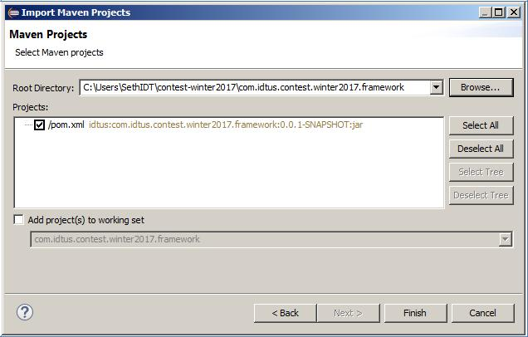

1. Browse to location of the unzipped framework code on your system and click on the Finish buttonIf you have successfully imported the framework project into Eclipse, you should see framework project appear in the Package Explorer on the left hand side of Eclipse.

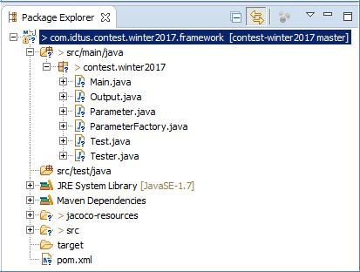

Successful import of framework project into Eclipse

* 1. If you have an error in your project due to the fact that the JRE for the project is set to something other than 1.7 or 1.8, simply switch the version of JRE on the project build path by right clicking on ‘JRE System Library [JSE-1.5]’ under the project contents, and selecting ‘Properties’. Under the properties, you can set the proper JRE (1.7 – 1.8).

1. **Executing the framework in Eclipse**

The framework, at this time, uses three **required** arguments (-jacocoAgentJarPath, -jacocoOutputPath, and - jarToTestPath) and three optional arguments (-bbTests, - timeGoal, and -toolChain) in order to execute and test a black-box executable jar. Additionally, the framework currently accepts a –h or –help switch to trigger the help menu.

usage: com.idtus.contest.winter2017.framework [-h] [-help] [-jacocoAgentJarPath <arg>] [-jacocoOutputPath <arg>] [-jarToTestPath <arg>]

-h help

-help help

**-jacocoAgentJarPath** <arg> path to the jacoco agent jar

**-jacocoOutputPath** <arg> path to directory for jacoco output

**-jarToTestPath** <arg> path to the executable jar to test

-bbTests <arg> number of iterations to test, default to 1000 if omitted

-timeGoal <arg> number of minutes to test, default to five minutes if omitted

-toolChain <arg> flag to output in YAML format, default to false if omitted

The entry-point for the framework is found in Main.java.

To execute the framework through Eclipse, right click on the Main.java file in the Package Explorer and select Run As > Java Application. If the three required arguments have not been set, you should see the usage print to stdout.

To set the three required arguments for the framework, you will need to open the Run Configuration for the project. This can be done by clicking on Run > Run Configurations at the top of Eclipse. Make sure that the ‘Main’ configuration is selected in the left side of the Run Configuration window and then select the ‘Arguments’ tab on the right hand side. You will need to add program arguments for the three required arguments.



**jacocoAgentJarPath** –We distributed the jacoco agent jar file as part of the supporting files incom.idtus.contest.winter2017.supportingfiles.zip. Inside the expanded directory, the relative path to the jacoco agent jar should be: idt_contest\jacoco\lib\jacocoagent.jar. If you put the idt_contest directory directly into the C:\ directory, your jacocoAgentJarPath (absolute) should be **C:\ idt_contest\jacoco\lib\jacocoagent.jar.**

**jacocoOutputPath** –This could be any directory on your system - it is not important that you use a specific one.When we were running locally, we used idt_contest\jacoco as our jacoco output directory. If you put the idt_contest directory directly into the C:\ directory, your jacocoOutputPath might be **C:\ idt_contest\jacoco.**

**jarToTestPath –** This is the path to the black-box executable jar that you intend to test. We distributed all of thesample black-box executable jars as part of the supporting files in com.idtus.contest.winter2017.supportingfiles.zip. Inside the expanded directory, the relative path to the jars to test should be: idt_contest\jars. If you put the idt_contest directory directly into the C:\ directory and intended to test RegexPatternMatch.jar, your jarToTestPath might be **C:\idt_contest\jars\RegexPatternMatch.jar**.

All arguments are entered with a hyphen preceding the argument name and a space separating the argument name and value:

-jarToTestPath C:\\idt_contest\\jars\\RegexPatternMatch.jar-jacocoOutputPath C:\\idt_contest\\jacoco-jacocoAgentJarPath C:\\idt_contest\\jacoco\\lib\\jacocoagent.jar

-bbTests 200

-timeGoal 2

-toolChain

Example of program arguments filled out completely to execute framework against RegexPatternMatch.jar

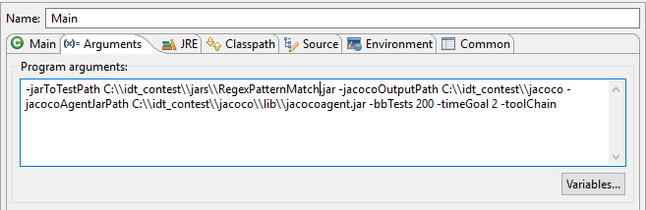

After updating Arguments > Program Arguments and executing the framework again, the Console in Eclipse should show you results from the testing.**5. Adding Test Cases to the Framework**







You can define more test cases in a JSON file that will be executed by this test framework. The JSON file should be put on $CLASSPATH and have the same name as the jar under test. Please see the JSON files under src/main/resources/json/ source directory for more information.

RegexPatternMatch.json

[

{

"parameters":[

*"^a"*,

*"aboard"*

],

"stdOutExpectedResultRegex":*".*matches.*"*,

"stdErrExpectedResultRegex":*""*

},

{

"parameters":[

*"sha$"*,

*"sha"*

],

"stdOutExpectedResultRegex":*".*matches.*"*,

"stdErrExpectedResultRegex":*""*

},

……

……

……

……

]

**6. Building and Executing the Framework JAR**

When you want to build JAR file for the framework source code, there are two options. You can choose from Gradle and Maven. Both are widely adopted build tools by industries.

**Build with Gradle**

Use *build.gradle* file to configure dependencies and tasks for build. Run following steps at command line under com.idtus.contest.winter2017.framework directory:

>gradle tasks

>gradle build -x test

Executable jar “com.idtus.contest.winter2017.framework.jar” is generated under build\libs directory. If you are using Windows, execute the jar through the batch file:

|  |
| --- |
| idt.bat -jarToTestPath C:\\idt_contest\\jars\\TesterTypeCheck.jar -jacocoOutputPath C:\\idt_contest\\jacoco -jacocoAgentJarPath C:\\idt_contest\\jacoco\\lib\\jacocoagent.jar -bbTests 100 -timeGoal 1 |

If your machine runs on macOS, Unix, or Linux, execute the jar through the bash file.

|  |
| --- |
| sh idt.sh -jarToTestPath /idt_contest/jars/TesterTypeCheck.jar -jacocoOutputPath /idt_contest/jacoco -jacocoAgentJarPath /idt_contest/jacoco/lib/jacocoagent.jar -bbTests 100 -timeGoal 1 -toolChain |

**Build with Maven**

Maven uses *pom.xml* to manage dependencies and build configurations. Run following steps at command line under com.idtus.contest.winter2017.framework directory:

> mvn clean compile assembly:single

Executable jar “com.idtus.contest.winter2017.framework-0.0.1-SNAPSHOT-jar-with-dependencies.jar” is generated under *target* directory. Execute the jar at command line:

|  |
| --- |
| java -jar target/com.idtus.contest.winter2017.framework-0.0.1-SNAPSHOT-jar-with-dependencies.jar -jarToTestPath C:\\idt_contest\\jars\\TesterTypeCheck.jar -jacocoOutputPath C:\\idt_contest\\jacoco -jacocoAgentJarPath C:\\idt_contest\\jacoco\\lib\\jacocoagent.jar -bbTests 100 -timeGoal 1 |

**7. Launching the Framework GUI**

After executable jar is generated from Gradle, the framework GUI can be launched at command line if using windows:

>idt-ui.bat

If your machine runs on macOS, Unix, or Linux, GUI can be launched through the bash file.

> sh idt-ui.sh

If jar is generated from Maven, the framework GUI can be launched at command line with the following line:

>java -cp target/com.idtus.contest.winter2017.framework-0.0.1-SNAPSHOT-jar-with-dependencies.jar contest.winter2017.GuiLauncher

IDT Tester window is in display.

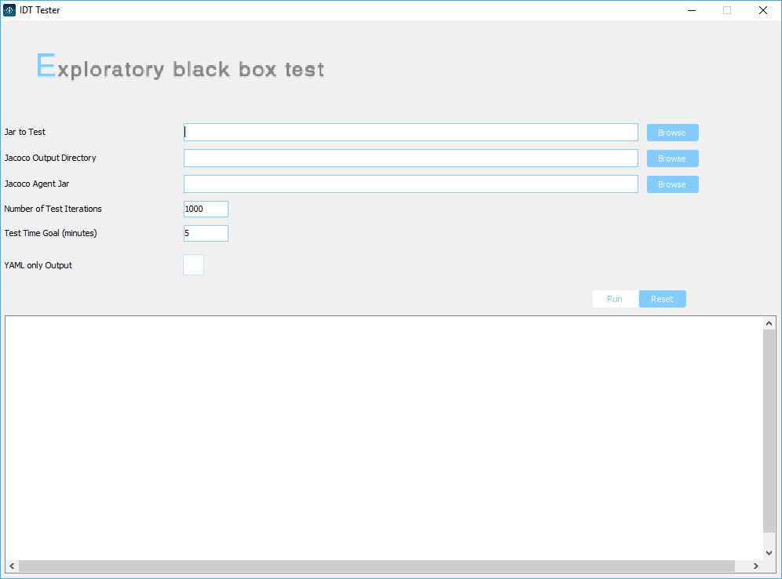

IDT Tester GUI Window

The user interface offers same functionality as command line tool. The Browse button opens up dialog window to choose the file or path needed for test. Run button executes the test. The output field displays test result. Reset button cleans up the fields and output.

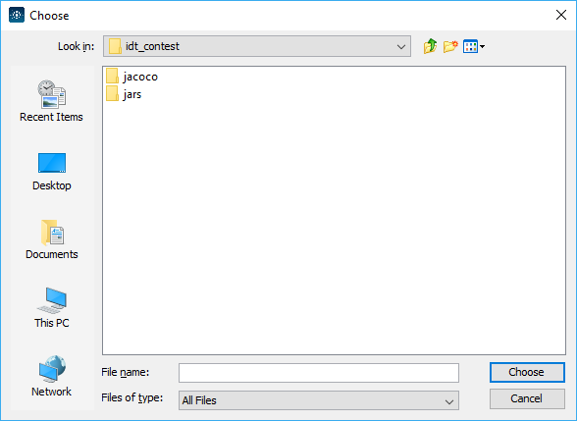

File Choose Window when Clicking Browse Button

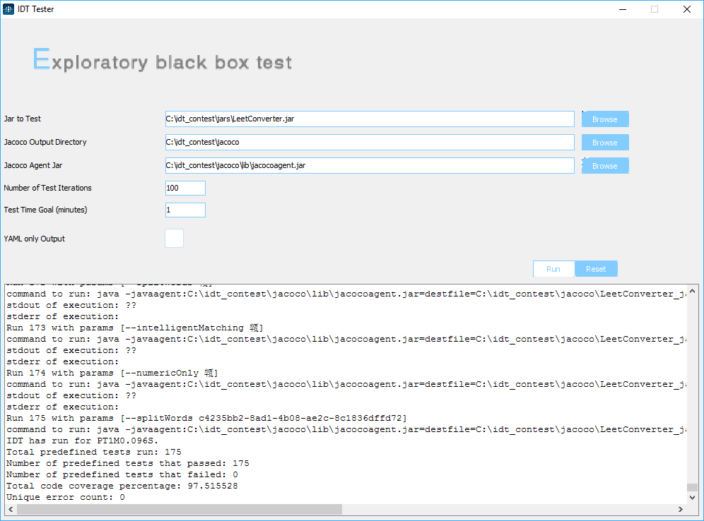

Running a Test in IDT Tester GUI Window

**8. Output File**

Test results are automatically saved as `idt-yyyy-MM-ddTHH-mm-ss.out` in the source code folder.

A glimpse on a non YAML output file

IDT options:

-jacocoAgentJarPath C:\idt_contest\jacoco\lib\jacocoagent.jar

-jacocoOutputPath C:\idt_contest\jacoco

-jarToTestPath C:\idt_contest\jars\LeetConverter.jar

-bbTests 100

-timeGoal 60

-toolChain

Running basic tests...

command to run: java -javaagent:C:\idt_contest\jacoco\lib\jacocoagent.jar=destfile=C:\idt_contest\jacoco\LeetConverter_jar_jacoco.exec -jar C:\idt_contest\jars\LeetConverter.jar "fun"

stdout of execution: |=|_|/\/

stderr of execution:

basic test result: PASS

……………

……………

……………

……………

IDT has run for 00:01:0.096.

Total predefined tests run: 175

Number of predefined tests that passed: 175

Number of predefined tests that failed: 0

Total code coverage percentage: 97.515528

Unique error count: 0