## IOT and Blockchain Project Report

On

## “Pharmaceutical Supply chain management system using IoT and blockchain technologies”

## Submitted by

1. **Atharv Nikam**
2. **Abhishek Misar**
3. **Vipul Dunde**

**Table of Contents**

|  |  |  |  |
| --- | --- | --- | --- |
|  | **Chapter** | | **Page No.** |
|  | **Abstract** | |  |
| **1** | **Introduction** | |  |
| **2** | **Related Work** | |  |
|  |  | Literature Survey /Analysis of existing methods |  |
| **3** | **Proposed Work** | |  |
|  |  | Problem Statement |  |
|  |  | Iot Significance in the proposed work |  |
|  |  | Architecture/Model/Block Diagram |  |
|  |  | Hardware and Software Requirement |  |
|  |  | Results obtained |  |
| **4** | **Conclusion** | |  |
| **5** | **References** | |  |

**Abstract**

Block chain and Iot are changing the functioning of supply chain management systems. Every year due to product losses, supply chains incur big loss. Traditional supply chains also face a lot of challenges due to complex networks. Blockchain network with integrated Iot is the key to overcome many of these problems. It provides important features such as decentralization which ensures that there is no monopoly in the system and this can reduce tampering of products and it improves the efficiency of the supply chain by providing a shared ledger. The implementation rate of Block chain networks with integrated Iot is less and is only used by some big companies. One of the sole reasons being the implementation is complex. In this paper we demonstrate how it can be implemented in the supply chain management system. This paper helps people understand the benefits about Block chain and Iot based systems and its implementation.

Introduction

Supply chains play a vital role in today’s pharmaceutical industries. Supply chain management maintains the balance between demand and supply and involves activities right from extracting resources to manufacturing to converting them into drugs and vaccines and ensuring a delivery at a right time which will reach the end consumer. Supply chains are complex and sensitive as they depend on always changing consumer demands. Ensuring the highest quality is the primary goal of supply chains. Block chain networks integrated with IOT are proposed in this study to achieve the following: (1) The primary challenge for pharmaceutical supply chains is to ensure safe delivery to dispensaries without any counterfeiting of drugs. This brings a need for improved visibility in supply chains and also trust on security among all stakeholders. (2) The other crucial challenge is to maintain certain temperature conditions for pharmaceuticals in which they are effective and viable. Hospitals, Patients, Dispensaries all depend on pharmaceutical supply chain and logistics to deliver Anaesthetics, Insulins, Antiserums and Vaccines which are viable only in cold temperatures. (3) Another problem that supply chains in general face is going through multiple paperworks such as Certificate of origin, Import Declaration, Pro Forma Invoice, Packing list, Bill of lading.

**Number of total counterfeit incidents by year, 2014-18**

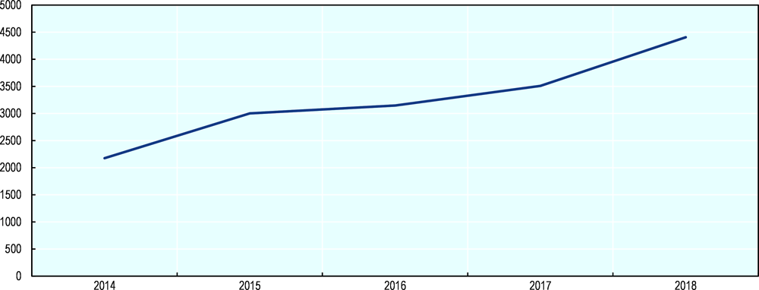

This requires us to build a decentralized smart monitoring system with an interface to properly manage the pharmaceutical supply chain. The continuous monitoring of temperature is necessary to ensure that medicines are effective and viable. Temperatures sensors can monitor the temperatures inside the package. As authenticity and security is a matter of concern in this system decentralization is considered to be the best solution. As synchronized digital data geographically spread across multiple states, countries is a requirement, Shared ledger is also considered for this system.

**Top provenance economies of counterfeit pharmaceuticals imported into the EU, 2014-2016**

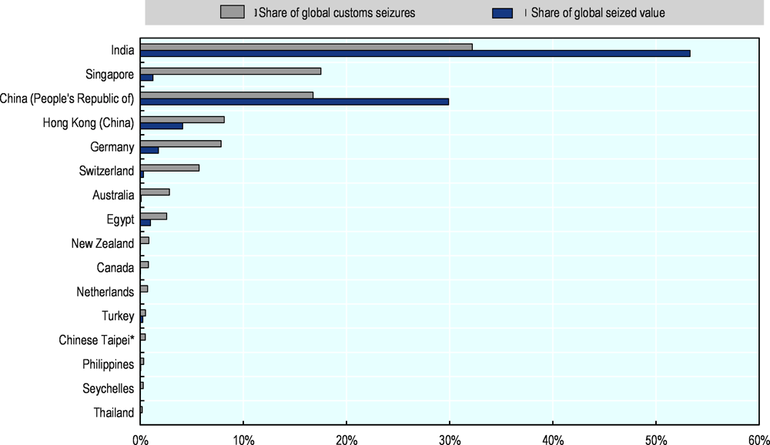

*Source*: OECD/EUIPO database.

Blockchain technology provides both decentralization and shared ledger. The temperature sensor data can be stored in blocks by implementing a blockchain network. The hash of the temperature sensor is stored in blockchains. This ensures Data integrity and security. Blockchain platforms work on the concept of peer-to-peer networks so to reduce paperwork and also provide authenticity of it, digital signatures can be used.

**Pharmaceutical Supply chain**

A pharmaceutical supply chain starts from the supplier who delivers the raw materials and ends with the end-user customer, for example, hospitals, patients, pharmacy shops. The pharmaceutical supply chain takes care of movement and storage of produced medicines from source to the destination. A pharmaceutical drug supply chain system has the following important elements:

* Manufacturers: The manufacturer receives orders from wholesalers or distributors and ships the finally produced pharmaceutical drugs in large quantities to distributor warehouses.
* Governments: Governments impose regulations and taxes on the import and export of drugs/medicines.
* Wholesaler: The wholesaler propagates the process and distributes pharmaceutical drugs to dispensaries and hospitals. This saves time and effort of the manufacturer from the distribution of drugs.
* Dispensaries: Dispensaries and hospitals purchase the pharmaceutical drugs from wholesalers. The drugs received by dispensaries and hospitals are given or sold to end-users or patients.

The top priority in any health system is delivering medicine as a strategic product. In the present context of a health-conscious society, management of pharmaceutical supply chains has become more complex because it involves the life-saving interest of human beings and requires the participation of different stakeholders such as pharmaceutical manufacturers, wholesalers, distributors, customers, information service providers and regulatory agencies. Limited research is available in the area of pharmaceutical supply chains. Pharmaceutical companies, a most important player of the drug supply chain, are subject to many risks. These risks interrupt the quantity and quality of supply of medicine and their delivery to the accurate place and customers and at the correct time.

Literature Review

Till date, authors have worked on some decentralized models of supply chains. In the following section, we are describing some of the methods used to implement Blockchain and Iot in supply chains.

[1]IoT INTEGRATED BLOCKCHAIN BASED AUTOMOTIVE SUPPLY CHAIN Blockchain based automotive supply chain can be implemented in two ways such as incoming logistic service to the plant and outgoing distribution service to the dealers and the importers.

IoT INTEGRATED BLOCKCHAIN BASED PHARMACEUTICAL SUPPLY CHAIN

[2]BLOCKCHAIN-ENABLED SUPPLY CHAIN GRANULARITY FRAMEWORK Smart contract module generator

[3]Combining IoT with Blockchain Technology: Emerging Research Areas Traceability and Interoperability Blockchain technology is already used in combination with tamper-evident RFID-tags to aid in the verification of the provenance (e.g., geographic source or origin) and authenticity of bottles of fine wine.

[4]IoT Monitoring Module This aims to provide food identification and environmental monitoring, along with shipment journeys and supply chain activities. The collected data are then used to evaluate food shelf life and quality decay.

[5]Building a scalable and high throughput blockchain distribution network (BDN) with the bloXroute server and Raft consensus algorithm that is suitable for IoT devices with high throughput. Building an Internet of Things (IoT) and blockchain-based supply chain management for pharmaceutical drugs.

Proposed Work

**Proposed solution :**

* As pharmaceutical products travel through the supply chain, It requires improved visibility of the supply chain and trust on security among all stakeholders. We incorporate blockchain technology. Due to shared ledger and decentralization of power which are inherent features of the Blockchain technology, it brings a sense of trust in the digital ecosystem.
* The proposed solution uses sensors and RFID scanners that help monitor the temperature of the package. If temperature value exceeds the threshold the package is rejected by the system.
* In the proposed system it is easy to approve a package which requires paperwork by using digital signatures.

**Our system :**

* Building an Internet of things (Iot) and Blockchain based supply chain management for pharmaceutical products.

1. *Blockchain*

Bitcoin’s public ledger—the blockchain—was first introduced in 2009 by Satoshi Nakamoto[5]. Bitcoin was the first widely used implementation of peer-to-peer trustless electronic cash. Thenceforth, many other forms of electronic cash (call cryptocurrencies) have been created using similar structures. Blockchain is being used in many different fields beyond cryptocurrencies. The new concept of smart contract has entered the scene . Smart contracts[6] are computer protocols that facilitate, verify, or enforce the negotiation or performance of a contract. They provide the ability to directly track and execute complex agreements between parties without human interaction. On the other hand, smart properties are agreements whose ownership is controlled via the blockchain, using contracts. The potential uses of blockchain technology go beyond Bitcoin. Blockchain technology has the following properties:

• decentralized control: A decentralized scheme in which no central authority dictates the rules.

• data transparency and auditability: A full copy of every transaction ever executed in the system is stored in the blockchain and is public to all the peers.

• distribute information: Every network node keeps a copy of the blockchain to avoid having a centralized authority privately keep all that information.

• decentralized consensus: The transactions are validated by all the nodes of a network instead of a central entity. This breaks with the paradigm of centralized consensus. • secure: The blockchain is tamper-proof and cannot be manipulated by malicious actors.

A blockchain contains a set of blocks, and every block contains a hash of the previous block, creating a chain of blocks from the genesis block to the current block. A genesis block is the first block in a blockchain. The genesis block is almost always hardcoded into the software. It is a special case in that it does not reference a previous block. Blocks have a set of transactions. A transaction is a transfer of values between different entities that are broadcast to the network and collected into the blocks. All transactions are visible in the blockchain.

1. *Blockchain and IoT Based Supply Chain Management*

In a pharmaceutical supply chain a wholesaler purchases products from the manufacturer. After that the wholesaler distributes these pharmaceutical products to dispensaries and hospitals. In this supply chain the package is transferred from one place to another and it involves multiple entities.

The involvement of multiple entities poses a big risk of counterfeiting of drugs. The proposed solution is to create a Blockchain and Iot based system that records and timestamps the transfer of goods at each point in the supply chain. As packages travel to through the supply chain, every transaction of the pharmaceutical product should be time stamped with the current entity. The shared ledger ensures the security and safety of the packages. The stakeholders involved can access the complete transport history of the product. The supply chain of pharmaceutical products brings another challenge that many Anaesthetics, Insulins, Antiserums and Vaccines are required to be stored in cold temperatures. If the temperature goes above the specified threshold the medicines and drugs become ineffective. Several solutions like use of refrigerated vehicles or use of thermo boxes/isothermal boxes exist. Monitoring of temperature is still a big challenge.

The temperature value is stored in the Blockchain and a Hash value is calculated which stores all the transactions about the product. The Hash Value is calculated from a hash function. This Hash value is always unique and cannot be deleted.

We build a Blockchain framework with following components :

* **RFID scanner :** The RFID technology is used to track the products at each stage of the supply chain management. The RFID tag is attached to each product and at each stage, the RFID scanner is used to scan the tags. This is used to improve the data collection process.
* **Sensor :** A sensor is required to monitor the temperature of the package. The sensors will continuously transmit data when the package is transported from one place to another.
* **Order creation :** Once a product enters a supply chain a new order is created. The package information can be retrieved by the RFID scanner.
* **Order transfer :** When order is transferred from one entity to another the information is stored in the blockchain.
* **View scanned product :** All entities can see the product details in the supply chain with a dashboard based application.
* **Smart Contract :** The supply chain management system described in this paper is governed by the operations defined in a single smart contract. The smart contract is an agreed set of terms and conditions for a product which the complete supply chain must follow. The smart contract is unique and cannot be deleted from the system.

We proposed a system where all the stakeholders agree on a set of terms and conditions for the package through a smart contract. As we are focusing on the pharmaceutical supply chain the right temperature is necessary. Therefore all stakeholders in the pharmaceutical supply chain agree on a temperature condition which must be maintained at all times during the supply chain. In this paper we considered a temperature of -6C and below which is necessary for medicines to be viable.

So if the temperature of the package exceeds -6C the system will alert all the stakeholders involved with a message “Inspection required”. The BlockChain will break as the hash value will change and this will ensure the safety, security as well as compliance of the package. The system will also send all the data on a cloud platform. This data includes timestamps, temperature values, no of orders and package information.

**Architecture/Model :**

The architecture/circuit for the temperature sensor is also given in Fig 1.1 Here we made the circuit on tinkercad and we also plotted the graph by sending to Thingspeak.

Components of Architecture:

* Arduino Microcontroller
* WiFi Module(ESP8266) to send data to Thingspeak
* Red and Green LED
* Temperature sensor(TMP36)

ThingSpeak is an IoT analytics platform service that allows you to aggregate, visualize and analyze live data streams in the cloud. ThingSpeak provides instant visualizations of data posted by your devices to ThingSpeak.

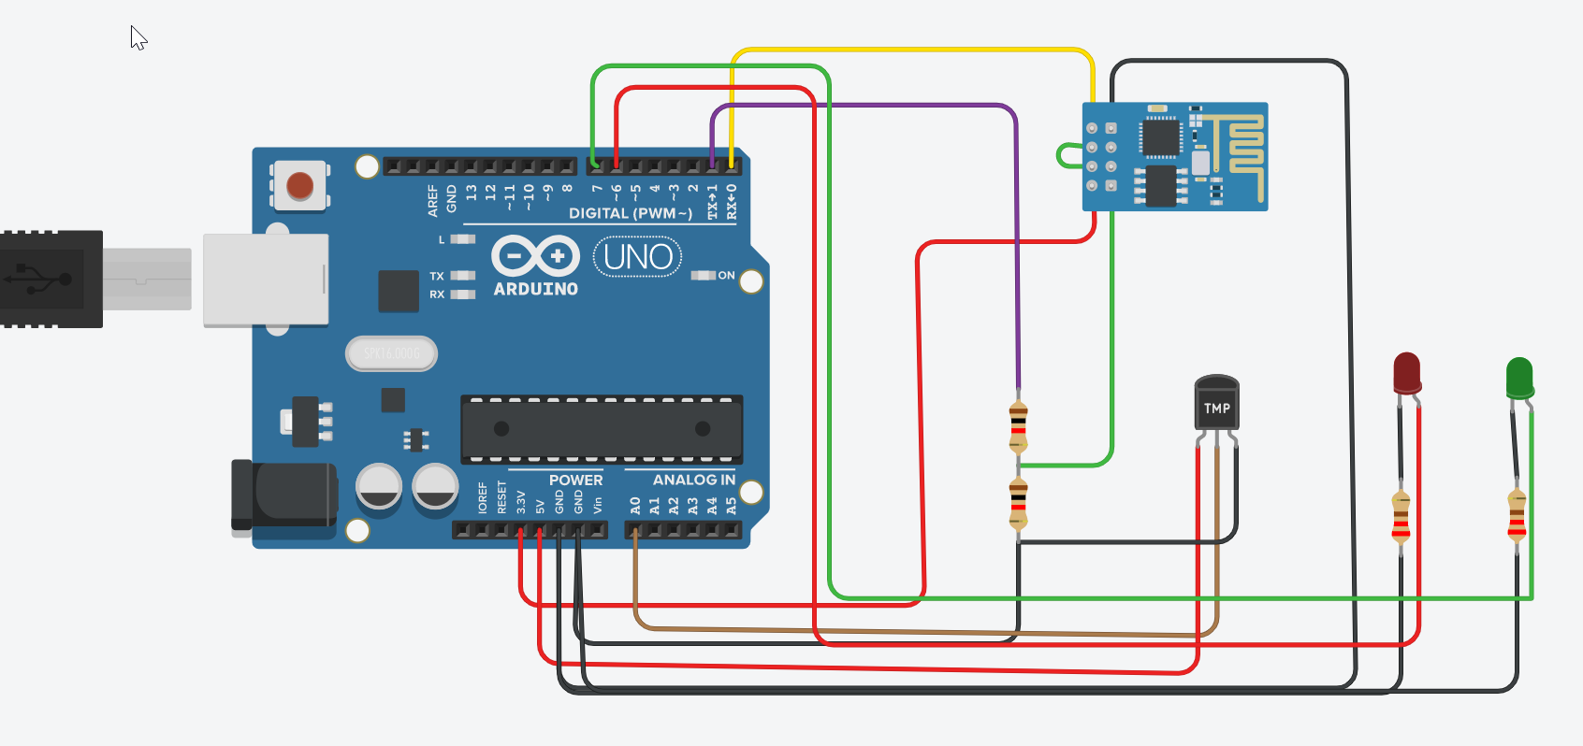

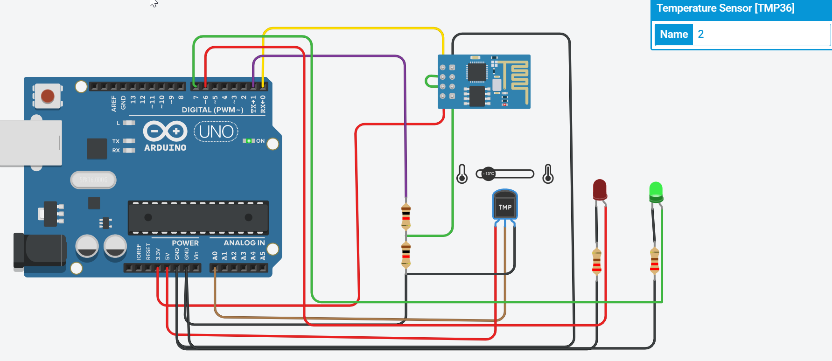

If the temperature of the package is -6C or below the green LED will glow and this indicates the product is compliant.

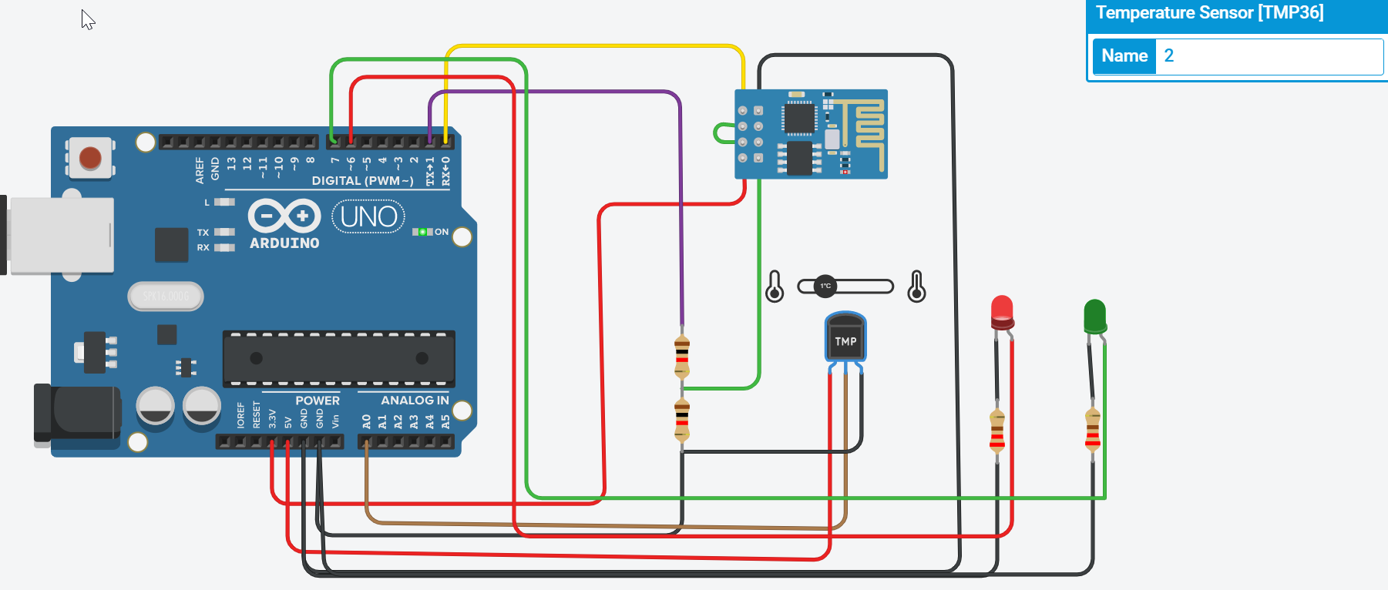

If the temperature exceeds -6C the package will be discarded and the Red LED will glow and also the party at that time will be responsible for it.

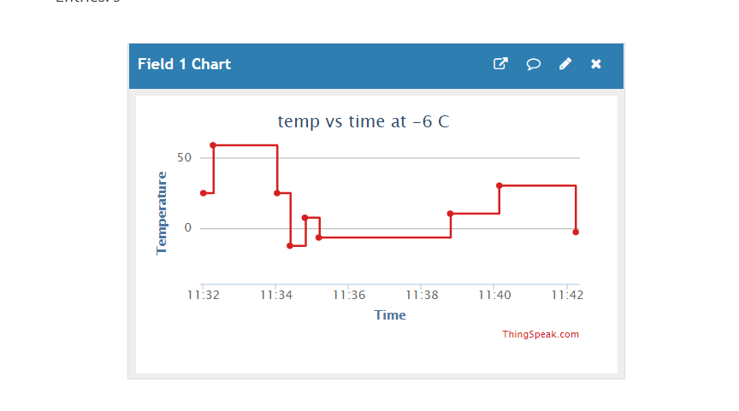

We also made some mockups of the proposed system. We made this dashboard mockup with a retailer’s perspective.

**Features:**

* Package Tracking
* Live Temperature monitoring
* Transport History
* Digital Paperwork
* Proposing Contracts

2.1 Retailer Dashboard view

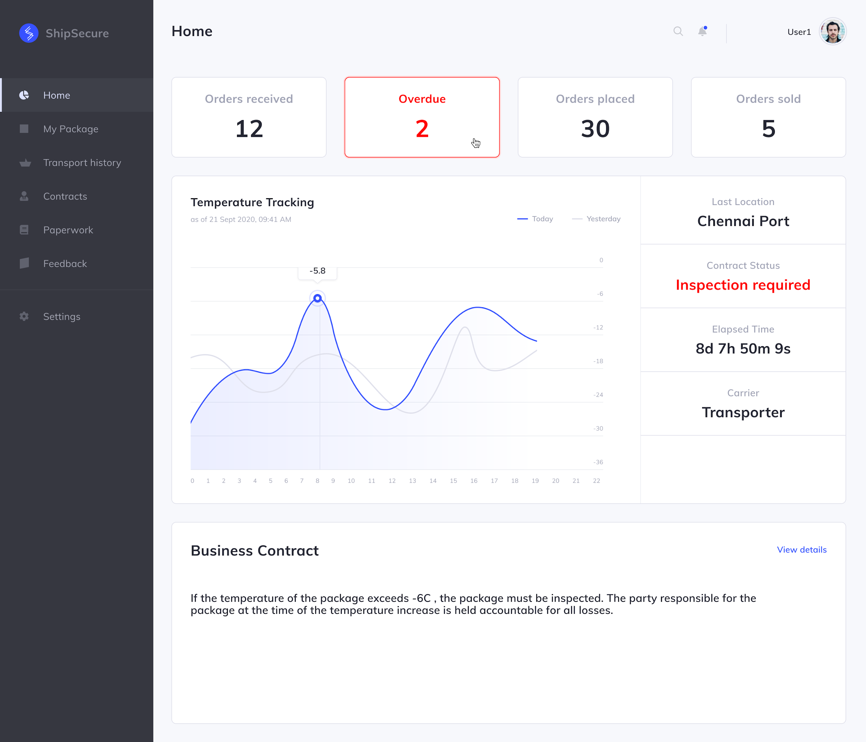

2.2 My package view

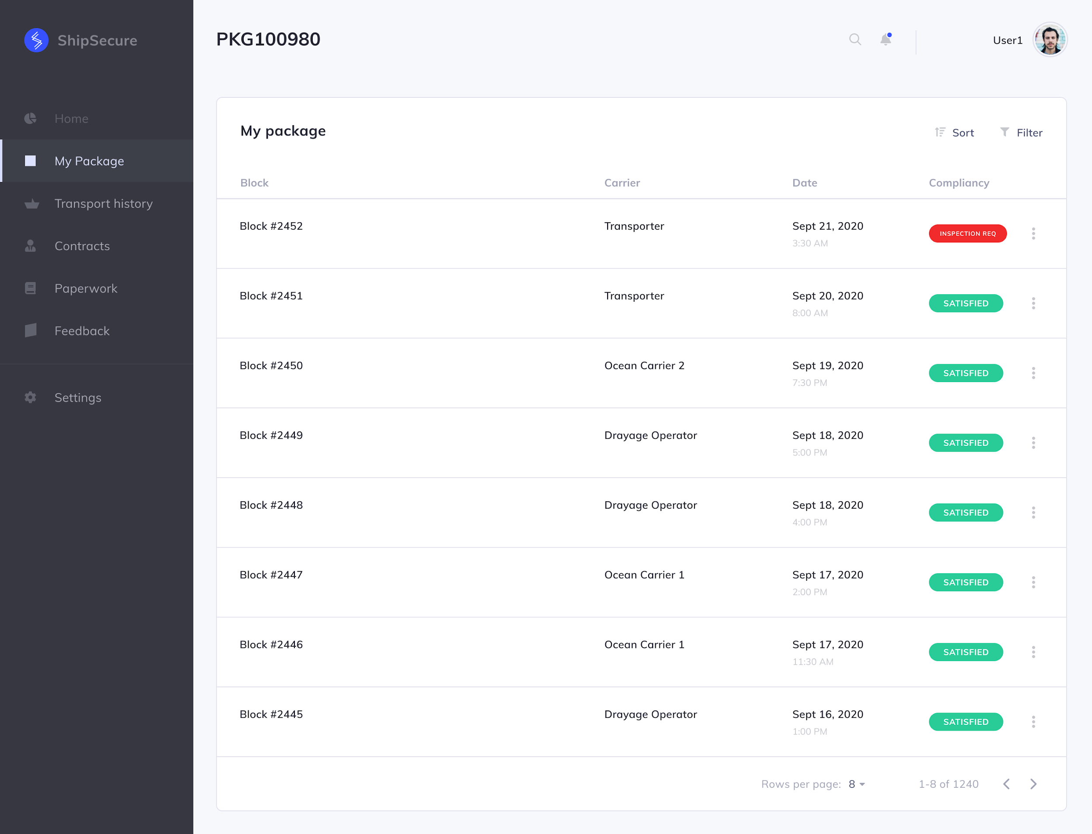

**Iot Significance in the proposed work :**

IoT (Internet of things) is an interconnected collection of sensors, medical devices, QR (quick response) codes, RFID (radio-frequency identification) tags, barcode systems, and applications through cloud-based online networks. IoT architecture includes the objects that capture data, interacts with the real world; the Internet global platform including a cloud that expedites transmission; hosting and processing of data as well as its information integration and processing capability.

In the traditional pharmaceutical supply chain, the movement of the product from the manufacturers to the end-users is a long chain, and the system is not transparent. Thus, the tracking of the occurrence of drug counterfeit and the quality of drugs is challenging. But by using an IoT integrated blockchain system and visualizing the supply chain information, the product movement data can be shared and accessed to improve the responsiveness, planning, decision making; and quality of products.

The remote monitoring, control, and management of the healthcare products are enabled by IoT. An IoT computer hardware board with the processing and networking abilities is interfaced with the sensors on the product or device for reading and control. It also can communicate with the cloud and blockchain. The data captured from the sensors and products can be stored and analyzed, providing real-time intelligent decision support to relevant stakeholders across the healthcare Supply Chain. The proposed system automates the identification process of products, trace and track products globally, achieves transparency, reduces time and cost, and then will achieve customer satisfaction.

The RFID technology is used to track the products at each stage of the supply chain management. The RFID tag is attached to each product and at each stage, the RFID scanner is used to scan the tags. This is used to improve the data collection process. Using a low-cost Esp8266 Wi-Fi module, the collected data is easily shared among the suppliers and the managers. Thus, the managers and suppliers are able to access the information from the system database.

The GIS (Geographic Information System), GPS (Global Positioning System) are used along with the sensor technology. These technologies enable tracking the vehicle location and thus the safety of onboard products is ensured.

Wireless Sensor Networks (WSNs) is an IoT technology which principally operates on smart sensors for sensing and monitoring. It is a sensor network for tracking and controlling the status of various devices like their temperature, noise, location, and movement. Temperature, flow level, infrared, air pollution, moisture proximity and displacement, pressure, and speed are being monitored by the use of sensors. WSN can cooperate and interact with RFID tags, and thus improve the transparency and trust level among consumers as well as vendors.

Some pharmaceutical drugs have specific temperature requirements, whether they are in storage or transportation. Thus the various temperature sensors, humidity sensors are used to monitor the conditions during the cold storage or the refrigerated vehicles. This will improve the safety during the supply chain. During the distribution of drugs, the sanitary conditions can be ensured when consolidating and de-consolidating loads (crates, boxes, pallets) for distribution.

Various IoT cloud platforms are available in the market which works similarly to the middleware software. The aim is to link IoT devices and their applications. The application protocols that are specifically designed for IoT devices such as the Constrained Application Protocol (CoAP) and machine to machine IoT connectivity protocol (MQTT) and cloud services can be integrated with the IoT embedded software. It will provide seamless, timely, and efficient access to the cloud. Such integration of IoT blockchain will aggregate, store, process, and perform analytics on IoT data for further presentation to Supply Chain users and administrators, through web-based dashboards and decentralized apps.

Many IoT hardware boards are available with open-source hardware-software. These include the popular Arduino microcomputer boards as well as Raspberry PI (RPI). The embedded software of these boards is modified to support blockchain and cloud functionalities.

**Hardware and Software requirements:**

* Ethereum: Ethereum is a programmatic platform that includes a Turing complete scripting language called Solidity that can be utilized to build, deploy, and implement smart contracts. These contracts have no restrictions in terms of size and are stored in the blockchain.
* The JavaScript interface (i.e. the management hub) is used to connect the IoT devices to the blockchain network. The interface uses the web3 JavaScript API to communicate with the Ethereum nodes through RPC calls and a CoAP JavaScript library called node-coap to connect with the IoT devices.
* The CoAP server is used to listen to CoAP requests and respond to them while the CoAP client creates the CoAP request messages.
* The GIS (Geographic Information System), GPS (Global Positioning System) are required for tracking the locations of the products during shipment.
* The RFID tags are required that are attached to the products. The RFID scanners are also needed to scan these tags.
* Wireless Sensor Networks (WSNs) are needed to track and control the status of various devices like their temperature, noise, location, and movement.
* Temperature, flow level, humidity, infrared, air pollution, moisture proximity, and displacement, pressure sensors are required to record and monitor the status or condition of the product.
* The IoT cloud platform is necessary to store, process, and access the huge amount of information that is generated by the various IoT devices in the Supply chain.

Conclusion

Benefits of the application of Blockchain and Iot in enhancing the pharmaceutical supply chain visibility and security are obvious. In this paper, we discussed that package monitoring and information sharing is a basic condition for a successful supply chain management, especially for drugs counterfeiting. It is possible to observe that the supply chain information can be captured automatically and visualized smoothly. According to the practical problems encountered in conventional pharmaceutical supply chains, this paper has reviewed and discussed the current applications of Blockchain and Iot integration in the supply chain.

However, since the adoption of Blockchain and Iot is still in the early stage, this paper also discusses its development has experienced explosive growth. This provides support and considerations for pharmaceutical companies and other healthcare services providers to further adopt the application in global and standardized fashion, so as to realize its full potential as a better solution.

References

[1]Aich, S., Chakraborty, S., Sain, M., Lee, H., & Kim, H. (2019). A Review on Benefits of IoT Integrated Blockchain based Supply Chain Management Implementations across Different Sectors with Case Study. *2019 21st International Conference on Advanced Communication Technology (ICACT)*. doi:10.23919/icact.2019.8701910

[2]Dasaklis, T. K., Casino, F., & Patsakis, C. (2019). Defining granularity levels for supply chain traceability based on IoT and blockchain. *Proceedings of the International Conference on Omni-Layer Intelligent Systems*. doi:10.1145/3312614.3312652

[3]Rejeb, A., Keogh, J. G., & Treiblmaier, H. (2019). Leveraging the Internet of Things and Blockchain Technology in Supply Chain Management. *Future Internet,* *11*(7), 161. doi:10.3390/fi11070161

[4]Tsang, Y. P., Choy, K. L., Wu, C. H., Ho, G. T., & Lam, H. Y. (2019). Blockchain-Driven IoT for Food Traceability With an Integrated Consensus Mechanism. *IEEE Access,* *7*, 129000-129017. doi:10.1109/access.2019.2940227

[5]Singh, R., Dwivedi, A. D., & Srivastava, G. (2020). Internet of Things Based Blockchain for Temperature Monitoring and Counterfeit Pharmaceutical Prevention. *Sensors,* *20*(14), 3951. doi:10.3390/s20143951

[6]<https://www2.deloitte.com/us/en/insights/topics/emerging-technologies/blockchain-technical-primer.html>

[7]<https://www.ibm.com/blockchain/industries/supply-chain>

[8]<https://www.tradelens.com/platform>