Software Architecture Specification
Revision – 0.2
Last printed

Duel Reality
Josh Kilgore | TeamLead  Game Mechanics & AI
Obi Atuyei | User Interface
Tom Calloway | Open GL
Ye Tian | Database

Table of Contents
1 Introduction 4
1.1 Purpose of this Document 4
1.2 Document Scope (Tom) 4
1.3 Terminology 4
1.4 Acronyms 4
2 Architecture Overview 5
2.1 Goals and Objectives 5
2.2 Software Architectural Overview 5
2.2.1 Architecture Block Diagram (Josh) 5
2.2.2 Architecture Block Diagram Description 5
3 Architectural Specification 7
3.1 System Structure Overview 7
3.1.1 Game mechanics: (Josh) 7
3.1.2 Artificial Intelligence:(Josh) 8
3.1.3 User Interface (Obi) 8
4 References 10
List of Figures
Abstract
A summary of the document

Introduction

Purpose of this Document
The document shall provide an architectural description of the Duel Reality video game …

Document Scope (Tom)
This document establishes the functional architecture specification for the Duel Reality turn based PC game. This document applies to the Duel Reality software package alone, and is intended to influence the functional and design specifications of Duel Reality.

Terminology
Sprite: A two-dimensional pre-rendered figure.
Widget: An interactive feature pertaining to user interface graphics.
Units:

Acronyms
UI: User Interface
AI: Artificial Intelligence

Architecture Overview

Goals and Objectives
The goals and objectives of the overview regarding the behavior of the components

Software Architectural Overview
A detailed description of the overall software architecture and its major components

Architecture Block Diagram (Josh)
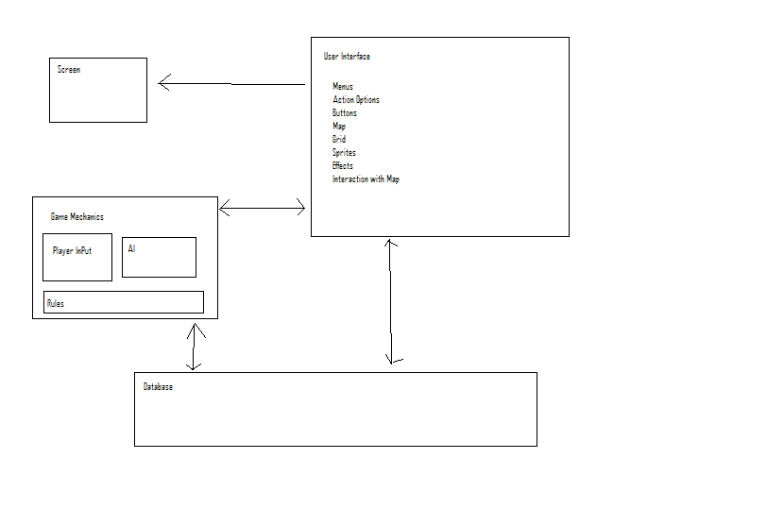
Figure 2-1: Top-level Block Diagram

Architecture Block Diagram Description

2.3 Game Flow Diagram(Josh)

Projected Program Flow
Game Start
Login Screen
Settings
Game Board
Award / Level Up Screen

The Gameflow diagram represents a projected flow of the game in execution. At the start of the game, the player will be presented with the Login Screen which will allow the user to either enter in a new name and create their profile or to login with an already existing profile. The game will then load the Settings screen which will enable the player to set different parameters of the individual game such as which map to play, the number, level and AI type of the opponant.
Once the Settings screen is complete, the Game Board screen will load on which the actual game is played. The game will continue until one side wins, or the player exits. At the end of the game, the Award/ Level Up screen will be loaded which will allow the player to see their advancement in rank, as well as to buy upgrades for their units. The player will then have the option to exit or return to launch another game.

Architectural Specification

System Structure Overview

Game mechanics: (Josh)
The game mechanics will consist of code which will encompass the actions of the game units by means of either input from the User Interface or through the Artificial Intelligence (AI) constructs. The mechanics are broken into 2 divisions: movement, and action.
The movement mechanics will involve changing the horizontal or vertical placement of the unit on the map grid. All units will be able to move forward and backward and side to side, up to the maximum number of spots that unit is able to traverse in a single turn. Two units will not be able to occupy the same space. Movement will in some cases mean maneuvering around obstacles on the map grid. Death of a unit will cause a death animation on screen and not allow that unit to be moved in subsequent rounds.
The action mechanics will involve the different options of units to act upon each other. For instance, an “attack” action of one unit to another will pass certain information including attacker power, and will indicate that the attacked unit how it’s parameter values will change as a result of the attack, such as reduced hit points.
Changes to unit statistics and position caused by actions and movement around the map grid will be updated in the database.

Artificial Intelligence:(Josh)
The artificial intelligence will provide an opponent for the player which will mimic another human player in competition. The AI will have different modes which it can present to the player..
The artificial intelligence will determine the appropriate action as a result of the actions taken by the player and the evolving status of the game board. The AI will update its perception and reactions whenever the board updates.
The different AI types that will be available will consist of aggressive, defensive, and normal modes. The mechanics of the AI will not change, only the threshold levels at which the states change will. For instance an aggressive unit may chose to fight against two units by itself, whereas a defensive unit will run back toward another friendly unit before engaging.

User Interface (Obi)

Player Units
The number of units at the start of the game shall be user-defined. This number may be anywhere between 2 and 20 units. However, each player shall start with the same number of units. The units shall be one of three (3) different sprites, with each sprite being a visual indicator of the unit’s capability. For example, the sprite for a General in an army shall indicate more unit capabilities than the sprite for a Major.

Context Menu
A context menu shall exist for two different objects:
Unit object: Clicking on a unit shall display a pop-up with the unit’s detailed status and any available actions for the player’s turn. Action options are attack, retreat, pursue, support, and defend.
Game object: Clicking on menu buttons above the battle field shall display a pop-up with detailed game status and available options for the game. Game options are “save game”, “end game”, and “restart game”.
The context menu shall be associated with audible sounds that are unique to each player action (for example, moving across cells, switching between menu options).

Layout
The game layout shall be a 2-dimensional overhead map overlaid on a grid. Each cell in the grid shall represent the relative position of a unit. The map shall be user-selectable from a pre-defined image database.
Theory of Operation

Interfaces

OpenGL Battle Window (Tom)
The OpenGL battle window is comprised of a single widget embedded within the layout of the main user interface. This widget is the main gaming window that acts as the graphical representation of the game battle currently taking place.

Battle Window Module Interface (Tom)
The OpenGL battle window reflects data passed to it from the other modules as well as input obtained from the user. The general interaction of the battle window with other modules is outlined in Figure 3-2 below. By design, the OpenGL module does not affect the other modules except in cases where the user performs tasks which change the current state of the game.

OpenGL Battle Window
User Input

Current Game State
Game Mechanics & AI
Database
General Window and UI State

Figure 3-2: Battle Window Connectivity Diagram (Tom)

Battle Window Content Retrieval (Tom)
The content of the battle window consists of a series of 2D images representing the battle background, friendly units, enemy units, special effects, and other objects. These files are dynamically loaded from disk and the filenames and locations of these images are passed from the modules which manage the state of the game.

OpenGL Battle Window
Game Content (file names passed from game state management modules)
Background Images
Unit Sprites & Effects
Miscellaneous

Figure 3-2: Game Content Loading (Tom)

References

