Software Architecture Specification
Revision – 0.1
Last printed 3/20/2010 09:41:00 PM

Duel Reality

Approval Block
Name | Responsibility | Initials
Josh Kilgore (Team Lead) | Game Mechanics & AI
Obi Atuyei | User Interface
Tom Calloway | Graphics Window
Ye Tian | Database
Abstract (Tom)

The following is a software architectural document for the Duel Reality personal computer game. The document identifies and explains important architectural design elements and serves the needs of those looking to understand the high-level architecture of the game itself.

Revision History (Tom)
Revision | Date | Revised By | Comments
1.0 | 3/19/2010 | Team | Initial release.
Table of Contents
1 Introduction (Obi) 1
1.1 Document Scope (Tom) 1
1.2 Terminology (Obi) 1
1.3 Acronyms (Obi) 1
2 Architecture Overview 3
2.1 Goals and Objectives 3
2.2 Software Architectural Overview 3
2.2.1 Architecture Block Diagram 3
2.2.2 Architecture Block Diagram Description 3
3 Architectural Specification 4
3.1 System Structure Overview 4
3.1.1 Game mechanics: 4
3.1.2 Artificial Intelligence: 4
3.1.3 User Interface (Obi) 5
3.1.4 OpenGL Battle Window (Tom) 8
3.1.5 Database (Ye Tian) 9
4 References 10

List of Figures (Tom)
Figure 2-1: Top-level Block Diagram 3
Figure 3-1: Start of Game Dialog 5
Figure 3-2: New Game Dialog 6
Figure 3-3: Active Game Session Menu 7
Figure 3-4: Chess Layout Showing Highlighted Knight Movement Options 7
Figure 3-5: Battle Window Connectivity Diagram (Tom) 8
Figure 3-6: Game Content Loading (Tom) 9
Figure 3-7: Database Interaction with Other Modules (Ye Tian) 10

Introduction (Obi)
This document describes Duel Reality and provides a system overview of the game.
Duel Reality is a turn-based strategy (TBS) game that is played offline on a PC. The game is played on a 2-dimensional (2D) map, with single-player as well as 2-player campaigns. In a single-player campaign, the opponent is an artificial intelligence (AI) model. The 2D maps are pre-defined with different terrain types that affect unit movement.
Each player is assigned a number of units from a pre-defined set of unit types. Each unit has its strengths and weaknesses and different types of attacks and map terrain add to its ability to attack or defend, thereby adding to the game strategy. Units can advance their levels to become more powerful, or less vulnerable to attacks. A unit’s Experience Points (XP) indicates this level.
The player has the ability to save a game session, including the state of the maps. This is to enable a player resume the same game at a different time. All saved game session data is local to the machine.
Each unit is assigned XP, Action Points (AP) and Health Points (HP). The unit’s movement and actions on each turn is dependent on its AP. The player can choose to end a turn or a turn automatically ends once the AP of all the units are depleted. Each unit’s HP determines its unit’s vulnerability to attacks. The unit is killed once its HP is depleted. Although a player loses a game if all its units are killed, the overall game campaign is user-selectable. The ultimate strategy of the game is to accomplish a campaign, using available actions per turn, while protecting the health of the units.

Document Scope (Tom)
This document establishes the functional architecture specification for the Duel Reality turn based PC game. This document applies to the Duel Reality software package alone, and is intended to influence the functional and design specifications of Duel Reality.

Terminology (Obi)
Sprite A two-dimensional pre-rendered figure.
Unit An individual infantry
Widget An interactive feature pertaining to user interface graphics.

Acronyms (Obi)
AI Artificial Intelligence
AP Action Point
XP Experience Point
GUI Graphical User Interface
UI User Interface

Architecture Overview

Goals and Objectives
The goals and objectives of the overview regarding the behavior of the components

Software Architectural Overview
A detailed description of the overall software architecture and its major components

Architecture Block Diagram
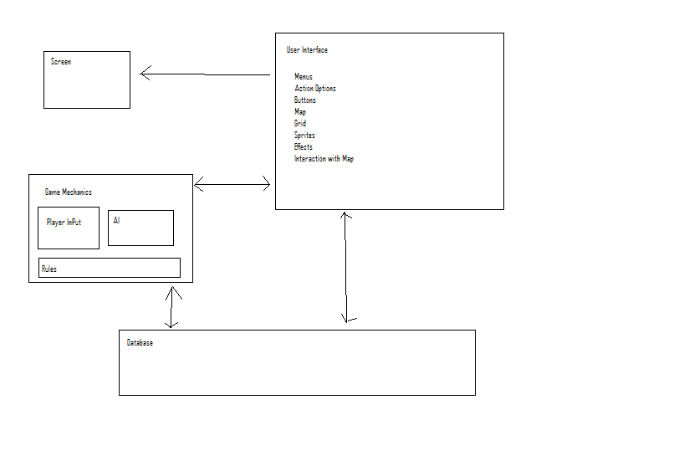
Figure 2-1: Top-level Block Diagram

Architecture Block Diagram Description

Architectural Specification

System Structure Overview

Game mechanics:
The game mechanics will consist of code which will encompass the actions of the game via either input from the User Interface or through the Artificial Intelligence (AI) constructs. The mechanics are broken into 3 divisions: movement, action, and miscellanious.
The movement mechanics will involve changing the horizontal or verticle placement of the unit on the map grid. All units will be able to move forward and backward, up to the maximum number of spots that unit is able to travers in a single turn. Possibly, this will initiate a sliding or movement animation for the unit. Two units will not be able to occupy the same space. Movement will in some cases mean manuevering around obsticles on the map grid. Death of a unit will cause a death animation on screen and not allow that unit to be moved in subsequent rounds.
The action mechanics will involve the different options of units to act upon eachother. The action mechanics will be passed as messages between the agents. For instance, an “attack” message from one unit to another will pass certain information including attacker power, and will indicate that the attacked unit how it’s parameter values will change as a result of the attack: reduced hit points, reduced movement, etc. Other possible actions include: Heal, sprint, defend, and so on.
Changes to unit statistics caused by actions and movement around the map grid will be updated in the database.

Artificial Intelligence:
The artificial intelligence will provide an opponent for the player which will mimic another human player in competition. The AI will have different modes which it can present to the player wither at radom or by players choice.
The artificial intelligence will consist of a finite state machine(FSM) that will determine the appropriate action as a result of the actions taken by the player and the evolving status of the game board. The AI will update it’s options whenever the board updates. The FSM will handle all Event Message Handling which is the means of processing actions between units, and the switching between unit states.
States that will be a part of the AI include:
advance – unit moves toward enemy
retreat – unit moves away from enemy
pursue – unit moves toward retreating enemy
support – unit moves toward enemy attacking friendly unit
attack – unit attacks enemy unit
defend – unit defents against attacking unit
callForHelp-unit being attack requests assistance
The different AI types that will be available will consist of aggressive, defensive, and normal modes. The mechanics of the AI will not change, only the threshold levels at which the states change will. For instance an aggressive unit may chose to fight against two units by itself, whereas a defensive unit will run back toward another friendly unit before engaging.
Miscellaneous game mechanics is the term used for such actions as leveling up of the player and individual unit parameters as a result of successful fights, once the individual map is concluded.

User Interface (Obi)
The purpose of the UI is to provide a user-friendly environment for retrieving and displaying game information to the user. In the background, the UI will transfer user or game information in a predefined format to the other modules. Ultimately, the UI will emphasize on attractiveness of the display and user friendliness.

Menus and Dialog Boxes (Obi)
To create the look of a conventional PC video game, Duel Reality will implement dialog boxes and pull-down menus for user-selectable game options.
Figure 3-2 is a hierarchical representation of dialog boxes that are displayed when the game is first run. The tutorial is an optional step in the dialog that may be selected depending on the player’s experience.

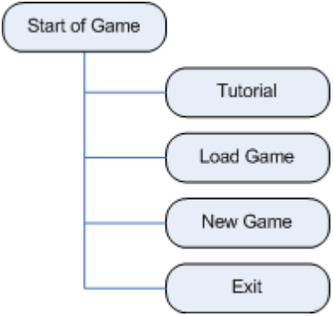
Figure 3-2: Start of Game Dialog

To the user, the UI will serve as a visual encapsulation of all the data processing required of the other modules to operate the game. This is demonstrated in Figure 3-4 where data to or from different modules are represented in the “New Game” dialog: the “Difficulty Level” option accesses the Game Mechanics module; the “Map” option accesses the OpenGL Battle Window module; and the “Players” option accesses the Database module.

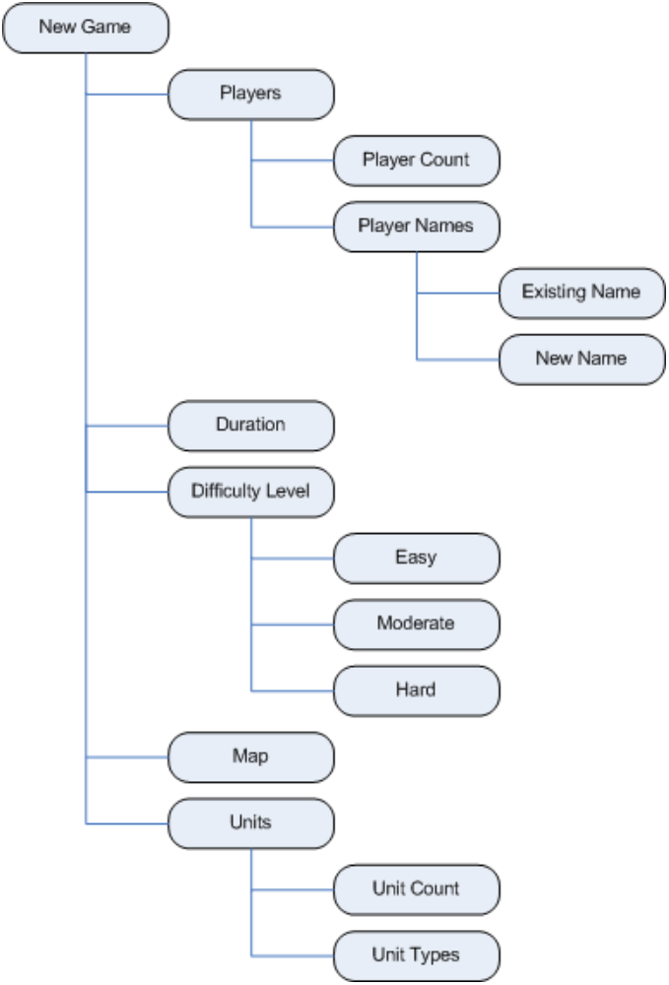
Figure 3-3: New Game Dialog

The menu options for an active game session will be implemented in a pull-down menu. Figure 3-4 illustrates the options available to an active game session.
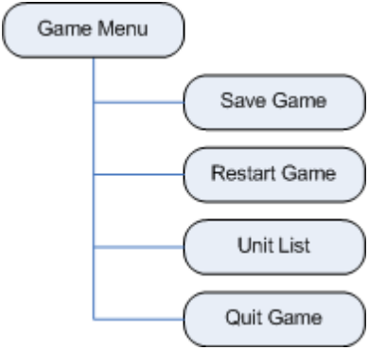
Figure 3-4: Active Game Session Menu

Unit Statistics (Obi)
Each unit will have its HP and AP displayed at all times. There will also be an option to show more detailed unit statistics whenever a unit is selected. The extra details will be the unit’s name and any attributes specific to the unit type. This will involve retrieving unit data from the Game Mechanics and the Database modules.

Unit Actions (Obi)
An attack menu will be displayed whenever a player attempts to attack an enemy unit. The context menu will provide attack and weapons options information. This will involve retrieving action options from the Game Mechanics module, which factors in the unit’s AP. The cells that a unit can move to will be highlighted whenever the unit is selected. This will involve retrieving movement data from the Game Mechanics module, which factors in unit’s AP and terrain. Figure 3-5 uses a chess layout to demonstrate the highlighted cells. The knight can move 2 cells horizontally and 1 square vertically, or 1 square horizontally and 2 squares vertically.

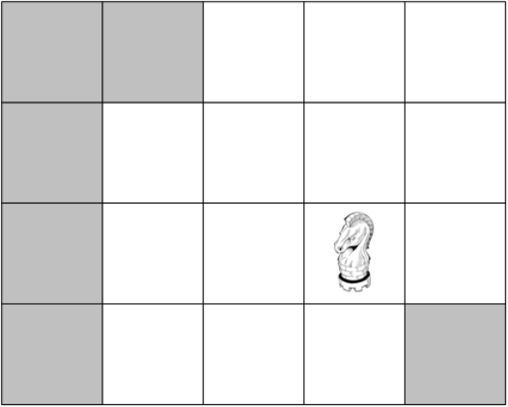
Figure 3-5: Chess Layout Showing Highlighted Knight Movement Options

Event Sounds (Obi)
The game session will have background music. However, actions such as moves, attacks, menu selections, game start, game end, etc, will also have special effects sounds. Each sound will be unique to its event.

Interfaces

OpenGL Battle Window (Tom)
The OpenGL battle window is comprised of a single widget embedded within the layout of the main user interface. This widget is the main gaming window that acts as the graphical representation of the game battle currently taking place.

Battle Window Module Interface (Tom)
The OpenGL battle window reflects data passed to it from the other modules as well as input obtained from the user. The general interaction of the battle window with other modules is outlined in Figure 3-6 below. By design, the OpenGL module does not affect the other modules except in cases where the user performs tasks which change the current state of the game.

OpenGL Battle Window
User Input

Current Game State
Game Mechanics & AI
Database
General Window and UI State

Figure 3-6: Battle Window Connectivity Diagram (Tom)

Battle Window Content Retrieval (Tom)
The content of the battle window consists of a series of 2D images representing the battle background, friendly units, enemy units, special effects, and other objects. These files are dynamically loaded from disk and the filenames and locations of these images are passed from the modules which manage the state of the game.
OpenGL Battle Window
Game Content (file names passed from game state management modules)
Background Images
Unit Sprites & Effects
Miscellaneous

Figure 3-7: Game Content Loading (Tom)

Database (Ye Tian)
The game database is a collection of tables and data records containing the names and status of all registered players and their units. The database will also contain links to the game content (maps and sprites) such that a player may manually or automatically load content for play.

Basic Description (Ye Tian)
Typical Units Parameters: The database provides a set of characters (units) that consists of 2D sprites with corresponding statistics such as health, attack power, attack range, and movement type. Every character has different style and highlight to enhance the variety and interest of the game. A minimum of three different unit types will be supported.
Start/Restart Game: New game shall be initialed with a map background and a set of opponents and player units randomly selected from the database table. The grids of map and the number of units are decided by choosing difficulty level. “Easy” corresponds to a small map and a few opponents, while “Hard” to a bigger map and more opponents. The relationship between these setting and the game complexity need future test and adjustment.
Storage/Retrieval of Map and Unit Data: The game content such as map and sprite data as well as player unit statistics that synchronized with the database shall be saved when the game is running. In the other way round, all the saved information including the map, sprite data and statistics are able to be reloaded for continuing the game.

Units Status Updating: Running behind the game appearance, database not only provides current status, but also records the results after any action or level up. During the game running, changes to unit status parameters caused by actions and movement around the map grid will be updated in the database. Database shall be synchronized with the real-time game evolving.

Interaction with Other Modules (Ye Tian)
User interface: Basic user interface menu such as “save game”, “load game”, and “restart game” will read or write the database information. In addition, along with success in battles, some pop-up menus like “level up” dialog will also update player units’ status in database, and high level parameters of enemy units may be allowed to use.
Game Mechanics: The units’ mechanic ability is based on reading the related parameters in database. Also, any mechanic action corresponds to an updated database including player units and enemy units.
OpenGL: units’ type and detailed status as well as any available actions for that turn will be displayed under OpenGL effects like clicking on a visible unit.
As shown in Figure, the database module interacts with all the three other modules, but does not affect them. It will provide interface for operation by other modules.

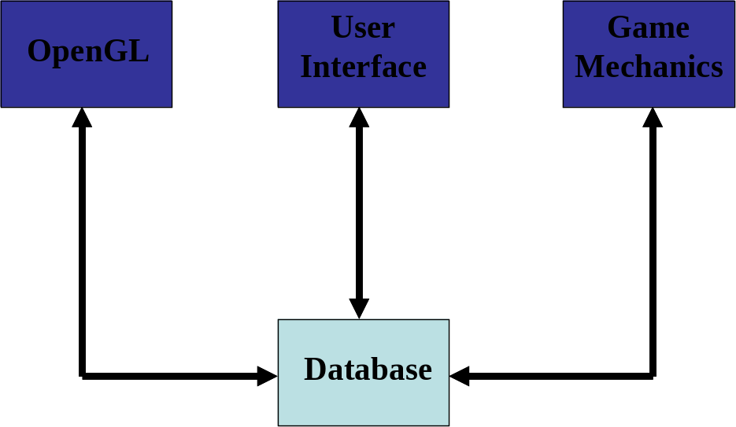
Figure 3-8: Database Interaction with Other Modules (Ye Tian)

References

