Software Architecture Specification
Revision – 0.1
Last printed 3/20/2010 21:41:00 A3/P3

Duel Reality

Approval Block
Name | Responsibility | Initials
Josh Kilgore (Team Lead) | Game Mechanics & AI
Obi Atuyei | User Interface
Tom Calloway | Graphics Window
Ye Tian | Database

Abstract (Tom)

The following is a software architectural document for the Duel Reality personal computer game. The document identifies and explains important architectural design elements and serves the needs of those looking to understand the high-level architectural design of the game itself.

Revision History (Tom)
Revision | Date | Revised By | Comments
1.0 | 3/19/2010 | Team | Initial release.

Table of Contents
1 Introduction (Obi) 4
1.1 Document Scope (Tom) 4
1.2 Terminology (Obi) 4
1.3 Acronyms (Obi) 4
2 Architecture Overview 6
2.1 Goals and Objectives(Josh) 6
2.2 Software Architectural Overview (Ye Tian) 6
2.2.1 Architecture Block Diagram(Josh) 6
2.2.2 Architecture Block Diagram Description (Josh) 7
3 Architectural Specification 9
3.1 System Structure Overview 9
3.1.1 Game mechanics(Josh) 9
3.1.2 Artificial Intelligence(Josh) 9
3.1.3 User Interface (Obi) 9
3.1.4 Graphics Window (Tom) 12
3.1.5 Database (Ye Tian) 14
4 References (Ye Tian) 17

List of Figures (Tom)
Figure 2-1: Top-level Block Diagram 6
Figure 2-2 Projected Program Flow 7
Figure 3-3: Start of Game Dialog 10
Figure 3-4: New Game Dialog 11
Figure 3-5: Active Game Session Menu 12
Figure 3-6: Chess Layout Showing Highlighted Knight Movement Options 12
Figure 3-7: Battle Window Connectivity Diagram (Tom) 13
Figure 3-8: Game Content Loading (Tom) 14
Figure 3-9: Data Representation (Tom) 14
Figure 3-9: Database Interaction with Other Modules (Ye Tian) 16

Introduction (Obi)
This document describes the Duel Reality game, in accordance with its Project Proposal [1]. The document also provides a system overview of the game.
Duel Reality is a turn-based strategy (TBS) game that is played offline on a PC. The game is played on a 2-dimensional (2D) map, with single-player as well as 2-player campaigns. In a single-player campaign, the opponent is an artificial intelligence (AI) model. The 2D maps are pre-defined with different terrain types that affect unit movement.
Each player is assigned a number of units from a pre-defined set of unit types. Each unit has its strengths and weaknesses and different types of attacks and map terrain add to its ability to attack or defend, thereby adding to the game strategy. Units can advance their levels to become more powerful, or less vulnerable to attacks. A unit’s Experience Points (XP) indicates this level.
The player has the ability to save a game session, including the state of the maps. This is to enable a player resume the same game at a different time. All saved game session data is local to the machine.
Each unit is assigned XP, Action Points (AP) and Health Points (HP). The unit’s movement and actions on each turn is dependent on its AP. The player can choose to end a turn or a turn automatically ends once the AP of all the units are depleted. Each unit’s HP determines its unit’s vulnerability to attacks. The unit is killed once its HP is depleted. Although a player loses a game if all its units are killed, the overall game campaign is user-selectable. The ultimate strategy of the game is to accomplish a campaign, using available actions per turn, while protecting the health of the units.

Document Scope (Tom)
This document establishes the functional architecture specification for the Duel Reality turn based PC game. This document applies to the Duel Reality software package alone, and is intended to influence the functional and design specifications of Duel Reality.

Terminology (Obi)
Sprite A two-dimensional pre-rendered figure.
Unit An individual infantry
Widget An interactive feature pertaining to user interface graphics.

Acronyms (Obi)
AI Artificial Intelligence
AP Action Point
XP Experience Point
GUI Graphical User Interface
UI User Interface

Architecture Overview

Goals and Objectives(Josh)
The goal of this project is to have all the pieces work together to offer the user a fully playable gaming experience.

Software Architectural Overview (Ye Tian)
The software architecture technically includes five major components: Game Mechanics, Artificial Intelligence, User Interface, OpenGL Graphics Window, Database.

Architecture Block Diagram(Josh)
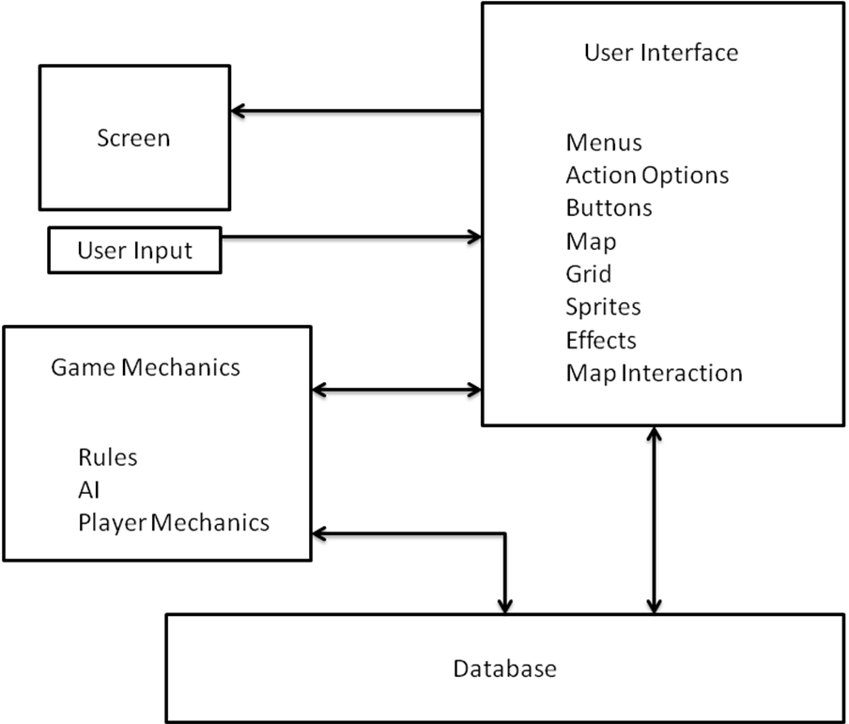
Figure 2-1: Top-level Block Diagram

Architecture Block Diagram Description (Josh)
The program displays graphics and text on the screen and interacts with the user by use of the mouse and keyboard. The User Interface takes input from the user and uses that to update the game. The User Interface covers the interaction with the user on the game board. The User Interface is responsible for handling player commands like “move here” and “attack this target.” This section is also responsible for such things as the login of players, game settings, and menu commands like “NewGame” and “Save Game.” The User Interface also outputs its data by drawing all of the objects which appear on the screen and the visual interactions between themselves and the gameboard.
The Game Mechanics section handles the inputs from the User Interface and applies the game rules and does the internal math between objects, and returning the results to the User Interface to be displayed on the gameboard. The game mechanics section also handles the Artificial Intelligence which is responsible for giving the player a playable opponent.
The Database section is responsible for retaining the data associated with the game and the units and passing that data back to the Game Mechanics and User Interface sections when needed.

2.3 Game Flow Diagram (Josh)
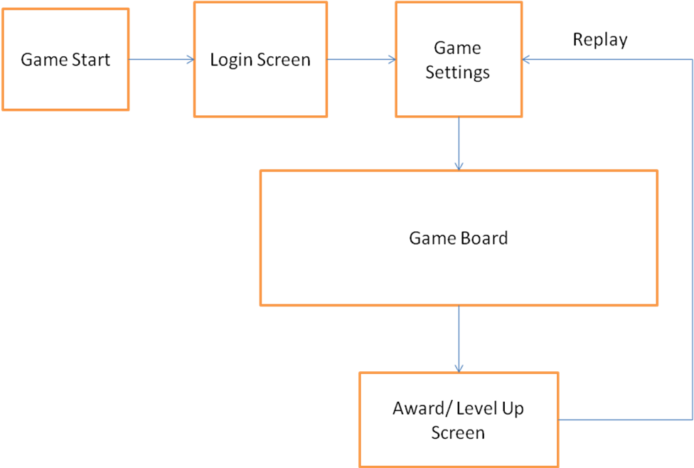
Figure 2-2 Projected Program Flow
The Game flow diagram represents a projected flow of the game in execution. At the start of the game, the player will be presented with the Log in Screen which will allow the user to either enter in a new name and create their profile or to log in with an already existing profile. The game program will then load the Settings screen which will enable the player to set different parameters of the individual game such as which map to play, the number, level, and AI type of the opponent.
Once the Settings screen is complete, the Game Board screen will load on which the actual game is played. The game will continue until one side wins, or the player exits. At the end of the game, the Award/ Level Up screen will be loaded which will allow the player to see their advancement in rank, as well as to buy upgrades for their units. The player will then have the option to exit or return to launch another game.

Architectural Specification

System Structure Overview

Game mechanics(Josh)
The game mechanics will consist of code which will encompass the actions of the game units by means of either input from the User Interface or through the Artificial Intelligence (AI) constructs. The mechanics are broken into 2 divisions: movement, and action.
The movement mechanics will involve changing the horizontal or vertical placement of the unit on the map grid. All units will be able to move forward and backward and side to side, up to the maximum number of spots that unit is able to traverse in a single turn. Two units will not be able to occupy the same space. Movement will in some cases mean maneuvering around obstacles on the map grid. Death of a unit will cause a death animation on screen and not allow that unit to be moved in subsequent rounds.
The action mechanics will involve the different options of units to act upon each other. For instance, an “attack” action of one unit to another will indicate to the attacked unit how it’s parameter values will change as a result of the attack, such as reduced hit points.
Changes to unit statistics and position caused by actions and movement around the map grid will be updated in the database.

Artificial Intelligence(Josh)
The artificial intelligence will provide an opponent for the player which will mimic another human player in competition. The AI will have different modes which it can present to the player..
The artificial intelligence will determine the appropriate action as a result of the actions taken by the player and the evolving status of the game board. The AI will update its perception and reactions whenever the board updates.
The different AI types that will be available will consist of aggressive, defensive, and normal modes. The mechanics of the AI will not change, only the threshold levels at which the states change will. For instance an aggressive unit may chose to fight against two units by itself, whereas a defensive unit will run back toward another friendly unit before engaging.

User Interface (Obi)
The purpose of the UI is to provide a user-friendly environment for retrieving and displaying game information to the user. In the background, the UI will transfer user or game information in a predefined format to the other modules. Ultimately, the UI will emphasize on attractiveness of the display and user friendliness.

Menus and Dialog Boxes (Obi)
To create the look of a conventional PC video game, Duel Reality will implement dialog boxes and pull-down menus for user-selectable game options.
Figure 3-3 is a hierarchical representation of dialog boxes that are displayed when the game is first run. The tutorial is an optional step in the dialog that may be selected depending on the player’s experience.

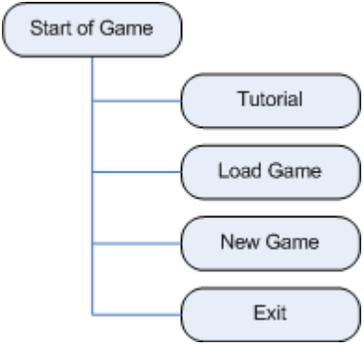
Figure 3-3: Start of Game Dialog

To the user, the UI will serve as a visual encapsulation of all the data processing required of the other modules to operate the game. This is demonstrated in Figure 3-5 where data to or from different modules are represented in the “New Game” dialog: the “Difficulty Level” option accesses the Game Mechanics module; the “Map” option accesses the OpenGL Battle Window module; and the “Players” option accesses the Database module.

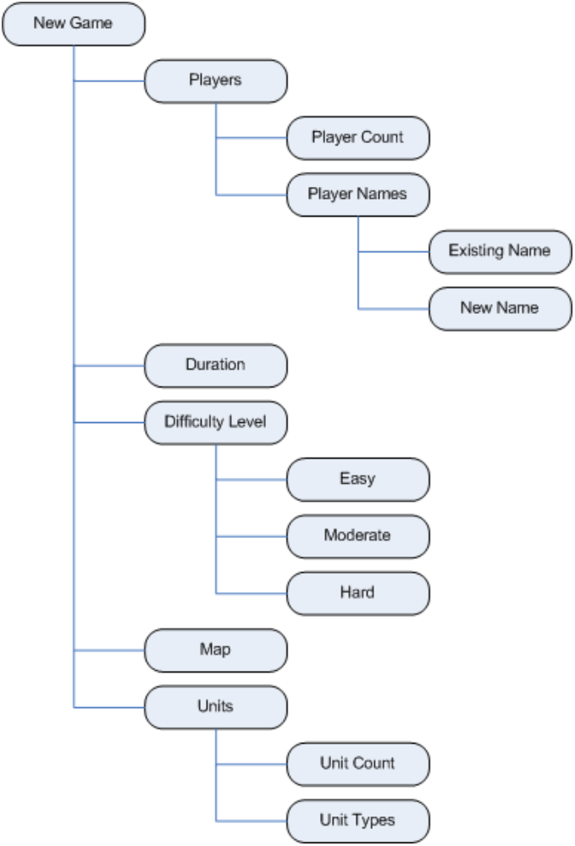
Figure 3-4: New Game Dialog

The menu options for an active game session will be implemented in a pull-down menu. Figure 3-5 illustrates the options available to an active game session.
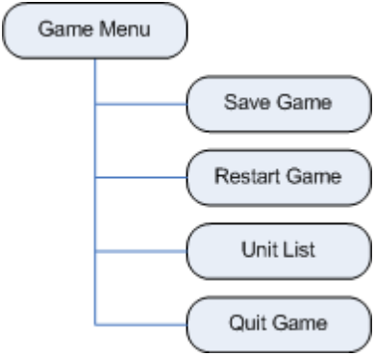
Figure 3-5: Active Game Session Menu

Unit Statistics (Obi)
Each unit will have its HP and AP displayed at all times. There will also be an option to show more detailed unit statistics whenever a unit is selected. The extra details will be the unit’s name and any attributes specific to the unit type. This will involve retrieving unit data from the Game Mechanics and the Database modules.

Unit Actions (Obi)
An attack menu will be displayed whenever a player attempts to attack an enemy unit. The context menu will provide attack and weapons options information. This will involve retrieving action options from the Game Mechanics module, which factors in the unit’s AP. The cells that a unit can move to will be highlighted whenever the unit is selected. This will involve retrieving movement data from the Game Mechanics module, which factors in unit’s AP and terrain. Figure 3-6 uses a chess layout to demonstrate the highlighted cells. The knight can move 2 cells horizontally and 1 square vertically, or 1 square horizontally and 2 squares vertically.

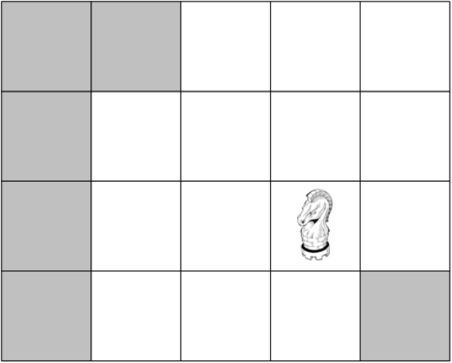
Figure 3-6: Chess Layout Showing Highlighted Knight Movement Options

Event Sounds (Obi)
The game session will have background music. However, actions such as moves, attacks, menu selections, game start, game end, etc, will also have special effects sounds. Each sound will be unique to its event.

Graphics Window (Tom)
The graphics window is comprised of a single widget embedded within the layout of the main user interface. This widget is the main gaming window that acts as the graphical and auditory representation of the game battle currently taking place. It consists of an OpenGL frame which will represent scenery, game units, world objects, and a gaming grid in two dimensions. Generally speaking, the graphics window takes input from both the other modules and the users themselves, and represents that information on the screen. The only non graphical or auditory output of the graphics window exists when user input is passed down through the OpenGL widget into the core game mechanics and user interface modules.

Graphics Window Module Interface (Tom)
The OpenGL graphics window reflects data passed to it from the other modules as well as input obtained from the user. The general interaction of the battle window with other modules is outlined in Error: Reference source not found below. By design, the OpenGL module does not affect the other modules except in cases where the user performs tasks which change the current state of the game.

OpenGL Graphics Window
User Input

Current Game State
Game Mechanics & AI
Database
General Window and UI State

Figure 3-7: Battle Window Connectivity Diagram (Tom)

Graphics Window Content Retrieval (Tom)
The content of the battle window consists of a series of 2D images representing the battle background, friendly units, enemy units, special effects, and other objects. These files are dynamically loaded from disk and the filenames and locations of these images are passed from the modules which manage the state of the game. This flow of information is illustrated in Figure 3-8 below.
Figure 3-8: Game Content Loading (Tom)
OpenGL Graphics Window
Game Content (file names passed from game state management modules)
Background and Object Images
Unit Sprites & Effect Images
Miscellaneous Sound Files

Graphics Window Output (Tom)
The graphics window fulfills its primary purpose by representing data from the other modules and reacting to user input. This data is presented through the use of both visual graphics and sound effects as shown below in .
OpenGL Graphics Window
PC Monitor

PC Sound System

Figure 3-9: Data Representation (Tom)

Database (Ye Tian)
The game database is a collection of tables and data records containing the names and status of all registered players and their units. The database will also contain links to the game content (maps and sprites) such that a player may manually or automatically load content for play.

Basic Description (Ye Tian)
Typical Units Parameters: The database provides a set of characters (units) that consists of 2D sprites with corresponding statistics such as health, attack power, attack range, and movement type. Every character has different style and highlight to enhance the variety and interest of the game. A minimum of three different unit types will be supported.
Start/Restart Game: New game shall be initialed with a map background and a set of opponents and player units randomly selected from the database table. The grids of map and the number of units are decided by choosing difficulty level. “Easy” corresponds to a small map and a few opponents, while “Hard” to a bigger map and more opponents. The relationship between these setting and the game complexity need future test and adjustment.
Storage/Retrieval of Map and Unit Data: The game content such as map and sprite data as well as player unit statistics that synchronized with the database shall be saved when the game is running. In the other way round, all the saved information including the map, sprite data and statistics are able to be reloaded for continuing the game.

Units Status Updating: Running behind the game appearance, database not only provides current status, but also records the results after any action or level up. During the game running, changes to unit status parameters caused by actions and movement around the map grid will be updated in the database. Database shall be synchronized with the real-time game evolving.

Interaction with Other Modules (Ye Tian)
User interface: Basic user interface menu such as “save game”, “load game”, and “restart game” will read or write the database information. In addition, along with success in battles, some pop-up menus like “level up” dialog will also update player units’ status in database, and high level parameters of enemy units may be allowed to use.
Game Mechanics: The units’ mechanic ability is based on reading the related parameters in database. Also, any mechanic action corresponds to an updated database including player units and enemy units.
OpenGL: units’ type and detailed status as well as any available actions for that turn will be displayed under OpenGL effects like clicking on a visible unit.
As shown in Figure, the database module interacts with all the three other modules, but does not affect them. It will provide interface for operation by other modules.

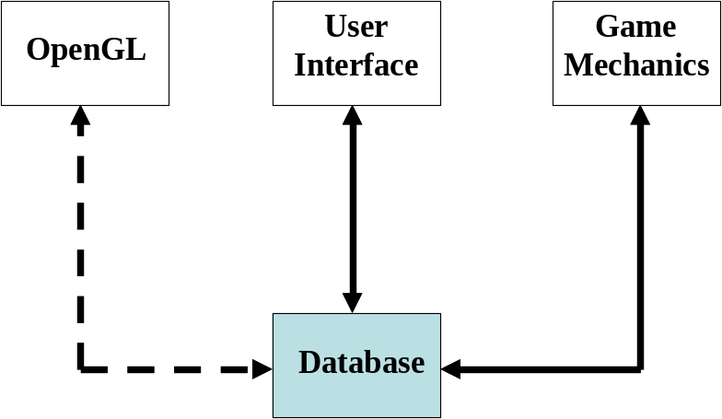
Figure 3-10: Database Interaction with Other Modules (Ye Tian)

References (Ye Tian)
- Team Gold: Josh Kilgore, Obi Atueyi, Thomas Calloway, Ye Tian, "Duel Reality: A Turn-Based Battle Strategy Game", Proposal, 02/19/2010.

