Bradley Eddowes, Isaiah English, Shane Allison

Machine Learning: Group Project

CSC 403

Dr. Mooney

**Group Project Report**

## I. Problem Description

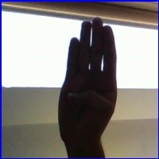Figure 1.1

200x200 pixel original sample image

The American Sign Language (ASL) Alphabet Test dataset was chosen to perform stochastic gradient descent and decision tree classification. This dataset consists of 84000 images, like that displayed in figure 1.1, and 29 classifications for the images: Any letter A through Z, space, delete, and nothing. This data can be used to train the two selected models to classify a given image of a hand as a character. The two models chosen to train the data will be the stochastic gradient descent (SGD) classifier and decision trees.

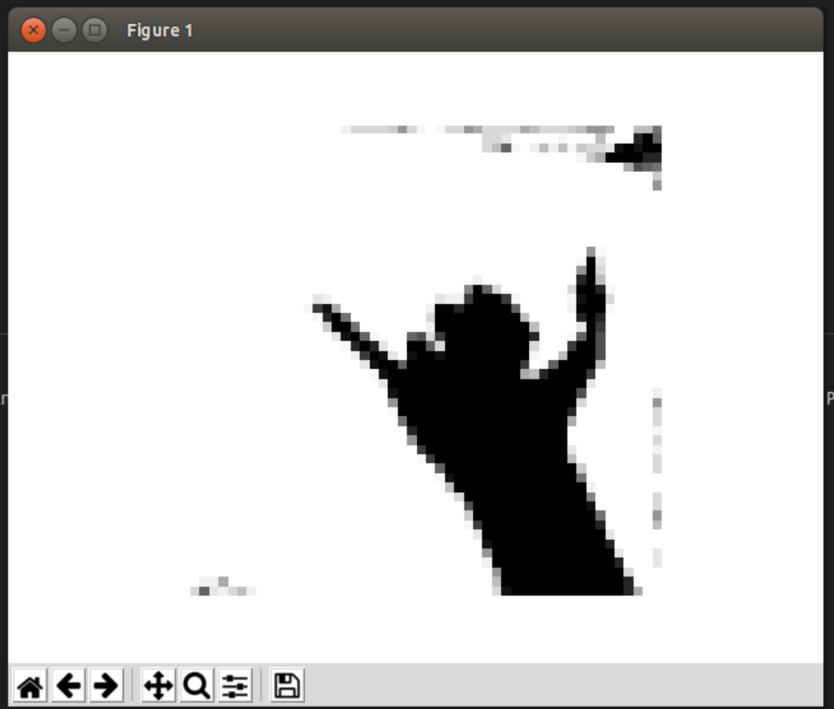Figure 1.2

50x50 pixel HSV determined mask

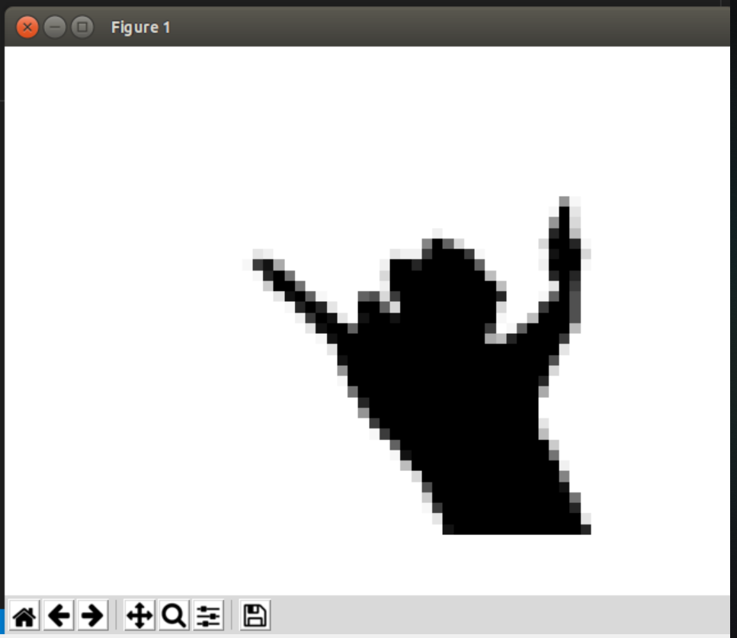Figure 1.3

Cropped (40x40) grey scale image

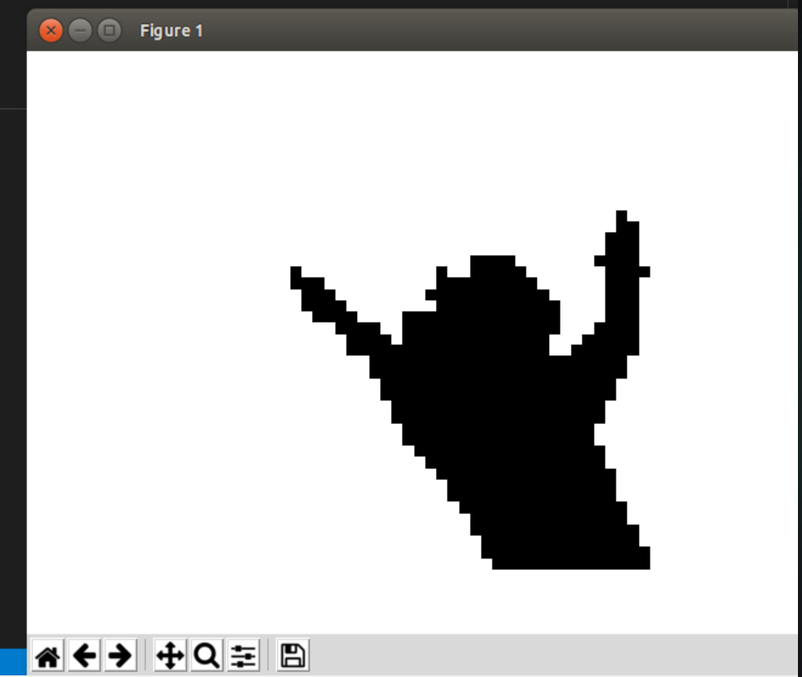Figure 1.4

Cropped 40x40 image with black and white reduction

The HSV mask will be used to detect and highlight the hands within the images provided by the dataset, as displayed in figure 1.2. The images will then be reduced to black and white and later greyscale, uncropped (50x50 pixels) and later cropped to 40x40 pixels to test the models. The cropping will be done to reduce extraneous noise and focus on the hand/subject of the image (notice the lack of background pixel noise between figures 1.2 and 1.3). The black and white reduction also simplifies the data (shown in figure 1.4).

## II. Data Analysis

The only feature to be used from this dataset analysis will be the pixel values; That is, a number between 0 and 1 that represents the color scale, from white to black respectively, of the pixel. These pixels can be seen in figures 1.2 and 1.3. It should be noted that for the images with the black/white mask applied, the pixel values will either be 0 or 1, not anywhere in between; An example of these pixel values can be seen in figure 1.4.

## III. Training & Validation

**Binary Tree:**

Binary Classification:

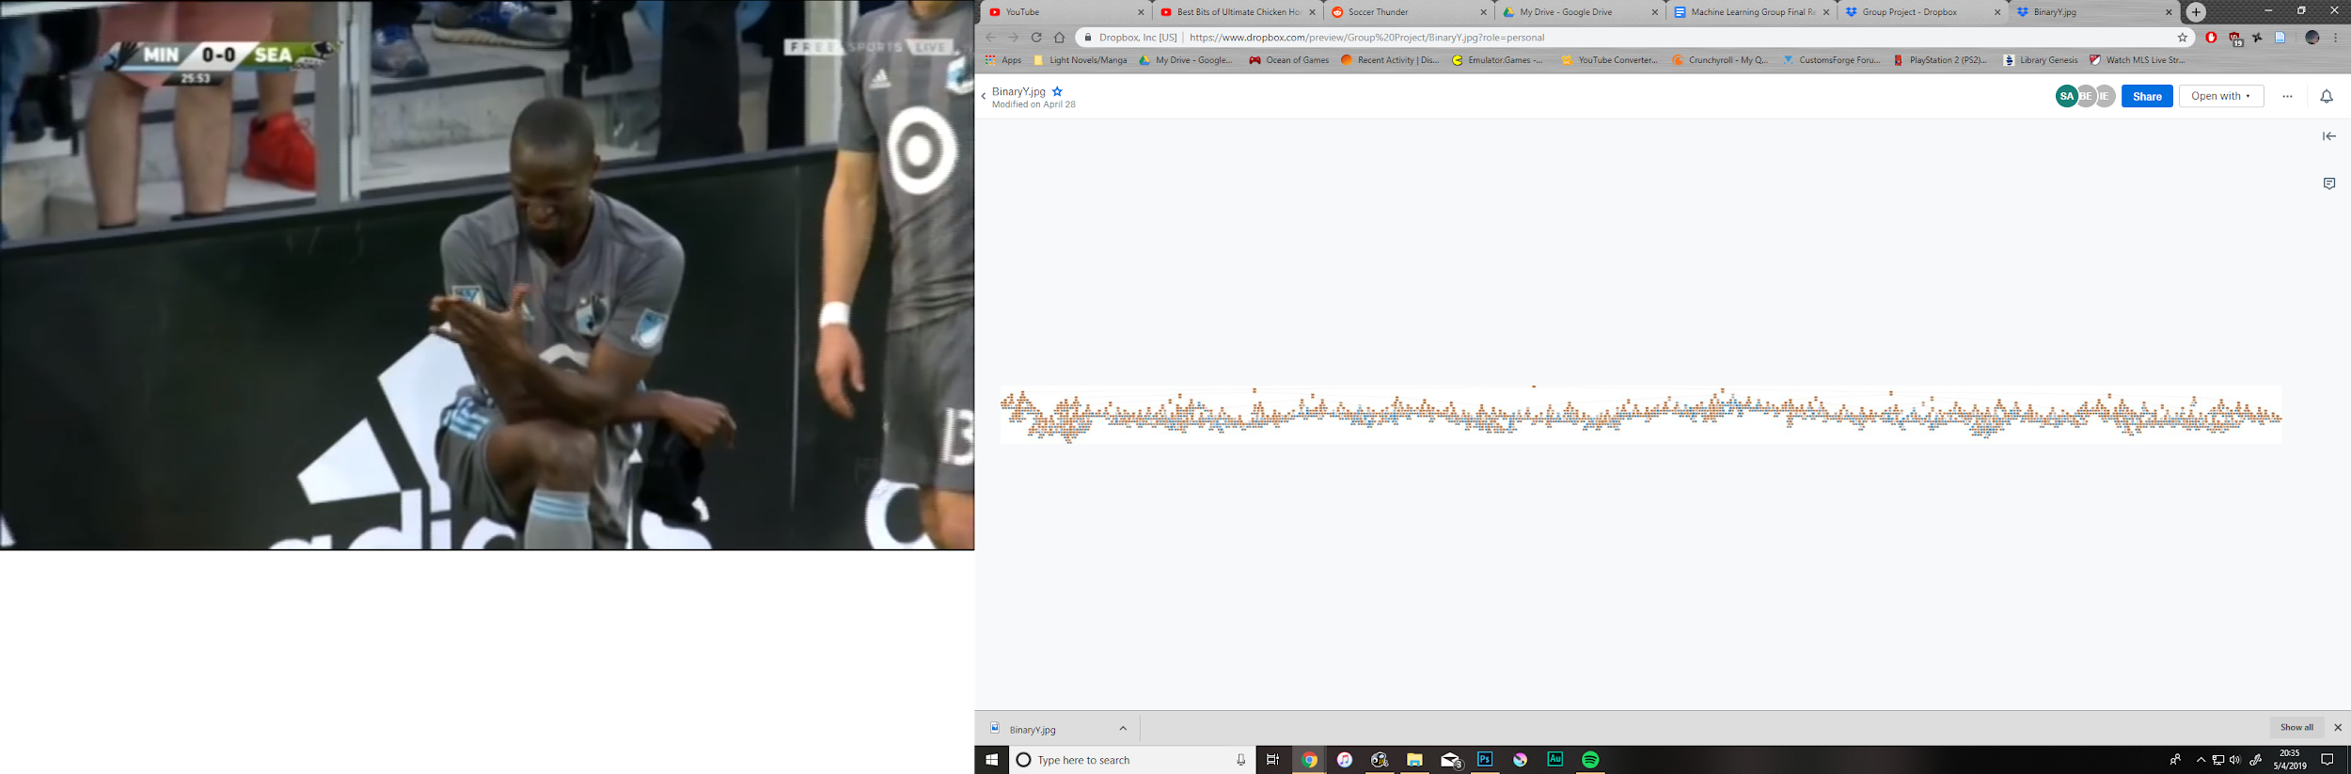

Multiclass Classification:

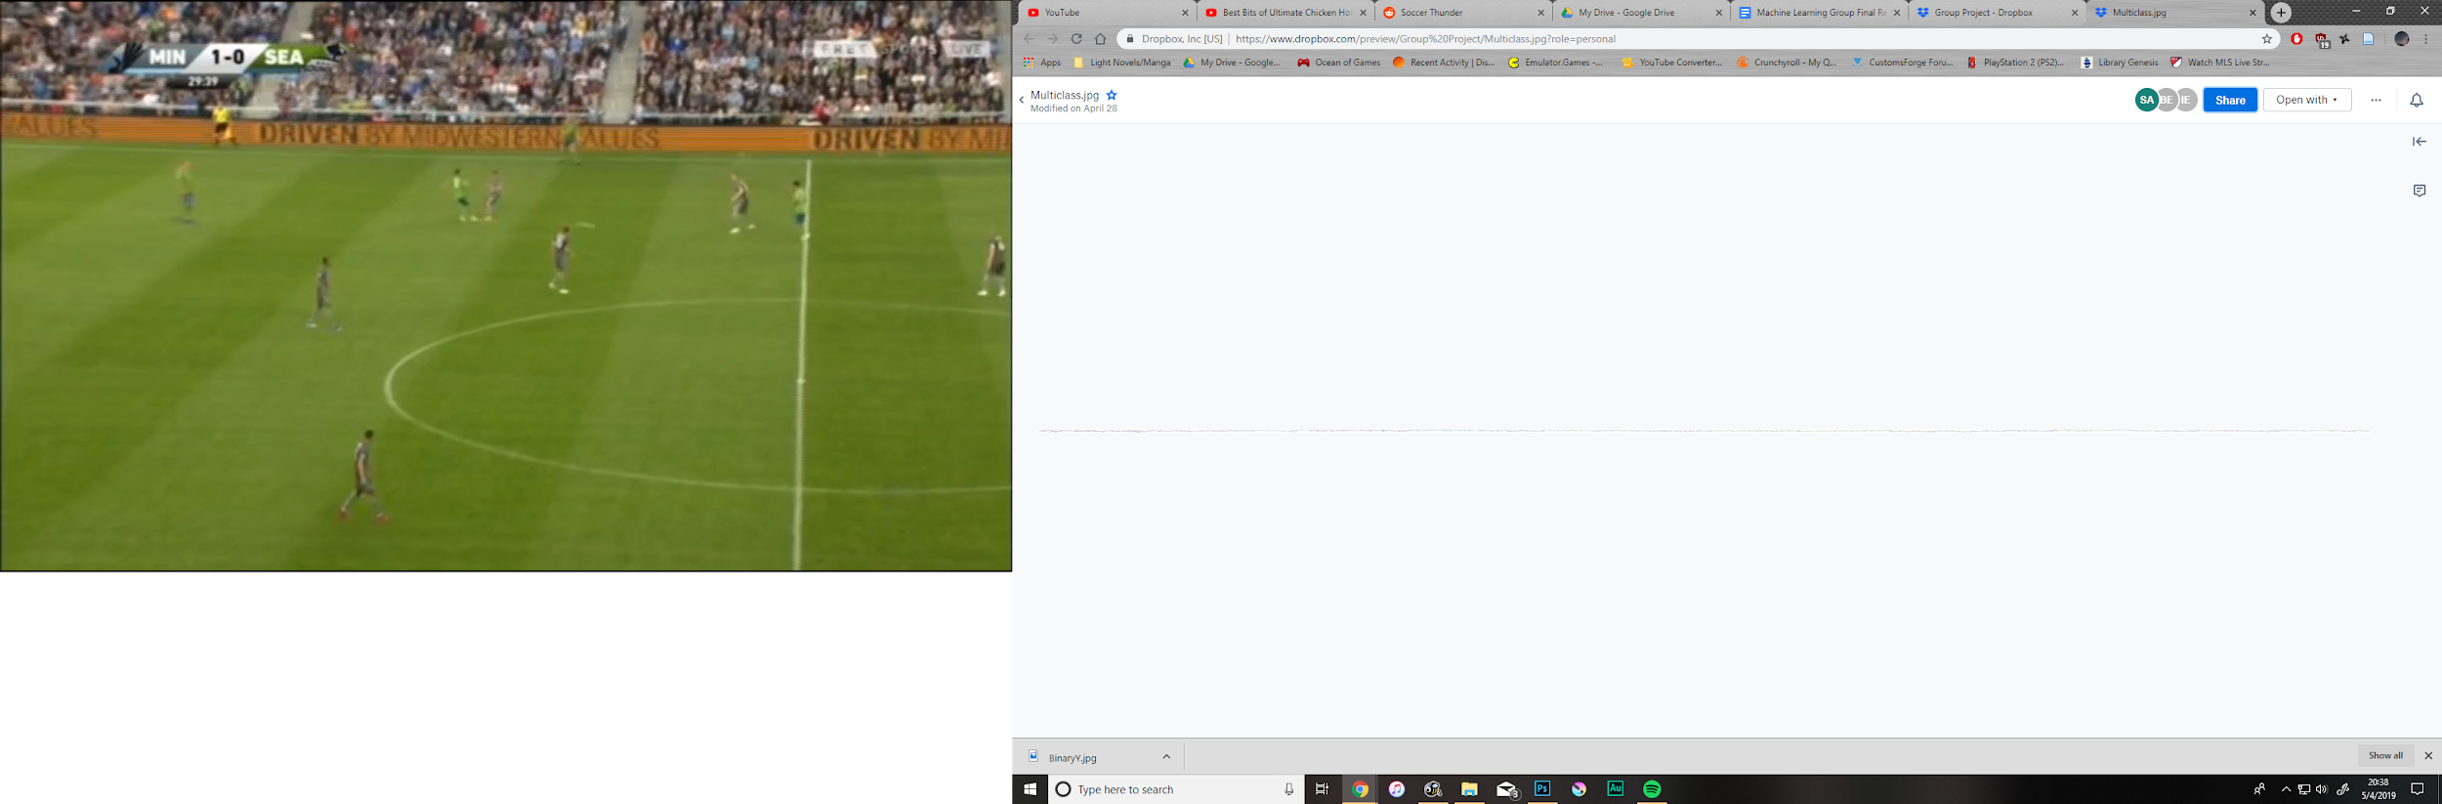

(Note: Images are attached along with this document)

**Reduced to Black/White & Cropped**

SGD Classifier:

Cross Validation Scores: 0.93182582 | 0.95447557 | 0.96328658

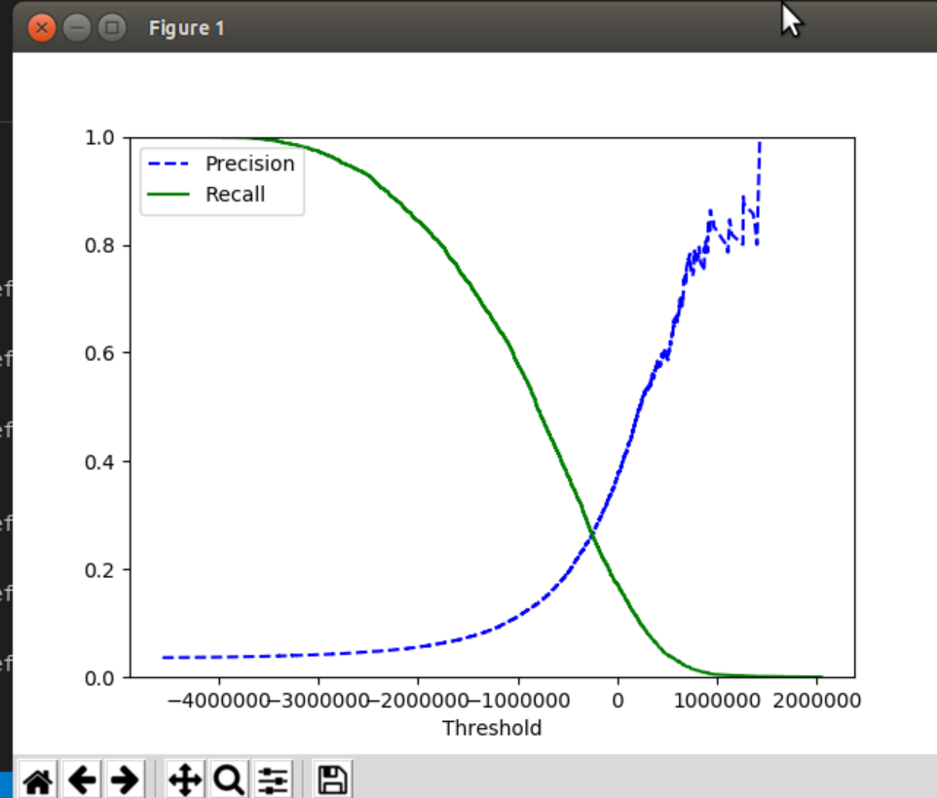Figure 3.1

Shown in figure 3.1 is the Precision & Recall vs. Threshold curve for black/white, cropped training

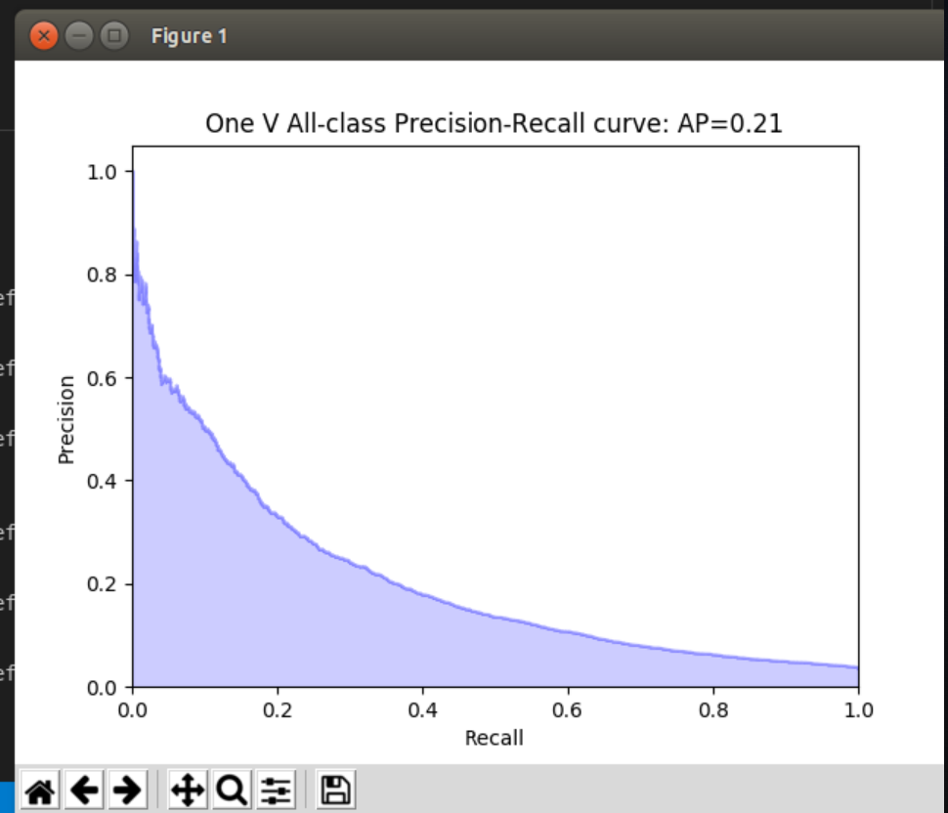Figure 3.2

Shown in figure 3.2 is the Precision vs. Recall curve for black/white, cropped training.

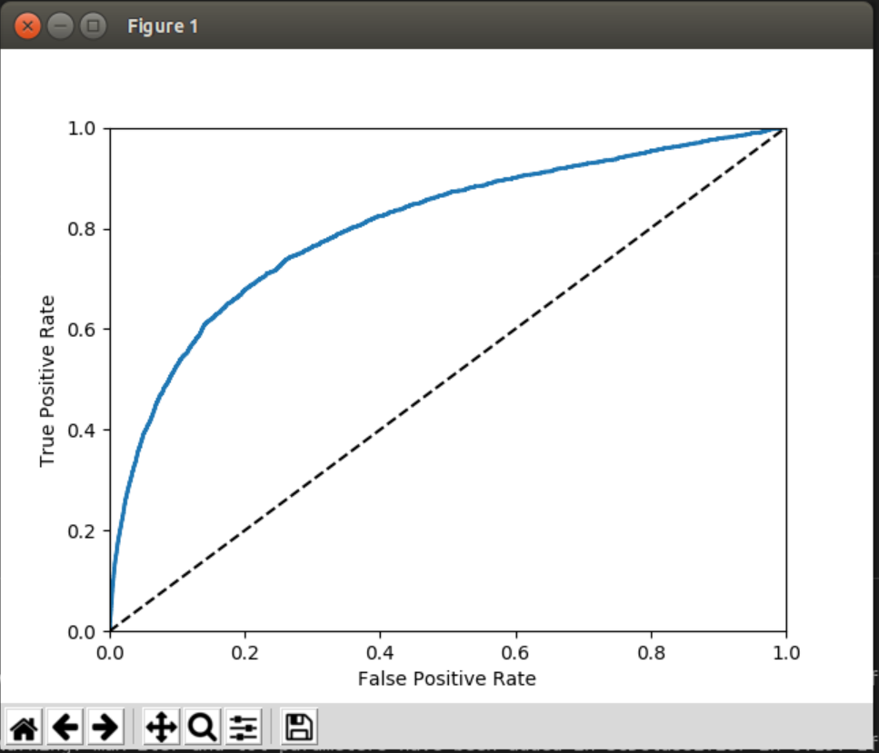Figure 3.3

Shown in figure 3.3 is the ROC curve for black/white, cropped training.

**Reduced to Black/White and Not Cropped**

SGD Classifier:

Cross Validation Scores: 0.96587 | 0.96625 | 0.939

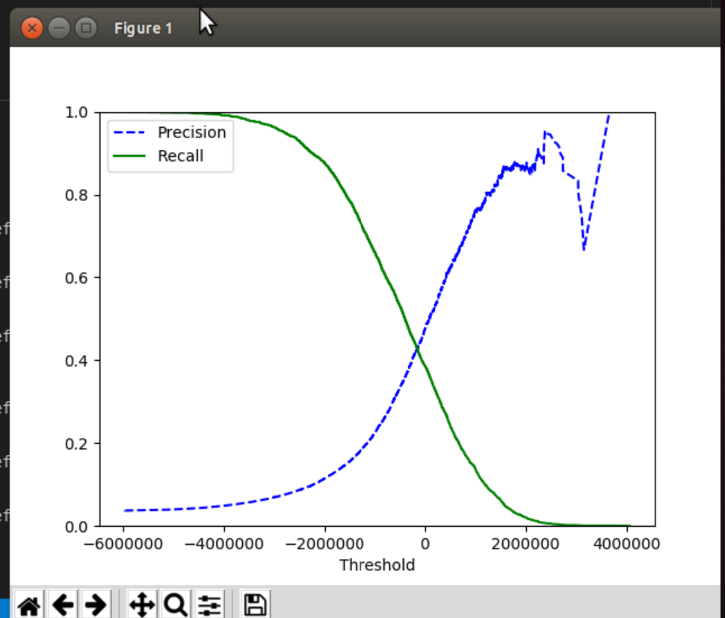Figure 3.4

Shown in figure 3.5 is the Precision & Recall vs. Threshold curve for black/white, not cropped training.

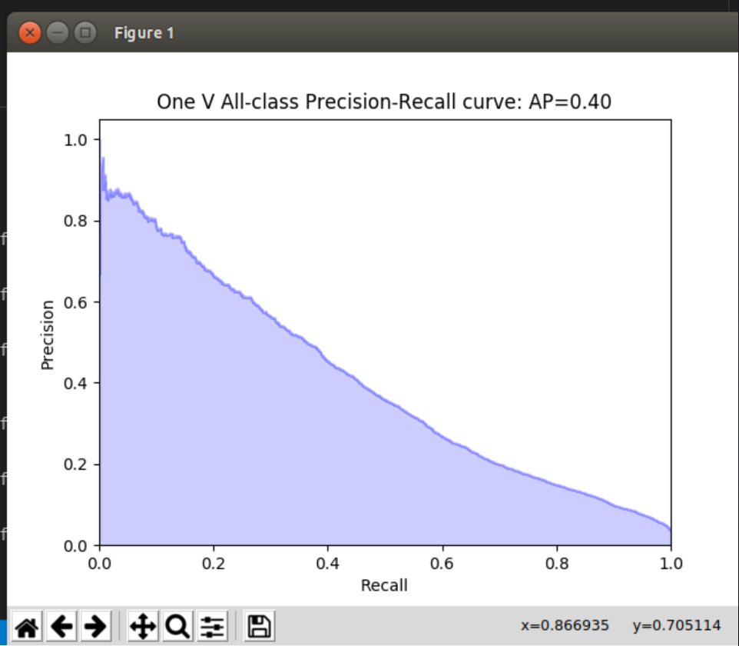Figure 3.5

Shown in figure 3.5 is the Precision vs. Recall curve for black/white, not cropped training.

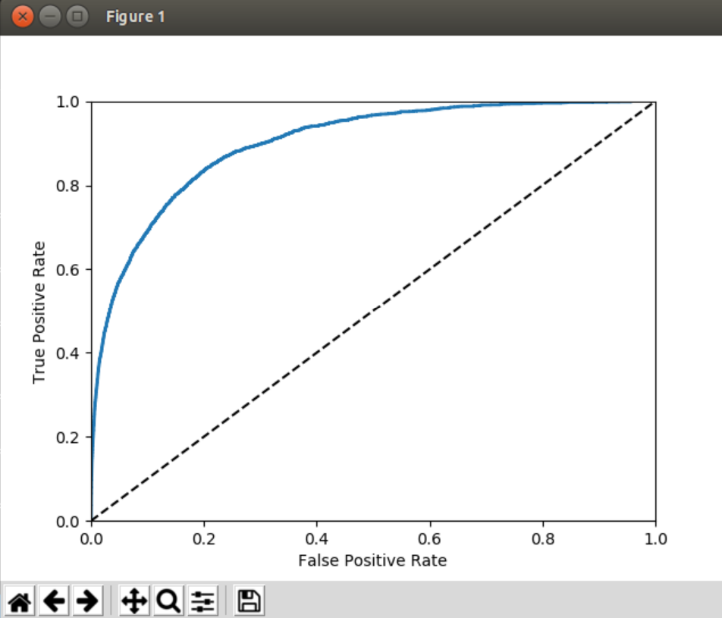Figure 3.6

Shown in figure 3.6 is the ROC Curve for black/white, not cropped training

**Grey Scale and Cropped**

SGD Classifier:

Cross Validation Scores: 0.965 | 0.954 | 0.896

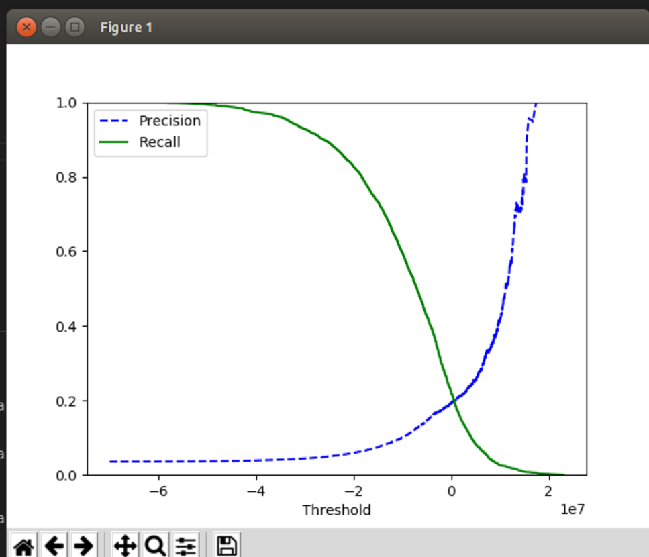Figure 3.7

Shown in figure 3.7 is the Precision & Recall vs. Threshold curve for grey scale/cropped training.

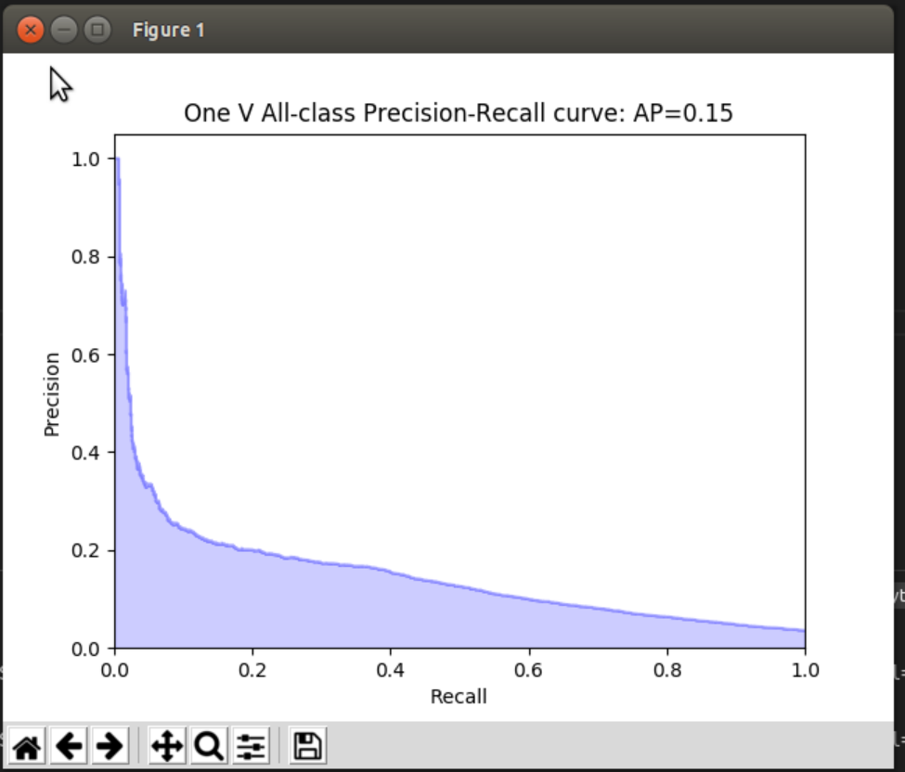Figure 3.8

Shown in figure 3.8 is the Precision vs. Recall curve for grey scale, cropped training.

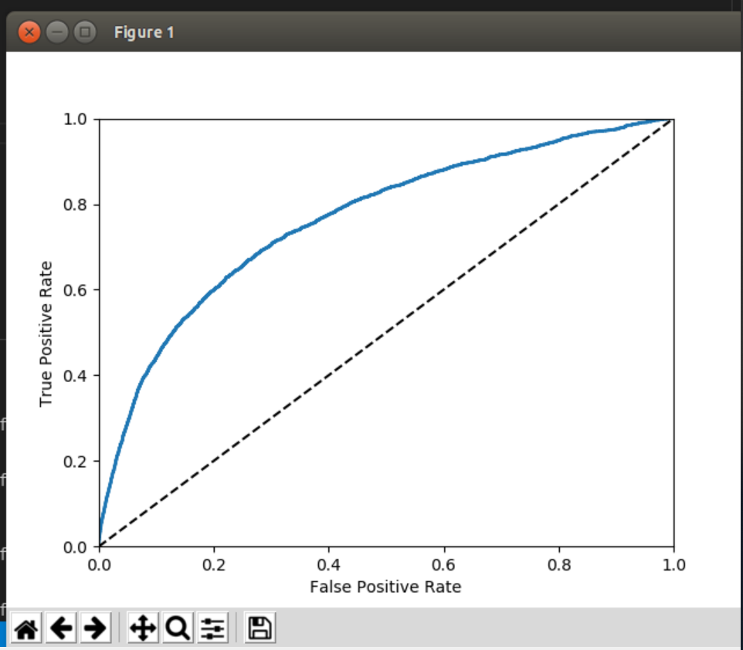Figure 3.9

Shown in figure 3.9 is the ROC curve for grey scale, cropped training.

**Grey Scale and Not Cropped**

SGD Classifier:

Cross Validation Scores: 0.9544 | 0.8329 | 0.9496

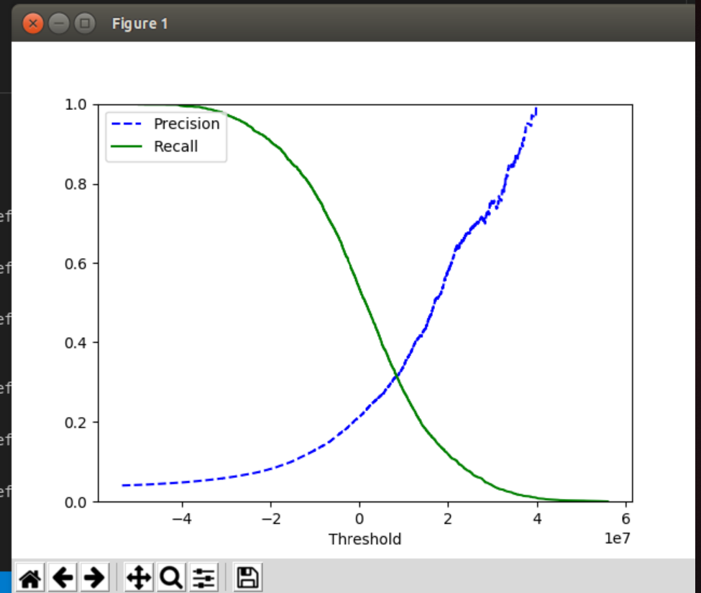Figure 3.10

Shown in figure 3.10 is the Precision & Recall vs. Threshold curve for grey scale, not cropped training.

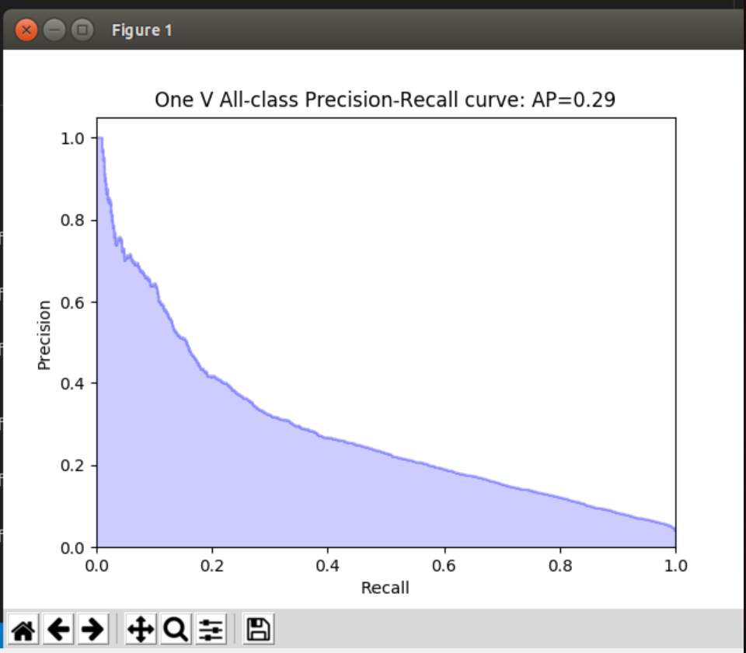Figure 3.11

Shown in figure 3.11 is the Precision vs. Recall curve for grey scale, not cropped training.

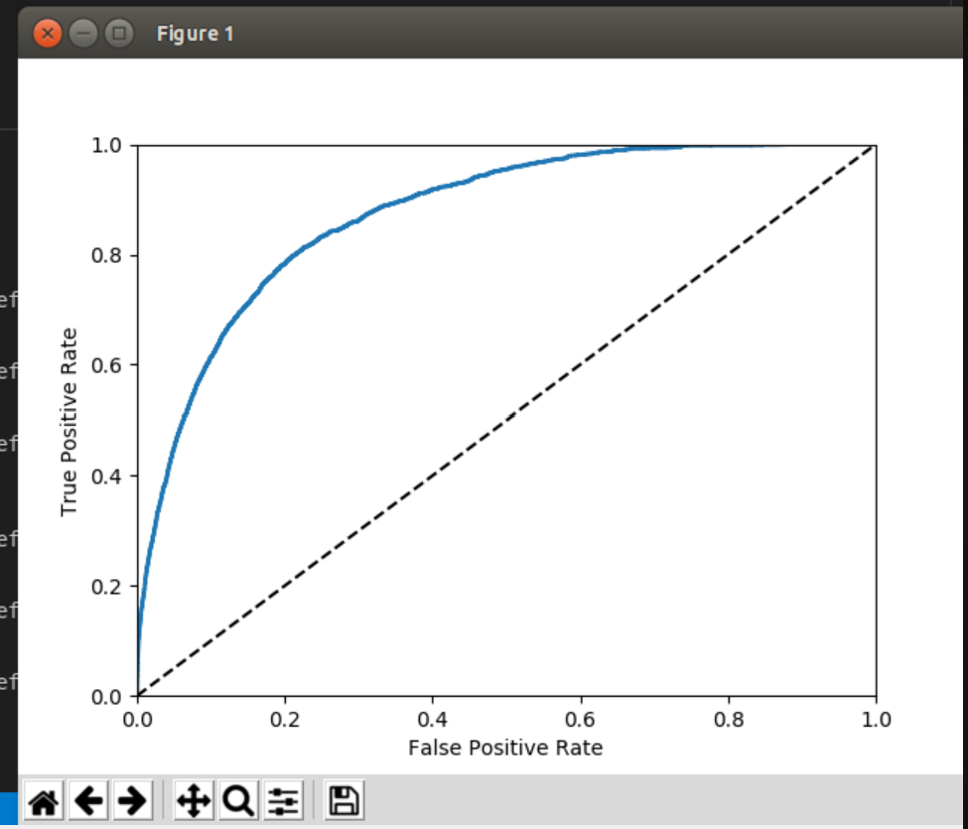Figure 3.12

Shown in figure 3.12 is the ROC curve for grey scale, not cropped training.

## IV. Performance Measurement

**Reduced to Black/White and Cropped**

SGD Prediction Score: 0.9495

One vs. One Binary Accuracy: 0.9755

One vs. Rest Multiclass Accuracy: 0.6965

Average: 0.87383

**Reduced to Black/White and Not Cropped**

SGD Prediction Score: 0.968

One vs. One Binary Accuracy: 0.9635

One vs. Rest Multiclass Accuracy: 0.6955

Average: 0.87567

**Grey Scale and Cropped**

SGD Prediction Score: 0.95574

One vs. One Binary accuracy: 0.96975

One vs. Rest Multiclass accuracy: 0.6475

Average: 0.85766

**Grey Scale and Not Cropped**

SGD Prediction Score: 0.95225

Decision Tree One vs. One Binary Accuracy: 0.96225

Decision Tree One vs. One Binary Accuracy: 0.642

Average: 0.852167

**Model Averages:**

SGD Accuracy Mean: 0.9563725

Decision Tree Binary Accuracy Mean: 0.9677575

Decision Tree Multiclass Accuracy Mean: 0.670375

**Conclusion:**

As can be seen by the average accuracies provided above, across the decision tree models, binary testing provided better results than the multiclass testing by a substantial margin. While the SGDClassifier model produced better accuracy for images that were reduced to black and white and not cropped than decision tree binary testing, the latter performed better in all other categories and yielded a higher average success rate.

The results also show that reducing the images to black and white pixels produced more accurate predictions, as well. Also, the average of the cropped results is 0.865745, while the average of the uncropped results is 0.863924, showing that cropping the images is better for classification, but the difference is minimal.

In conclusion, to produce the best classification results, black and white, cropped ASL images should be tested on a binary decision tree model.