NOTE: Channel 1 (Orange) : cin, Channel 2 (Blue) : cout (s(6))

Ripple Carry Adder

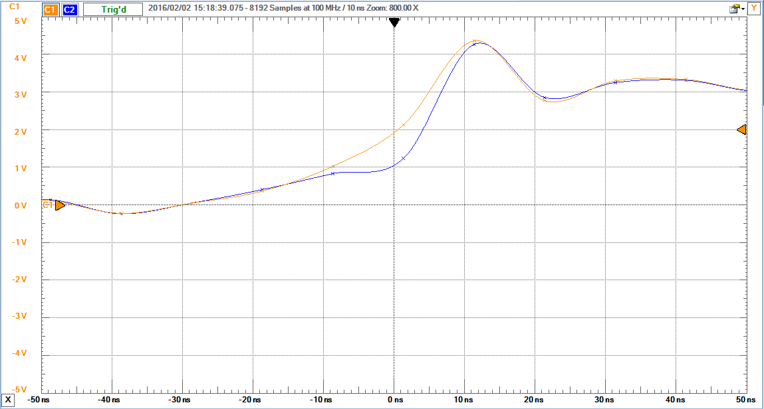

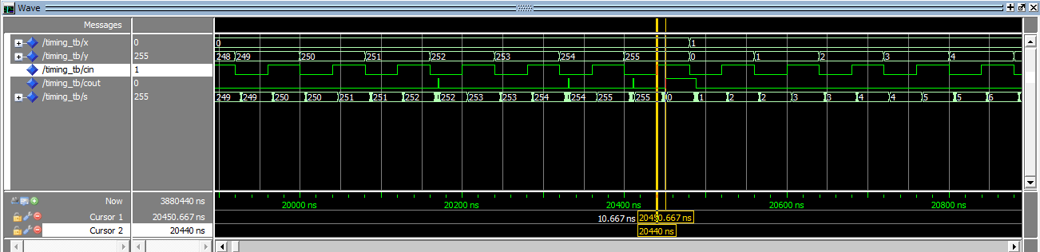

Diff = 10.667

Carry Lookahead Adder

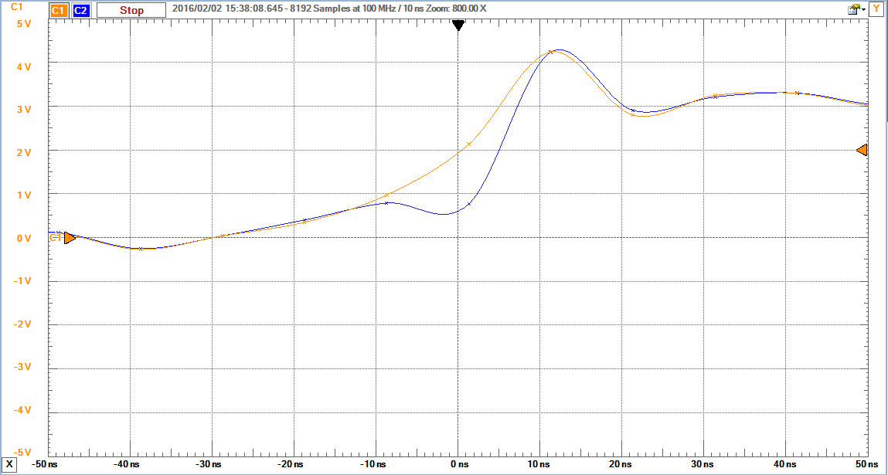

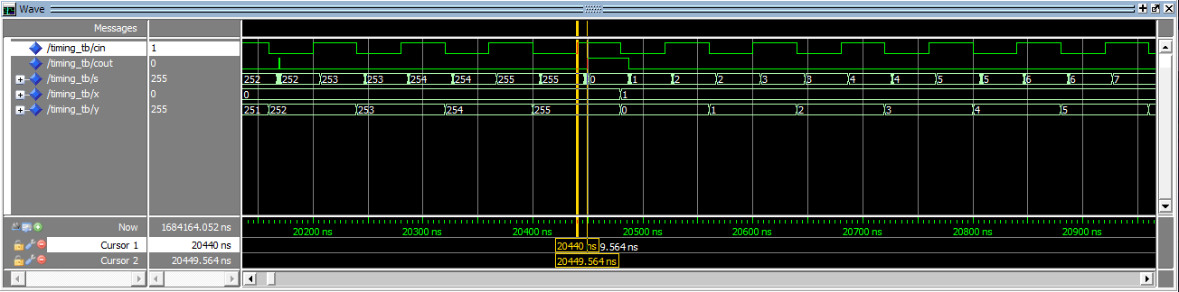

Diff = 9.564

Hierarchical

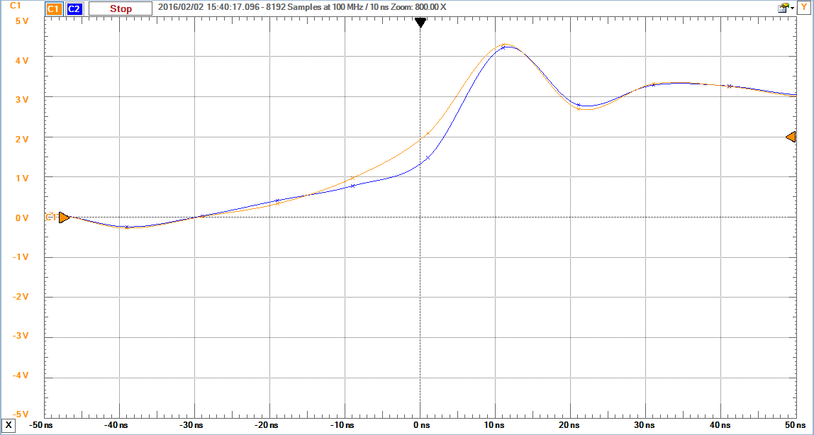

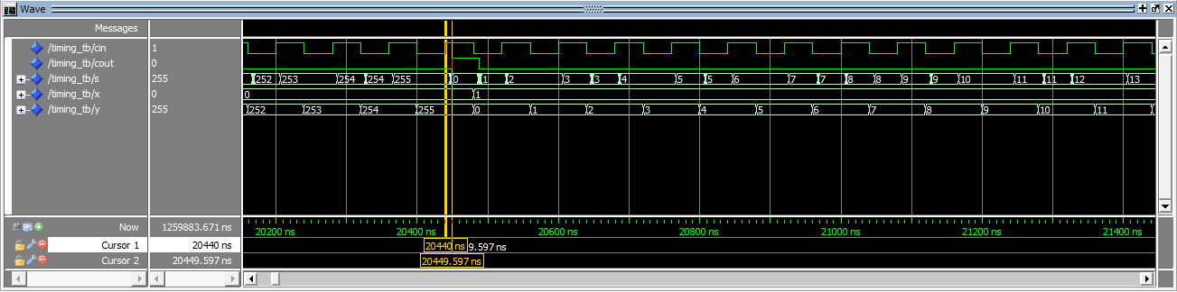

Diff = 9.597