**Decoders & ROM**

Note: The yellow marks refer to a warning about the vector being truncated, but this is not an issue. Since the counts (10-bit vectors) are used by the row and column decoders, which produce 6-7-bit vectors, the warning is present, but this is a necessary truncation for forming the ROM address.

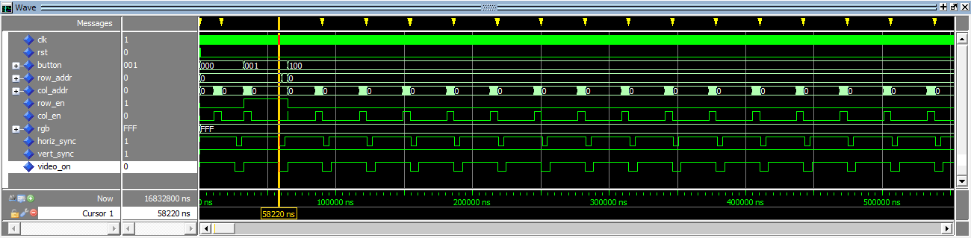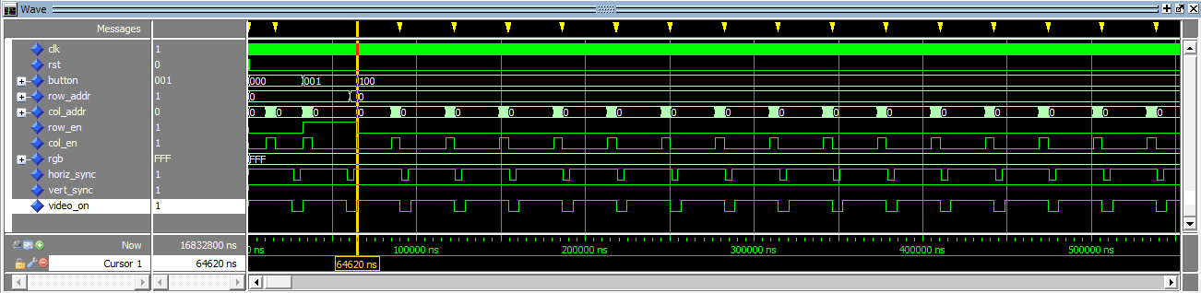

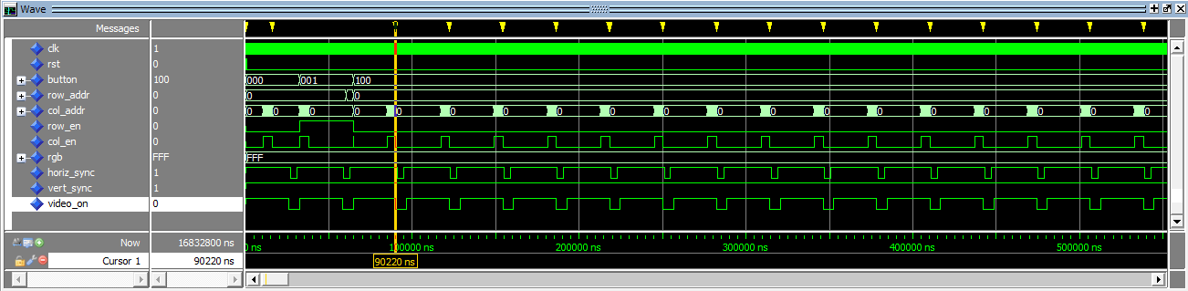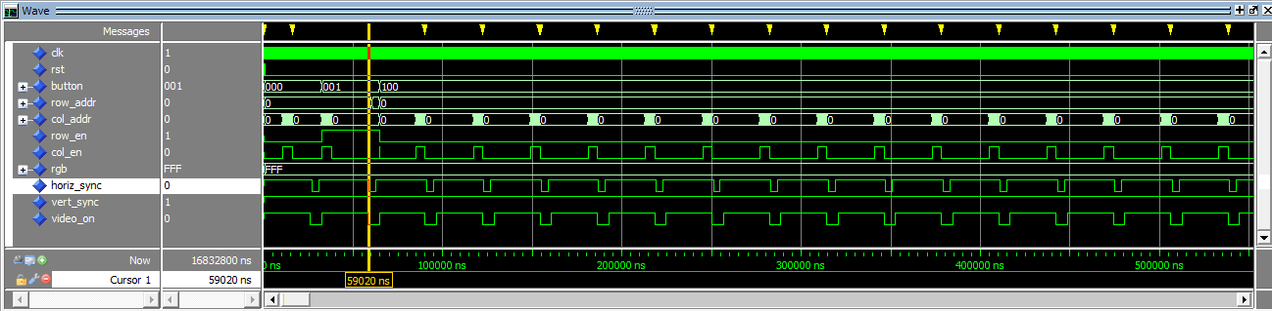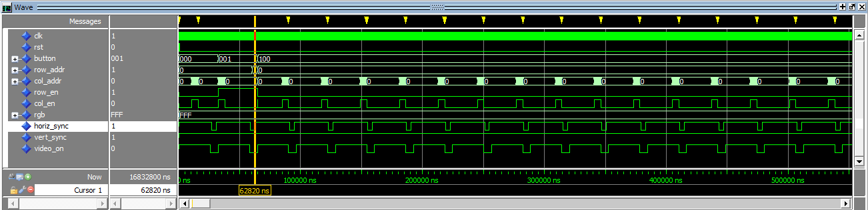

Note: Horiz_Sync width = 62820-59020 = 3800ns ≈ 3.77μs

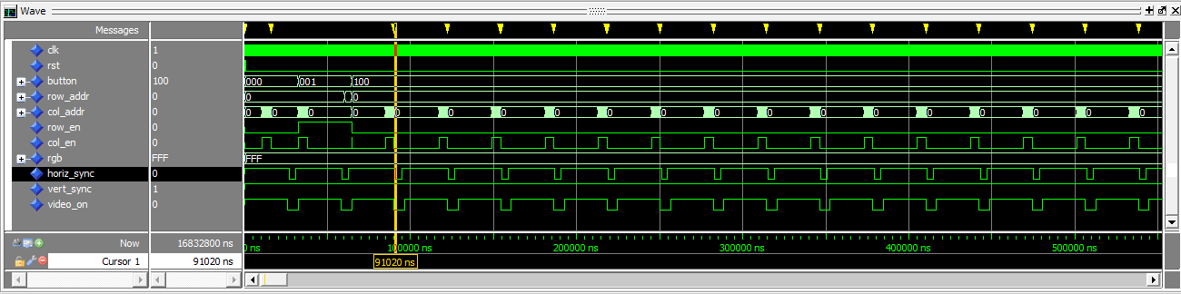

Note: Time between Horiz_Sync’s = 91020-59020 = 32000 ≈ 31.77μs

Note: The full simulation log is not show simply because of the length of the simulation and the warnings throughout.

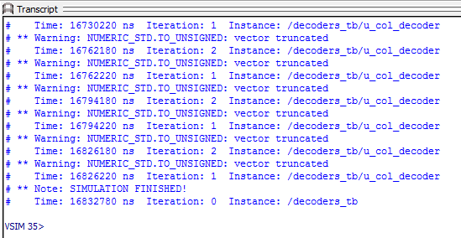

**VGA_sync_gen**

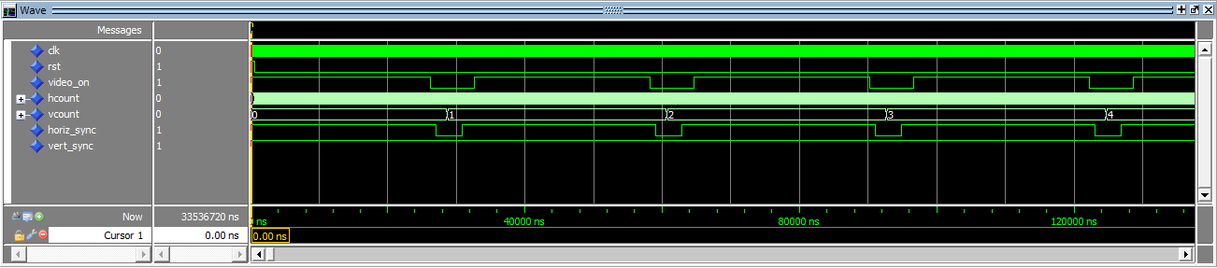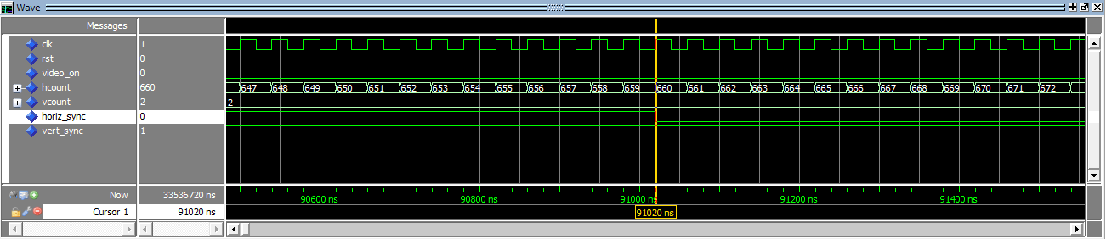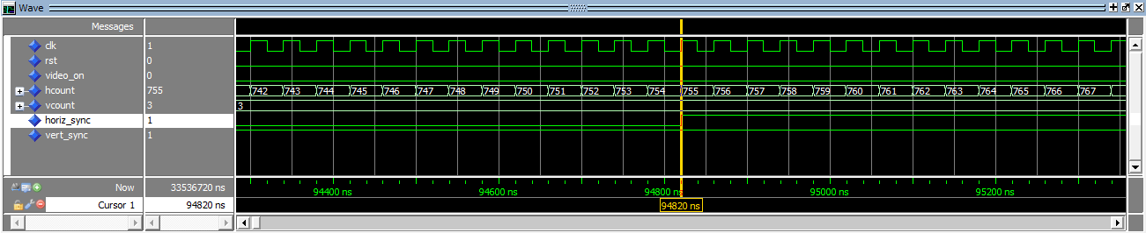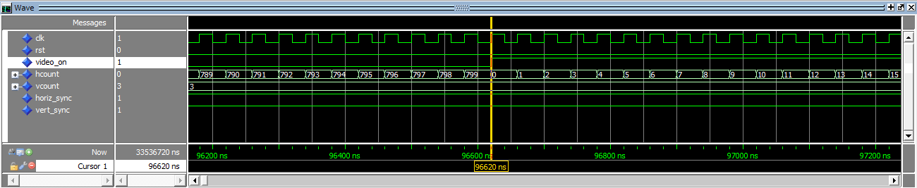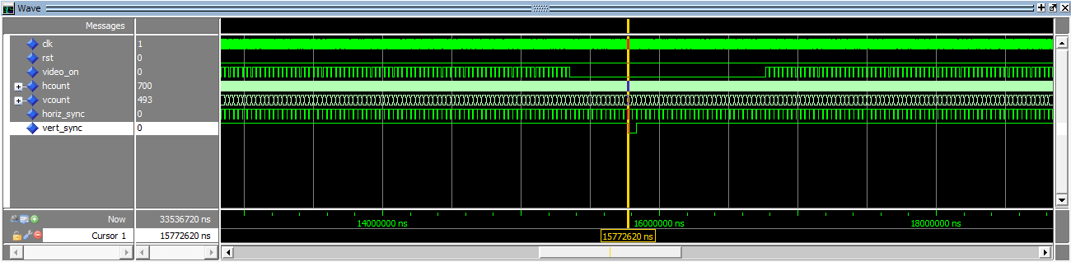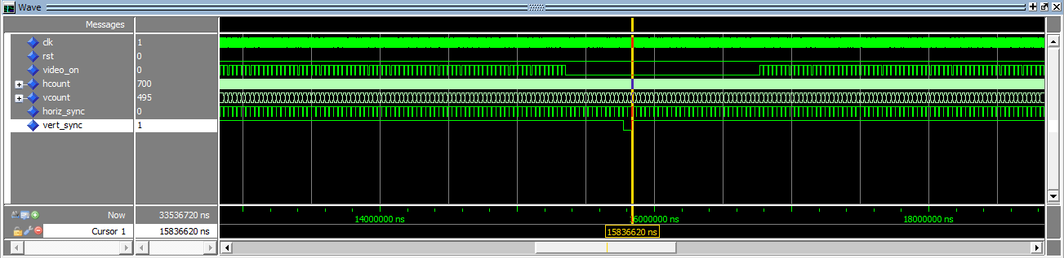

Note: Vert_Sync width = 15836620-15772620 = 64000ns

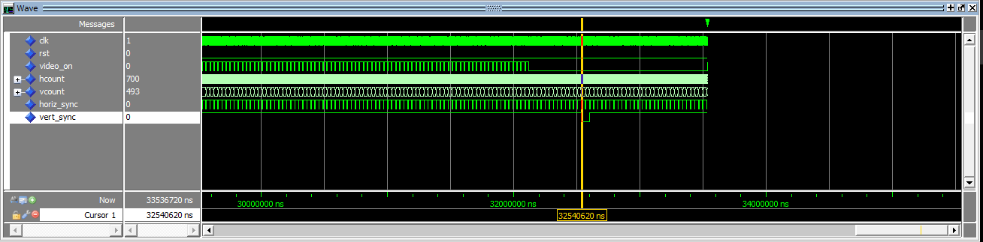

Note: Time between Vert_Sync’s = 32540620-15772620 = 16768000ns ≈ 16.6ms

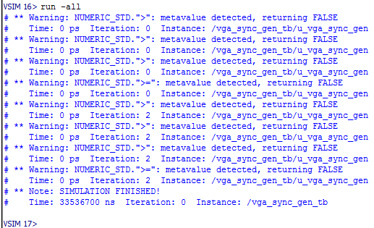

**top_level**

Note: Yellow tick marks serve the same purpose here as the with the decoders.

