Using Mercury
This document has been superseded by versions held by Anne Clarke and Elaine Oliver. We keep it here as source material for text and graphics.

Introduction
Mercury is designed to allow the input of student schedules as would have traditionally appeared in the lecture list. It is not intended to help with the task of scheduling¹. We try to integrate with existing systems where possible, to avoid multiple entry of data. Mercury will also provide data feeds for other systems and be embeddable in a departmental website.
A system such as this is complex and to do it well, meeting everyone's needs, takes some time. So far we have concentrated on entry, allowing departments to prepare timetables for publication in well advance of student arrival. We are also concentrating on NST IA, NST IB and MML, initially, using a more basic document-based system for other triposes. We hope to move other triposes over, with the consent of their organising committees, in the course of the year.
Note that while editing takes place according to lectures in “week patterns”, eg “Michaelmas weeks 1-4, Monday, Wednesday and Friday at 10”, the student view will mark each individual event on a regular daily calendar. The editing is done in patterns for speed as most courses are arranged according to a pattern.

Documents
If you are managing a tripos part other than NST IA, NST IB or MML, please submit a document or a link to a document on your own website to Education section. They will then use this to link to your document from the main mercury list page.

Screens
There are three screens in Mercury: the list, the calendar, and the details.
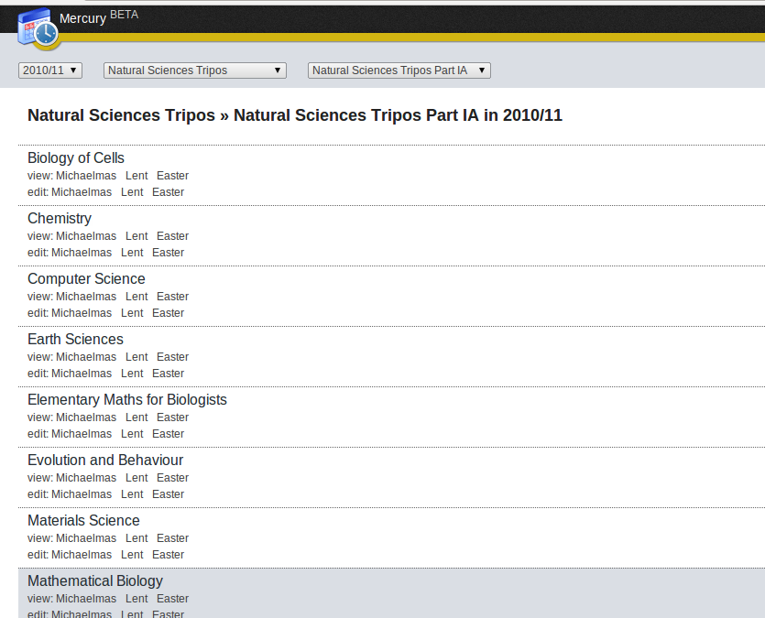
In the list you can select your tripos and part. If your subject is using documents, you can download them from here and you are done! If you are one of the subjects using the full calendar, click on the edit link to edit your timetable.

If you click on an edit link you will get the calendar screen. This screen is intended to be an overview of your course, so you can check all the events are there and correct, and for minor tweaks. It is also useful if you want to see how your course interacts with the other courses of the tripos. However, if you want to make major changes or rearrangement you will find this interface frustrating: you need the details page.

You can select the courses you want to see at the top and they will appear on a google-calendar type grid. Note that this grid represents the whole year: if multiple events happen at various times of the year you will see multiple boxes or a single box “various lectures of ...”.
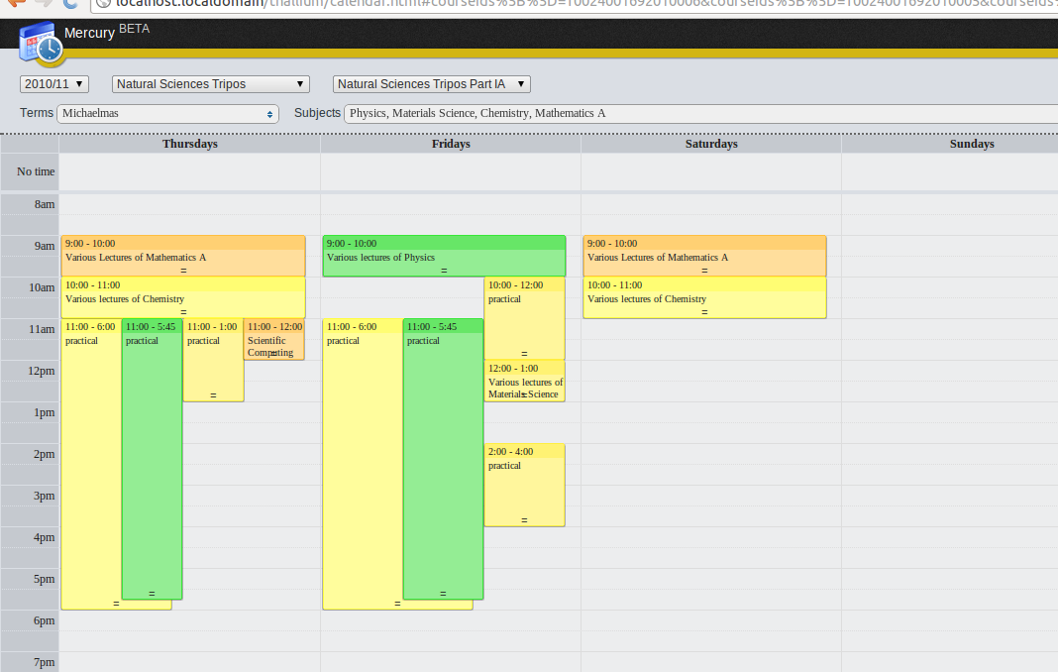
Further detail is available if you click on a rectangle, including details of each of the lecture series or practicals described by a rectangle marked “various...”. In such a case, a dropdown box at the top allows you to select which you are interested in. Here you can also change locations, subjects and timings without going to the details pages. Ideal for quick tweaks.

The syntax for events is a little complex but is designed to allow easy entry of the kinds of patterns seen in lecture courses. We ultimately hope to install a graphical aid to help here, but for now the syntax is as described below (in the section syntax). You can also move a block of lectures by moving the rectangle. For now, it is usually easier to edit dates and times from the details page.

Note that we always work with terms and week numbers. This prevents having to change details each year. In the screenshot below, the user has clicked on “various lectures of physics”. THey then see a popup box which lists those lectures and the user has selected mechanics. It is being lectured by Dr Riley in the Bristol-Myers-Squibb lecture theatre on Mondays, Wednesdays and Fridays at 9, during the first four weeks of Michaelmas term.
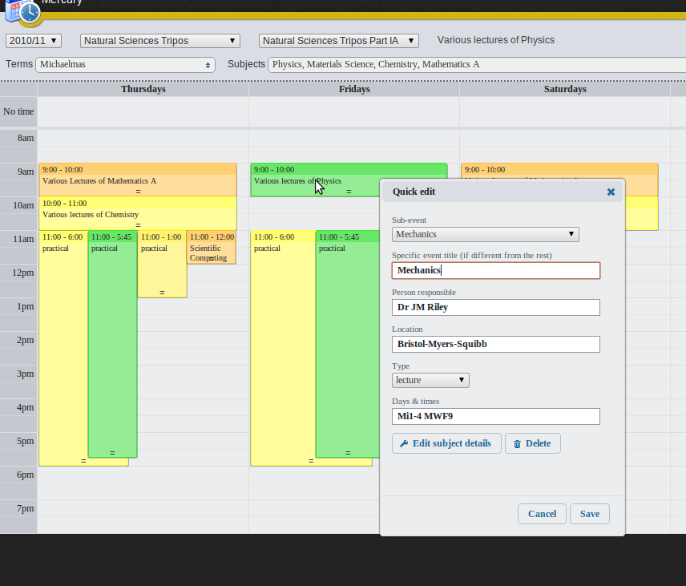
The final screen is the details screen. There are two tabs here. The 'basic' tab includes the supplementary material to be placed at the top and bottom of a timetable including further details of a course. The 'advanced' tab shows you your entire course as a table. This is where you will want to make any serious changes to your course. You get to it by clicking on “Edit Subject Details” in a popup for your course. It doesn't matter which event you selected to get the popup, it will get you to the same screen.

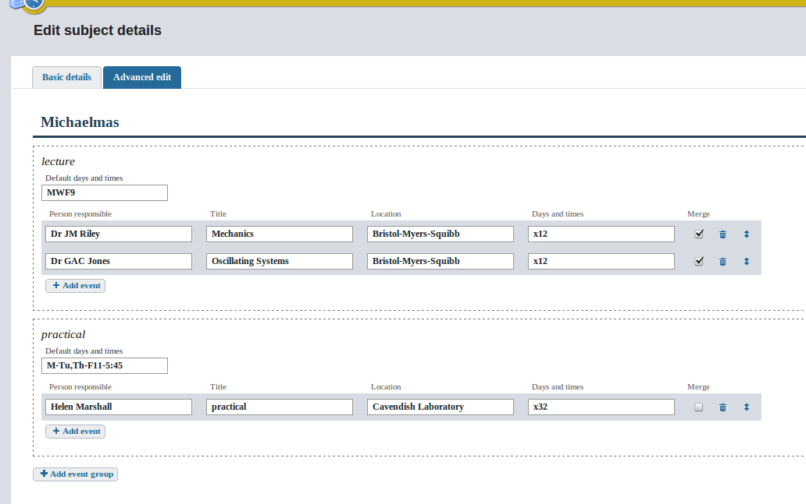
You will see that each term and each “type” of event (lecture, practical, etc), gets its own section. Most courses have lectures according to a pattern. In this case lectures are on Mondays, Wednesdays and Fridays at nine. If so, you can enter the pattern in the box at the start of each section and just write an x followed by the number of lectures. For example, here there are twelve mechanics lectures followed by twelve oscillating systems lectures. If your lectures or practicals don't have such an over-arching pattern you can instead enter a full pattern (eg Mi1-2 MWF9) on each row.

Delegating control

Syntax

