Quick Updates to Online Timetables
This document describes how to quickly change the online timetable for your subject, to correct it, to alter it year-on-year and to update or alter names or subjects. It takes us about half an hour to enter a subject from scratch for a whole year and, while you'll need a little time to get used to the system, you have the 2010 data already in place and won't need to enter it from scratch.

Logging In
Go to the front page and select your tripos and part. First you will need to login to the system. Use the login link at the top corner and login via raven. When you are back you will see some extra rows under each subject (compare first screenshot to second). These links allow you to edit your subject. If you don't see these extra rows, you don't have permission to edit and you will need to contact Education Section. See the before and after images below.
You can also edit the system from the calendar view. We don't currently recommend this for checking your entry as it takes longer and it can be easier to miss things.
Before and After
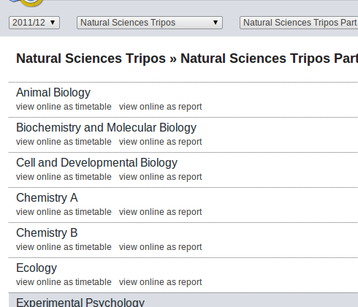
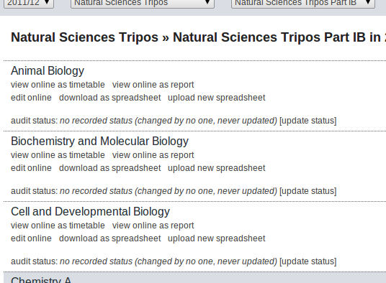

Choice One: Editing online
You can choose to edit you course online. At the start of the year it's probably easiest in the details view. Here's how you get to it:
- Click on “edit online” against your subject, this will take you to the calendar.
- Click in the middle of one of the boxes on the calendar for your subject. A small window will pop up.
- Click on “edit subject details” in that little window.
- Select the Advanced Edit tab.
Here you will see your lectures laid out in lists, one for each term. You can change names, titles, and location easily just by editing the list and hitting save (at the bottom of the page). You can reorder rows by dragging them with your mouse. When editing people, be sure to include their CRSID in square brackets after their name or write [none].
Times are represented a little awkwardly at the moment because of the wide range of ways courses are run. To see how to write time codes, see the Time Code section at the end of this document. We hope to replace time codes with a graphical interface soon, but the sheer variety of patterns (and sometimes their absence) makes this difficult. You have no need to understand time codes if all you are doing is changing names and lecturers.
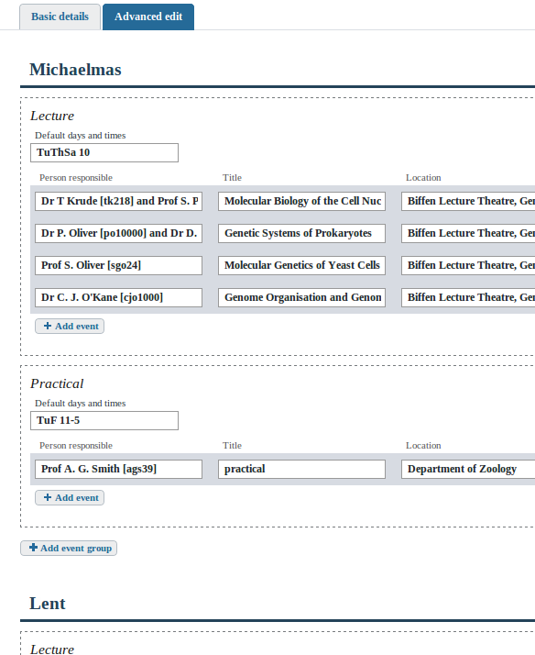
An example details page.
If you want to change the details at the top and bottom of a page, click on the “Basic Details” tab on the details page.
When you are done, click on home (top right) and you can click on “view as a report” to see if it is correct.
If you are happy with what you have done, or if you want to leave a note as to incomplete data, please click on “update status” this allows you to customize the message which admins see on the initial list screen, to aid communication about the status of the timetable.

Choice 2: Editing with a spreadsheet
Some people prefer editing things in a spreadsheet to doing it online. You can do that in our system, but it involves a little more work. If you want to change dates and times you will also need to understand Time Codes (see end of this document). Changing other details doesn't require that.
The spreadsheets we generate and accept are in CSV format. You will need to load and save them in CSV (not XLS). Excel can load and save files in CSV. If you have trouble uploading a file, that's the most likely cause.
If you are logged in and have permission, you will see “download as spreadsheet” as a link on the front page. This is a simple download link. Once it is downloaded, you can open the spreadsheet in Excel. When you are done, save it as a CSV on your computer and click “upload” to upload it back into the system.
When you are done you can click on “view as a report” to see if it is correct.
If you are happy with what you have done, or if you want to leave a note as to incomplete data, please click on “update status” this allows you to customize the message which admins see on the initial list screen, to aid communication about the status of the timetable.
The layout of the spreadsheet should be reasonably clear. The top line contains the code for your subject then your subject's name, organiser and location.
The next rows contain each of the subjects, recording their name, location, lecturer, and so on. To the right you will see two columns marked “head” and “foot”. These appear at the top and bottom of your entry, and cells underneath are presented as separate paragraphs.

Time Codes
Both the choices above use time codes. This is unfortunate. Editing online allows use of some simpler codes and will have a graphical interface before long; editing the spreadsheet will always need some understanding of them.
Though the codes look cryptic, we've designed them to match the usual way lectures are given, and to work from year to year. Don't worry, students (and lecturers, etc, except when editing) will not see time codes or patterns: they will just see normal dates, just like in previous years in the reporter.
A time code is a series of patterns separated by a semicolon. Each pattern specifies a term, week range, set of days and time range. For example Mi1-4 MWF10 means Michaelmas weeks 1 to 4, on Monday, Wednesday and Friday at 10. The term is specified with a two letter code from the first two letters of the term, Mi, Le or Ea. Week numbers go from 0 to 9 and can use dashes to represent a range. Days have the usual letter codes, M, Tu, W, Th, F, Sa/S, Su. Times are represented in the twelve or 24 hour clock, the system making the appropriate choice (eg 3 is 3pm, 9 is 9am). You can also give an end time after a dash and minutes after a colon. For example, Ea1-8 MWF 11:45-2:15 means Easter weeks 1 to 8, Monday Wednesday and Friday from 1145 to 1415.
An unfortunate side-effect of this system is that sometimes you will need multiple patterns to specify a Time Code. For example, if a lecture occurs on Wednesday at 12 of week 1 of Lent, then the Friday, Monday and Wednesday of week 2 and the Friday of week 3, three patterns are required, so the code would be Le1 W12 ; Le2 FMW12; Le3 F12 . This can soon get a little cryptic and hard to maintain. We are not happy with time codes appearing everywhere and are getting rid of them as soon as we can.
In the details view (but not elsewhere), there's a short hand available to you which can make things much easier. Here you can specify a pattern at the top of a section (eg MWF10) and then just say how many lectures there are, prefixed by an x. (eg x4). The system will work out exactly which of the days this is on the basis of how many lectures have gone before. This simplifies most courses. For example, consider lectures which go according to the pattern MWF9, and that the first entry just says x5. This entry will get all the first week's lectures and Friday and Mondays of week 2. The next just says x3. It gets the remaining week 2 lecture and the first two from week 3, and so on.
We will get rid of time codes as soon as we can, which will be from most places before the start of term but maybe too late for you to check the info, given all the other busy things which happen around the start of term. If you need any help with them, do get in touch. If you tell us your pattern, we can even help enter them for you ourselves.

