Islam A. Ebeid
Arkansas Tech University - CIS Department
Department Website – INFT5303

islam
[Pick the date]

Description:
This web site is designed to offer a variety of information for the computer and information science department and to be a complete reference for target audience: Current Students, Future Students, Parents, Potential Employees, and Alumni and the ABET.
Specifically it provides:
- Information on Programs offered by the department
- Course catalogs
- Information about the faculty and staff
- Latest news and events regarding the department
- Scholarships offered
- Student interaction : form submission , class schedules

Justification:
I wanted to make it simple to view and navigate , so the design is so simple consisting of four colors , which are the two official colors approved by tech , white and light blue
In the title and menu bar I used just two colors and in the content area I used basic white and tech green colors to achieve some accessability features with a border to focus on the main content of the page
The content area is composed of a main left colomn and a smaller right colomn
In the menu I tried to cover all possible content

Sitemap

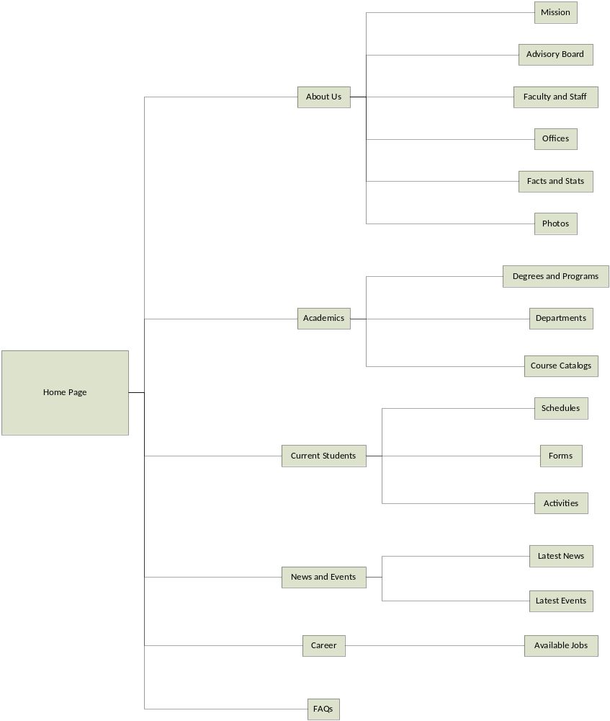

Screen Shots
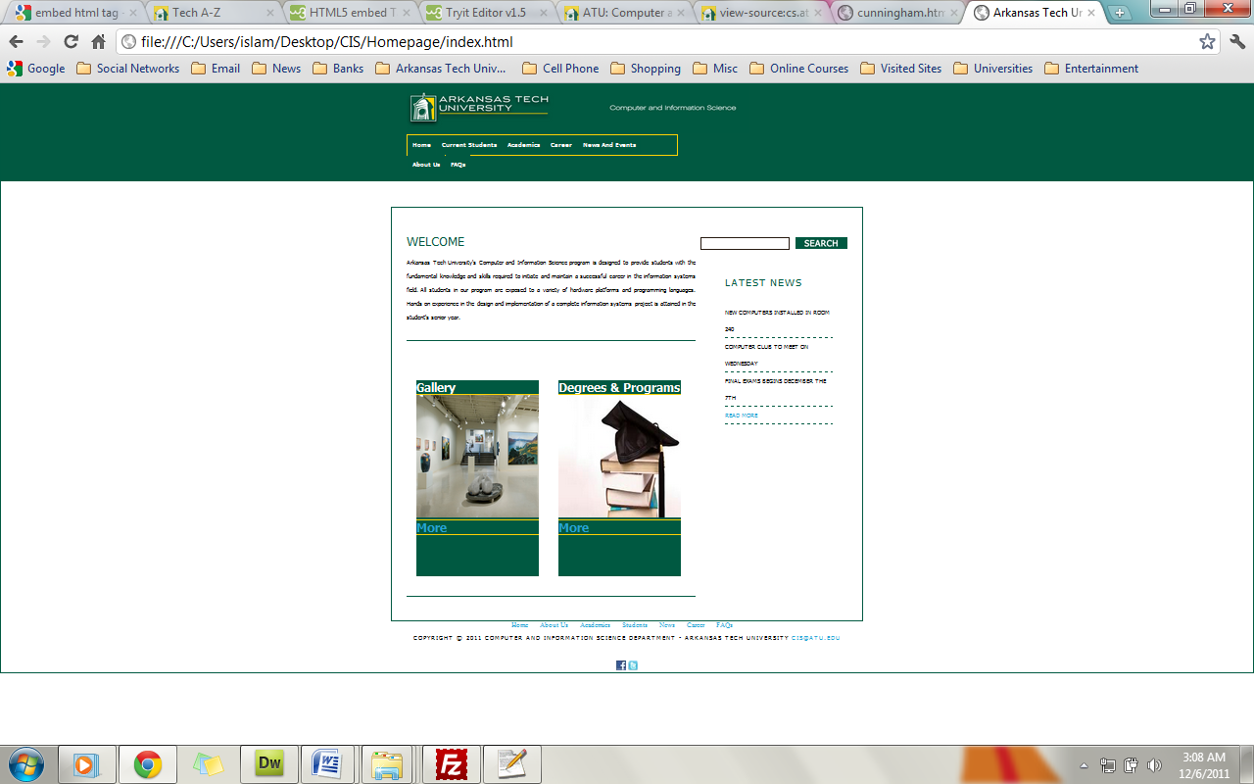
A general view of the welcome page zoomed out
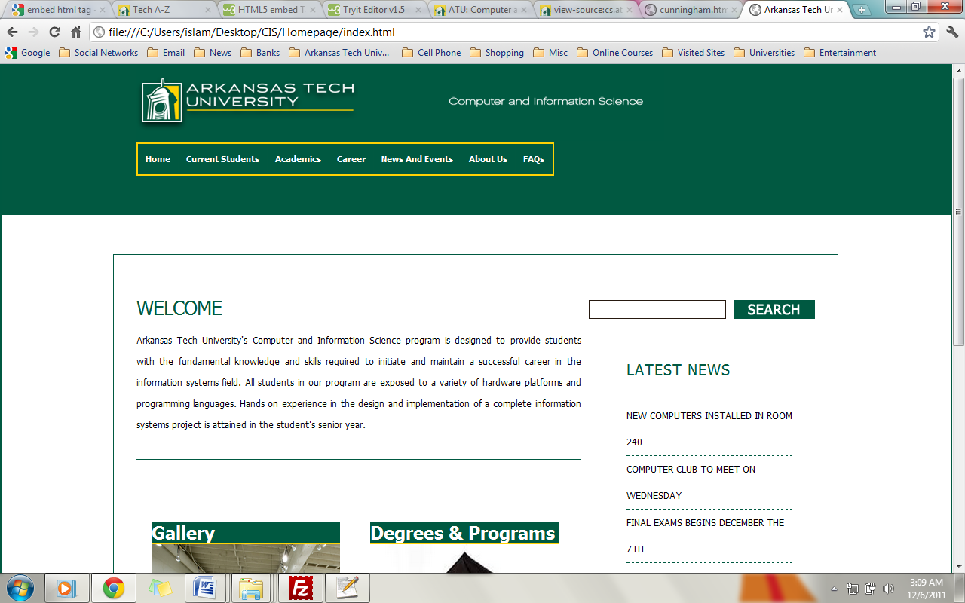
Welcome page
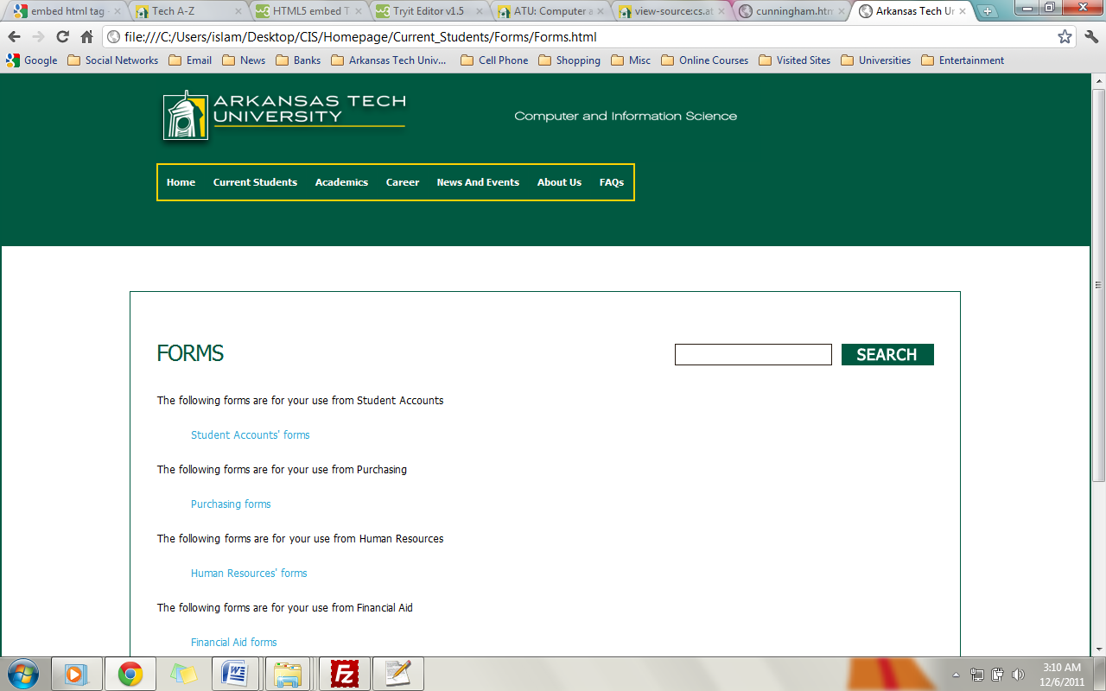
Current Student / Forms
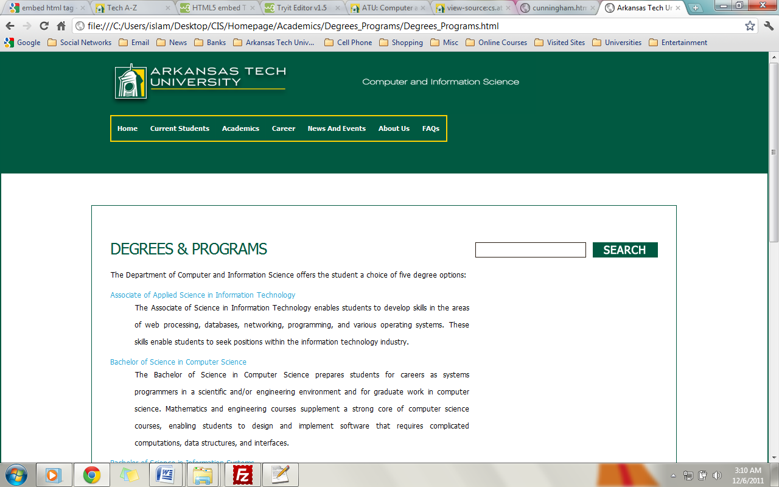
Academics/Degrees and Programs
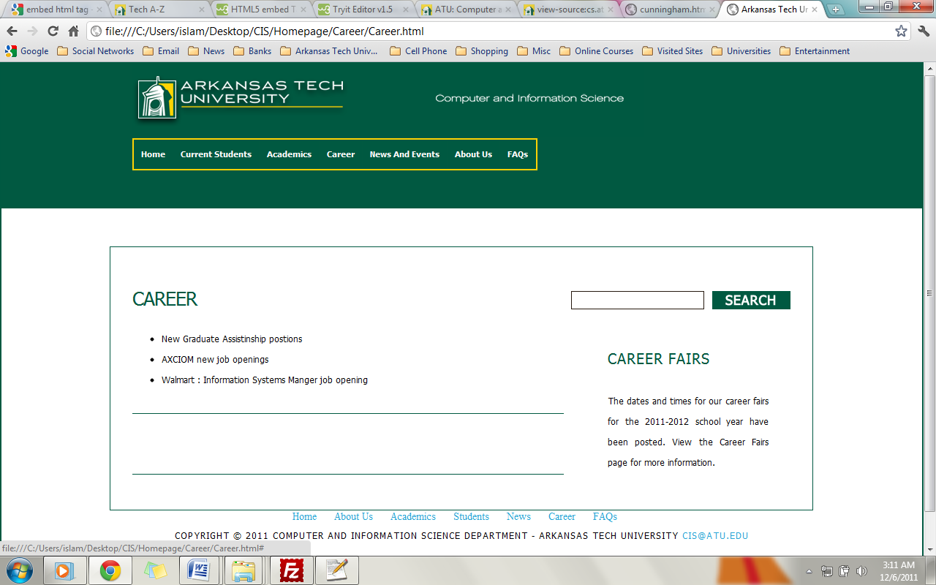
Careers
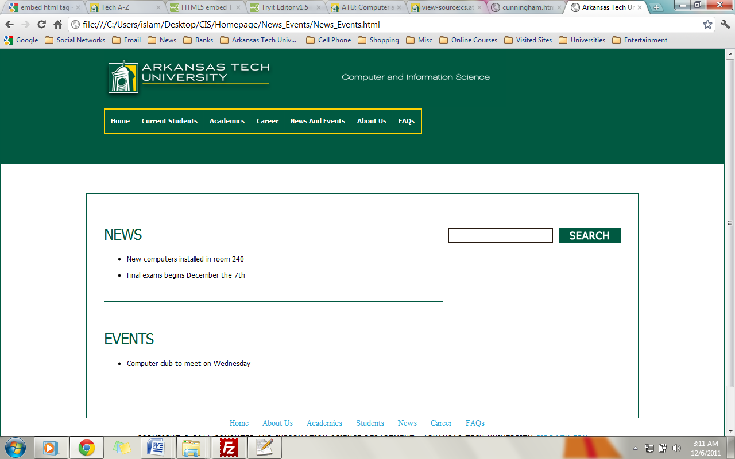
News and Events
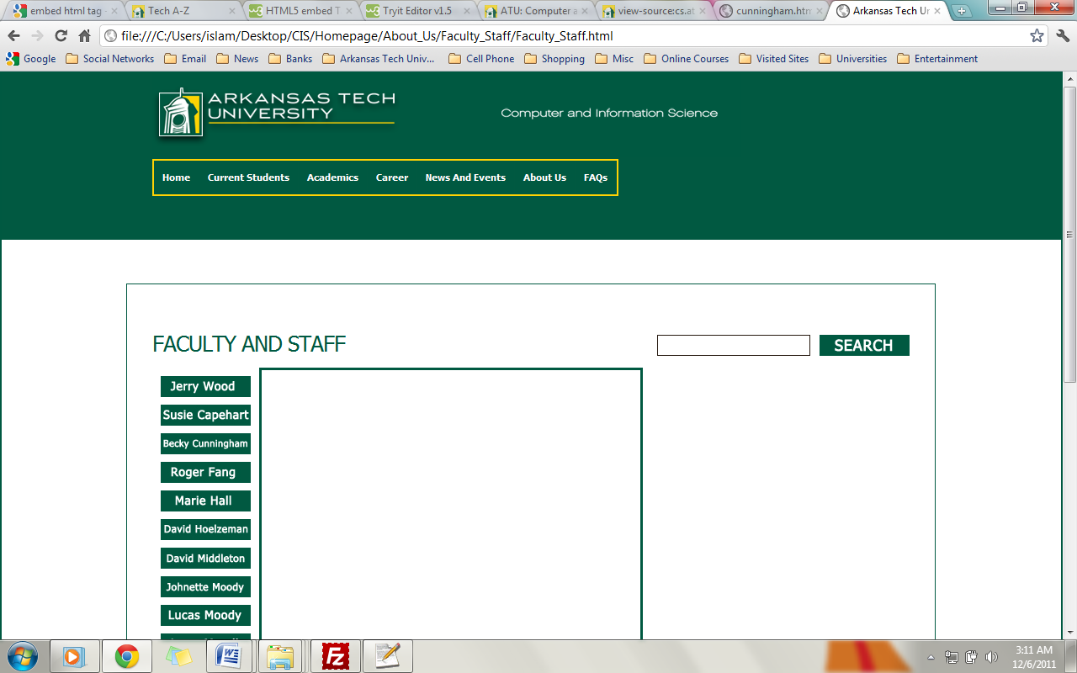
Faculty and Staff

Address on boole
/home/iebeid/public_html/FinalProject/CIS

