2A. Obtain Hub Data

After deciding the types of hubs to be displayed in the app, the data for the hub locations will need to be obtained. Obtaining this data can be achieved through numerous open data and private data sources. For the template, hub data will be gathered from OpenStreetMap for the hub types hospitals, police stations, and universities.

[OpenStreetMap](https://www.openstreetmap.org/#map=5/37.996/-88.154) (OSM) is a free open-access world geographic database. OSM data structure contains three main elements: node, relation, and way. Each one is a different method of representing the coordinates or polygons of points of interest (POI). These data can be used to represent hubs in a pestHubMap. One can obtain node data from OSM using [Overpass Turbo](https://overpass-turbo.eu/) and writing code to filter for desired nodes within a given boundary.

To obtain point data from OSM:

1. Go to [Overpass Turbo](https://overpass-turbo.eu/)
2. Enter code to filter for a particular amenity within given boundary
   1. To filter for all POI (of the three methods) with amenity labeled as “hospital” within a bounding box around Pennsylvania enter the following code:

[out:json][timeout:25];

(

node["amenity"="hospital"](9.7199,-80.5199,42.2696,-74.6895);

relation["amenity"="hospital"](39.7199,-80.5199,42.2696,-74.6895);

way["amenity"="hospital"](39.7199,-80.5199,42.2696,-74.6895);

);

out body;

>;

out skel qt;

* 1. Note: The code in red can be adjusted for desired amenity and bounded area

1. Click “Run” in the top left
   1. The results should appear similar to the following:

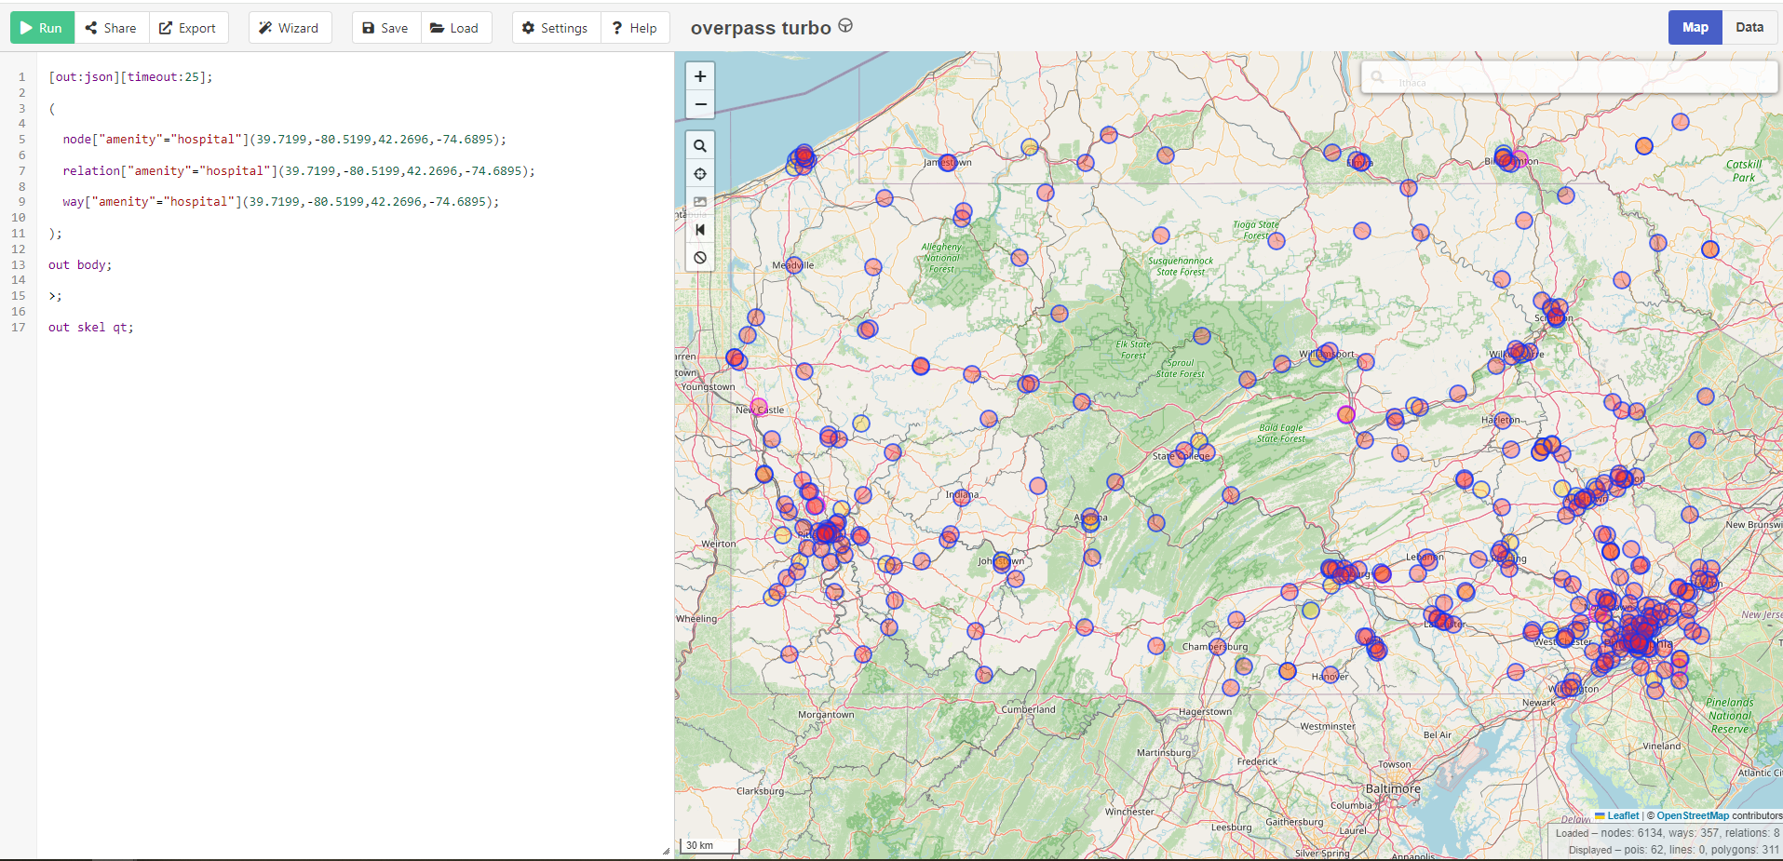

* 1. Note: The query returns POI outside of Pennsylvania because for this method used a bounding box which exceeds the area of Pennsylvania since it is not a perfect rectangle

1. If the results are satisfactory, click “Export”
   1. A pop-up window will display file format downloads. Download desired file format and name accordingly.
   2. For the template, download GeoJSON.
2. For the template, repeat steps 2-4 to obtain data for the other hub types
   1. Replace the amenity with “police” for police stations
   2. Replace the amenity with “university” for universities