4. Build Database – Local & Global

The following document describes how to build an SQL database, both locally and globally. It is recommended to build an app locally first to eliminate bugs and errors and test overall user experience. To build locally first, follow the steps to create a local SQL database and then move onto step 5. When ready to host globally, return here to step 4 and follow the below directions to create a global SQL database.

**Build SQL Database - LOCAL**

To host locally, first download WAMPServer.

To install WAMPServer:

1. Download WAMPServer for PC operating systems [here](https://sourceforge.net/projects/wampserver/files/latest/download)
   1. For non PC operating systems download [here](https://www.apachefriends.org/)
2. Follow directions closely when downloading WAMPServer. Any missteps may improperly install WAMPServer which upon launching services the application relies on may not be able to run.
   1. Close any applications that use port 80 (e.g. Skype)
   2. Disable or uninstall IIS. Go to Start -> Run type inetmgr and press OK. If an IIS configuration displays it is installed, otherwise IIS is not installed
   3. Make sure that all the C++ library updates are installed (windows is up to date)
3. Helpful tutorials for installation: [video](https://www.youtube.com/watch?v=7gMplrbDZJs), [post](https://themescode.com/install-wamp-server-windows-10/)
   1. [Troubleshooting tips](http://forum.wampserver.com/read.php?2,134915)

Once WAMPServer is installed and running properly (icon on taskbar turns green):

1. **Create local database**
   1. Click the green WAMPServer icon in thetaskbar
   2. Navigate to phpMyAdmin
   3. Log in with username “root” and blank password
   4. Click “Databases” at the top
   5. Under “Create Database” type in the name of the database
      1. This example will use PA_mock_app
   6. Click “Create”
   7. Click “Import” at the top
   8. Click “Choose File” and select one of the CSVs from 3A_Clean_Hub_Data > Hub_Data_Clean and “Open”
   9. At the bottom, toggle on “The first line of the file contains table column names”
   10. Click “Import”
   11. Reiterate through steps G-K until all datasets have been imported to the database
   12. Next, create a username and password to connect to the database (save this for step 6A). Click on the “PA_mock_app” database to the left.
   13. Click “Privileges” at the top
   14. Click “Add user account”
   15. Fill in a username and password. Remember to enter the password into sqlAccess.php file
   16. Next to “Global Privileges” check “Check all”
   17. Click “Go” at the bottom

**Build SQL Database – GLOBAL**

To display the hubs online, it is recommended to use a database management system such as MySQL along with the interface tool phpMyAdmin in tandem with cPanel site management platform, however other management platforms can be used.

The following directions demonstrate how to set up an SQL database through cPanel tools. While the interface workflow may be unique to cPanel, the general steps of setting up a database may be the same on another management site.

1. On cPanel, navigate to “MySQL Databases” under “Databases” 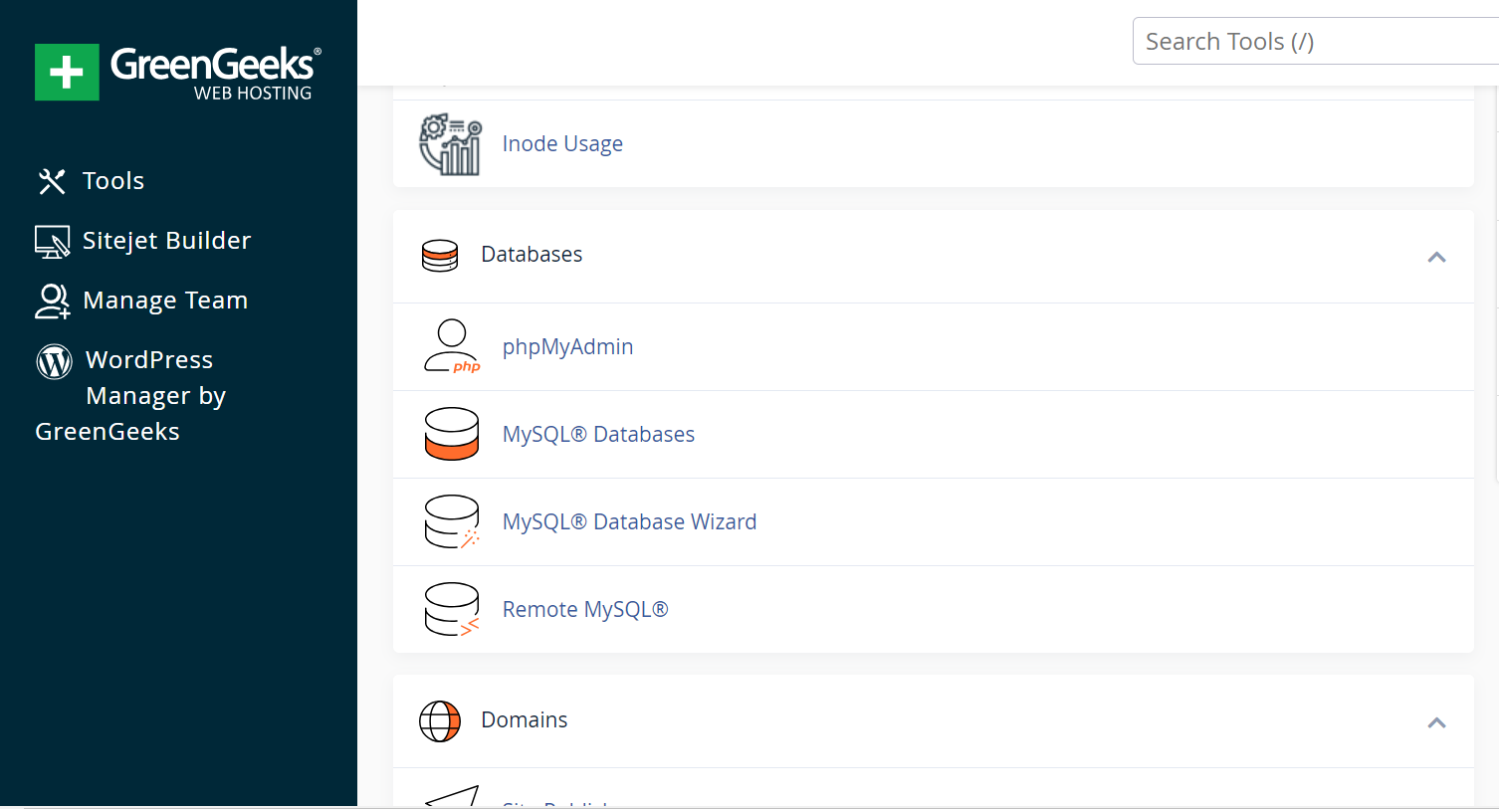
2. Click on “MySQL Databases”. There are several sections on this page that allow creation and manipulation of SQL databases. This step will tilize “Create New Database”, “MySQL Users – Add New User”, and “Add User to Database.”
   1. Go to “Create New Database”. There will be a field to determine the name of the new database. The name of the database will always start with the default username. The rest of the database username should be unique to the application. When a name is determined, click the “Create Database” button.
      1. This example will name the database PA_mock_app
   2. Next, a user must be created that will be added to the database. Navigate to “Add New User” in the “MySQL Users” section. Create a username and password. The username may or may not be the same as the database. *Make sure to copy down the password, this will be added to the sqlAccess.php file (Step 5) so the app can connect to the database and call on the data*. Once a username and password is determined , click the “Create User” button.
      1. The example will use the username PA_mock_app
   3. Now the user must be added to the database to make edits. Select the username and the database to add the user to. Click the “Add” button. Give the user “Global Privileges” and click “Save”
3. Now the SQL database has been created, go back to the cPanel “MySQL Databases” page and click on “phpMyAdmin” The screen should look like the image below. The databases are listed on the left.

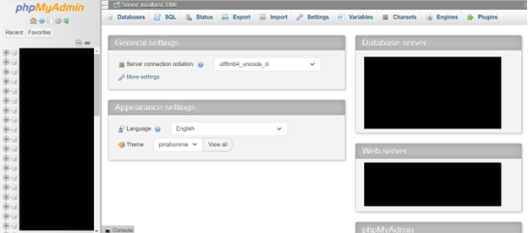

* 1. To add data to the database, click on the database listed on the left. Click “Import” and then “Choose File”. Unfortunately, each category of hub data must be uploaded individually, so choose one file to upload with the appropriate hub data. Scroll to the bottom and toggle the option on that says “The first line of the file contains the table column names”
     1. If the toggle option is not there, navigate back to the left-hand side and make sure to click on the database and then import. Do not click on existing datasets within the database to import more data
     2. For this example, upload the CSV files located in “3_Clean_Harmonize_Data” > “3B_Cleaned_Hub_Data”

1. Once all data files have been uploaded the database has now been built