5. Build User Interface

Now that all the data has been collected and cleaned and the SQL database has been created, the files to make the app can now be built. Step 5 is the same for hosting globally and locally.

The folder template contains all the material needed to host the app. The following explains each of the files and folders and how they work together to create the app.

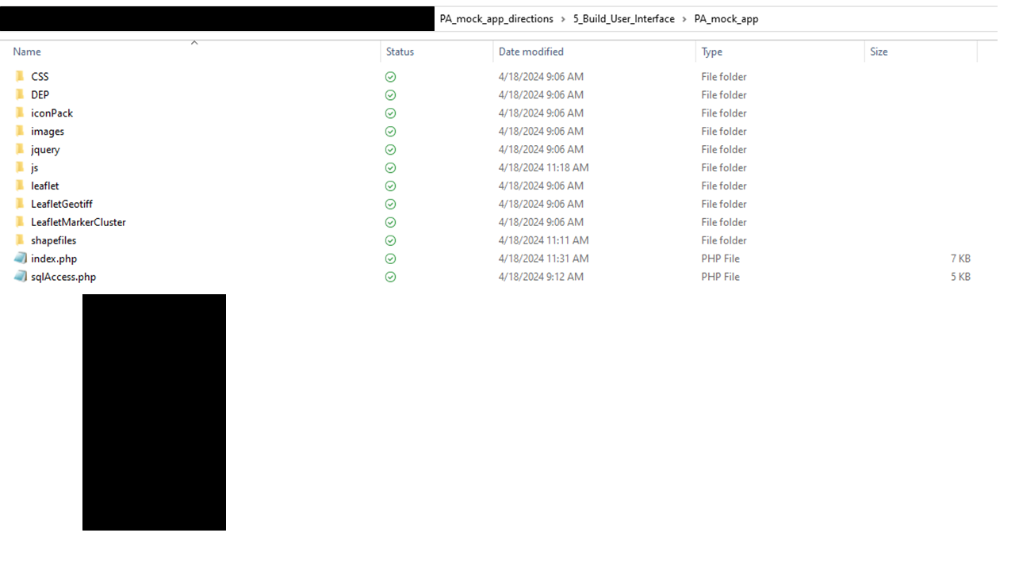

1. **Import data**
   1. sqlAccess.php: to import hub data, the SQL database created in step 4 must be connected to the app. *At the top of the sqlAccess.php file enter the appropriate username, password, and database name created in step 4.*
   2. Shapefiles folder: place all of the geographic data to display on the map in this folder. These files will be called on in the shapefileVars.js file. For the template, this folder contains:
      1. County_1km_grids: folder containing all the 1km grid of each county. Each county folder is zipped
      2. County_outline
      3. Establishment_risk
      4. Hub_density
   3. iconPack folder: contains symbols that will be attributed to specific hub categories. It is recommended to use royalty free transparent PNGs.
      1. *Update* iconTest.js *accordingly by duplicating code with the name of the new icon*
   4. Images folder: Upload an images to appear for the tab of the webpage at the top
2. **Update code to accommodate data**
   1. sqlAccess.php: in addition to inserting the username, password, and database name, the code should be updated to align with the hub types. The code should connect to the sql database, initialize the data, attribute the data to a layer, and match an appropriate icon.
   2. Index.php: This file serves to bring all the data and files together to create the map. Make sure all the files are properly called on. Here is also where coordinates and zoom can be set for the map. At the bottom, make sure to designate the appropriate buttons for each layer or category.
   3. Js > shapefilesVars.js: This code loads in all the shapefiles and can manipulate the appearance of the shapefiles by designating size, colors, transparency, etc. The end of the script assembles the shapefiles and to put them in the drop-down menu.
3. **Changing the map/app appearance:** To change the appearance of the interface navigate to the following:
   1. js > Basemap.js: To use a different basemap (topographic, satellite, etc.) adjust that in this script
      1. Script also includes links featured in the lower right corner which can be updated with customized feedback and about links
   2. CSS > mapstyle.css: This code dictates the interface appearance of the buttons and about information.
4. **Other files**:
   1. js > clusterButtons.js: Establishes functions to make buttons turn toggle on and off and change colors.
   2. Leaflet, leafletGeotiff, LeafletMarkerCluster: these folders are downloaded from leaflet map makers who publish their code publicly.