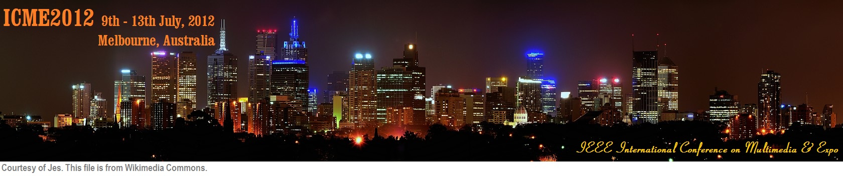

|  |
| --- |
| **IEEE International Conference on Multimedia & Expo Call for Tutorial Proposals  9th-13th July, 2012, Melbourne, Australia**  The [ICME 2012](http://www.icme2012.org/) Organizing Committee invites proposals for tutorials. ICME 2012 will take place in Melbourne, Australia from 9th to 13th July, 2012. The tutorials will be held on the first or last day of the ICME 2012, either on 9th or 13th July.  We seek proposals for half-day and full-day tutorials. We are interested in tutorials on established or emerging research topics within the field itself, but we also welcome tutorials from related research fields or application areas. The ideal tutorial should attract a wide audience, be broad enough to provide a gentle introduction to the chosen research area, and should also cover the most important contributions in depth. Proposals that exclusively focus on the presenter’s own work or commercial presentations are not eligible.  Topics of interest include, but are not limited to:   * Speech, audio, image, video, text processing * Signal processing for media integration * 3D visualization, animation and virtual reality * Multi-modal multimedia computing systems and human-machine interaction * Multimedia communications and networking * Multimedia security and privacy * Multimedia databases and digital libraries * Multimedia applications and services * Media content analysis and search * Hardware and software for multimedia systems * Multimedia standards and related issues * Multimedia quality assessment   **Proposal Submission**  Tutorial proposals must be in PDF format and submitted via emails to Tutorial co-chairs Yen-Kuang Chen (y.k.chen [at] ieee.org) and Shuicheng Yan (eleyans [at] nus.edu.sg).  **Selection**  All tutorial proposals may first receive peer review. Then, from the pool of proposal deemed of the highest quality, the chairs will make the final selection of tutorials to present the greatest variety to conference attendees and to fit the conference schedule.  **Upon Acceptance**  Speakers for all accepted tutorials will be required to sign a commitment to present at the conference within 30 days of notification. Speakers also need to provide a 300-word abstract (for inclusion in registration materials). Materials for the conference DVD must be delivered by 15th March, 2012.  **Proposal Format**  Proposals, prepared in an one‐column PDF file (no more than 3 pages), should include the following information:   * Title of the tutorial * Keywords * Format of the tutorial (1/2 day or 1 day) * Description of the tutorial   + I. Motivation---“Why is this topic important?”   + II. Objectives---“Why should one attend this tutorial?”   + III. Key takeaway messages---“What can the attendees learn from this tutorial?”   + IV. Target audience and prerequisite knowledge of audience---“Who should attend this tutorial?”   + V. Outline---“What does the speaker plan to give in the tutorial?”   + VI. Speaker’s credentials, e.g., a short BIO, whether the speaker has offered tutorials before---“Why should ICME choose this speaker to teach this tutorial?” * Materials: A description (one or two paragraphs) of materials to be provided to attendees on the conference DVD – course slides, annotated bibliography, code snippets etc. NOTE: the materials themselves do not need to be provided in the proposal.   **Important Dates:**   * Tutorial Proposal Due: 29th October, 2011 * Notification of Decision: 15th December, 2011 * Tutorial materials Due: 15th March, 2012   **Tutorial co-chairs:**  Yen-Kuang Chen (y.k.chen [at] ieee.org), Intel Corporation, USA  Shuicheng Yan (eleyans [at] nus.edu.sg), National University of Singapore, Singapore  Main conference email: [icme2012@icme2012.org](mailto:icme2012@icme2012.org)  Main conference website: <http://www.icme2012.org/> |