**2018 IES Women in Engineering Forum**

**Monday, October 22, 2018**

**14.05-15:05: Panel**

### **Panel Title: " Women AND Engineering: What Works, What Doesn't"**

**Moderators:**

Lucia Lo Bello, University of Catania, Italy,

Morgan Kiani, Texas Christian University, Fort Worth, USA.

**Panelists:**

* Seta Bogosyan, Istanbul Technical University (ITU), Turkey, and University of Alaska Fairbanks (UAF), USA
* Susan K. (Kathy) Land, IEEE Vice President of Technical Activities, Program Manager C2BMC S8.2-3 Missile Defense Agency, USA
* Nicola Palmarini, Global Manager AI for Healthy Aging, IBM's Thomas J. Watson Research Center, USA
* Clara Otero Perez, Director System Innovations ,NXP Semiconductors, the Netherlands
* Gaetana Sapienza, R&D Manager, ABB Corporate Research, Sweden
* Concettina Buccella, University of L’Aquila, Italy.

This event is to foster the women involvement in scientific and technical activities, but it is not intended for women only.

Professionals and students, independently of the gender, are welcome to the discussion to identify needs and new initiatives to fulfil the intended goals, while networking in a relaxed atmosphere.

**Panelists**

Seta Bogosyan



Istanbul Technical University (ITU), Turkey

University of Alaska Fairbanks (UAF), US.

Seta Bogosyan received her B.Sc., M,Sc. and Ph.D degrees in electrical and control engineering from Istanbul Technical University, Turkey in 1981, 1983, and 1991, respectively. She conducted her PhD studies at the Center for Robotics in University of California at Santa Barbara (UCSB), where she worked as researcher and lecturer between 1987 and 1991. She is currently a professor of electrical engineering at Istanbul Technical University (ITU) and University of Alaska Fairbanks (UAF).

Between 2015 and 2017, she served as a program director at NSF Office of Int’l Science and Engineering. Since 2017, she has overtaken a CPS expert position at the NSF Computer & Information Science and Engineering (CISE), also continuing with her research and professorship positions at UAF and ITU.

Her research interests are teleoperation/bilateral control systems, CPS unmanned/ autonomous vehicles, high efficiency control of HEVS/EVS, and remote labs. She has served as PI to many NSF, and other federally funded grants, and co-authored over a hundred journal and conference proceedings, several book chapters, and two books. She is the Director of the ITU CPS Lab, and Center for Advanced Vehicle Technologies-Autonomous Vehicles. She has also served as VP to IEEE IES, as associate editor of IEEE Transactions on Industrial Electronics (TIE), IEEE Industrial Electronics Society Magazine, (IEM), and is a Senior Member of IEEE.

**Panelists**

Susan K. Land

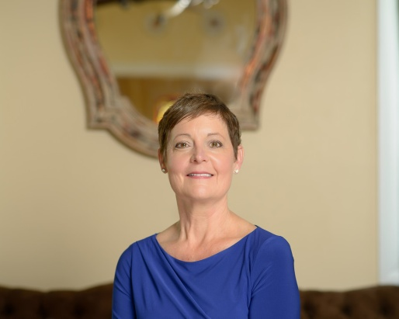

IEEE Vice President of Technical Activities, Program Manager C2BMC S8.2-3 Missile Defense Agency, USA

Susan K.(Kathy) Land is a Program Manager for the Missile Defense Agency in Huntsville, AL. She served as the 2009 president of the IEEE Computer, two terms on the Institute of Electrical and Electronics Engineers (IEEE) Board of Directors, and two terms as a member of the IEEE-USA Board of Directors (2013, 2016). She is currently the 2017 Vice President Elect for IEEE Technical Activities. She has more than 30 years of industry experience in the application of software engineering methodologies, the management of information systems, and leadership of software development teams. Ms. Land is the author or co-author of a number of texts, papers, podcasts, webinars all supporting sound software engineering principles and practical application of software process methodologies.

**Panelists**

Nicola Palmarini

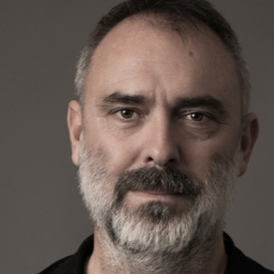

Global Manager AI for Healthy Aging, IBM Research - MIT/IBM Watson AI Lab Cambridge

Cambridge, MA (USA)

Nicola Palmarini is a researcher, teacher, writer and TEDx speaker focused on exploring the impact of cognitive technologies and their application in the society at scale and the life transitions of older adults. His primary areas of research are AI for Healthy Aging, The effect of loneliness as an accelerator of physical and cognitive diseases, Ageism as social discrimination.

With the book "Le Infiltrate" (Egea/Bocconi University Press, 2016) he explored the endemic lack of women in STEM careers and that research lead him to be founding board member of the NY based non-profit amazing.community which aims to support women over 55 in their career transition, transforming the false narrative about aging by redefining workplace inclusion, one woman at a time. The work of his team has been awarded two times with the Computer Honors Award and the Disability Matters - Market Place Award.

Between others, Nicola is a board member of International Scientific Advisory Committee at McMaster Institute for Research on Aging (MIRA) and member of the Gerontological Society of America. He works and lives in Boston.

**Panelists**

Clara Otero Pérez

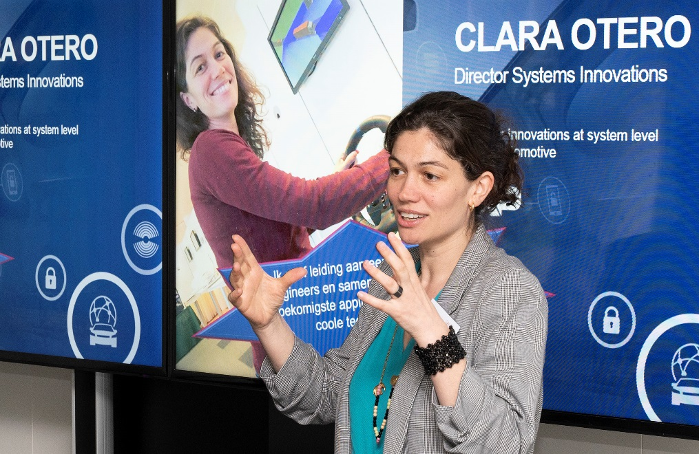

Director of Systems Innovations for NXP’s business unit Automotive in Eindhoven, Netherlands

Clara Otero Pérez is Director of Systems Innovations for NXP’s business unit Automotive in Eindhoven (NL). She is responsible for scouting new systems and applications where NXP’s products would play a role and build proof of concepts and demonstrators for those new applications such as connected car, autonomous driving and UAV.

After graduating in Physics by the University of Santiago de Compostela in Spain, she started to work for Philips Research in Eindhoven (NL) as a research scientist in the fields of resource scheduling, streaming architectures and real-time systems. In 2006 she moved to NXP and started working in automotive and secure connectivity related projects. Since 2008 she has worked as department manager driving innovation activities both internal as well as with partners in subsidy projects in the areas of IoT, connected car and cooperative mobility.

**Panelists**

Gaetana Sapienza

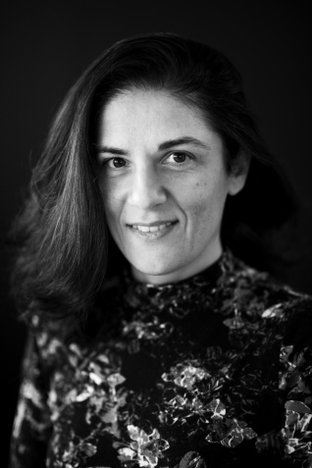

R&D Manager, ABB Corporate Research, Sweden and Head of Operations, SynerLeap, Sweden

Gaetana Sapienza holds a Ph.D. degree in Computer Science and Engineering from Mälardalen University, Sweden and received a M.Sc. degree in Computer Science Engineering from the University of Catania, Italy. She joined ABB in 2006, where she currently works as R&D Manager for Control, Optimization and Analytics at ABB Corporate Research. She is also Head of Operations at the innovation growth hub SynerLeap powered by ABB, in Sweden. Her main research areas of interest include embedded systems design, modelling and control of industrial automation and robotics applications. Gaetana holds several publications in international venues and journals.

**Panelist**

Concettina Buccella



University of L’Aquila

and DigiPower Ltd., L’Aquila, Italy

Concettina Buccella received the M.S. degree and the Ph.D. degree in Electrical Engineering from the University of L’Aquila, Italy, in 1988 and the University of Rome “La Sapienza” in 1995, respectively. After graduation she was a research engineer with Italtel SpA, L’Aquila, then in 1991 she joined the Department of Electrical Engineering at the University of L’Aquila, where she was an assistant professor and since 2001 she is Associate Professor of Electrotechnics. She holds the italian habilitations as Full Professor in Power Converters, Drivers, Machines and Power Systems and in Electrotechnics. She is Associate editor of IEEE Transactions on Industrial Electronics and of Springer's Journal of Intelligent Industrial Systems. In 2016 she has been elected Chair of IEEE-IES Renewable Energy Systems Technical Committee. Her research interests deal with smart grids, power converters modulation techniques, renewable energy management, analytical and numerical modeling. She was plenary speaker at International Conference of Energy and Water, September 25-27, 2013, Luanda, Angola and keynote speaker at International Conference on Renewable Energy Research and Applications, ICRERA-2018, October 14-17, 2018, Paris, France. She has been a Co-Founder of DigiPower Ltd., a University of L’Aquila spin-off operating in the field of industrial electronics, power systems, smart grids, modeling, electromagnetic compatibility. She has been a co-recipient of the 2012 Best Paper Award of the IEEE Transactions on Industrial Informatics for the paper “Smart Grid Technologies: Communication Technologies and Standards”, IEEE Transactions on Industrial Informatics, vol. 7, no. 4, pp. 529 - 539, Nov. 2011 and a co-recipient of the 2013 Best Paper Award of the IEEE Transactions on Industrial Informatics for the paper “Digital Control of Power Converters - A Survey ”, IEEE Transactions on Industrial Informatics, vol. 8, no. 3, pp. 437-447, Aug. 2012.

**Panel Moderator**

Morgan Kiani



Texas Christian University

Morgan Kiani has been a faculty member in the Department of Engineering at Texas Christian University since spring of 2011. She received her Ph.D. degree in Electrical Engineering from the University of Texas at Arlington in 2009. She was an adjunct faculty member at the University of Texas at Arlington prior to joining TCU. Her research interests include modeling and analysis of energy converters, numerical methods in power system simulation, integration of distributed generators in smart grid , fault detection in wind farms, energy harvesting, energy diversification and power electronics. Her teaching interests include electric circuits, power systems, power electronic systems and electromechanical energy conversion. Dr. Kiani has authored several scientific articles in peer reviewed journals and conference proceedings. She has a patent on active control of Doubly Fed Induction Generators (DFIG) used in wind energy harvesters.

**Panel Moderator**

Lucia Lo Bello

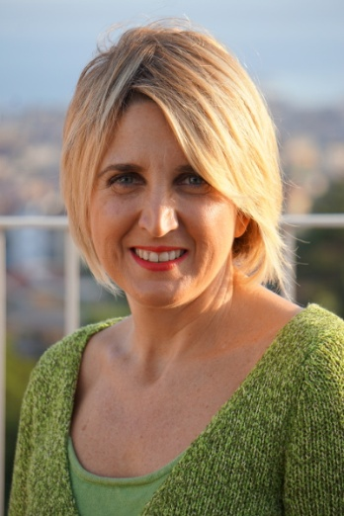

University of Catania, Italy

Lucia Lo Bello is tenured Associate Professor with the Department of Electrical, Electronic and Computer Engineering, University of Catania, Italy. She received the M.S. degree in Electronic Engineering and the Ph.D. degree in Computer Engineering from the University of Catania, Catania, Italy, in 1994 and 1998, respectively. She was also Guest Professor at the University of Malardalen, Sweden, in 2014 and Visiting Researcher with the Department of Computer Engineering, Seoul National University, Korea (2000-2001). In 2008 she was the recipient of the IEEE Industrial Electronics Society Early Career Award. She authored or coauthored more than 140 technical papers in the area of automotive communications, industrial networks, real-time embedded systems, and wireless sensor networks. She is responsible for several international and national projects and for research contracts in the area of automotive communications, industrial networks, and real-time embedded systems. Prof. Lo Bello is Senior Member of the IEEE. She was the Chair of the IEEE Industrial Electronic Society Technical Committee on Factory Automation for two terms (2014-15) and (2016-2017). Since 2004 actively involved in standardization activities, relevant to wired and wireless industrial networks, at both national and international level. She is the current IES representative within IEEE Women in Engineering.