**The 44th Annual Conference of the IEEE Industrial Electronics Society.**

**October 21-23, 2018**

**Omni Shoreham Hotel, Washington DC, USA**

**Young Professionals & Student Activities Program**

Chairs: Milos Manic, Xinghuo Yu, Marek Jasinski,   
Dmitri Vinnikov, Marek Turzynski, Hani Vahedi, Aleksander Malinowski

**Program**

**Sunday, 21. October.2018**

**Room:**

**Regency - at the conference opening ceremony**

**8:50 – 9:00** Message to Young Professionals & Student from the IES President Prof. Xinghuo Yu, VP for Membership Yousef Ibrahim, YP&S Committee Chair Marek Jasinski.

**Room:  
Empire - Young Professionals & Student Tutorial and Industry Link – Invited speakers,**

### **09:15-09:45** Tutorial:

### *“Galvanically Isolated Impedance-Source DC-DC Converters – Versatile Solution for Residential DC Microgrids,”*

### by Andrii Chub, TalTech University, Dept. of Electrical Power Engineering and Mechatronics, Tallinn, Estonia.

Chairs: Marek Jasinski

### **9:45-10:15** Industry Link:

### *“The stages in creating a successful product with innovation at each stage,”* by Michael W. Condry, Global Alliance for Innovators and Entrepreneurs, USA.

Chairs: Dmitri Vinnikov

### **10:15-10:45** Industry Link:

### “*Towards IoT-enhanced decision making in Enterprises*,”

### by Stamatis Karnouskos, SAP, Germany.

Chairs: Aleksander Malinowski

### **10:45-11:15** **S&YP Mentor and IEEE IES Past President Keynote Speaker (Plenary)**

### “*Designing Industrial Electronics systems a key … for success,”*

### by Kamal Al-Haddad, École de technologie supérieure (ÉTS), Montréal, Québec, Canada.

Chairs: Xinghuo Yu

# **Room:**

# **Empire - Young Professionals & Student IES-SYPA 3 Minute Speeches Session + Forum**

Chairs: Xinghuo Yu, Juan José Rodríguez Andina, Marek Jasinski

**13:15-14:35 YPS 3MSS + Forum**

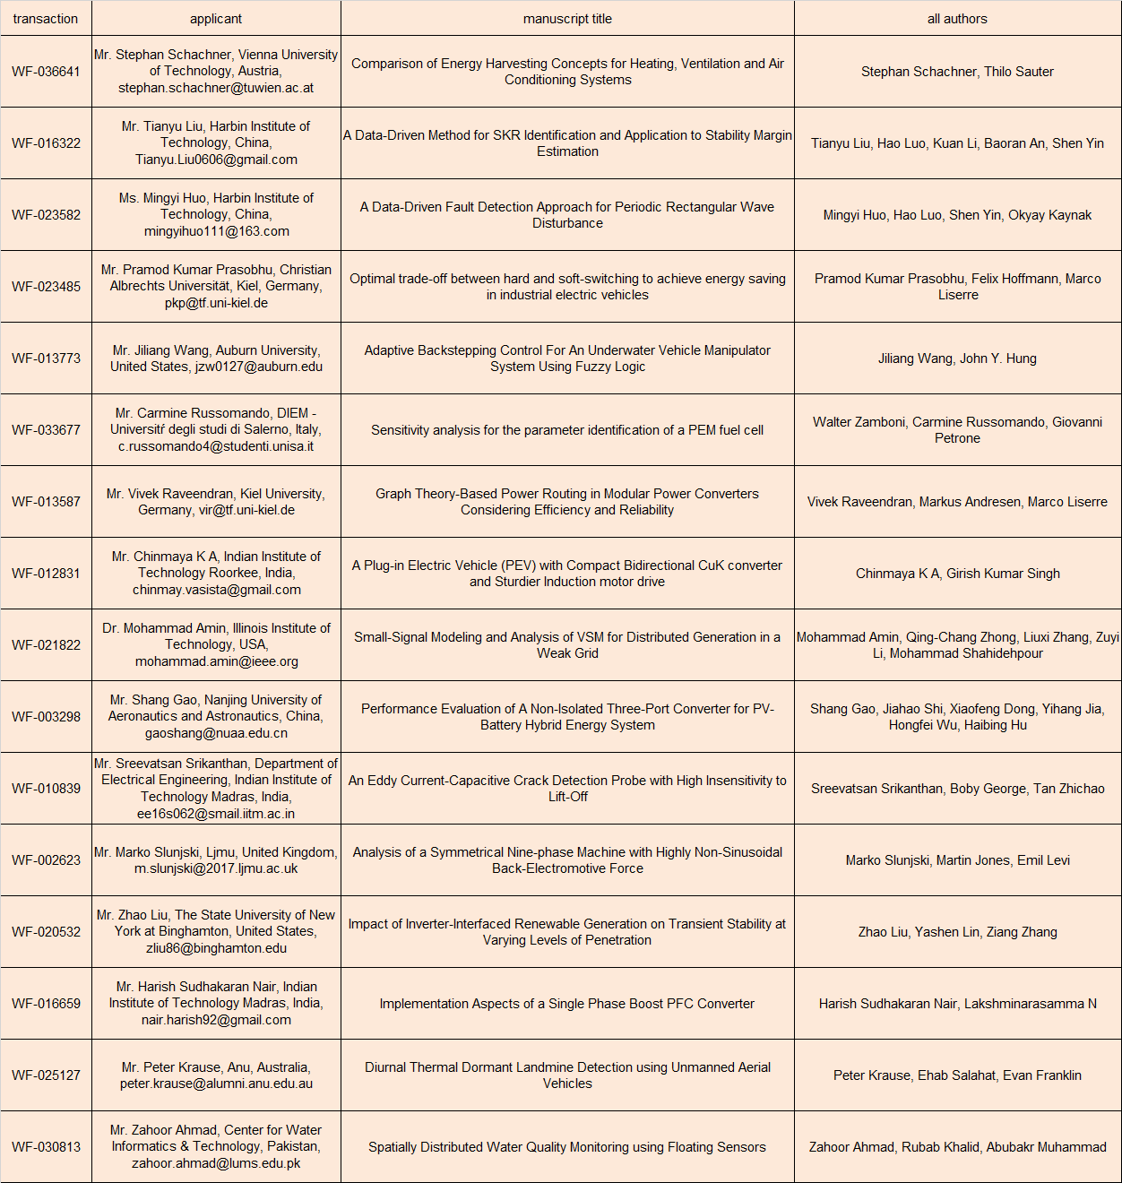

Each presentation has 3 minutes (video instead of classical presentation).

All videos are available online at IEEE IES YouTube Channel:

<https://www.youtube.com/channel/UCKg8GNii0Q-ieXE56AXosGg/playlists>

Please subscribe and like or dislike videos.

**14:35-14:40** VP for Conferences of IEEE IES Juan Rodríguez-Andina:

*“Conferences* – *what is the best in meeting professionals*!”

**14:40-14:45** VP for Publications of IEEE IES Mariusz Malinowski:

*“Publications* – *as a step for the better future*!”

**14:45-14:50** Lori A. Floyd-Miller, M.Ed. Graduate Programs Coordinator VCU College of Engineering.

**14:50-14:55** Champion of IEEE IES Chapters Kim Fung Tsang*:*

*“Chapters* – *a good choice for young at heart at any time!”*

**14:55-15:00** VP for Membership of IEEE IES Yousef Ibrahim:

*“IES Membership* – *profits not only for the youngest!”*

**15:00-15:05** Treasurer of IEEE IES C.J. (Allen) Chen:

*“IES financial assistance for awardees and volunteers”*

**15:05-15:10** Chair of IEEE IES WIE Committee Lucia Lo Bello:

*“Message to young researchers about women activities in IES and at IECON18*.”

**15:10-15:15** Chair of IEEE IES YP&S Activity Committee Marek Jasinski:

*“Sustainable development in IEEE IES YPS - Closing remarks and summary.”*

**19:30 - 21:30, Young Professionals & Student Party (YPS Party),**

**[Place: TBD]**

Chairs: Milos Manic, Dmitri Vinnikov, Marek Jasinski

*Dear Authors,*

*If you are Young Professional or Student (YPS), please register for the Young Professionals & Student Party on Sunday, 21. October 2018, 19:30 - 21:30.*

*The venue will be announced later by the conference website and IECON18 registration desk.*

*The YPS Party is free of charge.*

*Please confirm your attendance before 08.October.2018 Washington D.C. time, have a drink and chat with IEEE IES Officers/Fellows in relaxing and nice atmosphere.*

*If you would like to join us, please send the email to* [*dmitri.vinnikov@taltech.ee*](mailto:dmitri.vinnikov@taltech.ee) *with CC to* [*marek.jasinski@ieee.org*](mailto:marek.jasinski@ieee.org)*.*

*See you soon and, best regards,*

*on behalf of IEEE IES,*

*Xinghuo Yu, Milos Manic, Dmitri Vinnikov, Andrés A. Nogueiras Meléndez, and Marek Jasinski.*

**Monday, 22. October. 2018**

**18:30 - 22:00 [Gala Dinner - Banquet in Regency Ballroom]**

# **Young Professionals & Student Diploma Ceremony**

The diplomas will be distributed by IES President, IES Treasurer, Conference General Chair, IES VP for Membership, and IES Young Professionals & Student Committee Chair.

Should you have any questions, please contact Marek Jasinski at [marek.jasinski@ieee.org](mailto:marek.jasinski@ieee.org).

**Invited speakers details**

**Andrii Chub** (S’12–M’17) received the B.Sc. degree in Electronics and M.Sc. degree in Electronic Systems from Chernihiv State Technological University, Ukraine, in 2008 and 2009, respectively, and the Ph.D. degree in electrical engineering from the Tallinn University of Technology, Estonia, in 2016.

In 2018 he was awarded a competitive research fellowship from Chilean Solar Energy Research Center. Consequently, he is a Research Fellow in the Federico Santa María Technical University , Chile, and retains a position of Researcher in the Power Electronics Group of the TalTech University, Estonia. Prior to that, he was a Visiting Research Fellow in the Kiel University working in European Research Council project “Highly Efficient and Reliable Smart Transformer” between January and July 2017.

He has co-authored more than 70 papers and a book chapter on power electronics and applications. In addition, he holds several patents and utility models. His research interests include advanced dc-dc and dc-ac converter topologies, impedance source electric energy conversion technology, renewable energy conversion systems for energy-efficient residential buildings, and converter topologies for the smart transformer.

*Subject: “Galvanically Isolated Impedance-Source DC-DC Converters – Versatile Solution for Residential DC Microgrids.“*

**Abstract:** Galvanically isolated impedance-source dc-dc converters are a novel technology with numerous advantages. Wide input voltage regulation capabilities and high reliability enable application of these converters in extremely demanding residential DC microgrid. Thanks to the power circuit versatility, these converters can be used as a power electronic interface not only for the power sources with unidirectional power flow (e.g., the photovoltaic panels and fuel cells) but also in the bidirectional applications, such as modular battery storage systems.

This presentation will introduce a concept and main advantages of galvanically isolated impedance-source dc-dc converter technology and provide an insight into the impedance-source dc-dc technology, explain its general design and control principles and applicability issues in the residential power generation systems. Main differences from conventional voltage- and current-source counterparts will be outlined. Recent research advances in this field will be presented. Application examples of different topologies will be given along with application-specific experimental results. The following converters tested experimentally will be discussed:

- shade-tolerant PV module integrated buck-boost converter and its optimization through topology morphing and variable DC link control;

- low-cost PV module integrated converter;

- power conditioning unit for PMSG-based variable speed micro wind turbines;

- high-boost multiphase single-switch impedance-source converter for interfacing of renewable and alternative energy sources into a DC microgrid;

- bidirectional converter for the 24V battery energy storage system.

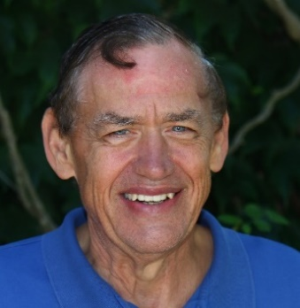**Michael** is currently Chair, Advisory Board, Clinicai, Inc.; he was the co-founder and vice chairman of the board for the Global Alliance for Innovators and Entrepreneurs, a new association to advise entrepreneurs and innovators on product creation opportunities. Formally, Michael was the Chief Technical Officer for Intel Corporation, Client Division. His career has a mixture of academic and industry positions, mostly in industry. Holding teaching and research positions at Princeton and the University of Illinois, at Illinois he led an internet application research team contributing findings to the US Internet committee under Al Gore. His industry roles included AT&T Bell-Labs, Sun Microsystems, and Intel. At Bell Labs, he was a co-architect for the Bellmac-32 processor and co-designed the System V Inode File System whose successors are in use today. At Sun he led standards for the Solaris/UNIX team founding the Open Group to enable these standards. Michael came to Intel to head up Networking Applications research in Intel Labs. Michael’s CTO role drove on customer innovation, design cost reduction, and other technologies and leading technical staff development. He led efforts to help the customer with system design and security. This plus efforts in technical staff development at Intel awarded him and his team the prestigious Intel Quality Award in 2015. His background includes projects in computer architecture, software, firmware, operating systems, networking, IoT, internet applications, standards, and computer security. Michael retired from Intel in June 2015.

Michael has patents in computer architecture and security. He has published many technical papers and regularly presents keynotes at technical conferences.

Michael is the President of the IEEE Technology and Engineering Management Society (TEMS). Michael is a senior board member for the IEEE Industrial Electronics Society (IES), he created and chaired the IEEE Industry Forum series that has successfully engaged industry in over 17 conferences. Michael is also a member of the IEEE Computer Society for over 28 years. He has chaired many IEEE conferences as well as the Industry Forum program.

*Subject: “The stages in creating a successful product with innovation at each stage.”*

**Abstract:** The process of product development confronts multiple challenges in going from idea to successful product. Along the way, there are many potential opportunities for innovation. Of course, there is the basic idea and its value, such as a sensor to detect cancer. Many challenges follow. The idea needs justifiable testing and proof of concept. It must be efficiently manufactured. The market must be focused and suitable for the cost/value of the product. Any standards or government policies must be met. All offer steps of innovation but these challenges must be met for success. This presentation overviews the “big picture” with existing examples of areas of challenge and solutions.

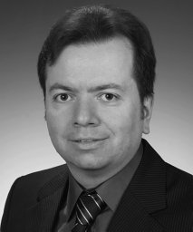**Stamatis Karnouskos** is an expert on the Internet of Things at SAP, Germany. He investigates the added value and impact of emerging technologies in enterprise systems. For over 20 years, he has led efforts in several European Commission and industry-funded projects related to the Internet of Things, Cyber-Physical Systems, Industrie 4.0, manufacturing, smart grids, smart cities, security, and mobility.

*Subject:* “*Towards IoT-enhanced decision making in Enterprises.*”

**Abstract:** In fast-paced business environments, the modern enterprises need to stay competitive. To do so, they continuously aim for optimization of their business processes as well as interactions with other stakeholders.

Internet of Things has empowered enterprise processes with detailed data upon which analytics can be realized, and insights can be acquired.

A challenging next step is to use analytics, combine them with business processes, and automate decision making.

New tools that enable such efforts to help the enterprise to optimize its resource usage, and adjust its processes for the new infrastructure need to be developed. Coordinating all of these actions in an efficient manner, ultimately empowers modern enterprises to stay competitive enhance their performance.

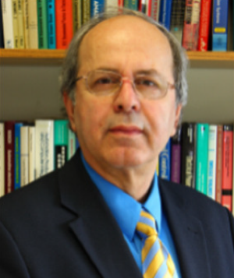

Kamal Al-Haddad (S’82-M’88-SM’92-F’07) received the B.Sc.A. and M.Sc.A. degrees from the University of Québec à Trois-Rivières, Canada, in 1982 and 1984, respectively, and the Ph.D. degree from the Institute National Polytechnique, Toulouse, France, in 1988. Since June 1990, he has been a Professor with the Electrical Engineering Department, École de Technologie Supérieure (ETS), Montreal, QC, where he has been the holder of the Canada Research Chair in Electric Energy Conversion and Power Electronics since 2002. He has supervised more than 100 Ph.D. and M.Sc.A. students working in the field of power electronics. He is a Consultant and has established a very solid link with many Canadian industries working in the field of power electronics, electric transportation, aeronautics, and telecommunications. He has coauthored more than 400 transactions and conference papers. His fields of interest are in high efficient static power converters, harmonics and reactive power control using hybrid filters, switch mode and resonant converters including the modeling, control, and development of prototypes for various industrial applications in electric traction, renewable energy, power supplies for drives, telecommunication, etc. Prof. Al-Haddad is a fellow member of the Canadian Academy of Engineering. He is IEEE IES President-Elect 2014-2015, Associate Editor of the Transactions on Industrial Informatics, IES Distinguished Lecturer and recipient of the Dr.-Ing. Eugene Mittelmann Achievement Award.

### *Subject: “Designing Industrial Electronics systems a key … for success.”*

**Abstract:**

In this presentation, an overview of the challenges facing young professionals in understanding the need for designing Industrial electronics systems. Become familiar with product certification standards, and the integration of university know-how into existing or newly developed industrial electronics product both on the power electronics side as well as on the control side. Creating and developing novel structure, novel controllers can certainly make a big difference in people life.