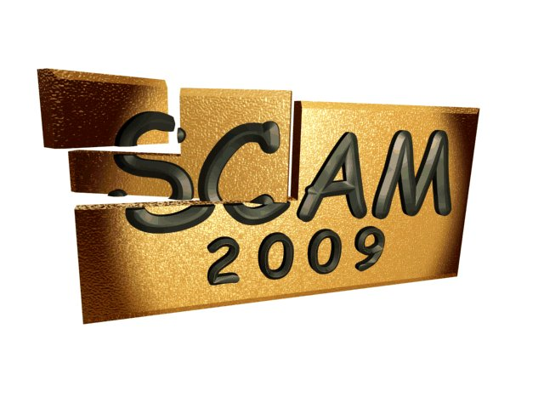    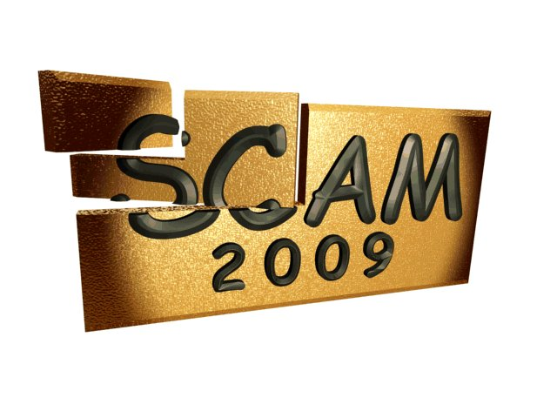 | Ninth IEEE International Working Conference on Source Code Analysis and Manipulation    SCAM 2009  20th – 21st, September 2009  Edmonton, Canada  http://www2009.ieee-scam.org/  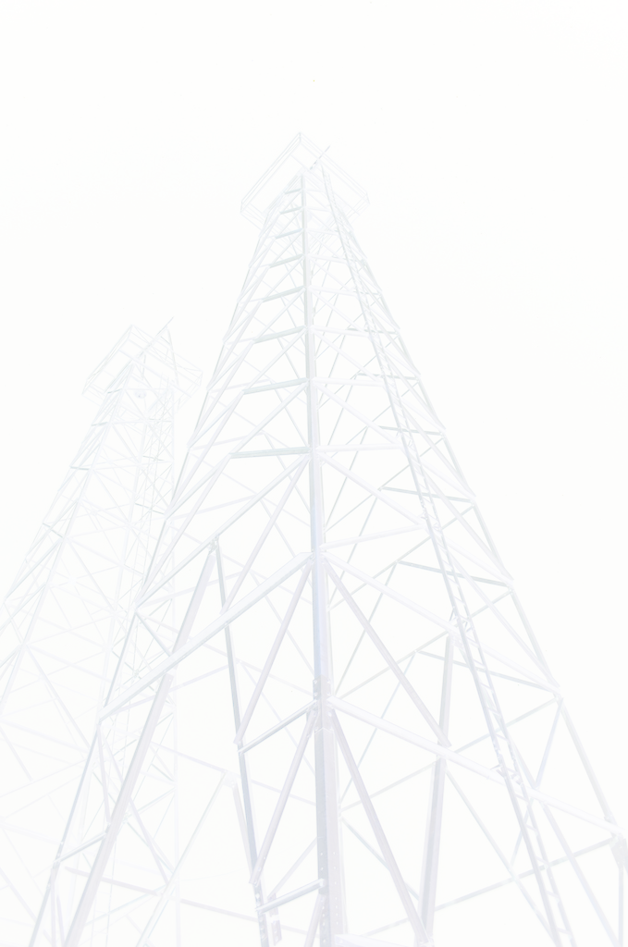
Co-located with: 25th IEEE International Conference on Software Maintenance (ICSM 2009)
http://icsm2009.cs.ualberta.ca/

General Chair:  Thomas R. Dean  Queen’s University, Canada  tom.dean@queensu.ca  Program Co-chairs:  Sibylle Schupp  Tech. Univ. Hamburg-Harburg, Germany  schupp@tuhh.de  Andrew Walenstein  University of Louisiana at Lafayette, USA  walenste@ieee.org  Tool Demonstration Chair:  Keith Brian Gallagher  University of Durham, UK  k.b.gallagher@durham.ac.uk  Publicity & Web Chair:  Zheng Li  King’s College London, UK  zheng.li@kcl.ac.uk  Financial Chair:  Dave Binkley  Loyola College in Maryland, USA  binkley@cs.loyola.edu  Proceedings Chair:  Dawn J. Lawrie  Loyola College in Maryland, USA  lawrie@cs.loyola.edu | The aim of this working conference is to bring together researchers and practitioners working on theory, techniques and applications which concern analysis and/or manipulation of the source code of computer systems. While much attention in the wider software engineering community is properly directed towards other aspects of systems development and evolution, such as specification, design and requirements engineering, it is the source code that contains the only precise description of the behaviour of the system. The analysis and manipulation of source code thus remains a pressing concern.  We welcome submission of papers that describe original and significant work in the field of source code analysis and manipulation. Topics of interest include, but are not limited to:  - program transformation  - abstract interpretation  - program slicing  - source level software metrics  - decompilation  - source level testing and verification  - source level optimization  - program comprehension  Submitted papers should not be longer than 10 pages. We also welcome submission of 2 page proposals for tool demonstrations expected to be performed live at the conference. All papers submitted should follow IEEE Computer Society Press Proceedings Author Guidelines. The papers should be submitted electronically via the conference web site. All accepted papers will appear in the proceedings which will be published by the IEEE Computer Society Press.  The best papers from SCAM 2009 will be considered for revision, extension, and publication in a special issue of the Software Quality Journal.
  Important Dates:
  Abstract submission:  Full paper submission:  Notification:  Camera Ready Due:  Workshop: | April 20th, 2009  April 27th, 2009  June 1st, 2009  June 30th, 2009  September 20th – 21st, 2009

