**DON BOSCO INSTITUTE OF TECHNOLOGY DEPARTMENT OF ELECTRONICS AND TELECOMMUNICATION**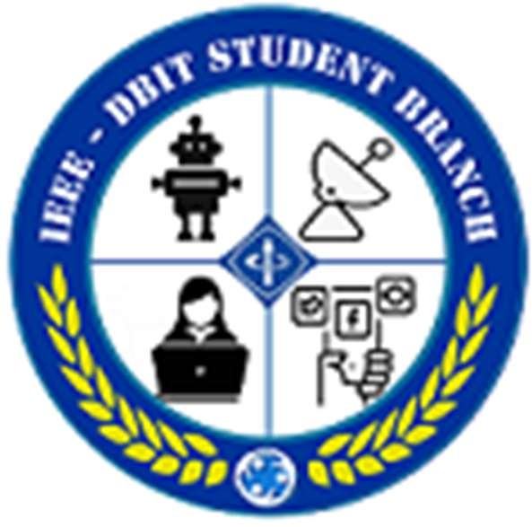

**IEEE-DBIT STUDENT BRANCH**

Title: Report on “Final Year Project Selection”

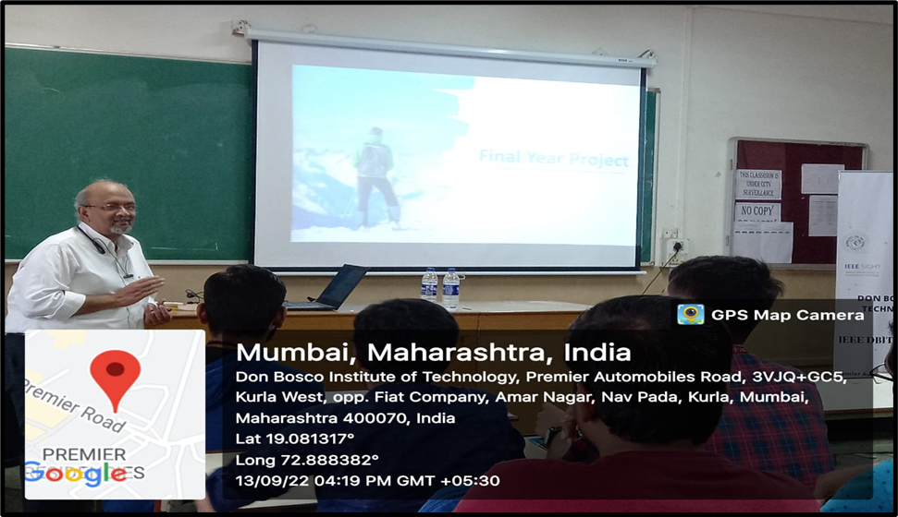

Topic: “Final Year Project Selection”

Date: 13th September; 2022

**Time:** 03:00 pm to 04:00 pm

**Venue:** EXTC CR3

**Speaker:** Mr. Abhay Phansikar, Director of Alizen Technologies, IMM past Chair IEEE Bombay Selection.

**Objective:** Students/Audiences should be able to select proper final year projects.

**No of Attendees :** 55

# Description:

* IEEE DBIT MTTS Student Chapter arranged a seminar on “Final year project selection” on 13th September; 2022.
* The speaker for the seminar was Mr. Abhay Phansikar, Director of Alizen Technology and also IMM past chair of IEEE Bombay selection.
* Mr. Abhay Phansikar introduced himself to attendees of the meeting. He was the Director of Alizen Technology and also IMM past chair of IEEE Bombay selection.
* He questions to the students/audience such as "Why is there a final project? why is it required? "Many students replied with a variety of answers”.
* They gave an introduction about the topic followed by diving into a detailed and thorough explanation about the importance of the selection of good final year project.
* He asked students many other questions such as their thoughts on higher education, where would they want to go for a master’s, etc.
* He also explained that one should have certain qualities to work on projects such as knowledge about the project, passion, communication, willingness and eagerness, clarity in thoughts, structuring of the project etc.
* The Project selected by the student must be used in society, Industry (eg. Application for order taking), Conservation (eg. Water recycling), and Automation (eg. Voice activated lights) all these examples were given by Mr. Abhay Phansikar.
* Projects he’s currently co-working on ‘ Sales app for Retails’ , ‘Data analysis of restaurants using ML’, ‘ Family tree app’, ‘ Personal info & app for portal’, ‘Health updates to children abroad using smart watch’ etc.
* After briefing was done then Q&A session was begin and then session was ended with vote of thanks.

**Summary of seminar analysis:**

The majority of the attendees who attended the webinar were students. Most of the participants have responded that the session was relevant and well organized. The questions asked during the webinar were answered in appropriate and satisfactory manner. The attendees agree that the overall session was valuable and informative. Decent number of attendees felt that they can now better understand the importance of selecting proper final year project or any project. Significant number of people were interested in participating in future webinars.

**Picture from the seminar:**

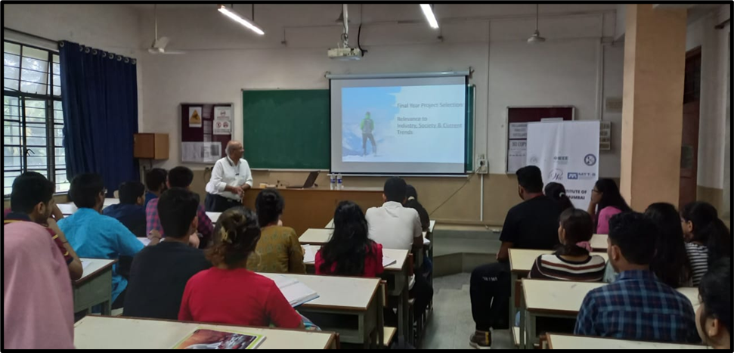

**Event Poster:**

