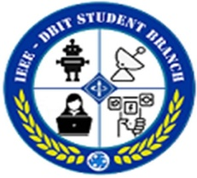**DON BOSCO INSTITUTE OF TECHNOLOGY**

**DEPARTMENT OF ELECTRONICS AND TELECOMMUNICATION**

**IEEE-DBIT STUDENT BRANCH**

Report on “Introduction Program”

Topic: “Introduction Program along with a Get-Together”

**Date:** 21st July, 2022

**Time:** 01:00 pm to 02:00 pm

**Venue:** Induction programMondini Hall C Wing 4th Floor , Lunch at Rev. Fr. Bosco Conference Hall, A wing 2nd floor.

**Guests:**

* Dr. Prasanna Nambiar (DBIT Principal & Faculty Mentor IEEE DBIT SIGHT)
* Ms.Namita Agarwal (EXTC-HOD)
* Prof. Gejo George (Former Branch Councilor of IEEE-DBIT SBC)
* Dr. Ashwini Kotrashetti (Former EXTC-HOD & Faculty Mentor IEEE DBIT MTT-S)

**Objective:**

* Induction Program of IEEE-DBIT SBC core team.
* Felicitate former Branch Councilor of IEEE-DBIT SBC Ms. Gejo George.

# Description:

* An Induction Program of IEEE DBIT Student Branch core was held on 21st July, 2022 in Mondini Hall. It was attended by the IEEE-DBIT SBC core team.
* The special guests invited were Dr. Prasanna Nambiar, Ms. Namita Agarwal, Ms. Gejo George and Dr. Ashwini Kotrashetti.
* The session was set in motion by the host for the day, Mr. Umer Shaikh (Vice-Chairperson of IEEE-DBIT SBC, MTT-S Chairperson) by extending warm greetings to everyone present for the event.
* Ms. Freda Carvalho (Current IEEE DBIT SB Counselor) by giving a brief introduction of special guests invited for the day. She conveyed her assurance to do her best while carrying out the newly allocated responsibilities to her as the newly appointed Branch Counselor.
* Ms. Shruti Gokhale (IEEE- DBIT Chairperson), addressed the gathering and assured a promising future for IEEE DBIT SBC by setting higher goals.
* Following this, Mr. Umer Shaikh carried out the duty of introducing the core members of the team. He then invited Dr. Prasanna Nambiar to address the core team.
* Dr. Prasanna Nambiar shared very inspiring words to motivate the team with. She propelled the idea of thinking big and thinking out of the box.
* Subsequently, Dr. Prasanna Nambiar felicitated Prof. Gejo George with a token of appreciation for carrying out the duty of Branch Counselor with dedication for 7 years. Dr. Prasanna Nambiar also appreciated her achievements and efforts due to which IEEE-DBIT was able to elevate to higher ranks.
* Towards the end, a group picture of all the members of the team along with the guests was clicked.
* The program was commenced by a vote of thanks by the host.
* The event concluded with a lunch in Mondini Hall.

Summary of Event Analysis:

1. It was induction function with IEEE members and Faculty.
2. Ms. Freda Carvalho (Current IEEE DBIT SB Counselor) gave a brief introduction of special guests and distributed the responsibilities to each member of IEEE.
3. Ms. Shruti Gokhale (IEEE DBIT Chairperson), addressed the gathering and assured a promising future for IEEE DBIT SBC by setting higher goals.
4. Mr. Umer Shaikh (IEEE DBIT Vice chairperson) carried out the duty of introducing the core members of the team. He then invited Dr. Prasanna Nambiar to address the core team.
5. Dr. Prasanna Nambiar shared very inspiring words to motivate the team with. She propelled the idea of thinking big and thinking out of the box.
6. Dr. Prasanna Nambiar felicitated Prof. Gejo George with a token of appreciation for carrying out the duty of Branch Counselor with dedication for 7 years.
7. Lastly we taken group photograph and had the delicious lunch doing chit-chat with members and faculty.

**Picture from the Event:** 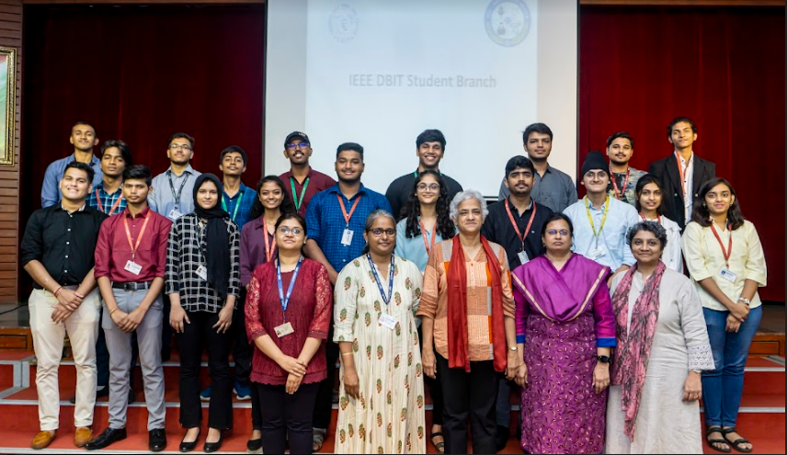

**Report Prepared by:** The Reporting Team, IEEE-DBIT Student Branch.

**Report Approved by: Ms. Freda Carvalho**