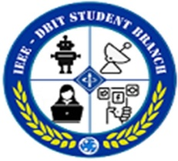**DON BOSCO INSTITUTE OF TECHNOLOGY**

**DEPARTMENT OF ELECTRONICS AND TELECOMMUNICATION**

**IEEE-DBIT STUDENT BRANCH**

Report on “Benefits of IEEE Membership.”

Topic: “Benefits of IEEE Membership”

**Date:** 21st October, 2022

**Time:** 11:15 am

**Venue:** Seminar Hall, Don Bosco Institute of Technology

**Resource Person:**

* Mr. Sandeep Mishra – Vice Chair, IEEE Membership Development Committee IEEE Bombay Section

**Objective:**

# Make students aware about the benefits of IEEE Membership

* Invite students to join IEEE - DBIT SBC

# Description:

* IEEE DBIT Student Chapter arranged a *“Benefits of IEEE Membership”* session on 21st Oct, 2022. The speaker invited was Mr. Sandeep Mishra.
* The aim of the seminar was to make students aware about the benefits available through IEEE Membership.
* The session was set in motion by Ms. Shruti Gokhale (IEEE-DBIT Chairperson) by extending warm greetings to everyone. Ms. Shruti Gokhale gave a brief introduction comprising of an overview of achievements and relevance of the IEEE in every domain.
* Mr. Sandeep Mishra introduced himself and started by listing out the objectives of the seminar.
* The speaker explained the IEEE Mission. It includes technical knowledge exchange, working with electronics, etc.
* He proceeded to explain about the various offers, IEEE website, the IEEE resume layout and so on.
* Mr. Sandeep Mishra explained about the IEEE Mentoring program and its benefits which could be accessed by the members which helps the students to integrate and enhance their profile. The concept of personal mentoring helps in professional development.
* Further, Mr. Sandeep Mishra introduced about the volunteering opportunities available which helps in developing strong networking and gain experience. All of these act as the building blocks to personal development and enhancement.
* He further explored the intriguing societies including Magnetic Society, Photonic Society and Signal Processing Society. The IEEE Resume Lab offers free samples letters, portfolios, and other documents.
* Later he discussed about the life insurances and disability discounts provided by IEEE. Mr. Sandeep Mishra gave out his contact details to those who want to reach out to him in the future.
* Dr. Ashwini Kotrashetti (Prof. - DBIT EXTC) took over. She spelled out the benefits of IEEE Membership.
* The seminar was open to a QnA session and students were able to get their queries answered.
* The session was concluded by a vote of thanks delivered by Miss. Shruti Gokhale (Chairperson - IEEE DBIT) to the speaker. She highlighted the current activities of the student branch to the crowd and motivated them to participate.
* **Event Poster:**

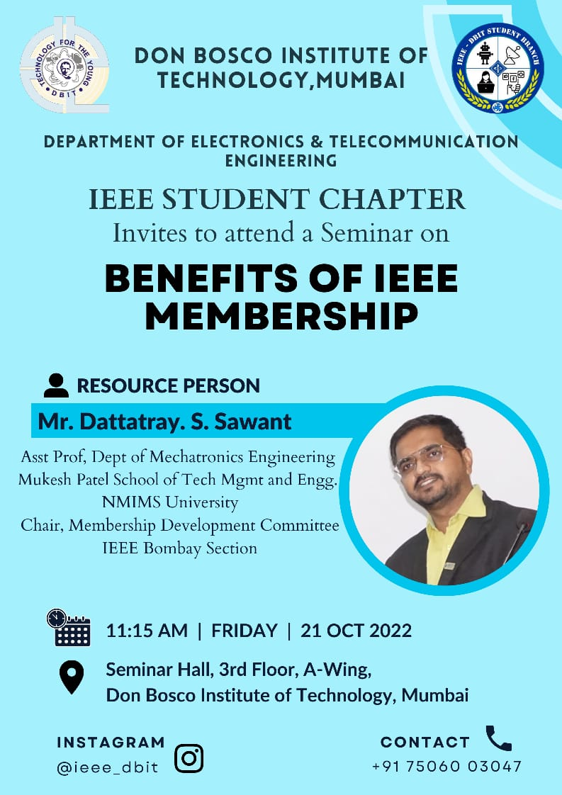

**Report Prepared by:** The Reporting Team, IEEE-DBIT Student Branch.

**Report Approved by:** Prof. Freda Carvalho (IEEE-DBIT Branch Council).