**DON BOSCO INSTITUTE OF TECHNOLOGY** 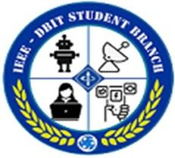

**DEPARTMENT OF ELECTRONICS AND TELECOMMUNICATION**

**IEEE-DBIT STUDENT BRANCH**

**Title: “STEM 2.0 – Demonstration of Electronic Experiments for School Students.”**

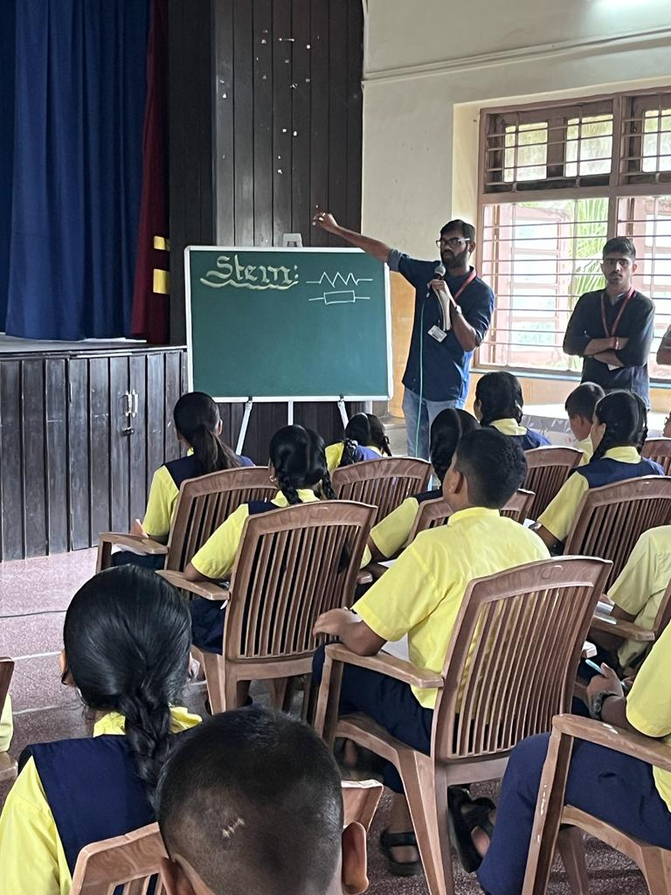

Topic: “Demonstration of Electronic Experiments for School Students”

**Date:** 10th September, 2022

**Time:** 10:00 am to 11:30 am

**Venue:**  Holy Cross High School, Kurla

**Speaker:** IEEE Team

**Objective: Knowledge about circuits , components and engineering fields**

* Students will get hands on experience of electronics.
* Easy experiments with demonstration.
* Increase motivation towards engineering.

**No of Attendees**: 90

**Description:**

* IEEE-DBIT Student Chapter arranged a workshop of “*S.T.E.M.-2.0 Demonstration of Experiments*” for class of 8th and 9th students on 10th September 2022.
* The introduction of S.T.E.M. Workshop. Further there was a brief explanation of various electronic components such as resistor, battery, capacitor, LED, IC, diode, and potentiometer.
* There were 5 experiments that was explained by the IEEE volunteers one by one to the students and even the demonstration was done practically.
* After the briefing and performance, the students also got the opportunity to demonstrate the experiments in groups.
* There was a Q&A session and after that seminar was ended with vote of thanks.

**Summary of session analysis:**

From the analysis we can determine that most of the attendees were students. Most of the participants have responded that the session was relevant and well organized. The questions asked during the webinar were answered in appropriate and satisfactory manner. The attendees agree that the overall session was valuable and informative. As reflected by the feedback, decent number of attendees felt that they can now better understand their measuring equipment and the measurement mechanics under practical conditions. Significant number of people are interested in participating in future webinars.

**Picture from the session:**

