**“Arduino Workshop”**

**Topic:** “Blink to build ARDUINO Workshop”

**Date:** 1st Feb, 2025

**Time:** 9:00 am to 11:00 am

**Venue:** EXTC Cr 2, C wing, Don Bosco Institute of Technology, Kurla, Mumbai 400070

**Speaker:** IEEE student chapter: Ayush Gajbhiye, Mayuri Kadam

**Support team:** Mohd Raza, Girish Sangare, Shafik Shaikh, Annanya Zadbuke

**No. of Participants Present: 32**

**No. of Girl Participants Present: 6**

**No. of Boy Participants Present: 26**

**Objective:** Introductory session for Arduino & Arduino IDE platform**.**

* Students can grasp and articulate the fundamentals of the Arduino platform, including its architecture and real-world applications.
* Students will gain proficiency in programming with the Arduino Integrated Development Environment (IDE) and utilize it to control hardware components for specific applications.

**Outcome:**

Hands-on Experience with Microcontrollers – Students learned to program and interface Arduino with various sensors, LEDs, and motors, enhancing their practical understanding of embedded systems.

Problem-Solving & Logical Thinking – By working on real-world projects, students developed critical thinking skills and the ability to troubleshoot hardware and software issues.

Foundation for Future Projects – The workshop provided students with the necessary knowledge to explore IoT, robotics, and automation, encouraging them to build their own innovative projects.

**Description:**

* IEEE-DBIT RAS Student Chapter organized an "Arduino" workshop for second-year students from all branches at DBIT on February 1, 2025.
* The workshop commenced on 1st Feb 9:00 am with an introduction of all students conducting it and then went on to basics of microprocessor and micro-controller.
* To further engage students, the speakers introduced a series of questions covering the fundamentals of electronics. Since students of other departments were also involved in the session, basic introduction of electronic components & connections was provided to students.
* Following the pre-session introduction, students were given an overview of Arduino, including its types, pin configurations, data-sheet, and general functionality.
* Students were also familiarized with other electronic components that would be used during the session, including sensors, LEDs, breadboards, and multimeters.
* After concluding the hardware description, the focus shifted to the software aspect. The Arduino IDE software was introduced, and the various tabs within the software were explained. The interaction between hardware and software was discussed, along with how coding in the software directs the functionality of the hardware.
* With the completion of the theoretical session, practical implementation began around 10:00 AM. Three experiments were conducted using Arduino to apply the concepts learned.

1. External LED blinking.
2. Ultrasonic sensors with Arduino UNO
3. Infrared sensors (IR) with Arduino UNO

* The practical session began with the software aspect, where students programmed the Arduino using the Arduino IDE for all three experiments. Student chapter explained the function of each code statement in detail.
* Students were provided with components to assemble the required circuitry, after which the programmed Arduino was connected to the circuit to enable functionality.
* Students observed the implementation of the experiments. The session concluded at 11:00 AM with a brief recap of the workshop was provided, summarizing the key learnings and activities.

**Conclusion:**

The Arduino workshop by the IEEE-DBIT RAS Student Chapter provided students with a hands-on understanding of both hardware and software aspects of Arduino. It began with fundamental electronics, followed by an introduction to Arduino and its components. Students learned coding in the Arduino IDE and implemented experiments to bridge software with hardware. After the session, electronics students were issued Arduino boards to use for their mini-projects in this semester. Having gained hands-on experience during the workshop, they are now well-equipped to handle and implement Arduino in their projects effectively. The session enhanced technical skills, fostering confidence and enthusiasm in embedded systems.

**Event Images: -**

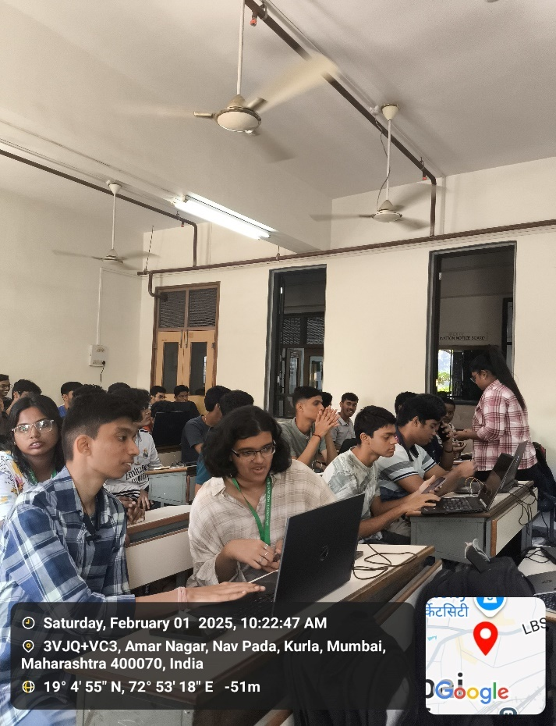

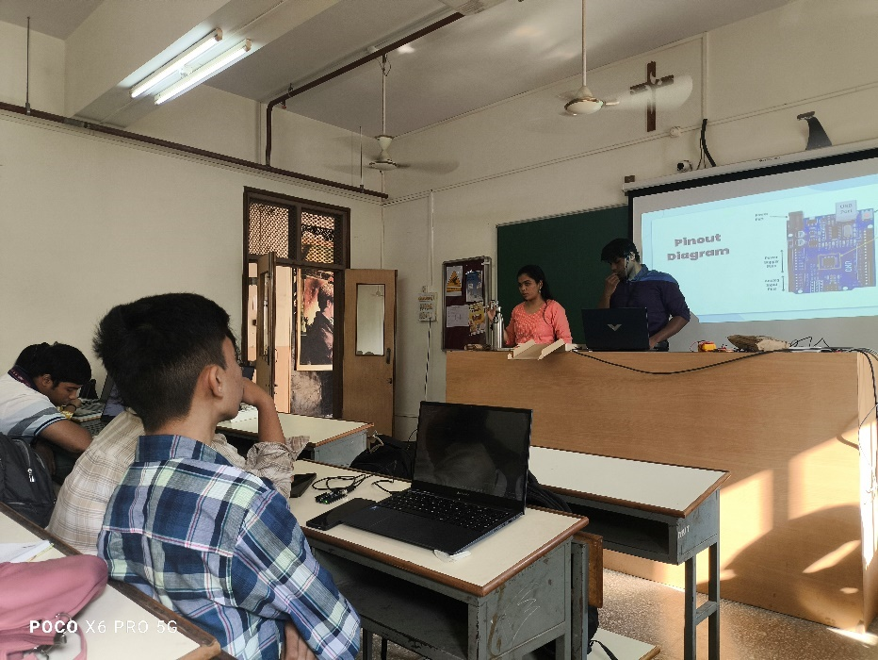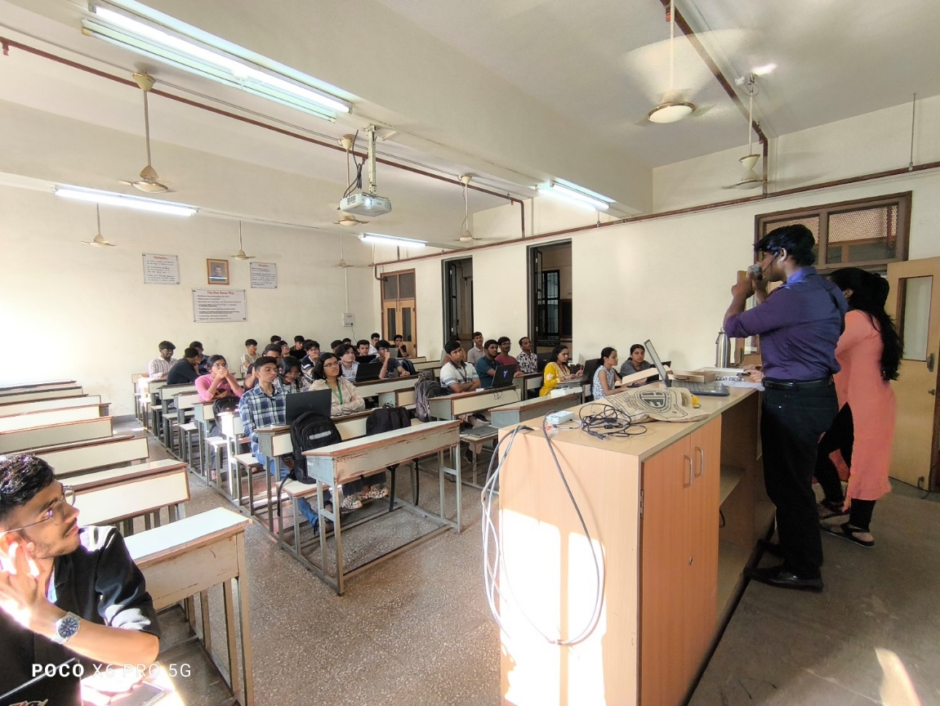

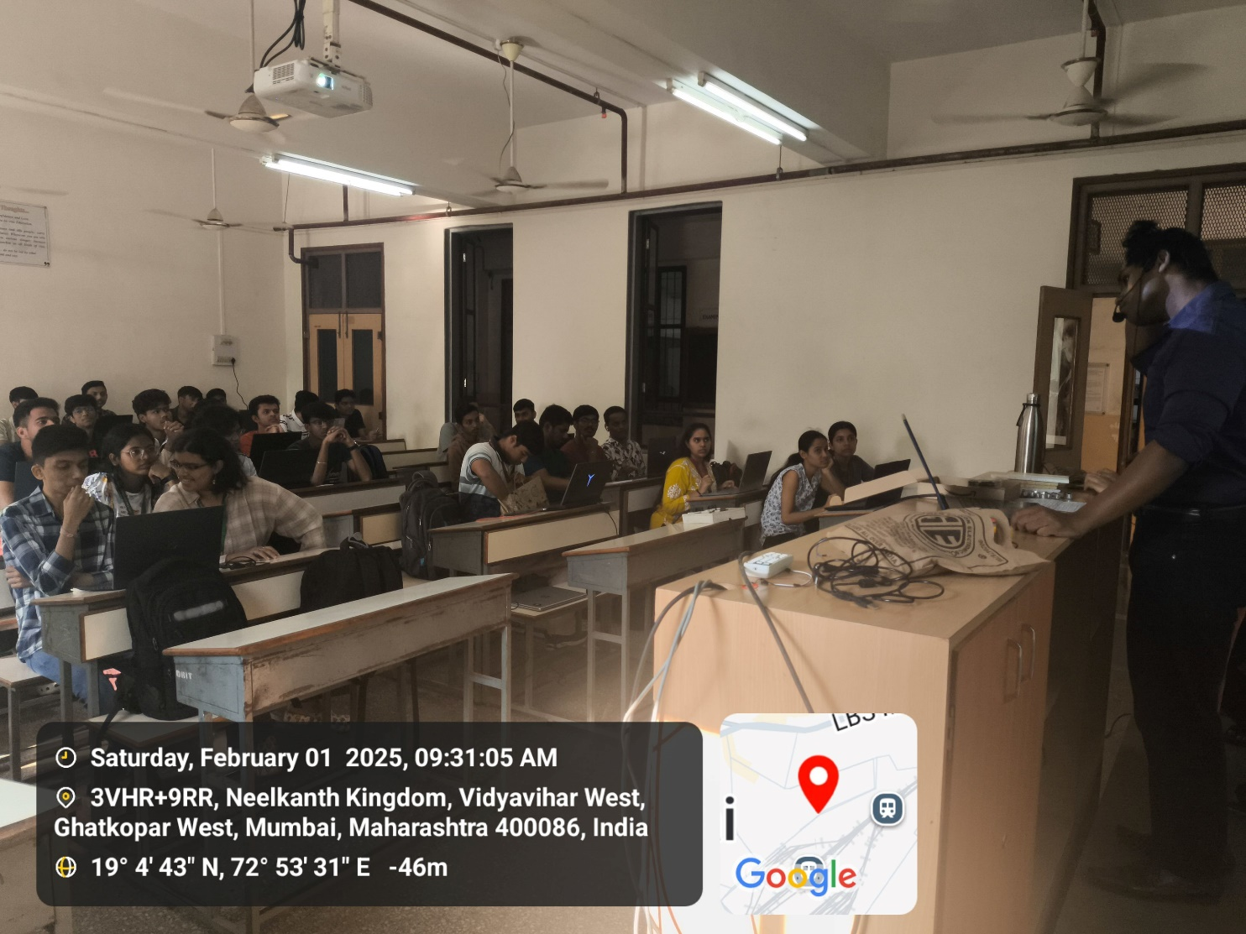

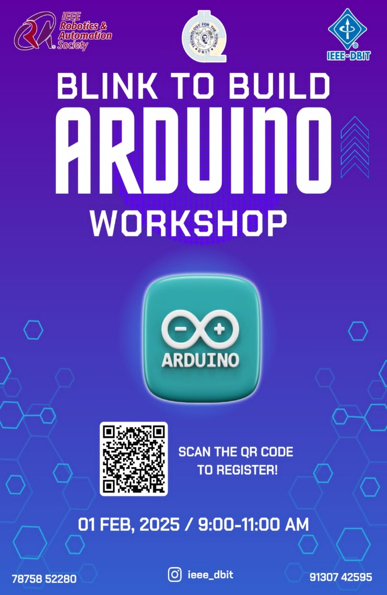

**Event Poster: -**

**Social Media Links:**

Instagram - <https://www.instagram.com/ieee_dbit/?hl=en>

Website – https://ieee.dbit.in

**Participants: -**

|  |  |  |  |  |  |
| --- | --- | --- | --- | --- | --- |
| **Roll no** | **Dept** | **Name** | **Roll No** | **Dept** | **Name** |
| 69 | IT | Rupali Kadam | 46 | EXTC | Vipaak Gaikwad |
| 56 | COMPS | Prasad Shinde | 19 | EXTC | Yukita Jaiswal |
| 73 | IT | Om Darekar | 68 | EXTC | Jancy Patlikadan |
| 70 | IT | Payal Samant | 04 | EXTC | Prajwala Bevanur |
| 17 | EXTC | Netra Hande | 35 | MECH | Aditya Parab |
| 09 | EXTC | Amey Dalvi | 28 | MECH | Tanish Kunder |
| 69 | EXTC | Ishant Patil | 16 | MECH | Prajwal Gowda |
| 66 | EXTC | Om Kurlekar | 43 | MECH | Sanket Prajapati |
| 59 | EXTC | Prabhat Kharat | 08 | MECH | Clive Dias |
| 35 | EXTC | Aryan Puranik | 34 | EXTC | Shravan Philse |
| 15 | EXTC | Saeesh Gidh | 47 | EXTC | Vinayak Yadav |
| 10 | EXTC | Deepak S | 71 | EXTC | Harshal H |
| 40 | EXTC | Raman Sharma |  |  |  |
| 11 | EXTC | Anant Deshmukh |  |  |  |
| 27 | EXTC | Akash Nadar |  |  |  |
| 05 | EXTC | Sumit Botle |  |  |  |
| 65 | MECH | Ankur Yadav |  |  |  |
| 51 | MECH | Jaydatt Sawant |  |  |  |
| 28 | EXTC | Daniel Sebastian |  |  |  |
| 29 | EXTC | Kartik N |  |  |  |

**Feedback Categories and Average Ratings:**

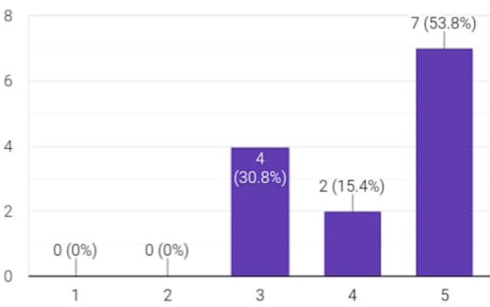Average Rating (4.15)

Comments on the workshop: -

* 1. Workshop was good for understanding the basics
  2. Organizing team should be more prepared about their presentation, they were stuck for a long time just for the password of protected text website. workshop should be more towards integration and programming rather than copy pasting codes.
  3. It was a very helpful workshop for beginners to start with Arduino projects
  4. The teaching crew needs to be a bit more professional but other than that the whole workshop was really great
  5. It’s a very cool workshop
  6. Overall good

Branches: -

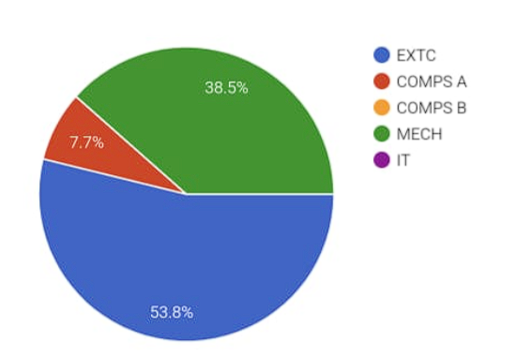

**Report Prepared by: IEEE DBIT reporting team**

**Name of the Student: Dhruv Tare**

**Post of the student: Reporting Head**

**Name of the Student: Pritika** **Mediboina**

**Post of the Student: Joint Reporting Head**