**HAM Radio Workshop**

**Date: 22nd & 23rd  March 2025**

**Time: 9:00 AM to 5:00 PM**

**Venue: Seminar Hall, A Wing, Don Bosco Institute of Technology, Kurla, Mumbai - 400070**

**Speakers: Team MARI**

**Jayesh V. Banatwala, Rohit Purohit, Arkay Kudali, Dayanand Malvi, Satyadev Sampara**

**Support Team:** Yashvi, Ayush, Pritika, Yukita, Samiksha, Dhruv, Anu, Amey

**Compering:** Mrunmai, Nirmiti

**Objective:**

The workshop aimed to bridge the gap between theoretical knowledge and practical applications of HAM Radio technology. The key objectives were:

* To introduce participants to HAM Radio communication and explain its fundamental principles
* To provide practical experience in building and operating antennas tailored for communication.
* To emphasize the use of HAM Radio in emergency scenarios and personal communication.
* To inspire students to consider HAM Radio as a potential career path by showcasing its versatility and impact.

**Outcome:**

The HAM Radio Workshop successfully met its objectives and provided participants with a transformative learning experience.

* Students gained hands-on experience in antenna creation and calibration, mastering the technical details of HAM Radio operation.
* Practical sessions, such as Morse code exercises and the FOX Hunt, enabled participants to apply their theoretical knowledge effectively.
* Interactions with industry professionals inspired attendees to explore career opportunities in HAM Radio and related fields.

**Description:**

#### The HAM Radio Workshop, held on 22nd and 23rd March 2025 at Don Bosco Institute of Technology, introduced students to the fundamentals of HAM Radio communication and practical antenna creation. Participants engaged in hands-on activities, such as building YAGI antennas and Morse code exercises, and applied their skills in a FOX Hunt competition. The event successfully combined learning with real-world applications, inspiring students to explore the field further.

#### Day 1: Introduction and Antenna Creation

The first day of the workshop laid a strong foundation by combining theoretical learning with hands-on activities.

**Morning Session:**

* Participants were introduced to the history and evolution of HAM Radio technology, emphasizing its relevance in modern communication systems. The session, led by **Mr. Jayesh V. Banatwala** from **Team MARI**, detailed the practical uses of HAM Radio, such as experimentation, self-training, and emergency communication
* A key highlight was the basics of Morse code, where participants explored its coding and decoding process through interactive exercises. To motivate participants, insights into licensing procedures and career opportunities in HAM Radio were shared.

**Lunch Break:**

* Participants regrouped at 2:00 PM, ready for an engaging hands-on session.

**Afternoon Session:**

* The focus shifted to building functional antennas under expert guidance. Trainers shared precise measurements for creating YAGI antennas optimized for a frequency range of 145 MHz.
* Components like tubes, connectors, and cables were provided, ensuring students had the resources required for assembly.
* At the soldering station, Mr. Banatwala demonstrated the soldering of cables to dipole antennas, ensuring secure connections for efficient signal capture.
* The session concluded with testing and calibration. Participants adjusted their antennas to achieve optimal performance, meeting parameters such as a **1:1 SWR**, **144–146 MHz frequency**, and **50Ω impedance**.

By the end of the day, every participant had successfully constructed and tested their antenna, ready for real-world application in the FOX Hunt event.

#### Day 2: Advanced Techniques and FOX Hunt Challenge

Day 2 emphasized the practical applications of the concepts learned and challenged participants to implement their knowledge during the competition.

**Morning Session:**

* The day began with a demonstration of techniques to utilize antennas for detecting signals. Participants learned how to strategically use the YAGI antenna and FM receiver to locate hidden transmitters. The speakers explained the three-stage antenna system (Director, Dipole, Reflector) and demonstrated how removing certain elements could enhance signal detection accuracy.
* Real-world examples of HAM Radio applications, such as rescue operations, were shared to inspire participants and highlight the technology's utility in critical situations.

**Afternoon Session**

* The FOX Hunt challenged participants to locate a hidden transmitter within the campus, applying their antenna-building skills and technical knowledge. Teams worked collaboratively, navigating obstacles and deciphering signal patterns.
* Each team was given duration of 20 minutes to find the transmitter.
* The competition fostered teamwork, problem-solving, and practical application of HAM Radio principles.

The event concluded with a heartfelt vote of thanks delivered by compeers, followed by mementos presented to the Team MARI trainers for their invaluable contributions.

**Photos of the Event:**

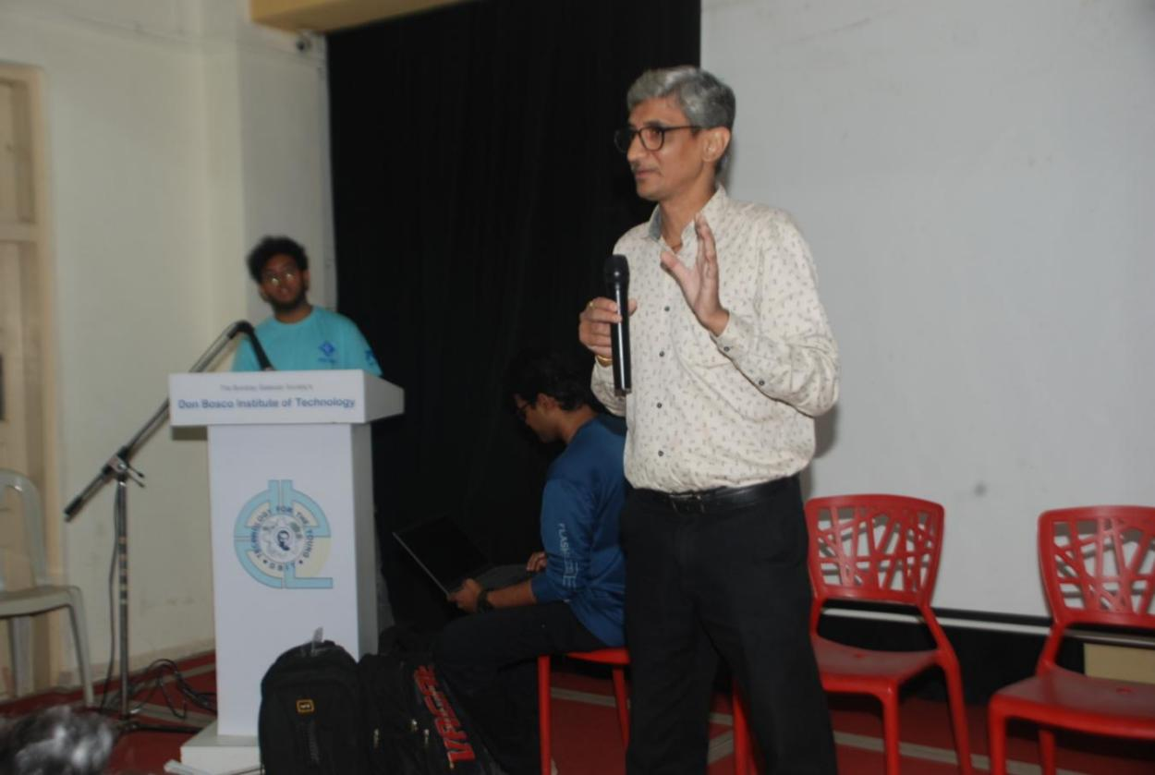

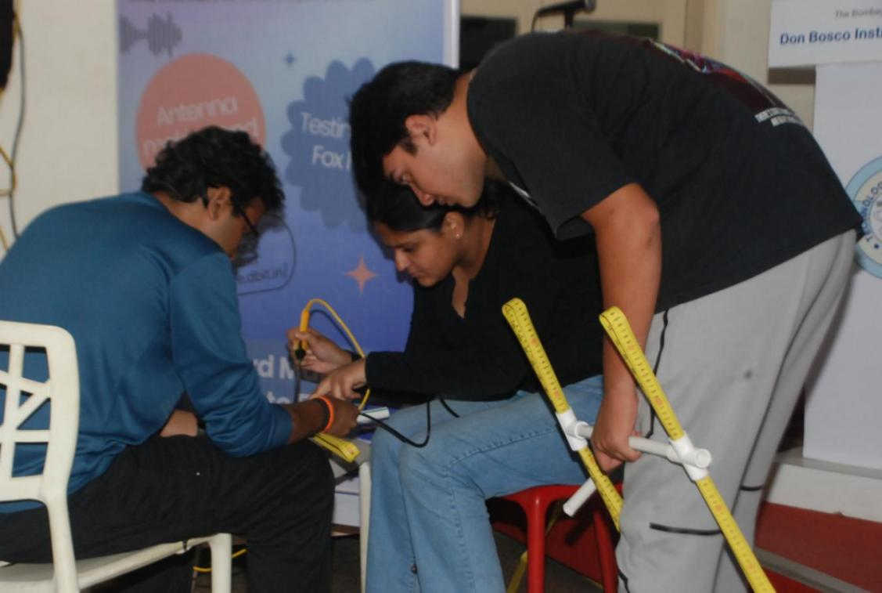

**Soldering cables to diploe antenna**

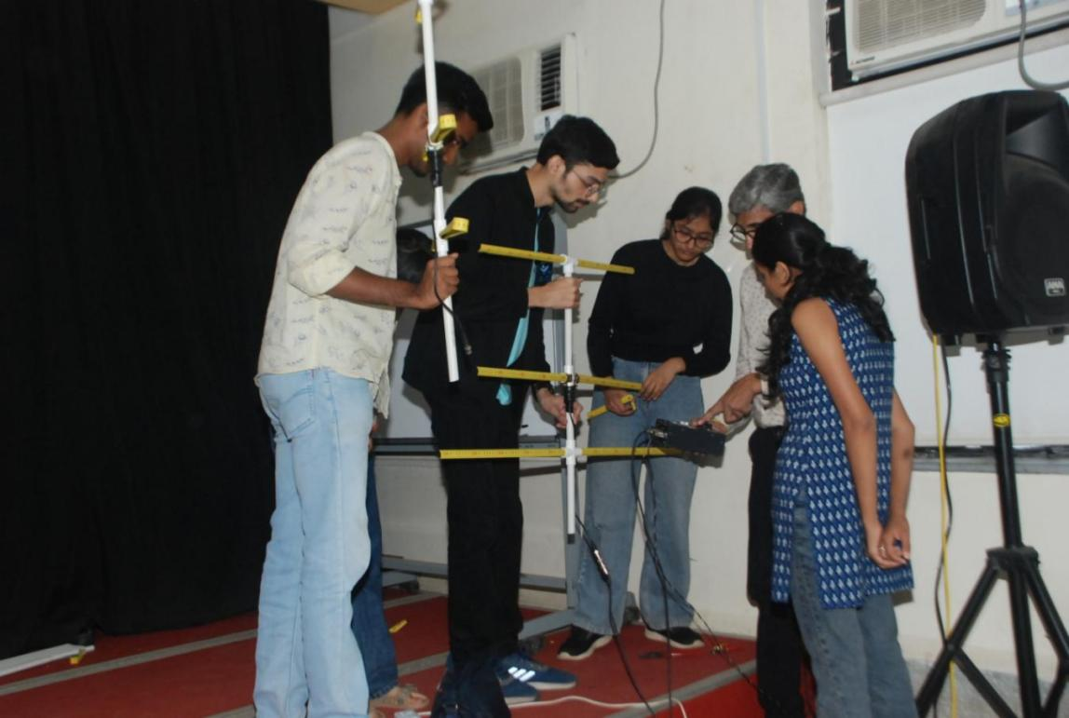

**Tuning antenna to 145Mhz frequency**

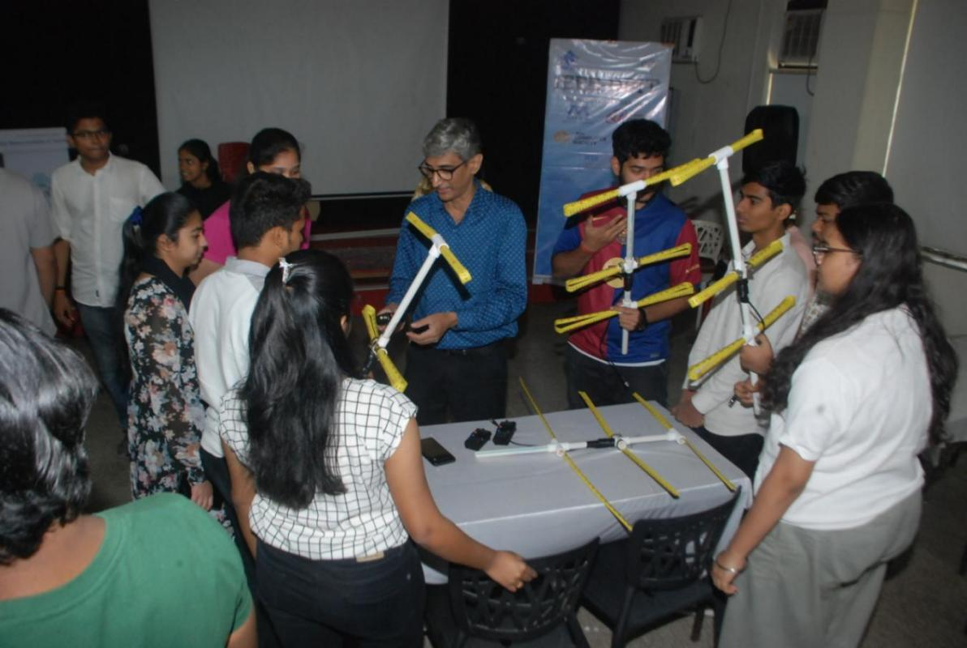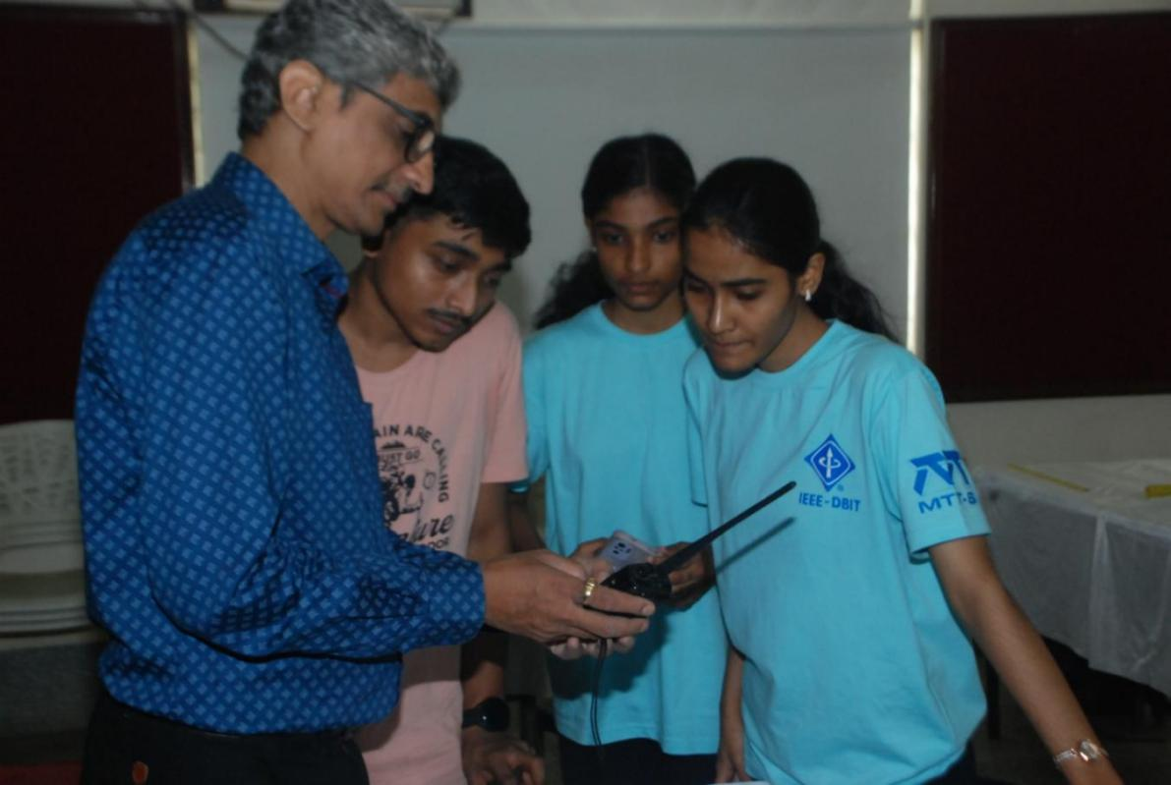

**Explaining ways to detect transmitted signal**

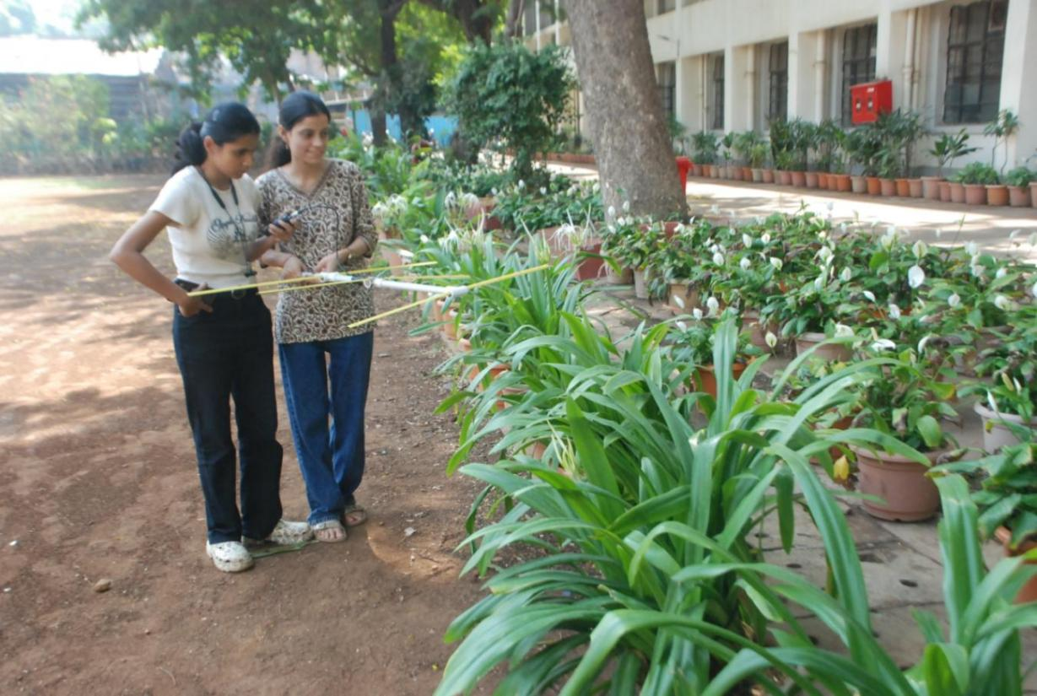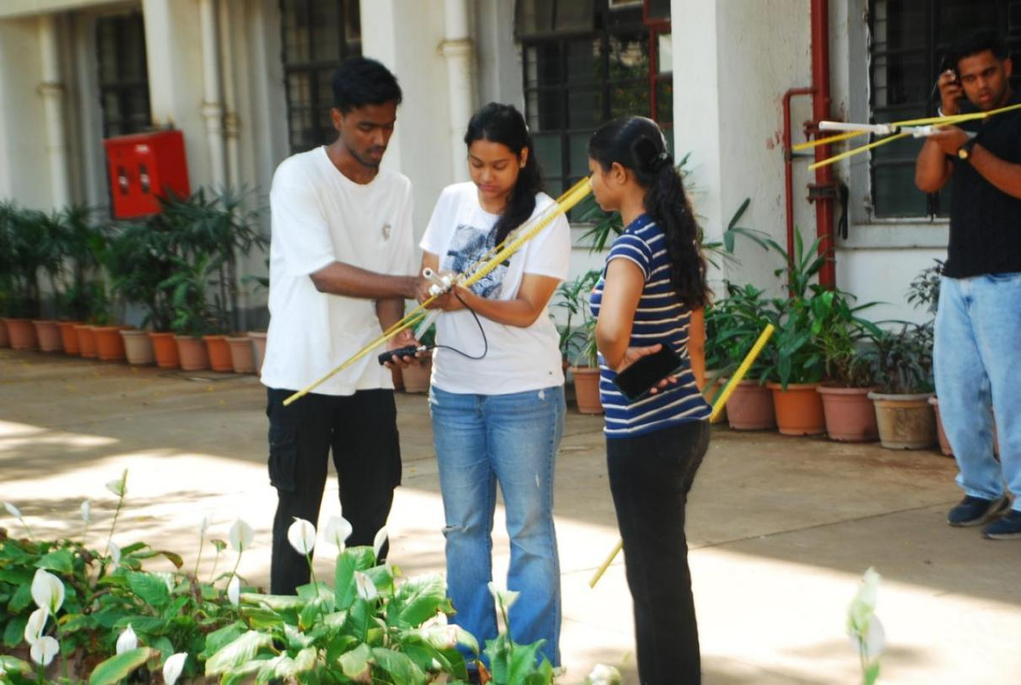

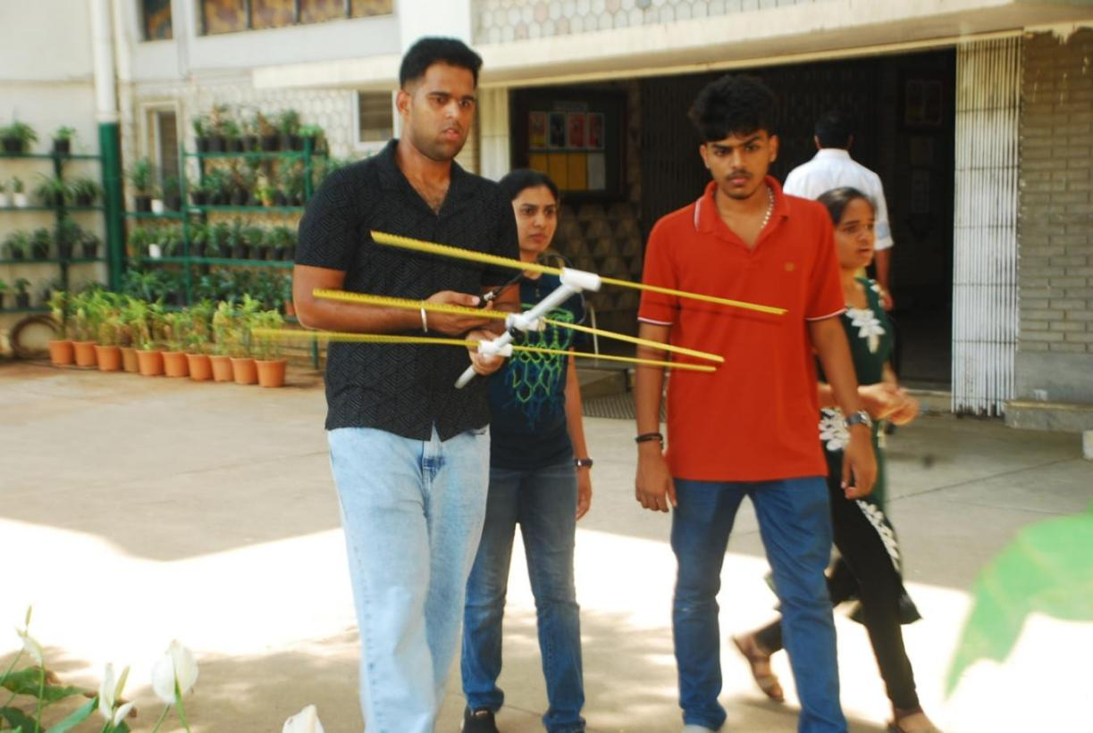

**Fox hunt in DBIT campus**

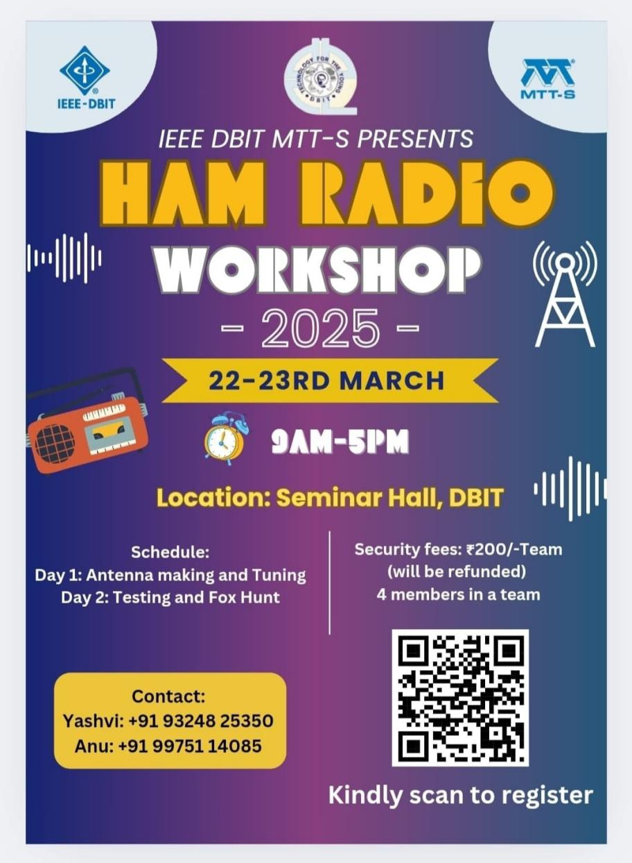

**Event Poster**

**Social Media Links:**

Linkdin - [https://www.linkedin.com/posts/ieee-dbit_successfully-completed-ham-radio-workshop-activity-7310998362151948289t9x3?utm_source=share&utm_medium=member_android&rcm=ACoAAAODaUoBr38XI63fJMZf4oMWg-m0WQQBiQ4](https://www.linkedin.com/posts/ieee-dbit_successfully-completed-ham-radio-workshop-activity-7310998362151948289-t9x3?utm_source=share&utm_medium=member_android&rcm=ACoAAAODaUoBr38XI63fJMZf4oMWg-m0WQQBiQ4)

Website-https://ieee.dbit.in/?fbclid=PAY2xjawJVnYZleHRuA2FlbQIxMQABpvVoqE33E2wKVxqPSlimOFc1-8Aj9UZ3sC1UGsmGbVVubLOAxkbS-wUZRQ_aem_vgeXwR8_YQ7up3f8DDCMrA

**Participants:**

|  |  |  |
| --- | --- | --- |
| **Name** | **Year** | **Department** |
| Neel Pujari | TE | EXTC |
| Aditya Punekar | TE | EXTC |
| Sarvambh Desai | TE | EXTC |
| Darshan Chaudhari | TE | EXTC |
| Soumin Pal | TE | EXTC |
| Ansari Aaraf | SE | EXTC |
| Blossom Mascarenhas | SE | EXTC |
| Janhavi Shejwal | SE | EXTC |
| Nikhil Shetty | SE | EXTC |
| Harshad Harad | SE | EXTC |
| Shaunal Patil | TE | EXTC |
| Ibrah Kazi | TE | EXTC |
| Tanmayee Ahire | TE | EXTC |
| Purva Dalvi | TE | EXTC |
| Narayan Dalvi | TE | EXTC |
| Soham Ghodigaonkar | TE | EXTC |
| Jasmit Ganvir | TE | EXTC |
| Ayush Gajbhiye | TE | EXTC |
| Prathamesh Patil | TE | EXTC |
| Prasad Gaikwad | TE | EXTC |
| Arya Munde | TE | EXTC |
| Zubia Sarang | TE | EXTC |
| Kartik Dandelia | TE | EXTC |
| Melissa Fernandes | TE | EXTC |
| Yashi Nimje | TE | EXTC |
| Ruchi Tiwari | TE | EXTC |
| Samruddhi Kapadnis | TE | EXTC |
| Aditi Mishra | TE | EXTC |
| Shaunak Patil | TE | EXTC |
| Sumit Shinde | TE | EXTC |
| Soumin Pal | TE | EXTC |
| Soham Derdekar | TE | EXTC |
| Sarvambh Desai | TE | EXTC |
| Omkar Dhebe | TE | EXTC |
| Darshan Chaudhari | TE | EXTC |
| Daniel Sebastian | SE | EXTC |
| Aryan Arde | TE | EXTC |
| Sarvesh Thorat | TE | EXTC |
| Umair Shaikh | TE | EXTC |
| Jaden Fernandes | TE | EXTC |
| Aditya Punekar | TE | EXTC |
| Nisha Singh | TE | EXTC |

**Feedback:**

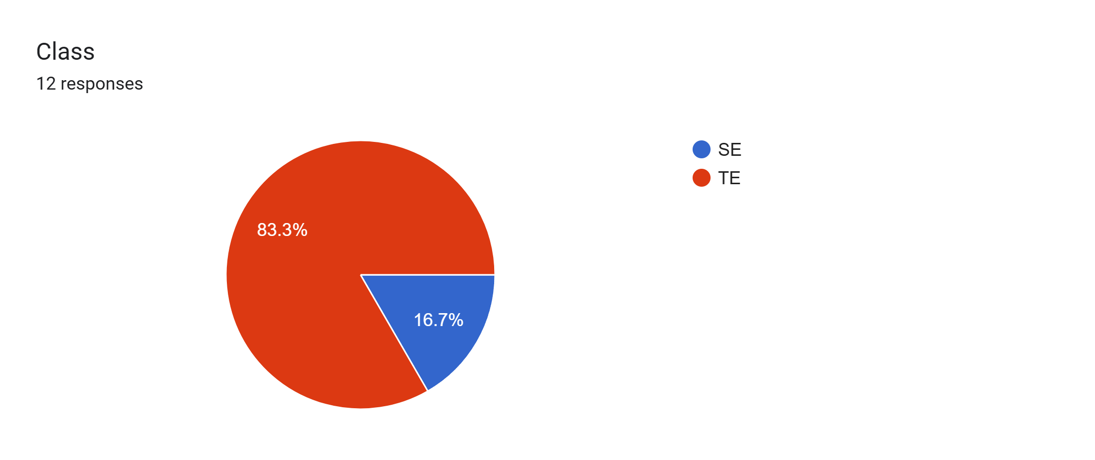

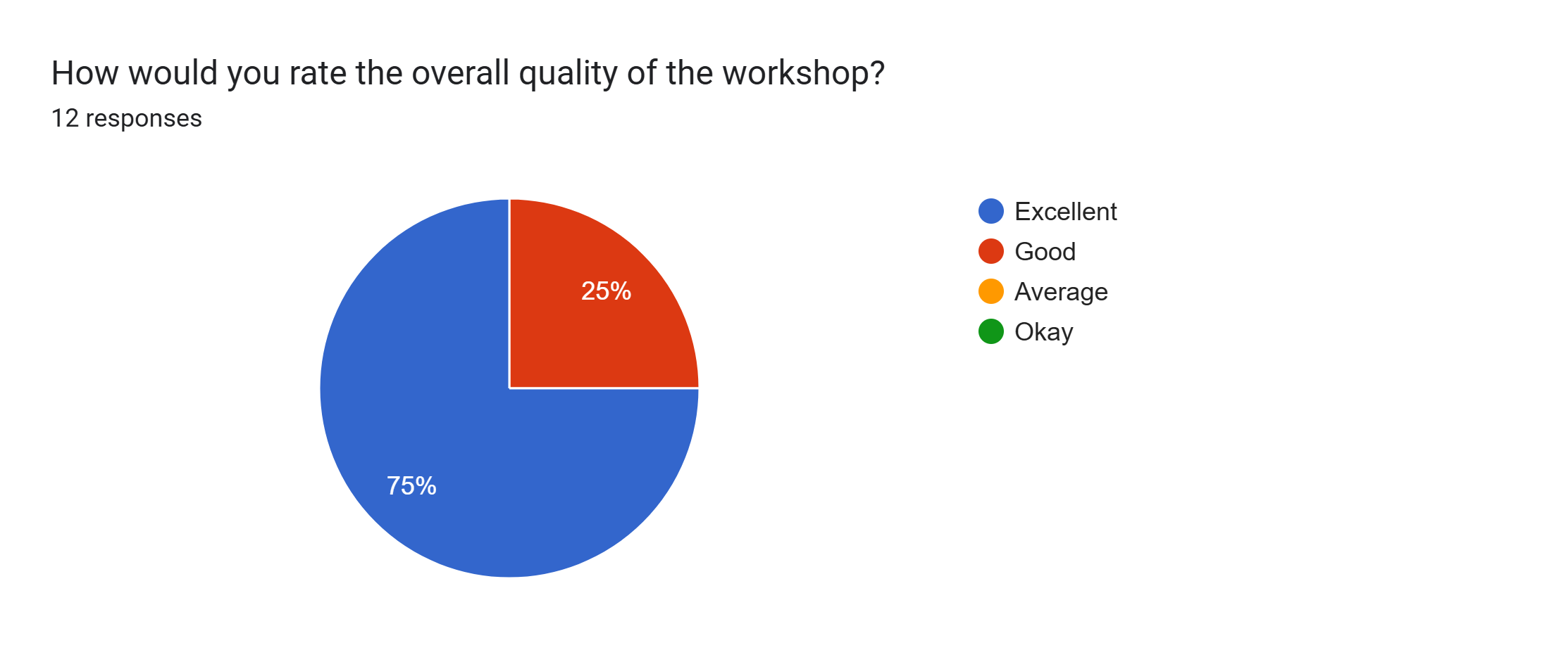

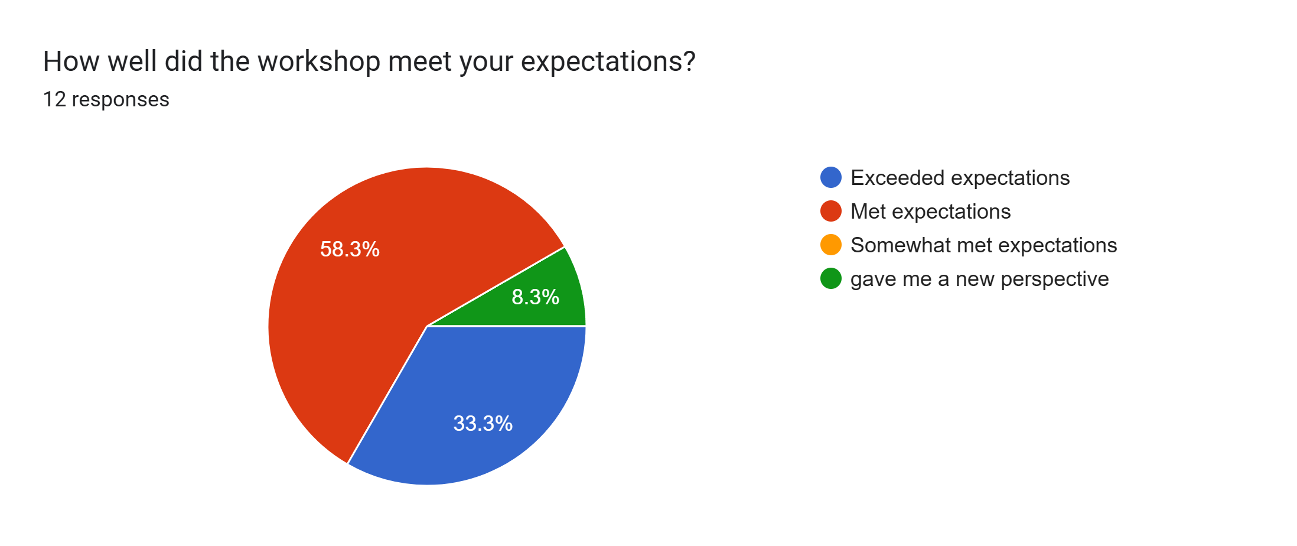

**Comments:**

* What did you like the most about the workshop?

1. To learn and understand the Morse code encode decode, making Yagi transmitter antenna,etc.
2. The introductory part where sir gave a birds eye view into the world of HAM
3. Hands-on experience
4. Antenna making
5. Good arrangements
6. HAM morse code
7. Sir’s interactive nature
8. Fox hunt
9. I like that it was a complete hands on experience of making a yagi uda antenna

* What are your thoughts in this workshop

1. This workshop gave us motivation and make our path crystal clear about extc engg. and introduces telecommunication field
2. Had a fun time and amazing speaker panel
3. It was fun
4. Excellent hands on experience
5. Sir was excellent and got to learn many things from this workshop
6. It is very informative I like it
7. It was a very interesting workshop . Got to know about the implementation of what we have studies in the theory . The fox hunt at the end was also a cool part

**Conclusion:**

The **HAM Radio Workshop**, organized by the **IEEE-DBIT MTT-S** Student Chapter, achieved its goal of providing a comprehensive understanding of HAM Radio communication. Through engaging sessions, practical projects, and an exciting competition, participants were equipped with both technical skills and career inspiration. The success of this workshop reflects the potential of **hands-on learning** to bridge academic knowledge with real-world applications.

**Report Prepared by: IEEE DBIT reporting team**

**Name of the Student: Dhruv Tare**

**Post of the student: Reporting Head**

**Name of the Student: Pritika** **Mediboina**

**Post of the Student: Joint Reporting Head**