**Roboton Workshop**

**Date: 4th & 5th March 2025**

**Time: 9:00 AM to 5:00 PM**

**Venue: Seminar Hall, A Wing, Don Bosco Institute of Technology, Kurla, Mumbai - 400070**

**Speakers:**

Priyanshu Sakharkar, Prathamesh Kurdekar, Zubia Sarang, Kartik Dandelia, Soham Ghadigaonkar

**Support Team:**

Pritika, Yukita, Samiksha, Ayush Gajbhiye

**Objective:**

The objective of the workshop was to provide participants with hands-on experience in designing and building a **gesture-controlled robot** using an **Arduino-controlled car** and an **accelerometer**. The key goals were:

* Introducing participants to **Arduino-based robotics and embedded systems**.
* Teaching the fundamentals of **robotic motion control and sensor interfacing**.
* Developing practical knowledge in **wireless gesture control using an accelerometer**.
* Encouraging participants to apply these concepts in **real-world automation projects**.

**Outcome:**

By the end of the workshop, participants:

* Successfully **built an Arduino-based robotic car**.
* Implemented **gesture control using an accelerometer on the second day**.
* Learned **Arduino programming**, motor driver integration, and wireless communication.
* Understood the **practical applications of motion-controlled robotics**.

**Description:**

The **"Roboton Workshop"** was organized by the **IEEE-DBIT RAS Student Chapter** and took place on **4th and 5th March 2025**. It was attended by students from various engineering branches.

**Day 1: Building the Robot**

* The workshop began with an **introduction to robotics and automation**.
* Participants learned about **Arduino, motor drivers, sensors, and power management**.
* A hands-on session guided them through **assembling the robotic car**, including:
  + Connecting **DC motors** and **motor drivers** to the Arduino.
  + Powering the system using a battery pack.
  + Writing and uploading **basic movement control code**.
* By the end of Day 1, participants had a functional **robotic car**.

**Day 2: Implementing Gesture Control**

* The session started with an introduction to **accelerometer sensors** and how they detect **tilt and motion**.
* Participants interfaced the **accelerometer module with Arduino** and programmed it to control the bot’s movement based on **hand gestures**.
* The final phase included:
  + **Calibrating the accelerometer** for accurate motion detection.
  + **Transmitting gesture signals** wirelessly to control the robot.
  + **Debugging and optimizing** gesture recognition for smooth navigation.
  + After successful implementation, a competition was held, where students participated in a timed race. The goal was to complete a predefined track using gesture-controlled robots. The top three teams that completed the track in the shortest time were declared winners.
  + The workshop concluded with a **demonstration**, where students successfully controlled their robots using **hand movements**.

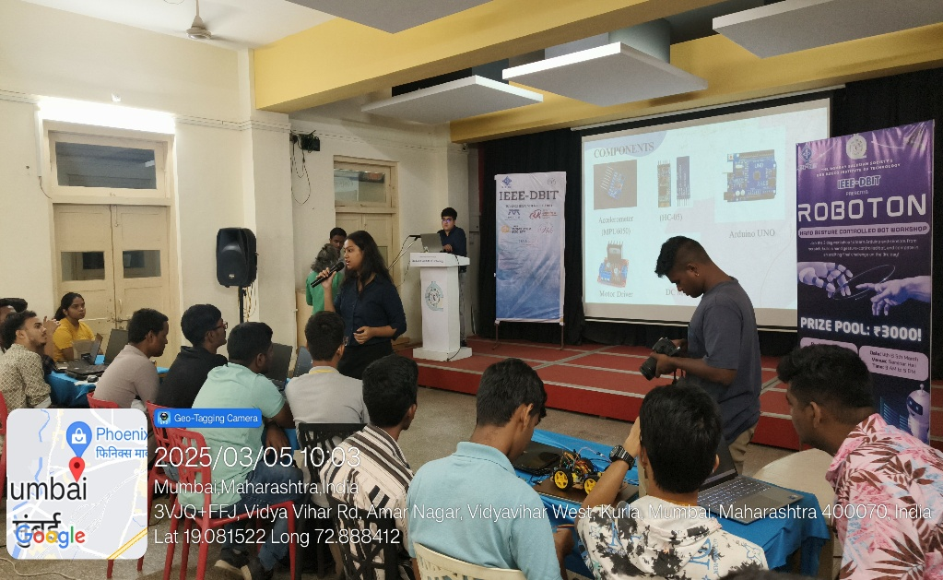**Photos of the Event:**

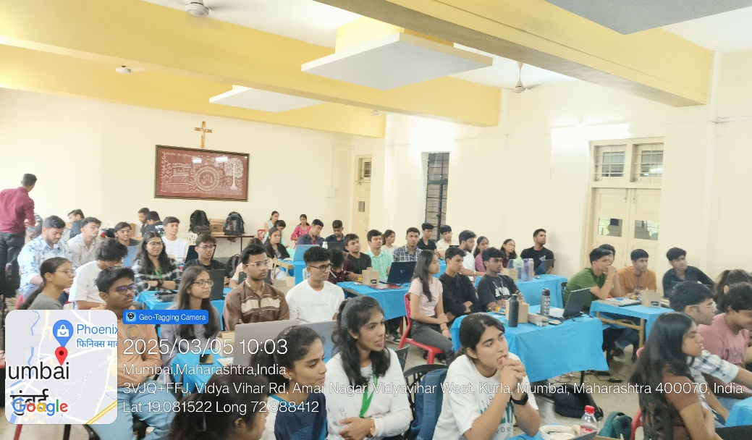

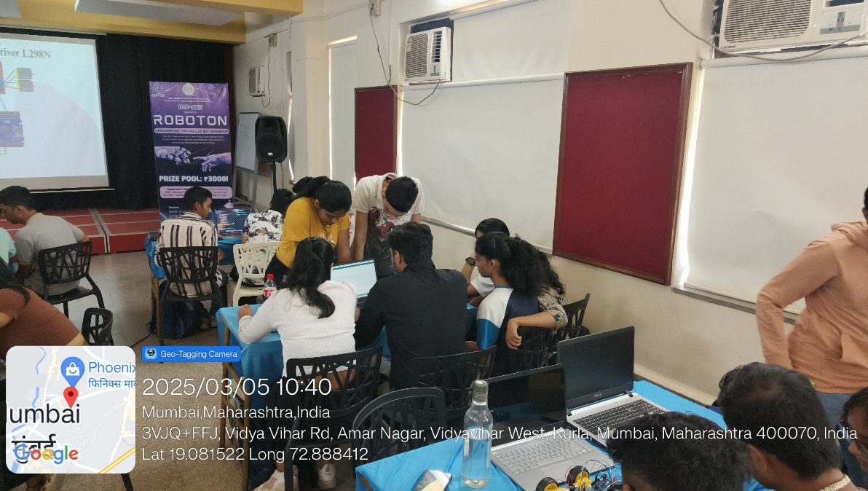

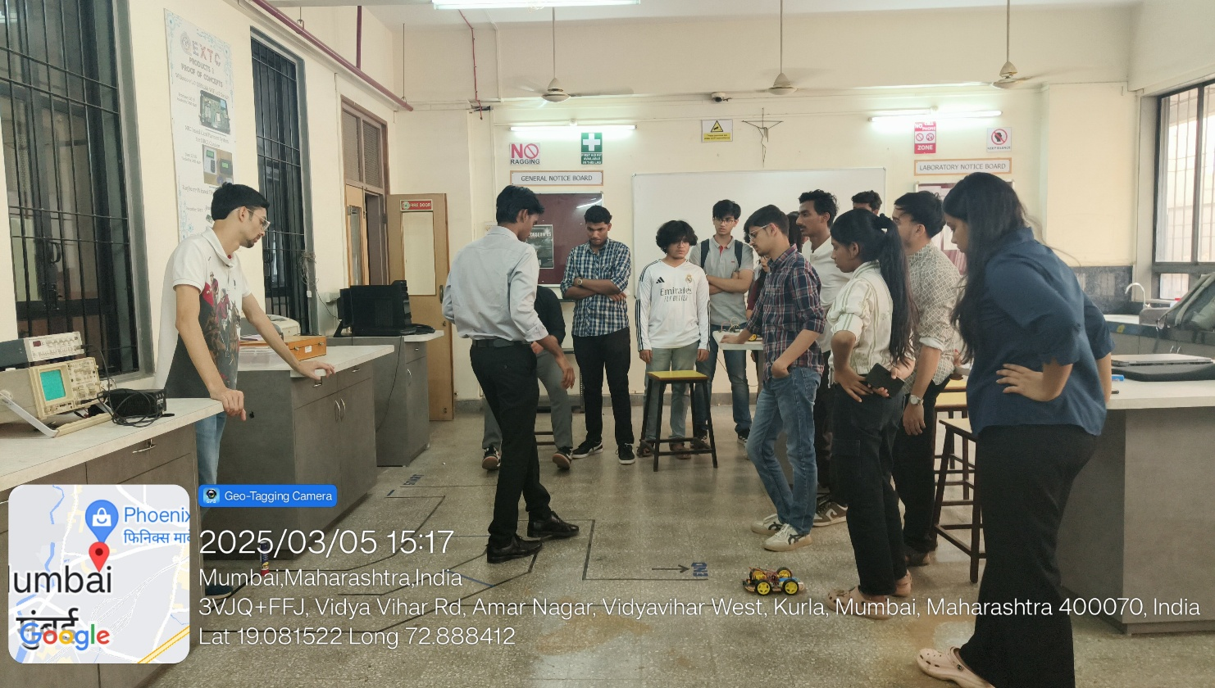

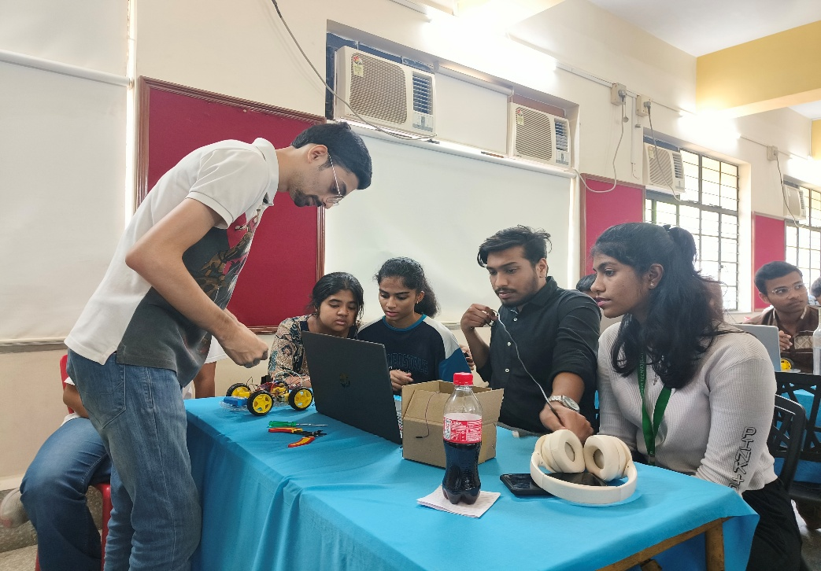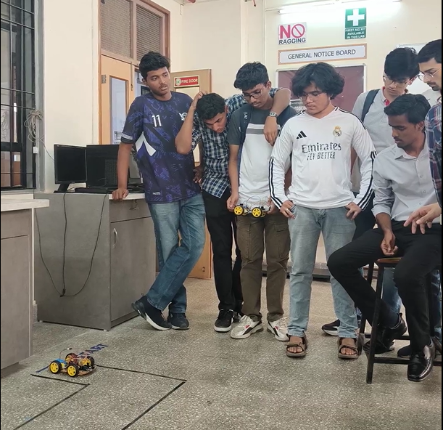

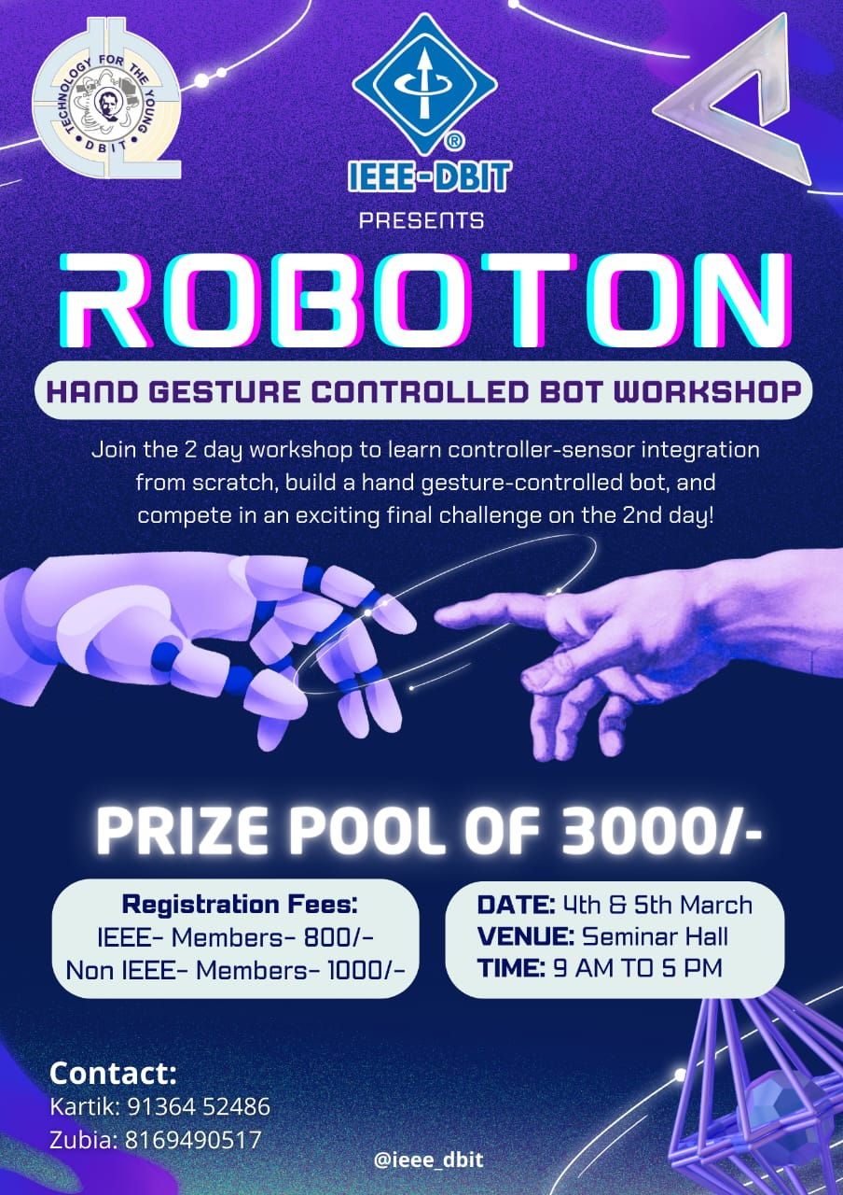**Event Poster:**

**Social Media Links:**

Instagram - <https://www.instagram.com/ieee_dbit/?hl=en>

Website – https://ieee.dbit.in

**Participants:**

|  |  |  |
| --- | --- | --- |
| **Name** | **Year** | **Department** |
| Swara Ghosalkar | FE | EXTC |
| Mohammed Hasan | FE | EXTC |
| Vinet Suryawanshi | FE | EXTC |
| Pratham Adavade | FE | MECH |
| Prajwal Gowda | SE | MECH |
| Jaydatt Sawant | SE | MECH |
| Tanish Kunder | SE | MECH |
| Aditya Pawar | SE | MECH |
| Sanket Prajapati | SE | MECH |
| Clive Dias | SE | MECH |
| Russel Ferreira | FE | MECH |
| Ralston Dsouza | FE | MECH |
| Shraddha Hebbar | FE | IT |
| Jenny Joy | FE | COMPS |
| Ivie Pendse | FE | IT |
| Ananya Shetty | FE | IT |
| Om Arolkar | FE | MECH |
| Mousam Patra | FE | IT |
| Siya Agivale | FE | EXTC |
| Huzan Mistry | SE | MECH |
| Ayush Mali | SE | MECH |
| Harsh Angare | SE | MECH |
| Aditya Pawar | SE | MECH |
| Sumit Botle | SE | EXTC |
| Deepak Sakha | SE | EXTC |
| Anant Deshmukh | SE | EXTC |
| Jai Salunke | SE | EXTC |
| Raman Sharma | SE | EXTC |
| Saha Anu | SE | EXTC |
| Yashvi Jain | SE | EXTC |
| Dhruv Tare | SE | EXTC |
| Saeesh Gidh | SE | EXTC |
| Aryan Puranik | SE | EXTC |
| Kripa Dewoolkar | SE | EXTC |
| Mrunmai Paktekar | SE | EXTC |
| Daniel Sebastian | SE | EXTC |
| Kartik Nyalapelli | SE | EXTC |
| Sneha Pawar | SE | EXTC |
| Harshali Gokhale | SE | EXTC |
| Pushkar Mahale | FE | EXTC |
| Ayush P | FE | IT |
| Pramit Kulkarni | FE | COMPS |
| Ayush Borle | FE | EXTC |
| Saarth Gandre | FE | EXTC |
| Simone D’sa | FE | IT |
| Ocina Serrao | FE | EXTC |
| Denver Gracias | FE | COMPS |
| Neha Haldankar | FE | EXTC |
| Aradhya Pawar | FE | EXTC |
| Parth Pawar | FE | EXTC |
| Abhinav Borse | FE | EXTC |
| Swanandi Chavan | FE | EXTC |
| Malcom Monserrate | FE | COMPS |
| Adam Davis | FE | COMPS |
| Amey Dalvi | SE | EXTC |
| Francis Penmadan | SE | MECH |
| Shaikh Umair | SE | MECH |
| Momin Umair | SE | MECH |
| Kapil Labde | SE | EXTC |

**Feedback:**

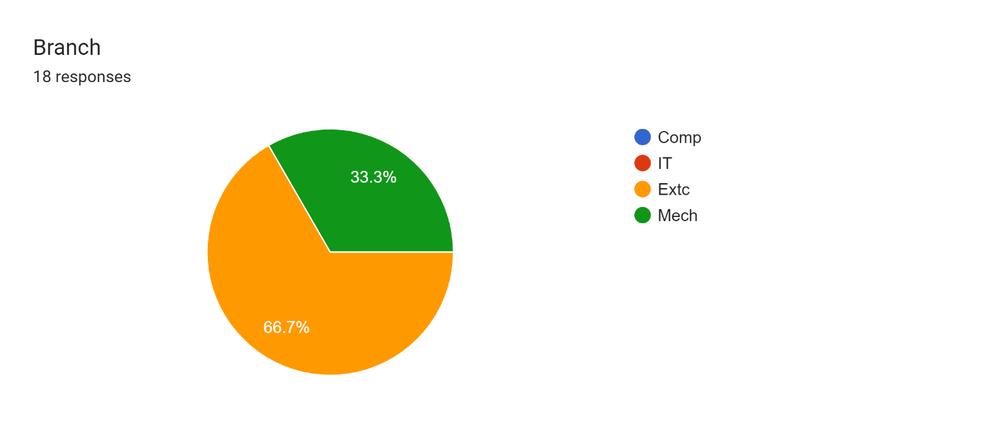

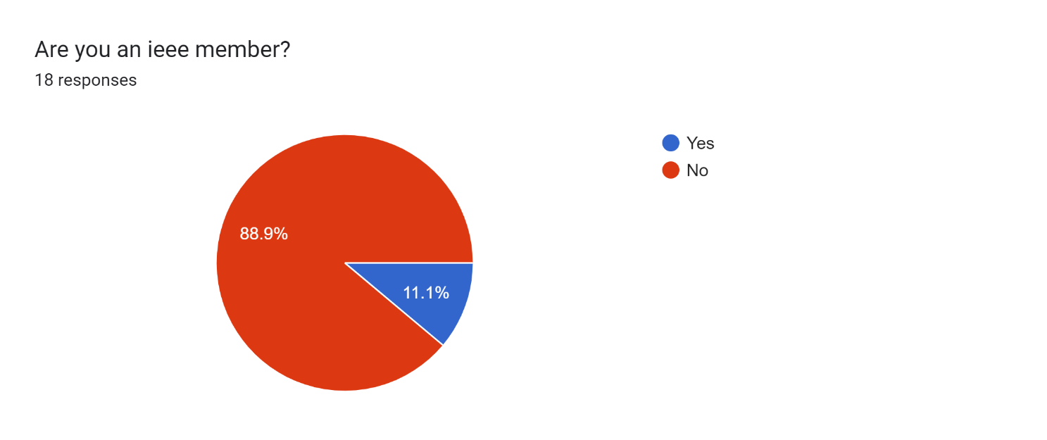

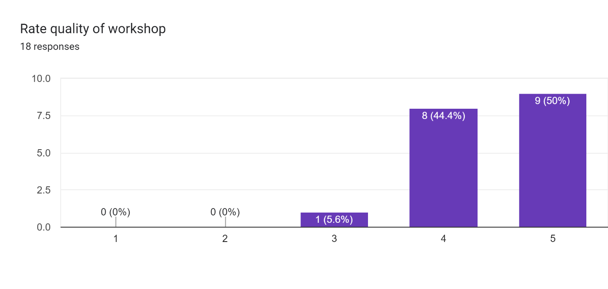

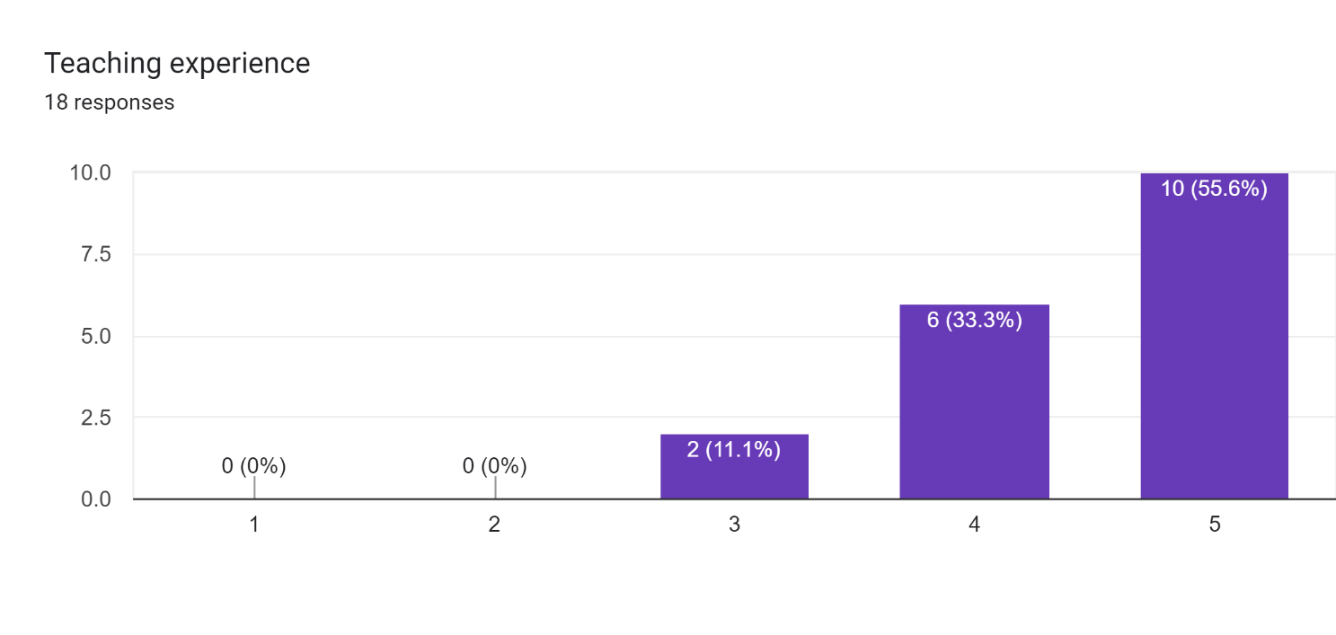

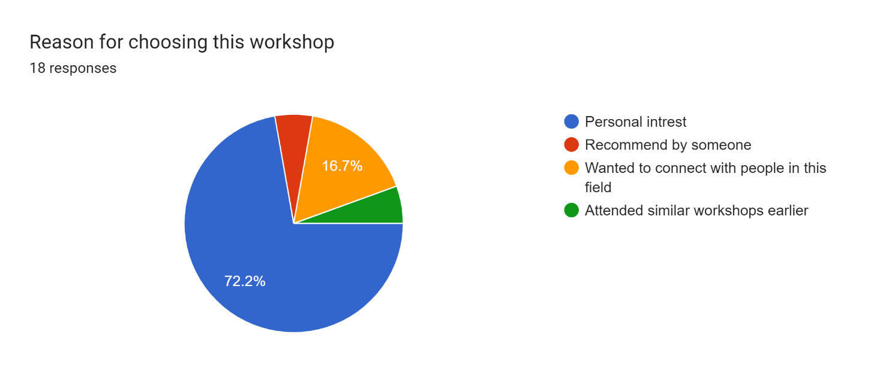

**Comments:**

* + 1. The workshop was great , have learn new things and the peer mentors are helpful and supportive , overall the workshop was fun with hands-on experience.
    2. Very interesting and I learn lot's of things which make me use in my further semester
    3. Improve devices quality
    4. Please elaborate the codes more
    5. Workshop was really good, enjoyed being a part of it.
    6. More Robotics Workshop
    7. Overall the workshop was good.
    8. Longer session would be nice. And fusion too
    9. Very encouraging mentors,they help us lot and give chance to participate in real life application such as robotics
    10. great workshop

**Conclusion:**

The **"Roboton Workshop"** provided students with **a complete understanding** of Arduino-based robotics, from hardware assembly to implementing wireless gesture control. The structured approach, with **robot construction on Day 1 and gesture-based automation on Day 2**, allowed participants to grasp both **mechanical assembly** and **sensor-based control techniques**. The workshop fostered technical skills, **encouraging students to explore advanced robotics applications** in automation and IoT.

**Report Prepared by: IEEE DBIT reporting team**

**Name of the Student: Dhruv Tare**

**Post of the student: Reporting Head**

**Name of the Student: Pritika** **Mediboina**

**Post of the Student: Joint Reporting Head**