**Wordpress Workshop**

**Date: 15th, 16th & 23rd March 2025**

**Time: 9:00 AM to 5:00 PM**

**Venue: Mechanical Lab 1, A Wing, Don Bosco Institute of Technology, Kurla, Mumbai - 400070**

**Speakers:** Guest Speaker: Mr. Tayyabali Sayyad

Student Speakers: Krushnali Mungekar, Shariya Ansari, Piyush Mistry, Moin Khan

**Support Team:** Glynis D'Mello

**Objective:**

The objective of the workshop was to equip participants with the essential skills to create, customize, and manage a fully functional website using WordPress. The key goals were:

* Understanding the basics of WordPress and its ecosystem.
* Learning how to install and set up WordPress.
* Exploring themes and plugins for website customization.
* Mastering content creation with pages, posts, and media.
* Learning basic SEO and website optimization techniques.
* Gaining hands-on experience in building a WordPress website.

**Outcome:**

By the end of the workshop, participants:

* Successfully installed and set up WordPress on their systems.
* Explored and implemented various WordPress themes and plugins.
* Learned content creation and website management.
* Understood SEO fundamentals and strategies for website optimization.
* Built and launched their own WordPress-based websites.

**Description:**

The **"Roboton Workshop"** was organized by the **IEEE-DBIT RAS Student Chapter** on **4th and 5th March 2025**. It was attended by students from various engineering branches and focused on **building a gesture-controlled robot** using **Arduino and an accelerometer**.

**Day 1: WordPress Basics & Setup**

The session started with an introduction to IEEE-DBIT and the importance of website development. Participants learned about:

* What WordPress is and the difference between WordPress.com and WordPress.org.
* Setting up WordPress on localhost using XAMPP/LAMP.
* Basic website settings including site title, tagline, and permalinks.
* Dashboard walkthrough covering pages, posts, media, themes, and plugins.
* Choosing and modifying themes, adjusting layout, fonts, and colors.

Hands-on session where participants built a basic website with a homepage and about page.

**Day 2: Customization, Plugins & SEO The second session introduced customization and optimization techniques:**

* Exploring essential plugins for SEO, security, forms, and caching.
* Learning about user management and membership plugins.
* Writing and optimizing blog posts using SEO techniques.
* Contest briefing: Participants were assigned tasks to create a portfolio or blog website.

**Day 3: Advanced Features & Live Website Launch The final day covered advanced topics and concluded with a competition:**

* Introduction to WooCommerce and e-commerce setup.
* Website monetization techniques such as Google AdSense and affiliate marketing.
* Future trends in WordPress, including AI-powered SEO and headless CMS.

**Photos of the Event:**

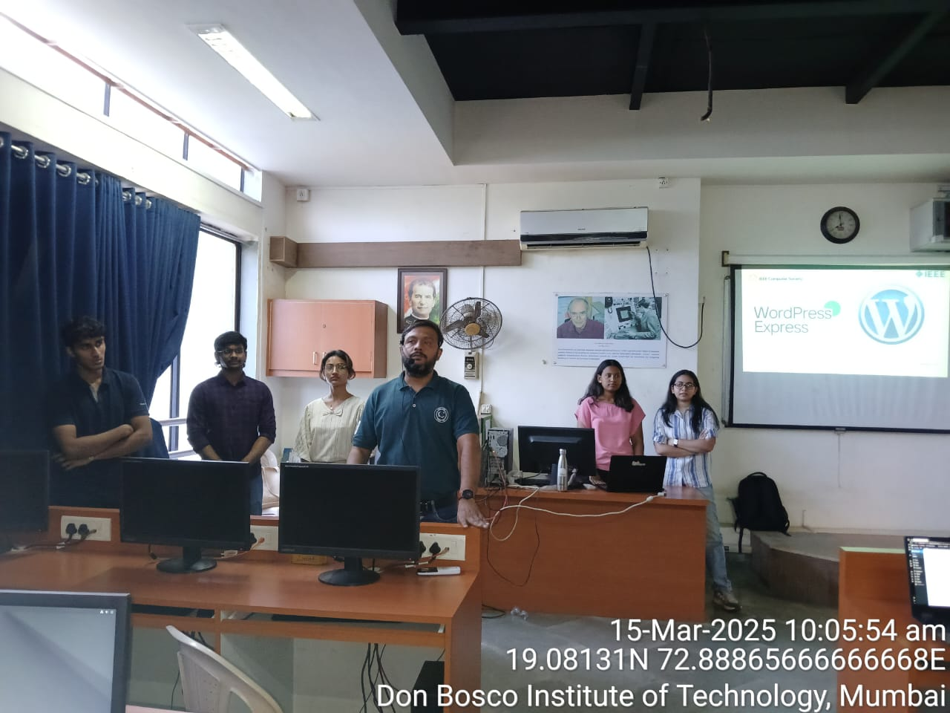

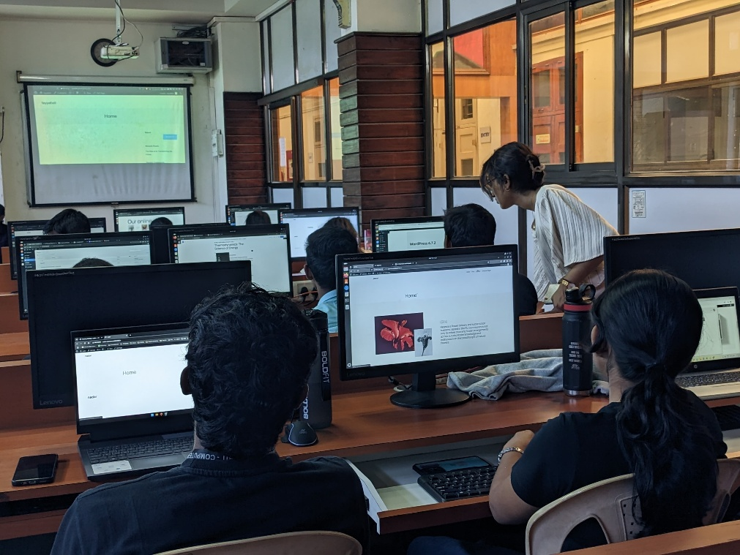

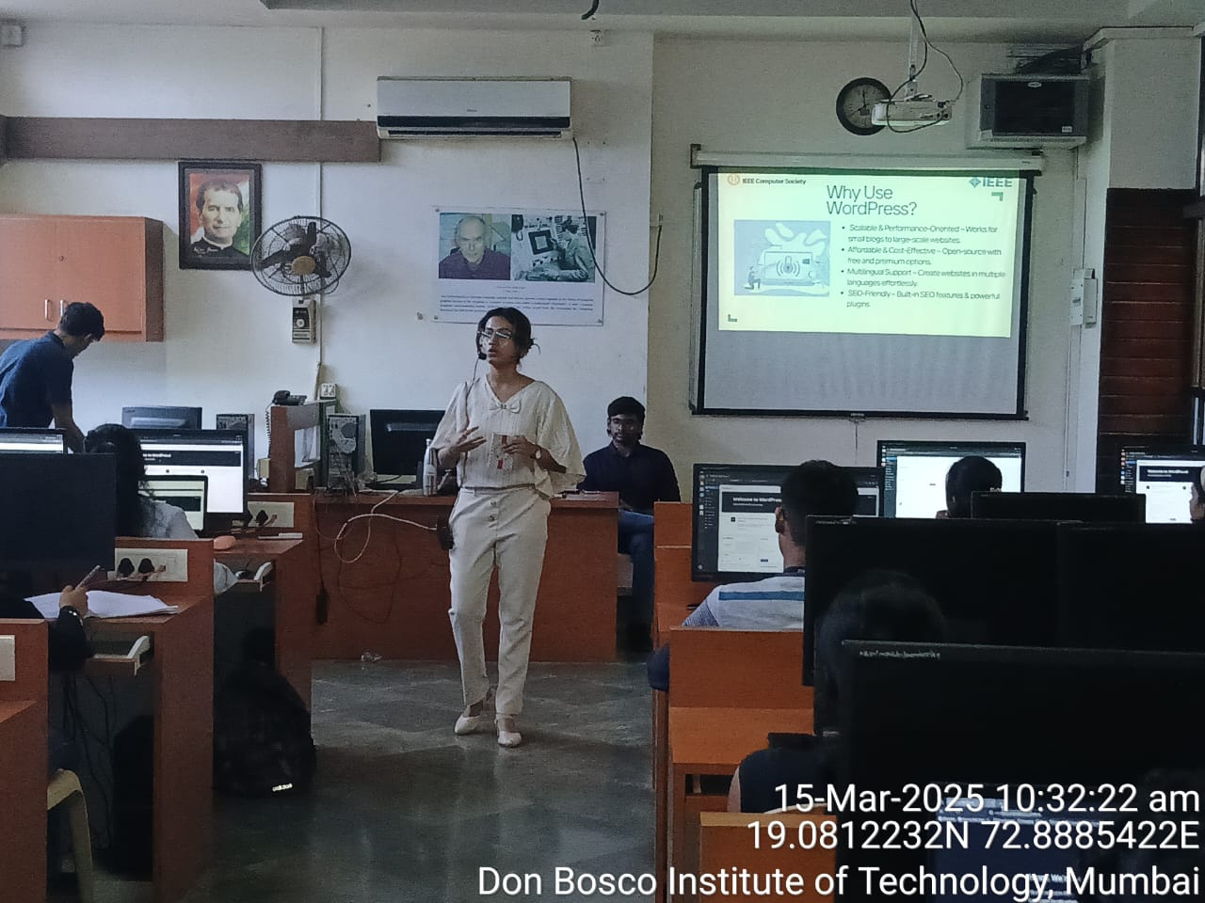

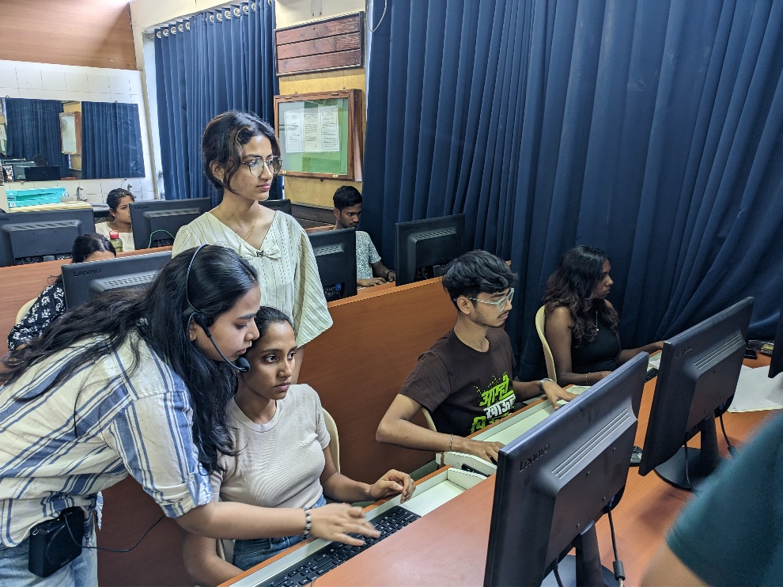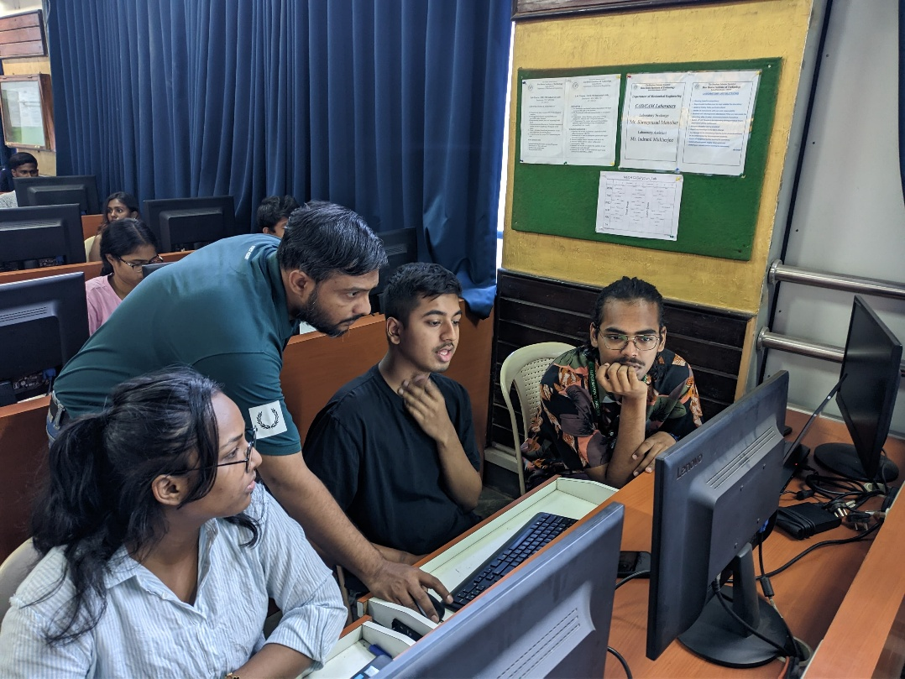

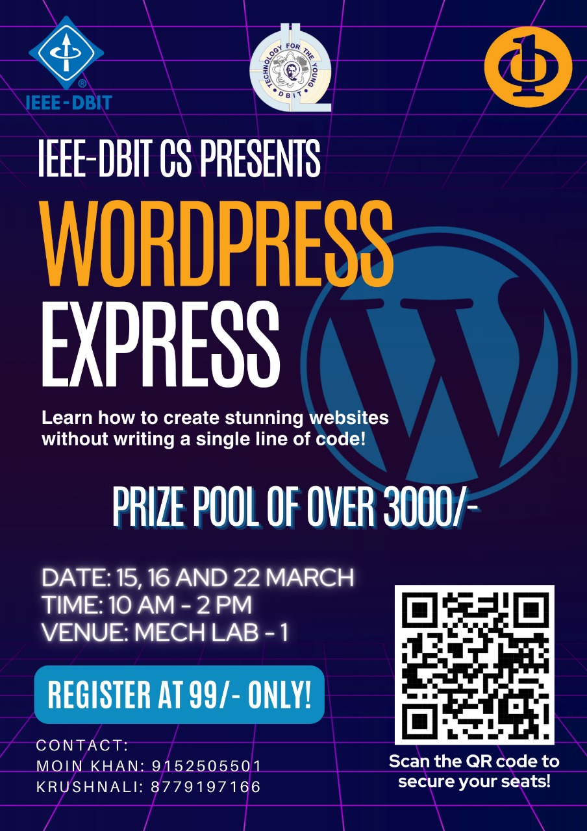**Event Poster:**

**Social Media Links:**

Instagram - <https://www.instagram.com/ieee_dbit/?hl=en>

Website – https://ieee.dbit.in

**Participants:**

|  |  |  |
| --- | --- | --- |
| **Name** | **Year** | **Department** |
| Astha Bombale | FE | IT |
| Sanket Prajapati | SE | MECH |
| Clive Dias | SE | MECH |
| Malcolm Monserrate | FE | COMPS |
| Risa Mathew Kadantot | FE | COMPS |
| Nadar Adam Davis Thangam | FE | COMPS |
| Jaydatt madan sawant | SE | MECH |
| SHRADDHA SRINIVAS YALOJI | FE | MECH |
| Anamika Pramod Panchal | FE | MECH |
| BLOSSOM FERNANDES | FE | COMPS |
| Saksham more | FE | EXTC |
| Nicole Lourdes Pereira | FE | COMPS |
| Aditya Makarand Sabnis | FE | COMPS |
| Yash Santosh Shinde | FE | EXTC |
| Paul Mani | FE | COMPS |
| Alston Coelho | SE | IT |
| Sampada | FE | IT |
| Roshell Miranda | FE | IT |
| Mousam Patra | FE | IT |
| Sanket Pratap Jadhav | FE | COMPS |
| Vimla Choudhary | FE | IT |
| Leona lobo | FE | COMPS |
| Seona Lobo | FE | COMPS |
| Jenny Joy Nereparambil | FE | COMPS |
| Anushka Sudhakar Shitap | FE | MECH |
| Asma Sayed | SE | COMPS |
| Tanvi Kale | FE | COMPS |
| Jaeden Lourenco Pereira | SE | COMPS |
| Steve serrao | SE | COMPS |

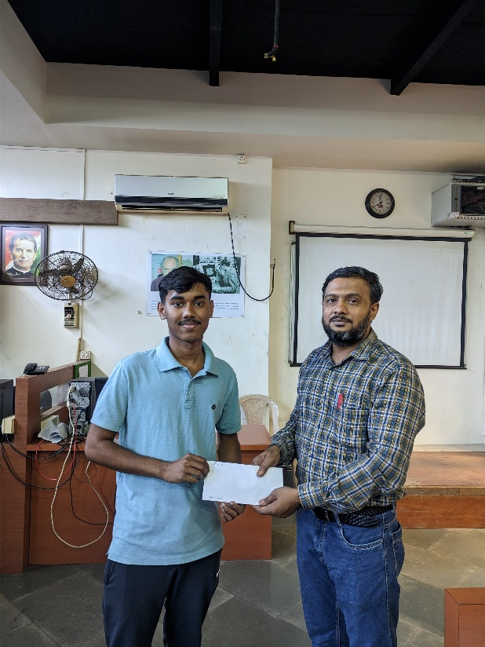**Winners of the Event:**

**1st Place**

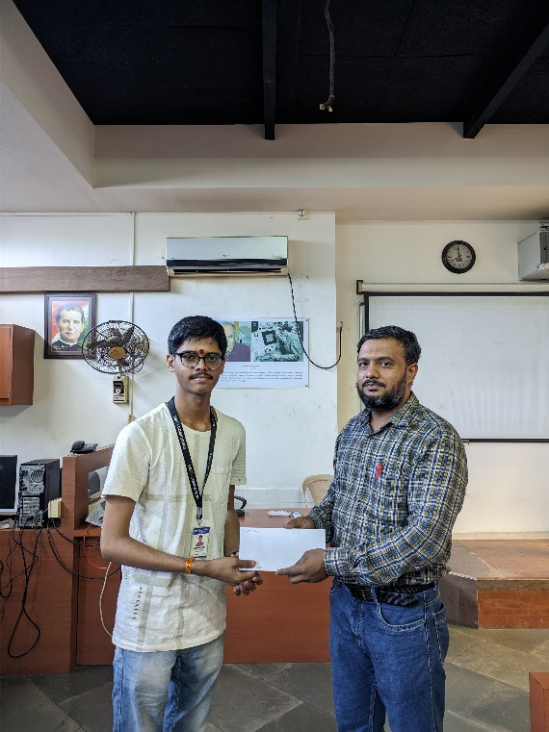**2nd place**

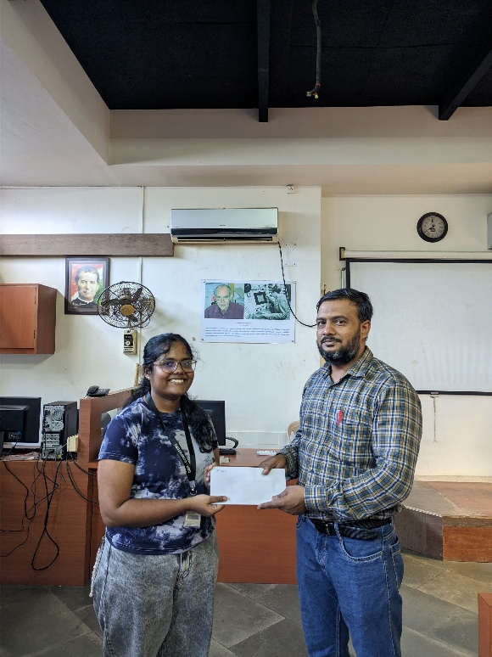

**3rd place**

**Feedback:**

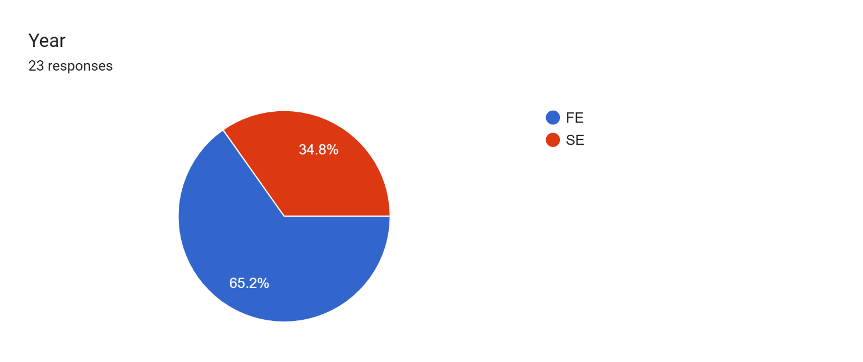

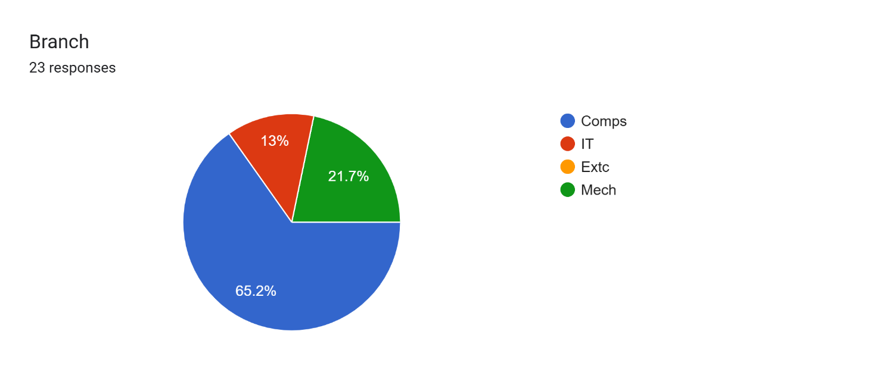

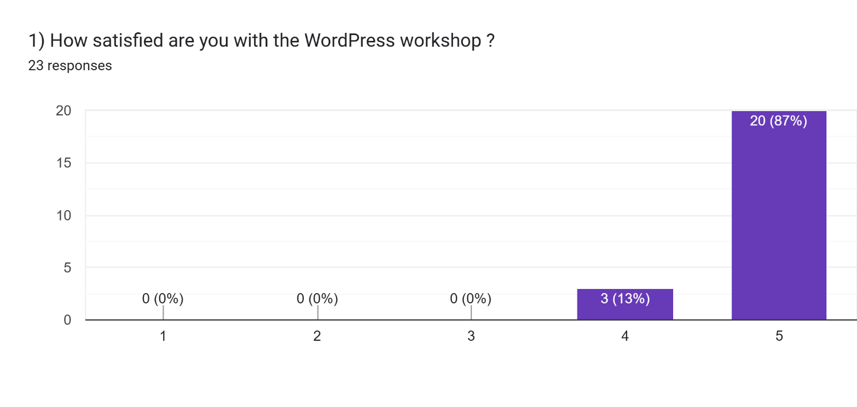

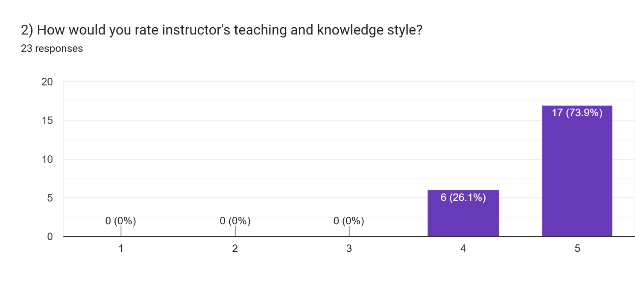

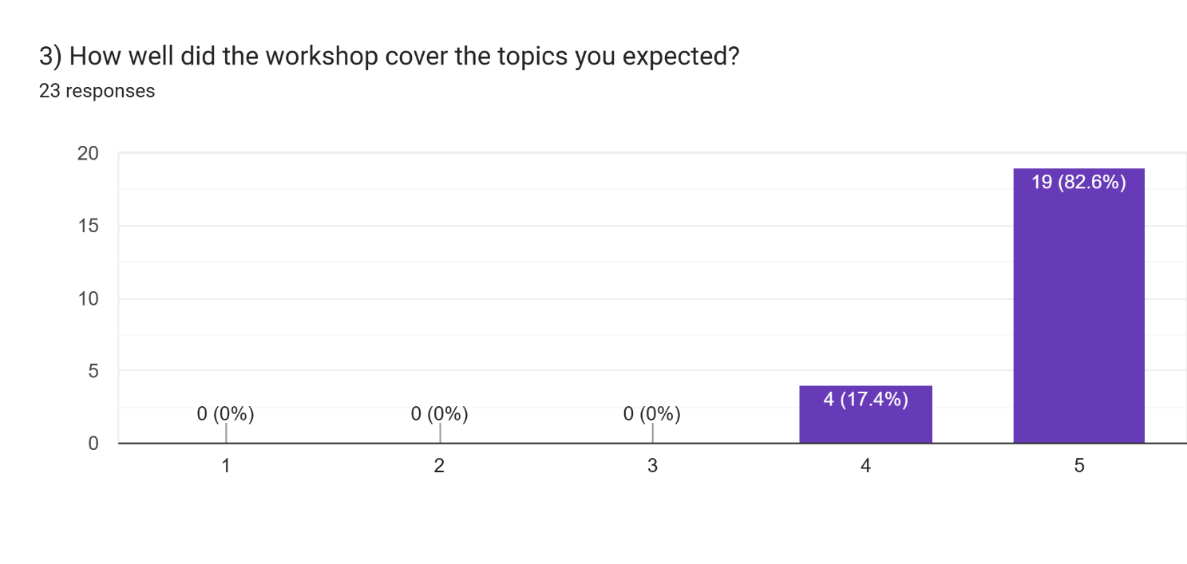

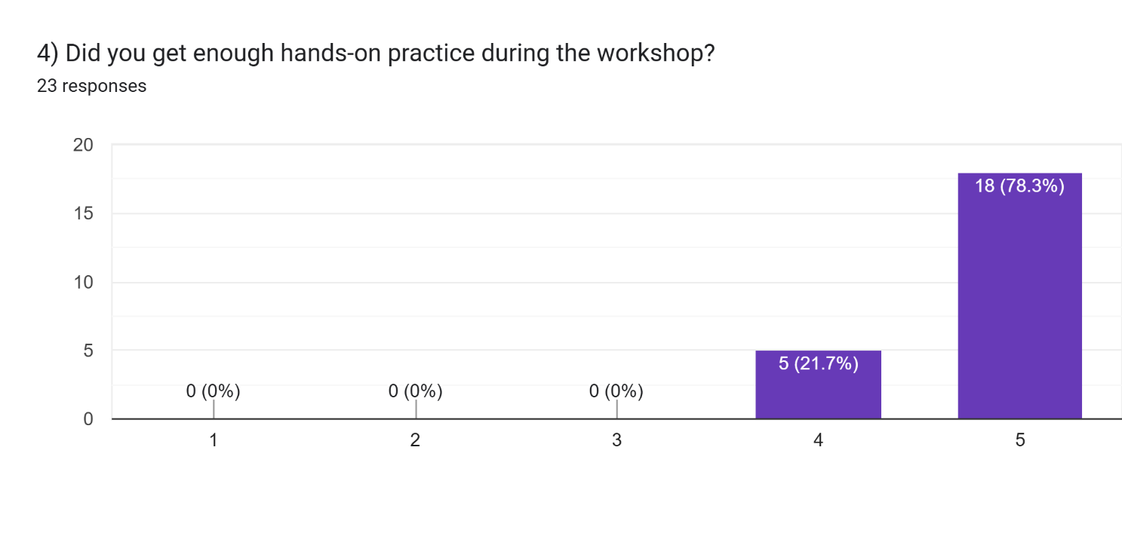

**Questions and Answers:**

1. **What did you like most about workshop?**
   1. I messed up while working and the instructor helped me a lot . Piyush sir helped a lot .
   2. Interaction and attention towards every participant
   3. Building my own website was pretty cool
   4. The volenteers, and the IEEE members teaching were pretty friendly and cooperative. They supported and guided well when needed individually.
   5. I liked session of giving us the practice of various plugins. And helping nature of mentors was commendable.
2. **What could be improved in future workshops?**
   1. More sessions could be held
   2. Nothing. It was a great experience
   3. All workshops should be held offline
   4. More sessions as it was a good experience this time
   5. Nothing!!! It was perfect
3. **What other workshops would you want us to conduct in the future?**
   1. A lot more coding based
   2. Basic webdev? Maybe?
   3. Workshops on More softwares like WordPress or related to computer,coding.
   4. App building
   5. Backend development introduction to

**Conclusion:**

The "WordPress Express: Fast-track Your Website" workshop provided students with a structured and practical approach to WordPress website development. By combining theoretical insights with hands-on practice, participants gained confidence in website creation, customization, and optimization. The competition added a fun and challenging aspect, encouraging active learning and skill application.

**Report Prepared by: IEEE DBIT reporting team**

**Name of the Student: Dhruv Tare**

**Post of the student: Reporting Head**

**Name of the Student: Pritika** **Mediboina**

**Post of the Student: Joint Reporting Head**