**Roboton Workshop**

**Date: 4th & 5th March 2025**

**Time: 9:00 AM to 5:00 PM**

**Venue: Seminar Hall, A Wing, Don Bosco Institute of Technology, Kurla, Mumbai - 400070**

**Speakers:** Prathamesh Kurdekar, Zubia Sarang, Priyanshu Sakharkar

**Support Team:**

Pritika, Yukita, Samiksha, Ayush Gajbhiye

**Number of participants:** 60

**Number of Boys:** 40

**Number of Girls:** 20

**Objective:**

The objective of the workshop was to provide participants with hands-on experience in designing and building a **gesture-controlled robot** using an **Arduino-controlled car** and an **accelerometer**. The key goals were:

* Introducing participants to **Arduino-based robotics and embedded systems**.
* Teaching the fundamentals of **robotic motion control and sensor interfacing**.
* Developing practical knowledge in **wireless gesture control using an accelerometer**.
* Encouraging participants to apply these concepts in **real-world automation projects**.

**Outcome:**

By the end of the workshop, participants:

* Successfully **built an Arduino-based robotic car**.
* Implemented **gesture control using an accelerometer on the second day**.
* Learned **Arduino programming**, motor driver integration, and wireless communication.
* Understood the **practical applications of motion-controlled robotics**.

**Description:**

The **"Roboton Workshop"** was organized by the **IEEE-DBIT RAS Student Chapter** on **4th and 5th March 2025**. It was attended by students from various engineering branches and focused on **building a gesture-controlled robot** using **Arduino and an accelerometer**.

**Day 1: Building the Robot & Understanding Arduino**

* The workshop began with an **introduction to robotics and automation**, emphasizing the role of **Arduino in modern embedded systems**.
* Participants were introduced to **Arduino hardware**, including **microcontrollers, sensors, motor drivers, and power management**.
* The speakers explained the **Arduino IDE** and guided students through **basic coding exercises**, such as:
  + **Blinking an LED** using the built-in LED pin.
  + **Reading sensor data** using analog and digital inputs.
  + **Controlling a DC motor** using PWM signals.
* Students then applied these concepts to **assemble the robotic car**, connecting **DC motors, motor drivers, and batteries** to the Arduino board.
* By the end of **Day 1**, every team had successfully built a **functional robotic car**, ready for gesture control implementation.

**Day 2: Implementing Gesture Control & Competition**

* The second day began with a **quiz competition**, testing students on **Arduino programming, sensor interfacing, and robotics concepts** covered on Day 1.
* Following the quiz, students were introduced to **accelerometers** and their role in detecting **tilt and motion**.
* Participants interfaced the **accelerometer module with Arduino**, programming it to **control the robot’s movement using hand gestures**.
* The final implementation phase included:
  + **Calibrating the accelerometer** for precise motion detection.
  + **Transmitting gesture signals wirelessly** to control the robot.
  + **Debugging and optimizing** the response time for better performance.
* After successful implementation, students participated in a **timed race** where each team controlled their bot using gestures to navigate a **predefined track**.
* The **winners of the workshop were decided based on both the quiz scores and the race performance**.
* The session concluded with a **demonstration and prize distribution** for the top three teams.

**Photos of the Event:** 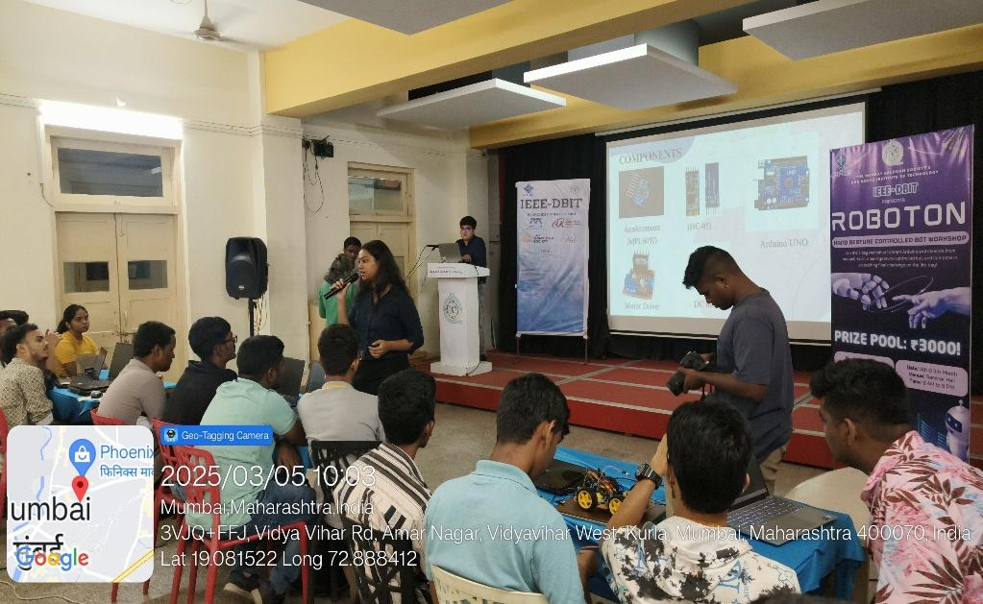

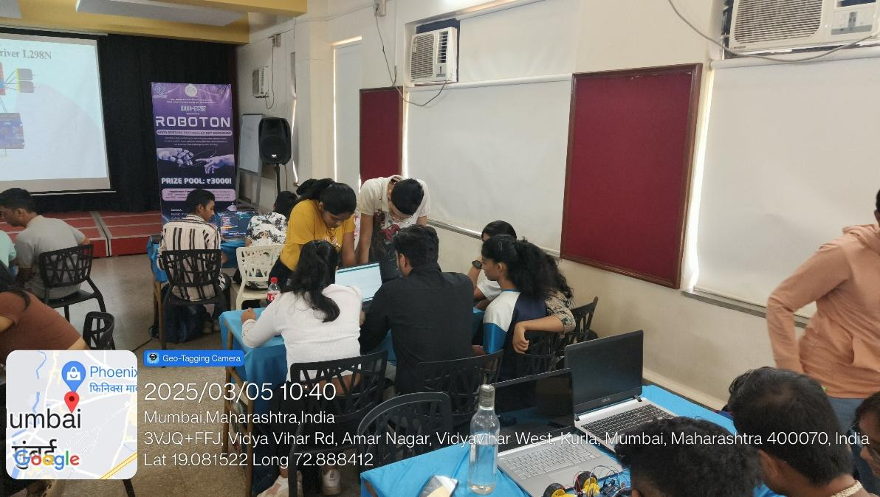

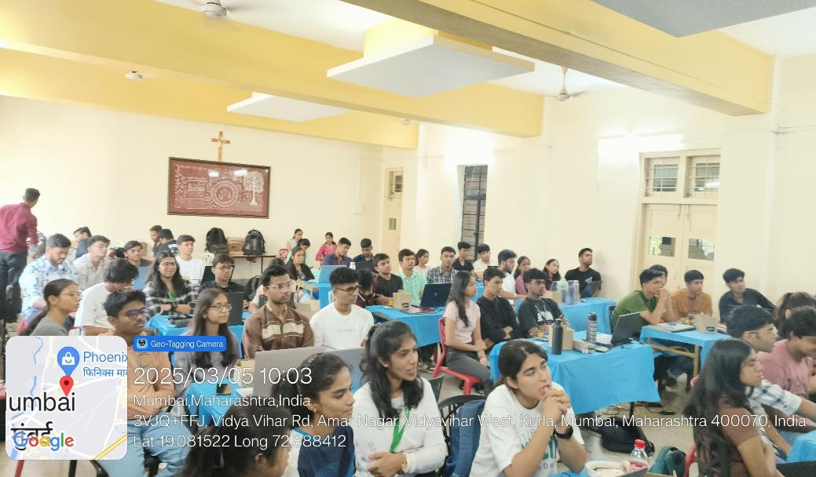

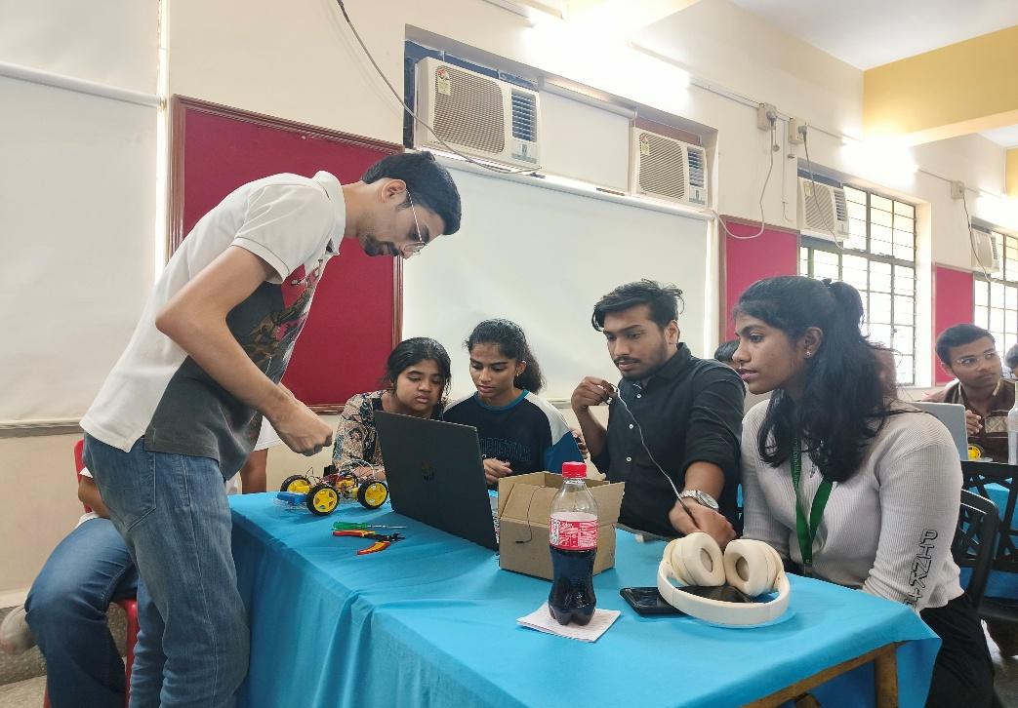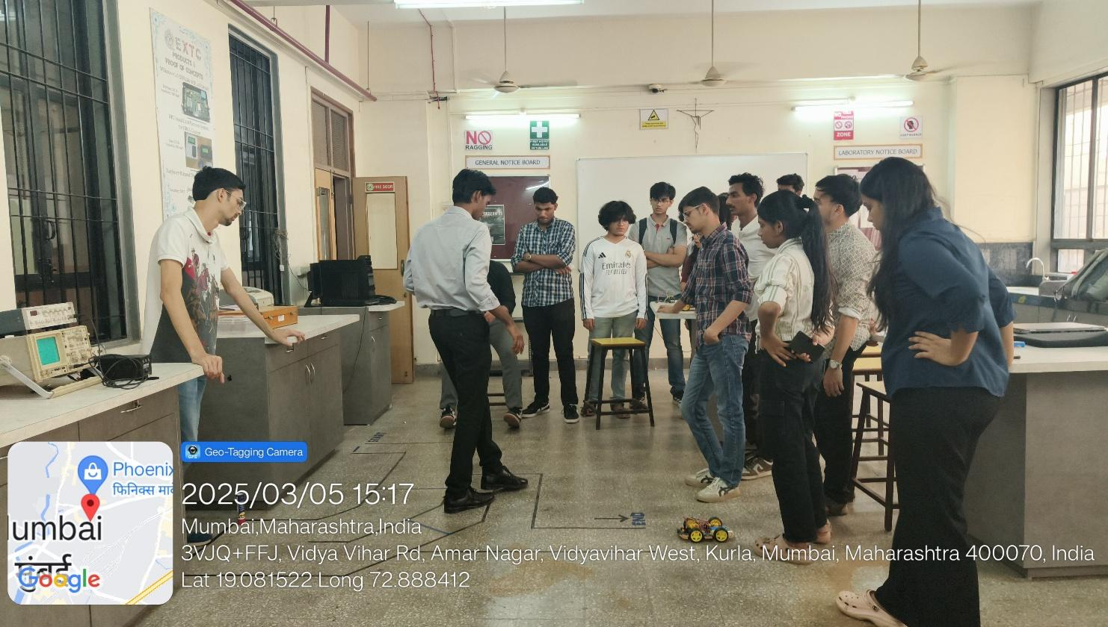

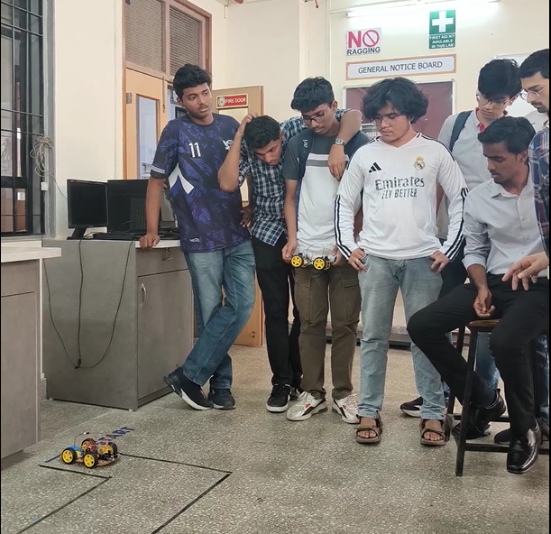

**Event Poster:** 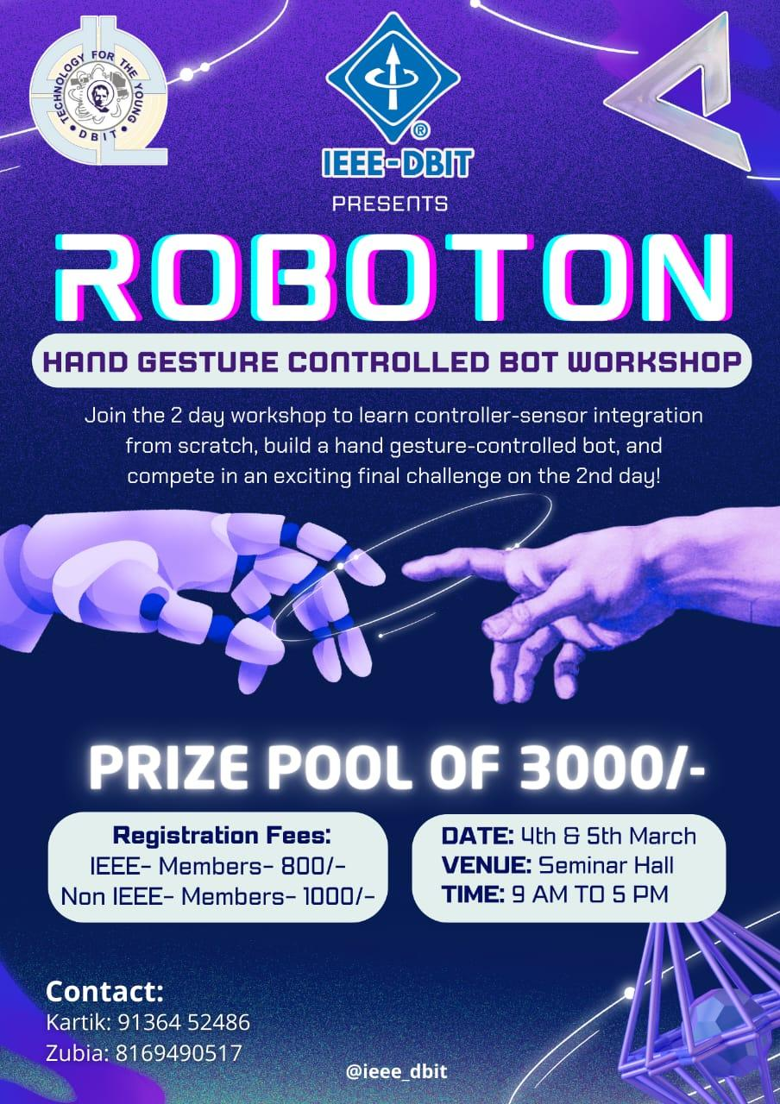

**Social Media Links:**

Instagram - <https://www.instagram.com/ieee_dbit/?hl=en>

Website – https://ieee.dbit.in

**Participants:**

|  |  |  |
| --- | --- | --- |
| **Name** | **Year** | **Department** |
| Swara Ghosalkar | FE | EXTC |
| Mohammed Hasan | FE | EXTC |
| Vinet Suryawanshi | FE | EXTC |
| Pratham Adavade | FE | MECH |
| Prajwal Gowda | SE | MECH |
| Jaydatt Sawant | SE | MECH |
| Tanish Kunder | SE | MECH |
| Aditya Pawar | SE | MECH |
| Sanket Prajapati | SE | MECH |
| Clive Dias | SE | MECH |
| Russel Ferreira | FE | MECH |
| Ralston Dsouza | FE | MECH |
| Shraddha Hebbar | FE | IT |
| Jenny Joy | FE | COMPS |
| Ivie Pendse | FE | IT |
| Ananya Shetty | FE | IT |
| Om Arolkar | FE | MECH |
| Mousam Patra | FE | IT |
| Siya Agivale | FE | EXTC |
| Huzan Mistry | SE | MECH |
| Ayush Mali | SE | MECH |
| Harsh Angare | SE | MECH |
| Aditya Pawar | SE | MECH |
| Sumit Botle | SE | EXTC |
| Deepak Sakha | SE | EXTC |
| Anant Deshmukh | SE | EXTC |
| Jai Salunke | SE | EXTC |
| Raman Sharma | SE | EXTC |
| Saha Anu | SE | EXTC |
| Yashvi Jain | SE | EXTC |
| Dhruv Tare | SE | EXTC |
| Saeesh Gidh | SE | EXTC |
| Aryan Puranik | SE | EXTC |
| Kripa Dewoolkar | SE | EXTC |
| Mrunmai Paktekar | SE | EXTC |
| Daniel Sebastian | SE | EXTC |
| Kartik Nyalapelli | SE | EXTC |
| Sneha Pawar | SE | EXTC |
| Harshali Gokhale | SE | EXTC |
| Pushkar Mahale | FE | EXTC |
| Ayush P | FE | IT |
| Pramit Kulkarni | FE | COMPS |
| Ayush Borle | FE | EXTC |
| Saarth Gandre | FE | EXTC |
| Simone D’sa | FE | IT |
| Ocina Serrao | FE | EXTC |
| Denver Gracias | FE | COMPS |
| Neha Haldankar | FE | EXTC |
| Aradhya Pawar | FE | EXTC |
| Parth Pawar | FE | EXTC |
| Abhinav Borse | FE | EXTC |
| Swanandi Chavan | FE | EXTC |
| Malcom Monserrate | FE | COMPS |
| Adam Davis | FE | COMPS |
| Amey Dalvi | SE | EXTC |
| Francis Penmadan | SE | MECH |
| Shaikh Umair | SE | MECH |
| Momin Umair | SE | MECH |
| Kapil Labde | SE | EXTC |

**Winners of the Workshop:   
1st Prize:** Sumit Botle (SE EXTC), Harsh Ankush Angre (SE Mech), Aditya Namdev Pawar (SE Mech), Ayush Pankaj Mali (SE Mech)

**2nd Prize:** Sanket Prajapati, Clive Dias (SE Mech), Ralston Dsouza (FE Mech), Russell Ferreira (FE Mech)

**3rd Prize:** Jai Salunkhe, Raman Sharma (SE EXTC), Anant Deshmukh (SE EXTC), Deepak Sakha (SE EXTC)

**Feedback:**

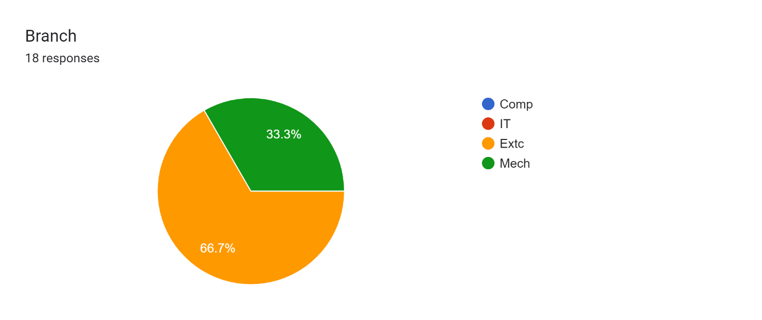

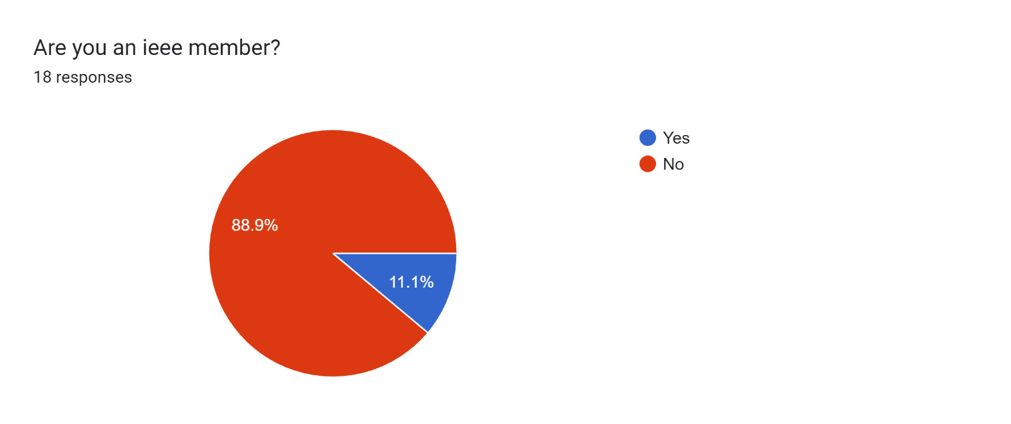

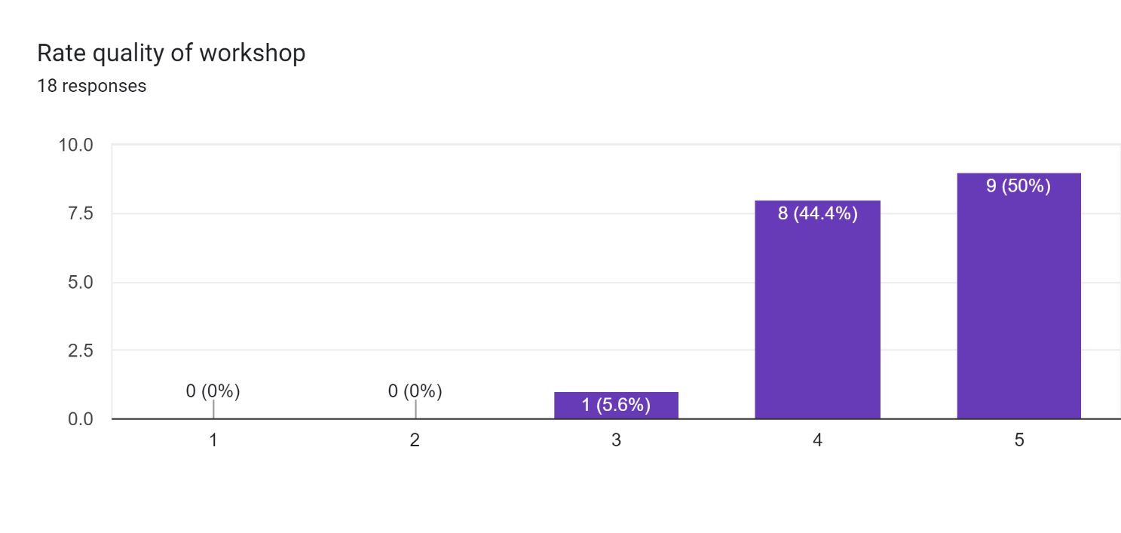

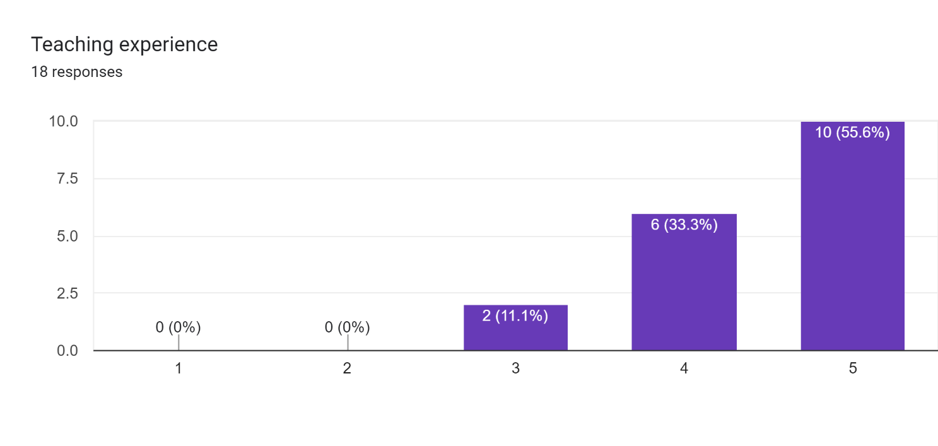

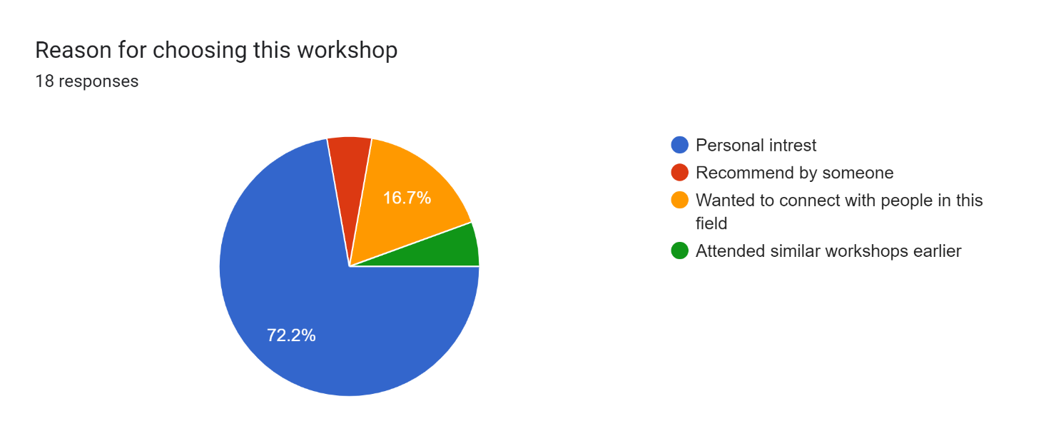

**Comments:**

* + 1. The workshop was great , have learn new things and the peer mentors are helpful and supportive , overall the workshop was fun with hands-on experience.
    2. Very interesting and I learn lot's of things which make me use in my further semester
    3. Improve devices quality
    4. Please elaborate the codes more
    5. Workshop was really good, enjoyed being a part of it.
    6. More Robotics Workshop
    7. Overall the workshop was good.
    8. Longer session would be nice. And fusion too
    9. Very encouraging mentors,they help us lot and give chance to participate in real life application such as robotics
    10. great workshop

**Conclusion:**

The **"Roboton Workshop"** provided students with **a complete understanding** of Arduino-based robotics, from hardware assembly to implementing wireless gesture control. The structured approach, with **robot construction on Day 1 and gesture-based automation on Day 2**, allowed participants to grasp both **mechanical assembly** and **sensor-based control techniques**. The workshop fostered technical skills, **encouraging students to explore advanced robotics applications** in automation and IoT.

**Report Prepared by: IEEE DBIT reporting team**

**Name of the Student: Dhruv Tare**

**Post of the student: Reporting Head**

**Name of the Student: Pritika** **Mediboina**

**Post of the Student: Joint Reporting Head**