IEEE SYSTEMS, MAN, AND CYBERNETICS SOCIETY
STUDENT BRANCH CHAPTER
KALYANI GOVERNMENT ENGINEERING COLLEGE
( KGEC )

SUMMER RESEARCH INTERNSHIP PROGRAMME
2 0 2 6
FINAL RESEARCH REPORT — SUBMISSION COVER PAGE
MedMNIST-Defer: A Cross-Modality Benchmark for Selective Prediction in Biomedical Imaging

PROGRAMME DETAILS
Domain / Track: | Healthcare | Duration: | [ Start – 14August, 2026 ]

Department: | Computer Science & Engineering | Batch / Year: | 2026
SUBMITTED BY
Student 1 | Gourango Mandal
UNDER THE MENTORSHIP OF
Mentor Name | Kaustabh Ganguly
Affiliation | Senior AI/ML engineer, Gracenote
DECLARATION
We hereby declare that this report is a record of genuine work carried out by us under the guidance of the above-mentioned mentor, as part of the IEEE SMC Student Branch Chapter, KGEC — Research Internship Programme 2026, and has not been submitted elsewhere for any other purpose.

Kaustabh Ganguly  Mentor's Signature | Programme Coordinator
IEEE SMC Student Branch Chapter, KGEC | Research Internship Programme 2026 | Date of Submission: [ 20 / 08 / 2026 ]


MedMNIST-Defer: A Cross-Modality Benchmark for Selective Prediction in Biomedical Imaging
IEEE SMC Student Branch Chapter, KGEC Research Internship Programme 2026

Abstract
Biomedical image classifiers are often assessed as if they must produce a prediction for every image. In practice, an uncertain case can be referred to a human reviewer or a more detailed examination. Selective prediction formalises this reject option by evaluating how accuracy changes when the least confident cases are deferred. This report studies MedMNIST-Defer, a cross-modality benchmark covering all 12 two-dimensional MedMNIST v2 subsets under one fixed experimental protocol. A ResNet-18 model was trained from scratch for eight epochs with random seed 42 and no data augmentation or per-dataset tuning. The following confidence measures were assessed: predictive entropy, maximum softmax probability, top-two probability margin, temperature-scaled entropy, and Monte Carlo dropout. Accuracy was calculated for 100%, 90%, 80%, 70%, 60%, and 50% coverages along with risk-coverage AUC and expected calibration error (ECE). The presented results demonstrate that keeping 50% of the most confident cases raises the accuracy by an average of 16.0 percentage points on the 12 datasets, with the benefits ranging from 9.6 to 20.9 points. The overall Wilcoxon signed-rank test shows p = 4.9 x 10⁻⁴. The five measures have similar performance, whereas the temperature scaling technique only helps to calibrate and does not affect deferral order. The paper describes the influence of such factors as test set size, low resolution of images, single-seed training, and threshold tuning after the fact. But the main contribution of the research is a generic way to measure selective prediction for different biomedical imaging problems and not a new deferral method.
Keywords: MedMNIST, Selective Prediction, ResNet-18, Expected Calibration Error (ECE), Biomedical Image Classification

1. Introduction

1.1 Background
Medical image classification systems are generally evaluated using statistics like accuracy or the area under the ROC curve. While helpful, such statistics make the assumption that the system is forced to decide on all cases. There is always an alternative approach within clinical practices that uncertain cases be referred to a specialist or subjected to a second test. Selective prediction treats this option as part of the prediction system. Instead of asking only whether the classifier is correct, it asks whether the confidence score can identify a subset of cases on which the classifier is more reliable [1], [2].
The central quantity is accuracy at a chosen coverage. At 100% coverage, every test image is retained and ordinary accuracy is recovered. At 50% coverage, only the half of the test set with the highest confidence is retained, while the remaining half is deferred. A useful confidence signal should therefore place a larger proportion of incorrect predictions among the deferred cases. The resulting coverage-accuracy curve describes the practical trade-off between automated workload and retained accuracy [1], [3].

1.2 Problem Statement
Selective prediction has been studied using reject-option classifiers, uncertainty estimates, and learning-to-defer methods. However, medical studies are often reported on one modality at a time, with different datasets, architectures, training budgets, coverage levels, and uncertainty measures. This makes it difficult to determine whether an observed improvement is due to the confidence method or simply to differences between datasets. The MedMNIST v2 collection offers a useful common basis because it contains 12 standardized two-dimensional biomedical datasets with official train, validation, and test splits [4].
The problem addressed in this report is therefore the lack of a common experimental reference for selective prediction across multiple biomedical imaging modalities. MedMNIST-Defer addresses this problem by applying one training and evaluation recipe to all 12 subsets and by comparing five confidence signals generated from the same trained model. The source report explicitly positions the work, as a benchmark and measuring instrument rather than as a new deferral algorithm.

1.3 Objectives
For an assessment of selective prediction on all 12 two-dimensional MedMNIST v2 datasets.
For a comparison of predictive entropy, max softmax probability, top-two margin, temperature entropy, and Monte Carlo dropout within the same trained model.
To measure accuracy at six coverage levels and summarize the complete risk-coverage behaviour using risk-coverage AUC.
To assess calibration using expected calibration error and examine whether calibration improvement corresponds to better deferral ranking.
To use paired bootstrap intervals and a collection-level Wilcoxon signed-rank test to assess the reliability of observed gains.
To identify practical limitations that affect the interpretation and possible deployment of selective prediction in biomedical imaging.

2. Literature Review and Background

2.1 Selective Prediction and Reject Options
The reject-option formulation is rooted in the classical error-reject trade-off introduced by Chow [1]. Later work formalized selective classification in terms of a predictor and a selection mechanism, with risk and coverage used to describe the resulting trade-off [2], [3]. Deep-learning methods such as SelectiveNet integrate the selection mechanism into network training, while Deep Gamblers treats abstention through a payoff formulation [5], [6]. These methods differ from the post-hoc policies used in this benchmark because the benchmark leaves the classifier unchanged and ranks already computed predictions.

2.2 Confidence, Uncertainty, and Calibration
A selective system depends on the ordering produced by its confidence score. Predictive entropy uses the complete class-probability distribution, while maximum softmax probability uses only the largest probability. The top-two margin measures the gap between the two largest probabilities. Monte-Carlo dropout provides a stochastic estimate of uncertainty by retaining dropout during inference [7]. Temperature scaling is a simple calibration method that changes the sharpness of predicted probabilities without changing the underlying class ordering in binary classification [8].
Calibration and selective ranking must not be thought of as being the same thing. A system can be calibrated in such a way that it gives unreliable probability estimates but ranks the right cases before the wrong ones. Similarly, calibration can help a system produce reliable probability estimates but not change the ranking order.

2.3 Medical Imaging and Learning to Defer
Medical imaging studies have used uncertainty estimates for referral, second opinions, and failure detection. Work in diabetic retinopathy, medical second opinions, and clinician-complementary diagnosis demonstrates the potential value of uncertainty-aware referral [9]–[11]. Learning-to-defer research further considers the performance of a particular human expert rather than simply removing uncertain cases [12], [13]. The present benchmark does not model an expert and therefore evaluates retained-case accuracy rather than complete human-plus-model performance.

2.4 MedMNIST as a Common Benchmark
MedMNIST v2 contains 12 two-dimensional and 6 three-dimensional biomedical datasets. The 2D collection covers blood-cell microscopy, breast ultrasound, chest radiography, dermatoscopy, retinal optical coherence tomography, abdominal CT, colorectal histopathology, pediatric chest X-ray, fundus photography, and kidney-cortex microscopy. Images are standardized to 28 × 28 pixels in the original benchmark, with official data splits and different task types including binary, multi-class, multi-label, and ordinal classification [4].
The small and standardized format makes MedMNIST suitable for controlled experiments, but it also limits clinical interpretation. The provided benchmarking report stresses that 28 × 28 images strip away diagnostic information, and that the generated absolute accuracy scores cannot be viewed as estimations of real-life performance. MedMNIST is intended as a research and educational benchmark rather than a clinical diagnostic system [4].

3. Dataset and Experimental Design

3.1 Dataset Composition
The experiment uses all 12 two-dimensional MedMNIST v2 subsets. Their official splits contain 518,175 training images, 70,467 validation images, and 119,320 test images in total. Test-set size varies substantially, from 156 images in BreastMNIST to 47,280 in TissueMNIST. This variation is important because statistical uncertainty becomes larger when the retained set contains only a small number of images.

Table1:Composition of the 12 MedMNIST v2 two-dimensional subsets used in the benchmark.
Dataset | Modality | Task | Classes | Train | Val | Test
BloodMNIST | Blood-cell microscopy | Multi-class | 8 | 11,959 | 1,712 | 3,421
BreastMNIST | Breast ultrasound | Binary | 2 | 546 | 78 | 156
ChestMNIST | Chest X-ray | Multi-label | 14 | 78,468 | 11,219 | 22,433
DermaMNIST | Dermatoscopy | Multi-class | 7 | 7,007 | 1,003 | 2,005
OCTMNIST | Retinal OCT | Multi-class | 4 | 97,477 | 10,832 | 1,000
OrganAMNIST | Abdominal CT (axial) | Multi-class | 11 | 34,561 | 6,491 | 17,778
OrganCMNIST | Abdominal CT (coronal) | Multi-class | 11 | 12,975 | 2,392 | 8,216
OrganSMNIST | Abdominal CT (sagittal) | Multi-class | 11 | 13,932 | 2,452 | 8,827
PathMNIST | Colorectal histopathology | Multi-class | 9 | 89,996 | 10,004 | 7,180
PneumoniaMNIST | Pediatric chest X-ray | Binary | 2 | 4,708 | 524 | 624
RetinaMNIST | Fundus photography | Ordinal | 5 | 1,080 | 120 | 400
TissueMNIST | Kidney-cortex microscopy | Multi-class | 8 | 165,466 | 23,640 | 47,280

3.2 Task-Specific Handling
Ten subsets use binary or multi-class softmax classification with cross-entropy loss. ChestMNIST is treated as a 14-output multi-label task using binary cross-entropy; a case is counted as correct only when all 14 labels are correct. This exact-match definition avoids a misleadingly high score caused by the large number of negative labels. RetinaMNIST contains five ordered diabetic-retinopathy grades but is evaluated as a multi-class task to remain consistent with the reference classification setting [4].

3.3 Data Integrity and Reproducibility
The benchmark uses the official MedMNIST data splits. The source project reports checksum verification against the metadata associated with the MedMNIST package and records the dataset version in a manifest. The repository also contains small class-stratified sample subsets so that the full pipeline can be tested without downloading the complete collection. These sample subsets are intended only to test the software pipeline and are not used for the reported scientific results.

4. Methodology

4.1 Selective Prediction Formulation
Let f(x) denote the classifier prediction and g(x) denote a confidence score. For a test set of n images and a chosen coverage c, the benchmark retains the ceil(cn) images with the highest confidence and defers the remaining images. Accuracy at coverage is the proportion of correct predictions among the retained images. The deferral gain is the difference between accuracy at coverage c and the full-coverage accuracy. Coverage levels of 100%, 90%, 80%, 70%, 60%, and 50% are evaluated.
The 50% coverage could be viewed as an easy triage, where the system deals with 50% of the scenarios on its own, while the rest go for further examination. This interpretation does not mean that the benchmark measured a real clinician's performance; the deferred cases are removed from the accuracy calculation.

4.2 Deferral Policies
Table 2 : Confidence policies evaluated using the same trained ResNet-18 weights.
Policy | Description
Predictive entropy | Uses the full predicted probability distribution; lower uncertainty indicates greater confidence.
Maximum soft-max probability | Uses the largest predicted class probability as the confidence score.
Top-two margin | Uses the difference between the largest and second-largest class probabilities.
Temperature-scaled entropy | Computes entropy after fitting a temperature on a held-out part of the training data.
Monte-Carlo dropout | Uses dropout during inference and averages probabilities from 10 stochastic passes.

4.3 Model and Training Protocol
The primary model is ResNet-18 trained from scratch. For single-channel datasets, the first convolution is changed to accept one input channel. A dropout layer with probability 0.3 is inserted before the final linear layer so that Monte-Carlo dropout can be evaluated without changing the trained backbone. The fixed training protocol uses Adam with a learning rate of 10⁻³, batch size 128, eight epochs, no augmentation, default PyTorch weight initialization, and random seed 42. Images are scaled to [0,1] and normalized using (x − 0.5)/0.5. The source benchmark deliberately avoids per-dataset tuning, early stopping, class weighting, learning-rate schedules, and ImageNet pretraining so that the comparison remains focused on deferral behaviour.

4.4 Evaluation and Statistical Analysis
For each dataset, the model is trained once, temperature is fitted on 10% of the training split using negative log-likelihood, deterministic logits are collected on the test set, and ten stochastic passes are used for Monte-Carlo dropout. The five confidence scores are then used to construct coverage-accuracy curves.
Risk-coverage AUC summarizes error across the complete confidence ranking; lower values are better. Expected calibration error is computed from 15 equal-width confidence bins. For statistical inference, 500 paired bootstrap resamples are generated for each dataset, policy, and reported coverage. The confidence ranking and retained set are recomputed inside each resample. A Wilcoxon signed-rank test across the 12 datasets is used to test whether deferral consistently improves accuracy at the collection level.

4.5 Software and Runtime
The reported implementation used Python 3.13, PyTorch 2.11.0 with CUDA 12.8, NumPy 2.4, and SciPy. The full 12-dataset benchmark, including training, Monte-Carlo inference, and bootstrap resampling, required approximately 326 seconds on an NVIDIA RTX PRO 4500 Blackwell Server Edition. The largest runtime was associated with Tissue MNIST, because of its large test set.

5. Results

5.1 Coverage-Accuracy Behaviour
The accuracy of the five approaches is shown in Figure 1 as the coverage level drops from 100% to 50%. The most significant trend is that accuracy improves as low-confidence instances are stripped out. The graphs for entropy, maximum soft-max probability, margin, temperature-scaled entropy, and Monte Carlo dropout are all very similar to one another. This means that, in the context of the 28 × 28 bench-marking framework and training regime, the specific type of confidence measure used makes less difference than the imaging modality and classifier employed.

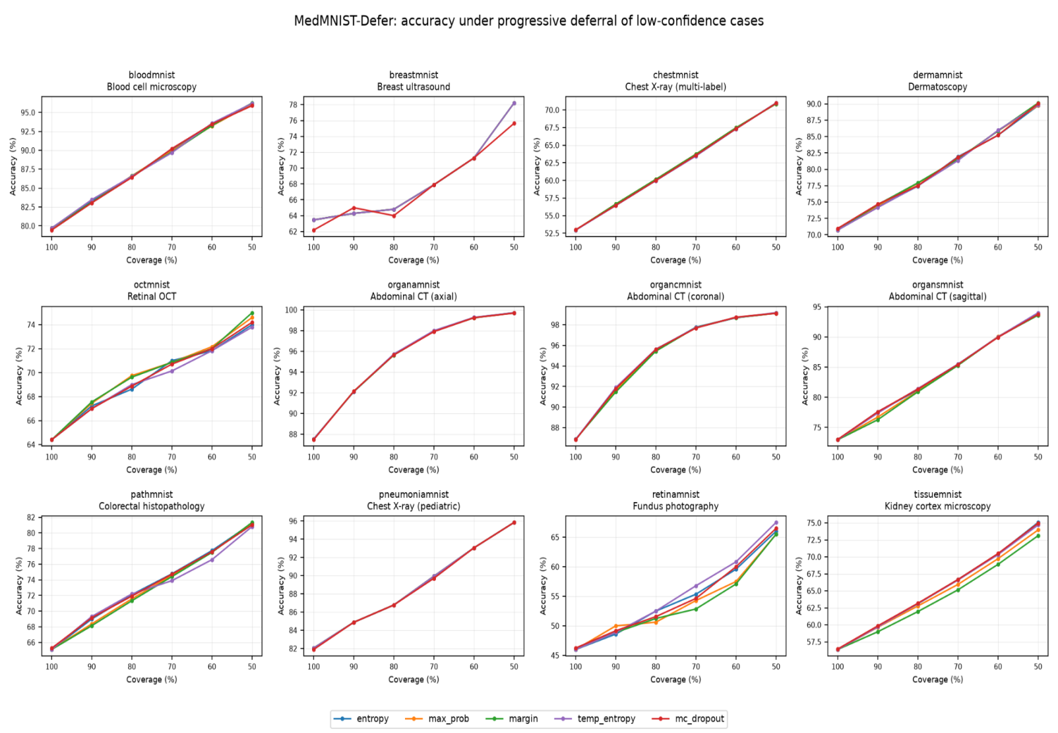
Fig. 1. Accuracy under progressive deferral across the 12 MedMNIST datasets.

However, the largest visual improvements are found in multiple datasets in which the full-coverage model has plenty of room for improvement even after the removal of uncertain instances. Invariants of OrganMNIST datasets demonstrate large retained accuracy, while RetinaMNIST and TissueMNIST are good examples to illustrate that a very large improvement may go along with relatively low accuracy retained. According to the original report, the RetinaMNIST dataset demonstrates +20.0 point improvement but has only 66.0% accuracy, while TissueMNIST has +18.7 point improvement but 75.1% accuracy retained.

5.2 Gain at 50% Coverage
Figure 2 shows the gain achieved by using only the most confident 50% of data. The entropy approach is the baseline rank here, and the gain is found to be dependent on the modality used. The maximum gain is achieved by OrganAMNIST at around 21 points, followed by RetinaMNIST, DermaMNIST, and TissueMNIST. The minimum gain is gained by OCTMNIST at 9.6 points. Overall, for the entire dataset, the source benchmark achieves an average gain of 16.0 points with a range of +9.6 to +20.9 points.
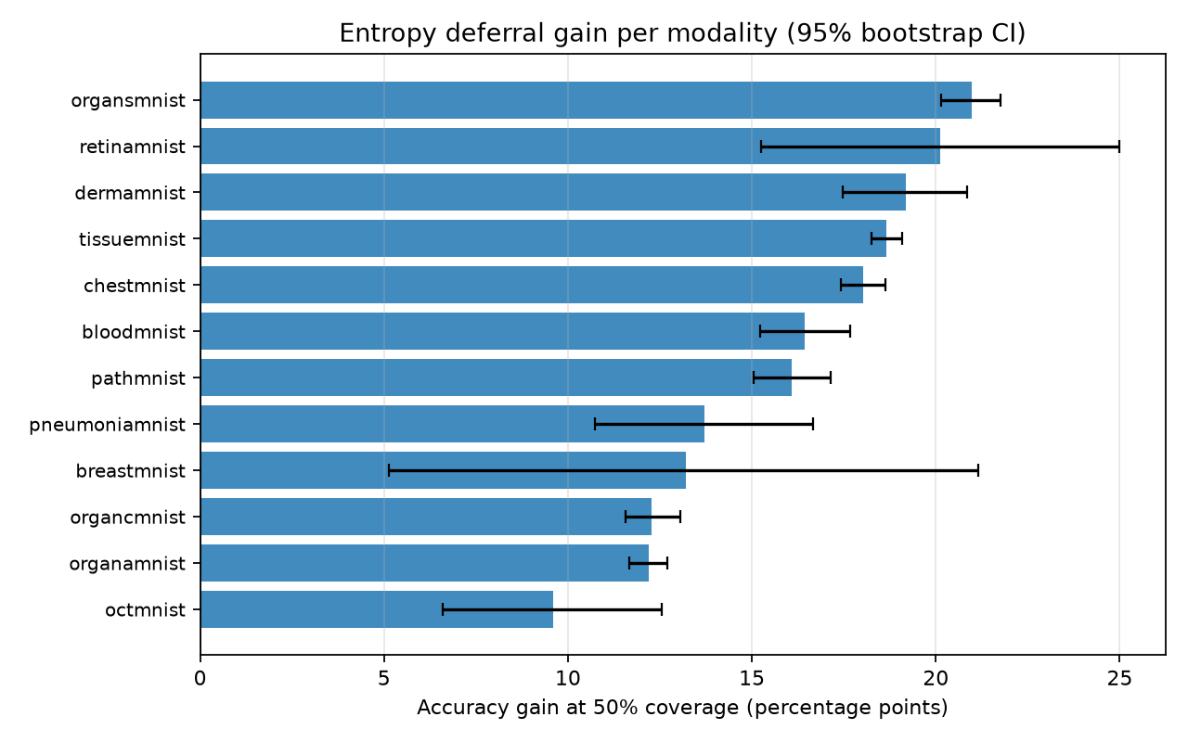
Fig. 2. Entropy deferral gain per modality.
The uncertainty intervals are most relevant in the case of smaller datasets. BreastMNIST dataset is based on only 156 test samples, and therefore, its uncertainty interval is more evident than the intervals of some larger subsets. In the original analysis, it was noted that 50% improvement was statistically significant across the whole dataset, while 90% could not be detected in smaller test sets.

5.3 Calibration and Deferral Benefit
In Figure 3, there is a comparison of expected calibration error prior to calibration against the gain in 50% coverage. There is a weak positive correlation between the two with a Pearson correlation coefficient value of r = 0.17. It is worth noting, that due to the limited number of datasets used, which is only 12, the correlation is considered descriptive but not confirmatory.
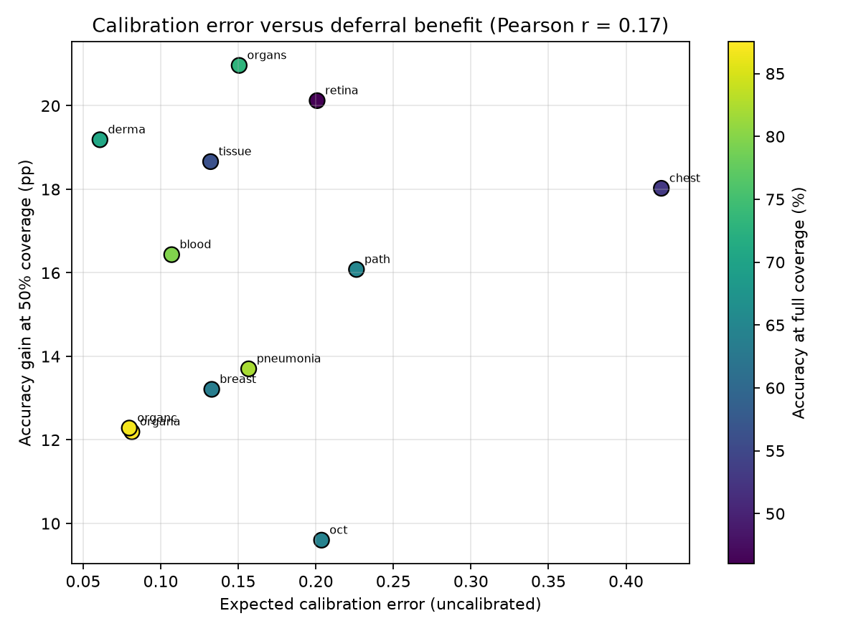
Fig.3: Expected calibration error versus defferral benefit across the 12 MedMNIST datasets.

5.4 Comparison of Deferral Policies
Figure 4 shows the comparison between the average benefit and the quality of ranking for the five policies. The mean improvements in accuracy scores are very similar with entropy and temperature-scaled entropy being around 16 percent and the rest of the policies very slightly above or below them. Risk-coverage AUC used to represent the quality of ranking is also tightly clustered. This finding aligns with the key point made in the benchmark.
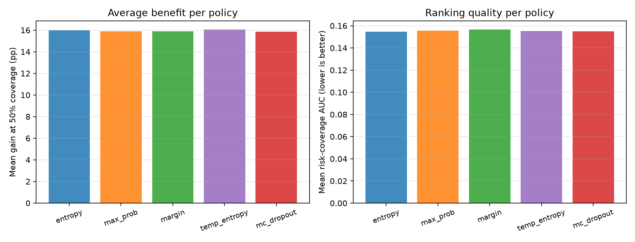
Fig. 4: Comparison of confidence measures based on average deferral benefit and risk-coverage ranking quality.

5.5 Main Quantitative Findings
Table 3: Summary of the results of the major benchmarks presented in the provided research and illustrations.
Measure | Result | Interpretation
Mean gain at 50% coverage | +16.0 percentage points | Across all 12 datasets.
Gain range | +9.6 to +20.9 points | Variation is mainly across modalities.
Collection-level Wilcoxon test | p = 4.9 × 10⁻⁴ | All 12 datasets move in the beneficial direction.
Policy spread | ≤ 0.18 points | Mean gains of the five confidence signals are tightly clustered.
Temperature scaling | 33% lower mean ECE | Deferral gain changes by only about +0.07 points.
Calibration-benefit correlation | r = 0.17 | Weak descriptive association across 12 datasets.
Full benchmark runtime | 326.3 seconds | One GPU, including bootstrap analysis.

6. Discussion

6.1 Why Deferral Improves Accuracy
The outcomes can be explained by the simplicity of the algorithm: classification mistakes do not have the same distribution with respect to confidence ordering. The removal of low-confidence classifications in case the mistake rate is higher for such classifications leads to higher accuracy of the remaining subset. Calibration of probabilities is not necessary for the benchmark; it only needs to provide confidence scores ranked by likelihood of correctness.

6.2 Confidence Policy Choice
The five strategies generate nearly identical improvements. This is significant because the maximum softmax probability strategy is significantly less computationally expensive compared to the Monte Carlo dropout strategy and does not involve further passes through stochastic inference. The findings thus offer little justification for adopting a more computationally expensive approach for uncertainty estimation. Any new uncertainty technique needs to generate greater benefits than variations within datasets to justify its added complexity.

6.3 Calibration Is Not the Same as Deferral Quality
Temperature scaling improves calibration but does not materially improve selective ranking. The benchmark reports a 33% reduction in mean ECE while the mean deferral gain changes by only +0.07 points. For binary classification, the entropy ordering is invariant under temperature scaling, so the coverage-accuracy curve remains unchanged. This result is a useful warning against treating improved calibration as direct evidence of improved triage performance.

6.4 Effect of Dataset Size
The width of the bootstrap intervals shows why test-set size must be considered when interpreting selective prediction. BreastMNIST has only 156 test images. At 90% coverage, only about 140 images remain, so a small accuracy difference can be hidden by sampling variability. In contrast, TissueMNIST has 47,280 test images and therefore provides much narrower estimates. A cross-dataset benchmark should retain this variation rather than artificially equalizing the test-set sizes.

6.5 Large Gains Do Not Guarantee Useful Models
A gain is relative to the model's full-coverage accuracy and should never be interpreted in isolation. RetinaMNIST gains 20.0 percentage points at 50% coverage but reaches only 66.0% on the retained cases. TissueMNIST gains 18.7 points and reaches 75.1%. These results demonstrate that deferral can make a weak model less wrong without making it clinically reliable. Absolute retained accuracy must therefore be reported alongside gain.

6.6 Practical Meaning
The benchmark provides a reasonable order for future evaluation in biomedical applications. First, establish that the base classifier has indeed learned meaningful structure and significantly outperforms a naive majority-class baseline. Second, assess a cheap uncertainty estimate like maximum softmax probability. Third, only consider more costly techniques if there is an actual measurable gain over the target dataset. Lastly, choose a deployment threshold based on validation data and review capability, not the test set. This keeps the benchmark's ranking analysis process distinct from the more difficult task of choosing a deployment threshold.

7. Limitations and Future Work
There are a number of limitations of this study. Firstly, all the experiments employed 28 × 28 pixel MedMNIST images. Therefore, the results can only describe the selective prediction behaviour in the particular benchmark conditions but not the clinical diagnostics one. Future experiments can employ the 64 × 64, 128 × 128, and 224 × 224 images from MedMNIST+ and explore the influence of image resolution on deferral performance [14].

Secondly, every dataset was trained with the only one random seed (seed 42). Despite the fact that the general conclusion of this study was not affected after correction of the problem with the random state, the absolute performance differed for some small datasets. Thus, multiple random seeds should be used in future experiments for obtaining more robust results.

Thirdly, the coverage was calculated right on the test set, which is good for analysis of the confidence ranking but not suitable for practical application since the confidence threshold should be found on the validation set and applied to unseen examples. Future experiments should thus investigate the threshold transfer and its influence on the selective prediction performance.

Fourthly, human experts were not included in the decision-making process in the current study. Deferred images were just thrown out without any further inspection by specialists. Therefore, this study provides information on improvement of accuracy of predictions made by the model, not on the performance of the whole human-in-the-loop system. Future experiments should thus incorporate human experts with annotations or reader studies and compare the performance of the model-based, expert-based, and joint decision-making strategies [10]–[13]. Besides, other approaches for learning-to-defer, like SelectiveNet or Deep Gamblers, or risk control via conformal prediction can be explored.

- Conclusion
Selective prediction was studied on 12 biomedical imaging data sets based on one shared MedMNIST-Defer benchmark and a fixed protocol for training a ResNet-18 model. Five confidence-driven strategies were analyzed in terms of coverage-accuracy curves, risk-coverage AUC, expected calibration error, and bootstrapping. At the 50% coverage, keeping the top most confident predictions improved accuracy by 16.0 percentage points on average in all 12 data sets with improvement seen in each of the data sets. The collection-level Wilcoxon test also revealed statistical significance of the improvement (p = 4.9 × 10⁻⁴).
The findings suggest that differences between the datasets are greater than those between the studied confidence policies. Thus, maximum softmax probability is a simple and effective baseline to be used in selective prediction, whereas temperature scaling only helps calibration and not much improves deferral ranking. This paper also shows the necessity to report coverage, retained accuracy, deferral gain, calibration, and uncertainty.
In general, the proposed benchmark offers a unified approach for selective prediction research in the context of biomedical image classification. However, the results should be interpreted taking into account the following limitations of the image resolution, the use of one training seed, test-set coverage evaluation, and lack of human readers. Further research can assess the performance of selective prediction in real-world settings based on higher-resolution images, multiple training seeds, validation-based thresholds, trainable learning-to-defer, conformal techniques, and reader evaluation.

References
[1] C. K. Chow, “On optimum recognition error and reject tradeoff,” IEEE Trans. Inf. Theory, vol. 16, no. 1, pp. 41–46, 1970.
[2] R. El-Yaniv and Y. Wiener, “On the foundations of noise-free selective classification,” J. Mach. Learn. Res., vol. 11, pp. 1605–1641, 2010.
[3] Y. Geifman and R. El-Yaniv, “Selective classification for deep neural networks,” in Proc. NeurIPS, 2017.
[4] J. Yang, R. Shi, D. Wei, Z. Liu, L. Zhao, B. Ke, H. Pfister, and B. Ni, “MedMNIST v2—A large-scale lightweight benchmark for 2D and 3D biomedical image classification,” Sci. Data, vol. 10, Art. no. 41, 2023, doi: 10.1038/s41597-022-01721-8.
[5] Y. Geifman and R. El-Yaniv, “SelectiveNet: A deep neural network with an integrated reject option,” in Proc. ICML, 2019.
[6] Z. Liu, Z. Wang, P. P. Liang, R. Salakhutdinov, L.-P. Morency, and M. Ueda, “Deep gamblers: Learning to abstain with portfolio theory,” in Proc. NeurIPS, 2019.
[7] Y. Gal and Z. Ghahramani, “Dropout as a Bayesian approximation: Representing model uncertainty in deep learning,” in Proc. ICML, 2016.
[8] C. Guo, G. Pleiss, Y. Sun, and K. Q. Weinberger, “On calibration of modern neural networks,” in Proc. ICML, 2017.
[9] C. Leibig, V. Allken, M. S. Ayhan, P. Berens, and S. Wahl, “Leveraging uncertainty information from deep neural networks for disease detection,” Sci. Rep., vol. 7, Art. no. 17816, 2017.
[10] M. Raghu, K. Blumer, R. Sayres, et al., “Direct uncertainty prediction for medical second opinions,” in Proc. ICML, 2019.
[11] K. D. Dvijotham, J. Winkens, M. Barsbey, et al., “Enhancing the reliability and accuracy of AI-enabled diagnosis via complementarity-driven deferral to clinicians,” Nature Medicine, vol. 29, pp. 1814–1820, 2023.
[12] D. Madras, T. Pitassi, and R. Zemel, “Predict responsibly: Improving fairness and accuracy by learning to defer,” in Proc. NeurIPS, 2018.
[13] H. Mozannar and D. Sontag, “Consistent estimators for learning to defer to an expert,” in Proc. ICML, 2020.
[14] S. Doerrich, F. Di Salvo, J. Brockmann, and C. Ledig, “Rethinking model prototyping through the MedMNIST+ dataset collection,” Sci. Rep., 2025, doi: 10.1038/s41598-025-92156-9.
[15] K. He, X. Zhang, S. Ren, and J. Sun, “Deep residual learning for image recognition,” in Proc. CVPR, 2016.
[16] A. Paszke, S. Gross, F. Massa, et al., “PyTorch: An imperative style, high-performance deep learning library,” in Proc. NeurIPS, 2019.
[17] B. Efron and R. J. Tibshirani, An Introduction to the Bootstrap. Boca Raton, FL, USA: Chapman & Hall/CRC, 1994.

