Global Illumination for Fun and Profit

Roy G. Biv*  Starbucks Research | Ed Grimley†  Grimley Widgets, Inc. | Martha Stewart‡  Martha Stewart Enterprises  Microsoft Research
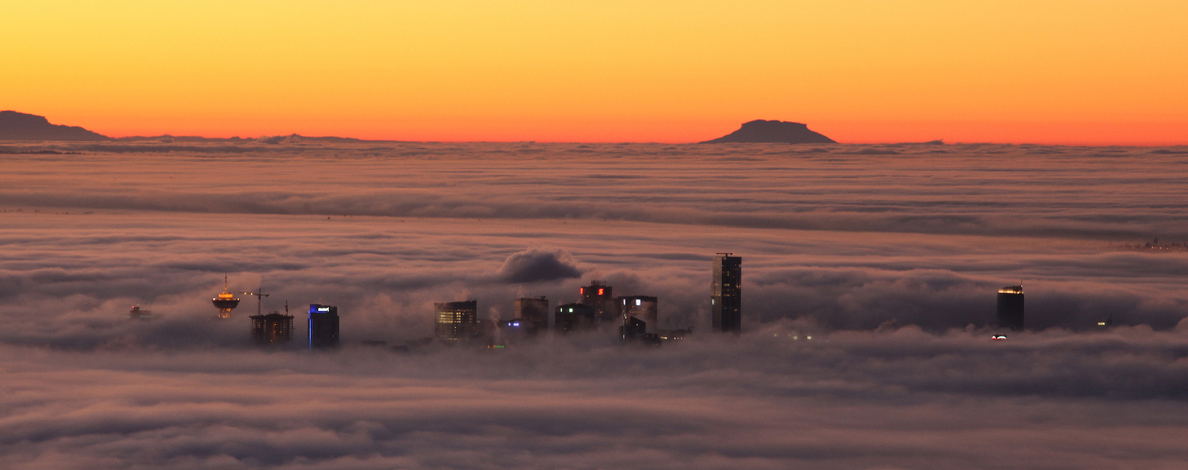
- In the Clouds: Vancouver from Cypress Mountain.

Abstract

Lorem ipsum dolor sit amet, consectetuer adipiscing elit. Ut purus elit, vestibulum ut, placerat ac, adipiscing vitae, felis. Curabitur dictum gravida mauris. Nam arcu libero, nonummy eget, consectetuer id, vulputate a, magna. Donec vehicula augue eu neque. Pellentesque habitant morbi tristique senectus et netus et malesuada fames ac turpis egestas. Mauris ut leo. Cras viverra metus rhoncus sem. Nulla et lectus vestibulum urna fringilla ultrices. Phasellus eu tellus sit amet tortor gravida placerat. Integer sapien est, iaculis in, pretium quis, viverra ac, nunc. Praesent eget sem vel leo ultrices bibendum. Aenean faucibus. Morbi dolor nulla, malesuada eu, pulvinar at, mollis ac, nulla. Curabitur auctor semper nulla. Donec varius orci eget risus. Duis nibh mi, congue eu, accumsan eleifend, sagittis quis, diam. Duis eget orci sit amet orci dignissim rutrum.

Index terms: Radiosity, global illumination, constant time.

Introduction
This template is for papers of VGTC-sponsored conferences which are not published in a special issue of TVCG.

* e-mail: roy.g.biv@aol.com
† e-mail: ed.grimley@aol.com
‡e-mail: martha.stewart@marthastewart.com
LEAVE 0.5 INCH SPACE AT BOTTOM OF LEFT COLUMN ON FIRST PAGE FOR COPYRIGHT BLOCK

Bibliography Instructions
Sort all bibliographic entries alphabetically but the last name of the first author.
Merge multiple references into one; e.g., use [3, 5] (not [3][5]). Within each set of multiple references, the references should be sorted in ascending order.
Verify all data obtained from digital libraries, even ACM's DL and IEEE Xplore etc. are sometimes wrong or incomplete.
Do not trust bibliographic data from other services such as Mendeley.com, Google Scholar, or similar; these are even more likely to be incorrect or incomplete.
Articles in journal—items to include:
- Author names
- Title
- Journal name
- Year
- Volume
- Number
- Month of publication

Use journal names in proper style: correct: ``IEEE Transactions on Visualization and Computer Graphics'', incorrect: ``Visualization and Computer Graphics, IEEE Transactions on''
Papers in proceedings—items to include:
- Author names
- Title
- Abbreviated proceedings name: e.g., “Proc.\
CONF ACRONYNM” without the year; example:
“Proc. CHI”, “Proc. 3DUI”, “Proc. Eurographics”,
“Proc. EuroVis
- Year
- Publisher
- Town with country of publisher (the town can be abbreviated for well-known towns such as New York or Berlin)
- Month of publication
- Vis Paper Acceptance Rate
Year | Submitted | Accepted | Accepted (%)
1994 | 91 | 41 | 45.1
1995 | 102 | 41 | 40.2
1996 | 101 | 43 | 42.6
1997 | 117 | 44 | 37.6
1998 | 118 | 50 | 42.4
1999 | 129 | 47 | 36.4
2000 | 151 | 52 | 34.4
2001 | 152 | 51 | 33.6
2002 | 172 | 58 | 33.7
2003 | 192 | 63 | 32.8
2004 | 167 | 46 | 27.6
2005 | 268 | 88 | 32.8
2006 | 228 | 63 | 27.6
2007 | 216 | 56 | 25.9
2008 | 197 | 50 | 25.4

Article when citing references, do not use the reference as a sentence object; e. g., wrong: “In [4] the authors describe…”, correct: “Lorensen and Cline [4] describe…”.
Include DOIs for all references which have a DOI. The DOI can be entered with or without the https://doi.org/ prefix.

Supplemental Material Instructions
In support of transparent research practices and long-term open science goals, you are encouraged to make your supplemental materials available on a publicly-accessible repository. Please describe the available supplemental materials in the Supplemental Materials section. These details could include (1) what materials are available, (2) where they are hosted, and (3) any necessary omissions.

Figure Credits
In the Figure Credits section at the end of the paper, you should credit the original sources of any figures that were reproduced or modified. Include any license details necessary, as well as links to the original materials whenever possible. For credits to figures from academic papers, include a citation that is listed in the References section. An example is provided below.

Equations and Tables
(1)
Equations can be added like so:
Tables, such as Tab. 1 can also be included.

Example Section
Lorem ipsum [4] dolor sit amet (see Fig. 2), consectetuer adipiscing elit, sed diam nonummy nibh euismod tincidunt ut laoreet dolore magna aliquam erat volutpat. Ut wisi enim ad minim veniam, quis nostrud exercitation ullamcorper suscipit lobortis nisl ut aliquip ex ea commodo consequat. Duis autem vel eum iriure dolor in hendrerit in vulpu-tate velit esse molestie consequat, vel illum dolore eu feugiat nulla facilisis at vero eros et accumsan et iusto odio dignissim qui blan-dit praesent luptatum zzril delenit augue duis dolore te feugait nulla facilisi.
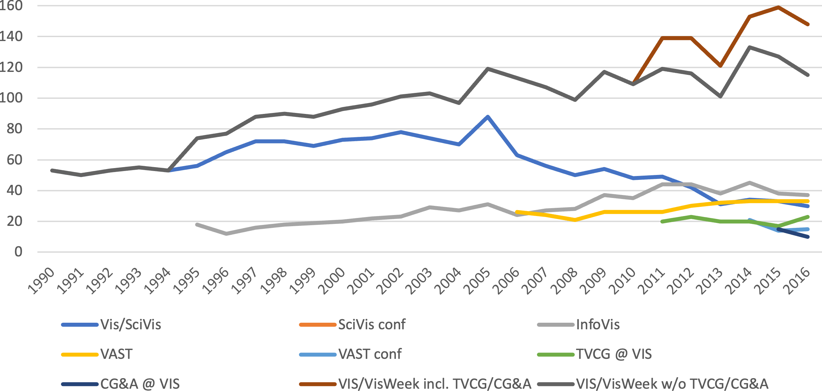
- A visualization of the 1990--2016 data from Tab.1, recreated based on Fig. 1 from [1] and is in the public domain.

Subsection One
Duis autem vel eum iriure dolor in hendrerit in vulpu-tate velit esse molestie consequat [6], vel illum dolore eu feugiat nulla facilisis at vero eros et accumsan et iusto odio dignissim qui blan-dit praesent luptatum zzril delenit augue duis dolore te feugait nulla facilisi.

Subsection Two
Lorem ipsum dolor sit amet, consectetuer adipiscing elit, sed diam nonummy nibh euismod tincidunt ut laoreet dolore magna aliquam erat volutpat.

Subsection One
Ut wisi enim ad minim veniam, quis nostrud exercitation ullamcorper suscipit lobortis nisl ut aliquip ex ea commodo consequat.

Subsection Two
Duis autemvel eum iriure dolor in hendrerit in vulpu-tate velit esse molestie consequat, vel illum dolore eu feugiat nulla facilisis at vero eros et accumsan et iusto odio dignissim qui blan-dit praesent luptatum zzril delenit augue duis dolore te feugait nulla facilisi.
Ut wisi enim ad minim veniam, quis nostrud exercitation ullamcorper suscipit lobortis nisl ut aliquip ex ea commodo consequat. Duis autem vel eum iriure dolor in hendrerit in vulpu-tate velit esse molestie consequat, vel illum dolore eu feugiat nulla facilisis at vero eros et accumsan et iusto odio dignissim qui blan-dit praesent luptatum zzril delenit augue duis dolore te feugait nulla facilisi.

Conclusion
Lorem ipsum dolor sit amet, consectetuer adipiscing elit, sed diam nonummy nibh euismod tincidunt ut laoreet dolore magna aliquam erat volutpat. Ut wisi enim ad minim veniam, quis nostrud exercitation ullamcorper suscipit lobortis nisl ut aliquip ex ea commodo consequat. Duis autem vel eum iriure dolor in hendrerit in vulpu-tate velit esse molestie consequat, vel illum dolore eu feugiat nulla facilisis at vero eros et accumsan et iusto odio dignissim qui blan-dit praesent luptatum zzril delenit augue duis dolore te feugait nulla facilisi.
Lorem ipsum dolor sit amet, consectetuer adipiscing elit, sed diam nonummy nibh euismod tincidunt ut laoreet dolore magna aliquam erat volutpat. Ut wisi enim ad minim veniam, quis nostrud exercitation ullamcorper suscipit lobortis nisl ut aliquip ex ea commodo consequat. Duis autem vel eum iriure dolor in hendrerit in vulpu-tate velit esse molestie consequat.

Supplemental Materials
Refer to the instructions for this section (Sec. 4). Below is an example you can follow that includes the actual supplemental material for this template:
All supplemental materials are available on OSF at https://doi.org/10.17605/OSF.IO/2NBSG, released under a CC BY 4.0 license. In particular, they include (1) Excel files containing the data for and analyses for creating Tab. 1 and Fig. 2, (2) figure images in multiple formats, and (3) a full version of this paper with all appendices. Our other code is intellectual property of a corporation—Starbucks Research—and there is no feasible way to share it publicly.

Figure Credits
Refer to the instructions for this section (Sec. 4). Below is an example you can follow that includes the actual supplemental material for this template:
Figure 1 image credit: Scott Miller / Special to the Vancouver Sun, January 22, 2009, page A6.
Figure 2 is a partial recreation of Fig. 1 from [1], which is in the public domain.

Acknowledgments
The authors wish to thank A, B, and C. This work was supported in
part by a grant from XYZ.

References
- P. Isenberg, F. Heimerl, S. Koch, T. Isenberg, P. Xu, C. Stolper, M. Sedlmair, J. Chen, T. Moller, and J. Stasko. vispubdata.org: A Metadata ¨ Collection about IEEE Visualization (VIS) Publications. IEEE Transactions on Visualization and Computer Graphics, 23, 2017. To appear. doi: 10.1109/TVCG.2016.2615308
- G. Kindlmann. Semi-automatic generation of transfer functions for direct volume rendering. Master’s thesis, Cornell University, USA, 1999.
- Kitware, Inc. The Visualization Toolkit User’s Guide, January 2003.
- W. E. Lorensen and H. E. Cline. Marching cubes: A high resolution 3D surface construction algorithm. SIGGRAPH Computer Graphics, 21(4):163–169, Aug. 1987. doi: 10.1145/37402.37422.
- N. Max. Optical models for direct volume rendering. IEEE Transactions on Visualization and Computer Graphics, 1(2):99–108, June 1995. doi: 10.1109/2945.468400.
- G. M. Nielson and B. Hamann. The asymptotic decider: Removing the ambiguity in marching cubes. In Proc. Visualization, pp. 83–91. IEEE Computer Society, Los Alamitos, 1991. doi: 10.1109/VISUAL.1991. 175782.
- G. Wyvill, C. McPheeters, and B. Wyvill. Data structure for soft objects. The Visual Computer, 2(4):227–234, Aug. 1986. doi: 10.1007/ BF01900346.

The algorithm behind Marching Cubes [4] had already been described by Wyvill et al. [7] a year earlier.
Footnotes appear at the bottom of the column.

