Ian Eggleston

1. Basal area is the total square feet of a tree trunk calculated by measuring the diameter of the trunk at four feet from the ground. This provides a consistent measurement of tree width and growth at the same height.

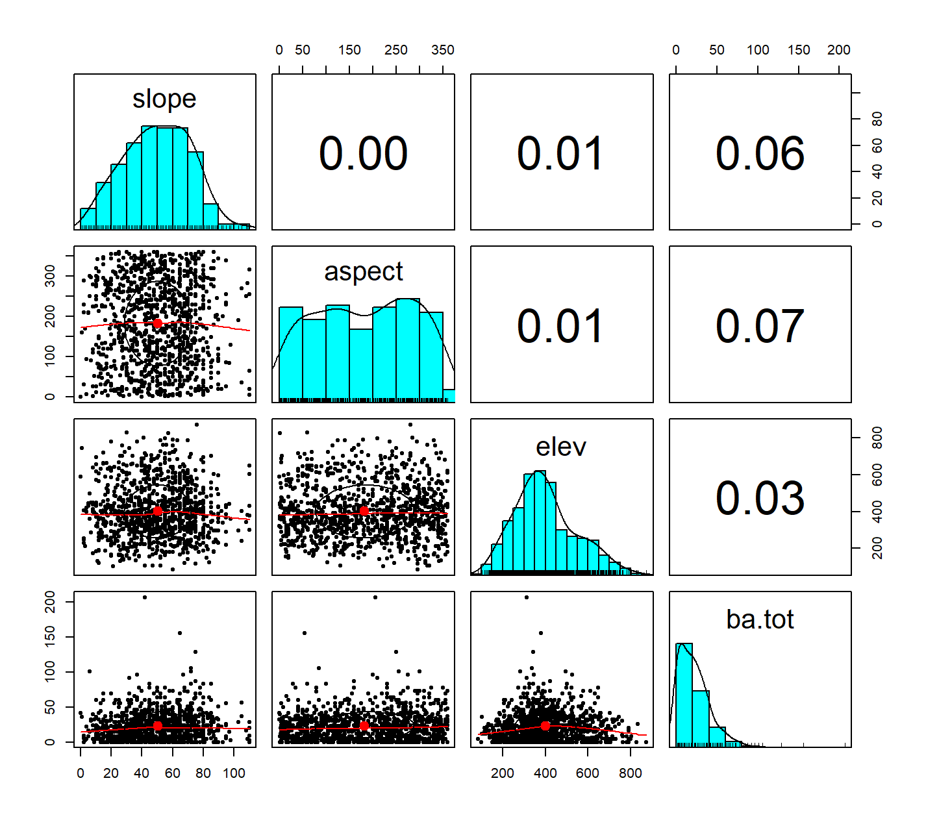

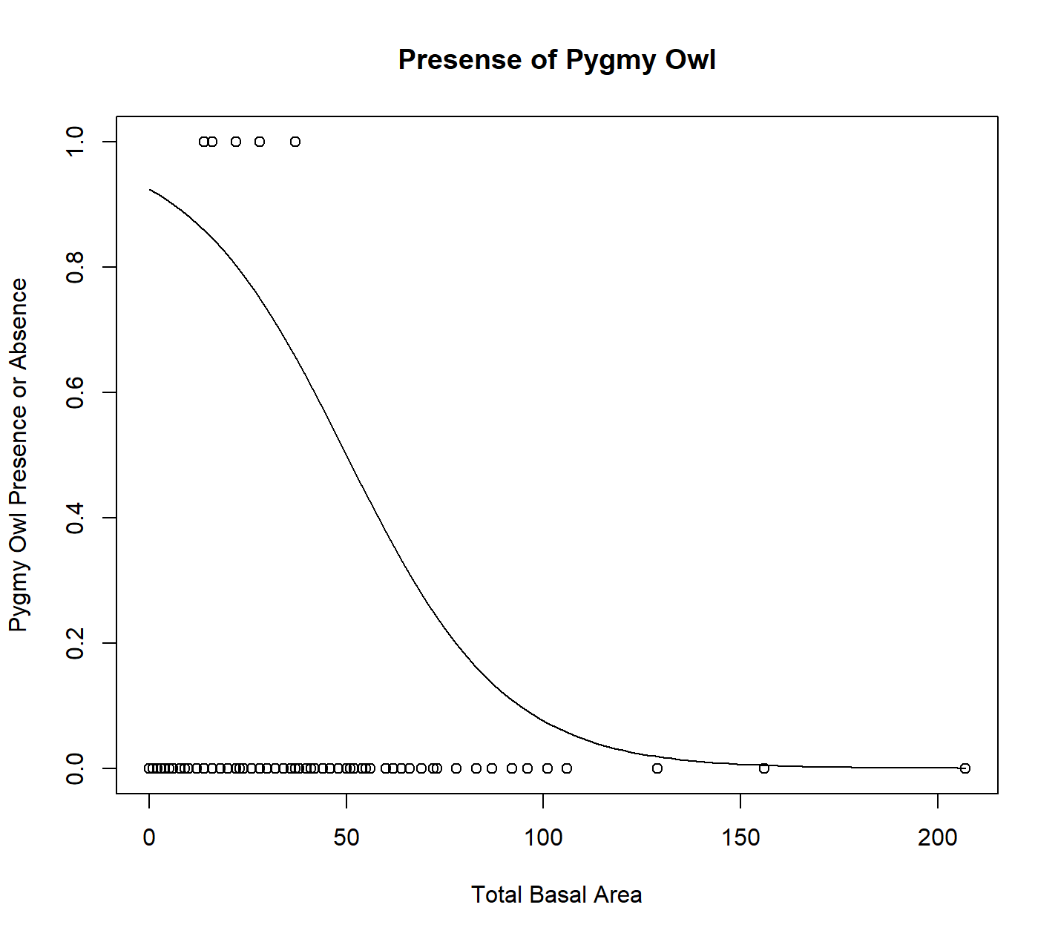

1. Based on the plot, the pygmy owl seems to prefer younger, smaller trees in a forest with higher tree coverage. The few sightings that were recorded show it present in the smaller basal area trees, however other predictors may be better to use. The plot was changed to see the effect of different types of trees; however, this did not seem to affect the pygmy owl presence. When elevation was used, it showed the owls did not have a preference as the data points were evenly spread across different elevations. The logistic model seems to be a decent fit because it shows the majority of data points were at a smaller basal area.

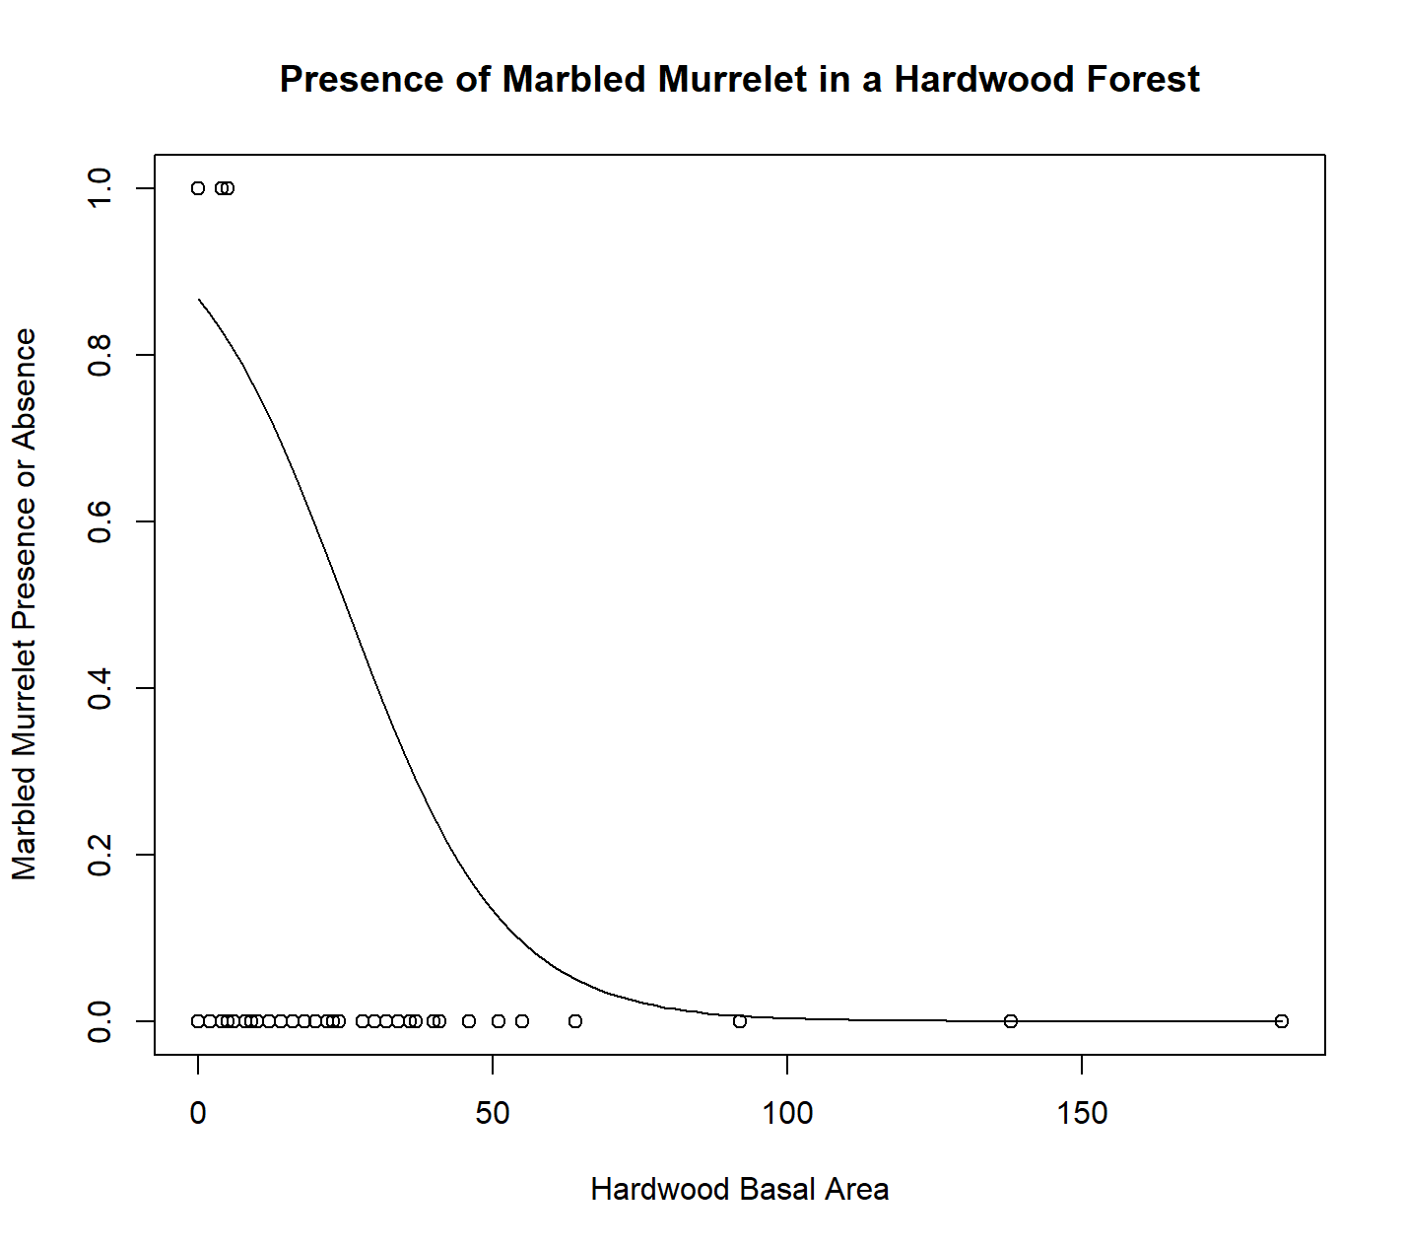

1. There were few sightings of the marbled murrelet, based on the data. The plot above shows its presence in hardwood forests, but additional plots were made in other forest types. They all showed few sightings and at smaller basal areas than the pygmy owl. This could suggest the marbled murrelet prefers more tree cover with younger trees. The logistic model again shows the majority of sightings are at the beginning of the plot and quickly drops off as basal area increases.
2. 181 total Gray Jays counted
3. my_vec_GRJA = sample(dat_all$GRJA)

sum(my_vec_GRJA)

1. 110 different sites identified at least one Gray Jay.
2. GRJA_presence = as.numeric(sample(dat_all$GRJA) > 0)

sum(GRJA_presence)