Ian Eggleston

exp_fun = function(x, a , b)

{

return(a * exp(-b * x))

}

1. 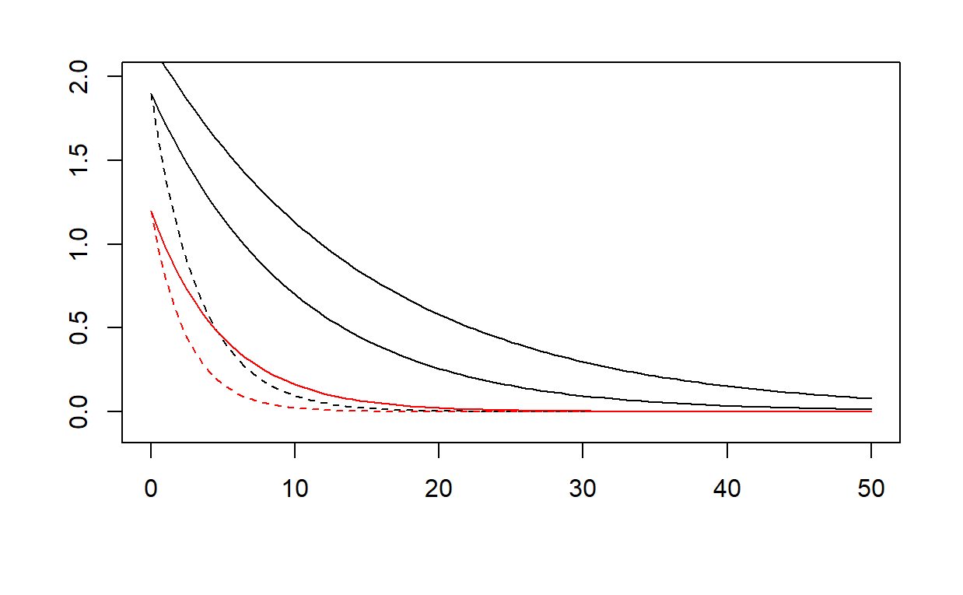
2. Varying parameter a changes where the y-intercept is on the plot. It describes the starting point of these curves, at x=0.
3. Changes to the b value affect the slope of the curve. Larger values have a steeper slope, while smaller values have a shallower curve.
4. 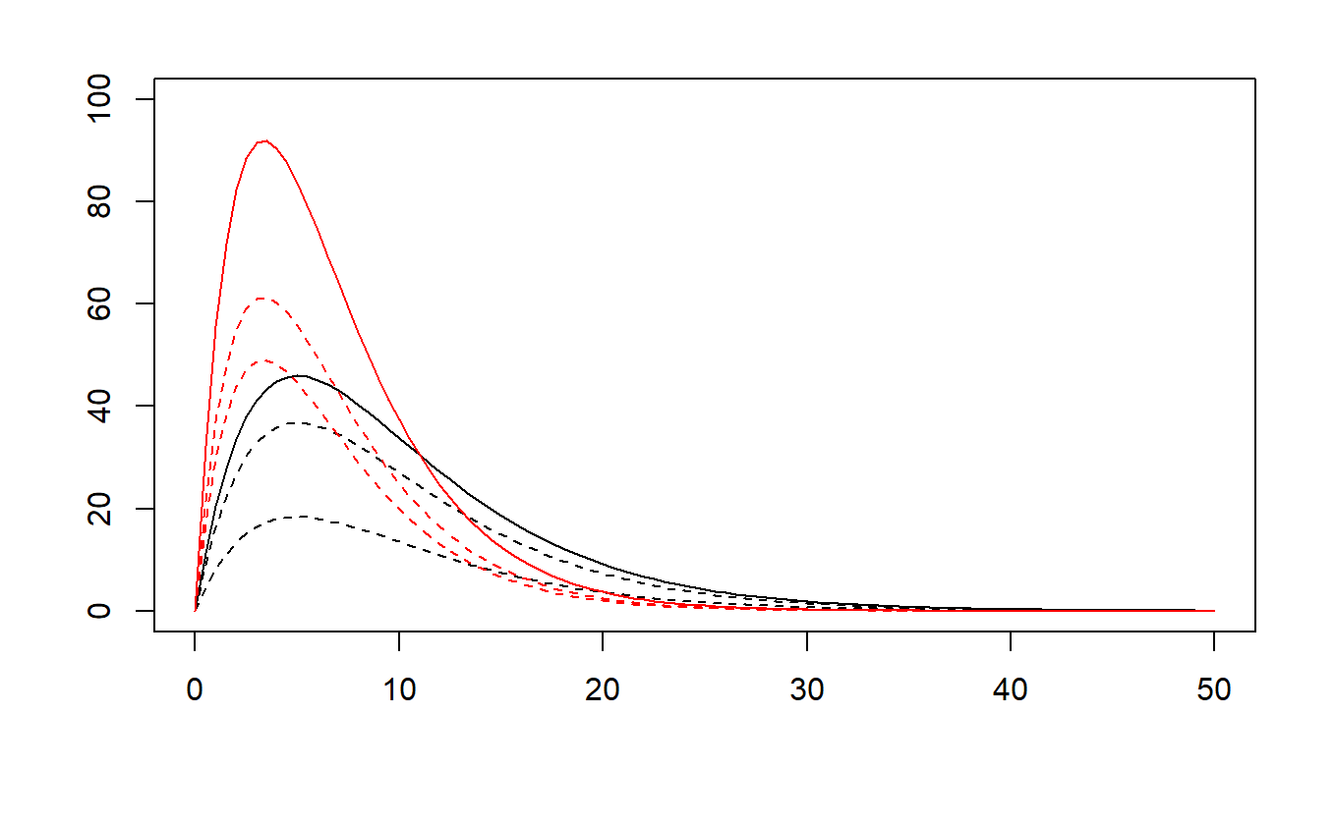
5. Changing the a value adjusts the height of the peak for each curve. The a is not exactly the y-value for the height of the curve, but they seem to be closely related.
6. Changing the b values adjusts the sharpness of the peak for each curve. A larger b value gives the black curves where you can see they are not as steep as the red ones.
7. curve(line_point_slope(x, 1500, 0.01, -0.0002), add = TRUE, col = “red”)  
   The values used for my linear model were: x1 = 1500, y1 = 0.01, slope = -0.0002. The x1 value is the final value for the x-axis, the y1 value is the final y-coordinate. These values restrict the curve to what can be seen in the scatterplot. The slope was chosen by trial and error of different slopes to see what fit best against the data. The previous trials can be seen as black lines that show the process of fitting the curve to the data.
8. The red line shows the linear function that seems to be best fit. 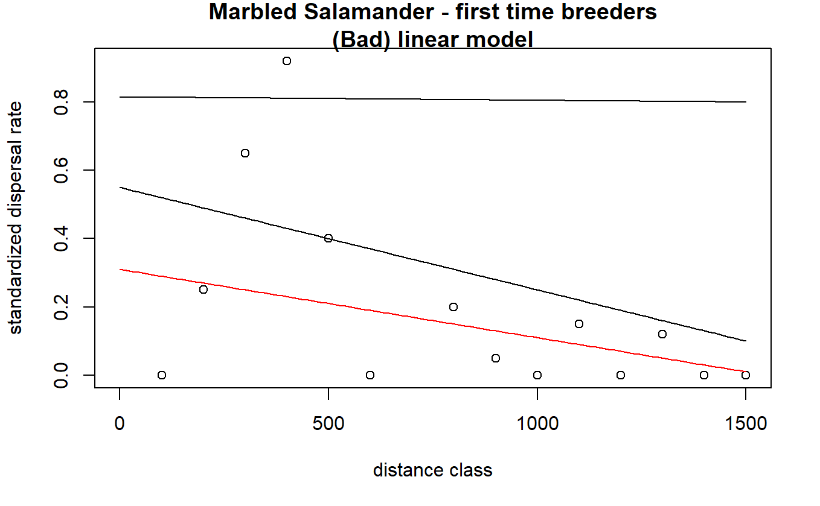
9. curve(exp_fun(x, 0.8, 0.0025), add = TRUE, col = "black")  
   The value for a was 0.8 and the value for b was 0.0025. A was chosen based on the y-intercept that seemed to encapsulate as many data points as possible. B was then the slope of the line, chosen through trial and error of fitting different curves to the plot. Once a reasonable curve and y-intercept were chosen, both values were slightly tweaked until the below curve was decided upon.
10. 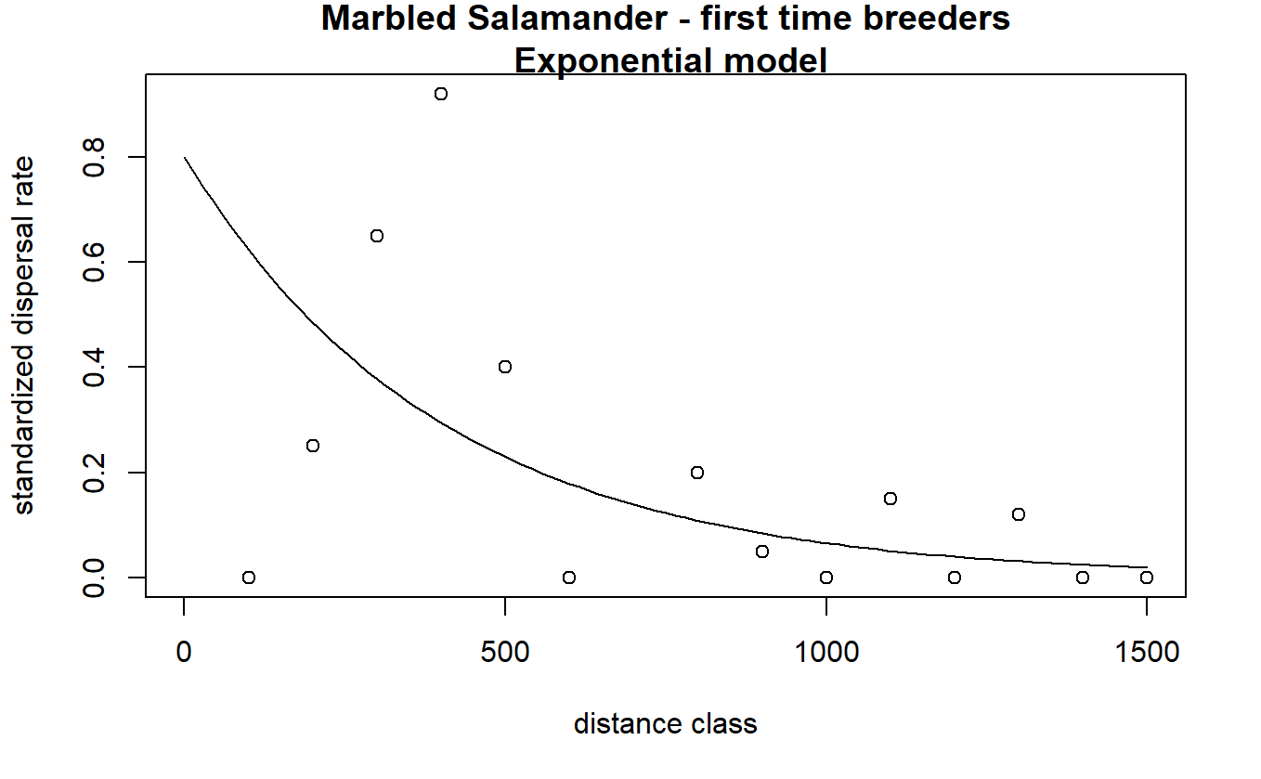
11. curve(ricker_fun(x, 0.007, 0.004)) The b value was an estimate of the highest point of the Ricker function. 1/b is the x coordinate for the highest point of the curve. This I estimated at 400 to calculate the b value of 0.004. I then tried calculating the a value, however this did not work very well so the value was adjusted based on trial and error. The final slope of a for the best fit curve was 0.007.
12. 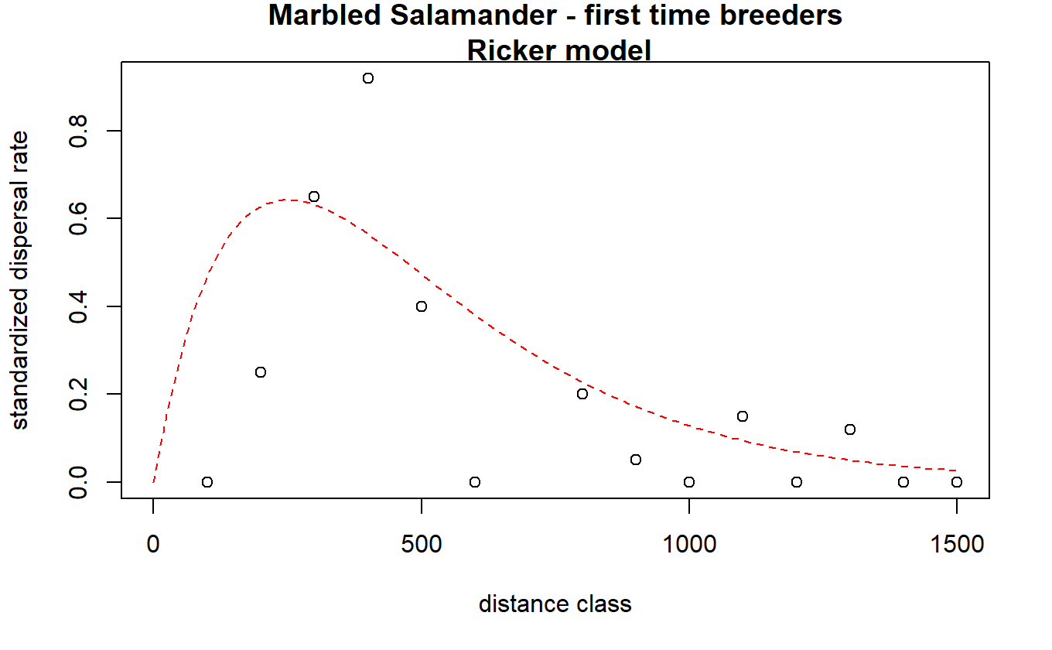

par(mfrow = c(1,3))

y_pred_linear = line_point_slope(dat_dispersal$dist.class, 1500, 0.01, -0.0002)

dat_dispersal$y_pred_linear = y_pred_linear

resids_linear = dat_dispersal$y_pred_linear - dat_dispersal$disp.rate.ftb

dat_dispersal$resids_linear = resids_linear

hist(dat_dispersal$resids_linear, main = "Histogram for Linear Residuals")

y_pred_exp = exp_fun(dat_dispersal$dist.class, 0.8, 0.0025)

dat_dispersal$y_pred_exp = y_pred_exp

resids_exp = dat_dispersal$y_pred_exp - dat_dispersal$disp.rate.ftb

dat_dispersal$resids_exp = resids_exp

hist(dat_dispersal$resids_exp, main = "Histogram for Exponential Residuals")

y_pred_ricker = ricker_fun(dat_dispersal$dist.class, 0.007, 0.004)

dat_dispersal$y_pred_ricker = y_pred_ricker

resids_ricker = dat_dispersal$y_pred_ricker - dat_dispersal$disp.rate.ftb

dat_dispersal$resids_ricker = resids_ricker

hist(dat_dispersal$resids_ricker, main = "Histogram for Ricker Residuals")

1. 