Ian Eggleston

Worked with Sarah Guitart

```{r}

require(palmerpenguins)

rm(list = ls())

sse_mean = function(x)

{

get_sd =

function(x){

return(sd(x, na.rm = TRUE))

}

get_sample_size =

function(x){

sample_size = sum(table(x))

return(sample_size)

}

sse = get_sd(x) / sqrt(get_sample_size(x))

return(sse)

}

sse_mean(penguins$body_mass_g)

sse_mean(mtcars$mpg)

dev.off()

```

two_group_resample_diff = function(x, n_1, n_2){

dat_1 = sample(na.omit(x), n_1, replace = TRUE)

dat_2 = sample(na.omit(x), n_2, replace = TRUE)

difference_in_means = mean(dat_1, na.rm = TRUE) - mean(dat_2, na.rm = TRUE)

return(difference_in_means)

}

set.seed(54321)

two_group_resample_diff(dat_pen$flipper_length_mm, 68, 152)

1. Monte Carlo because we are testing the null hypothesis.
2. 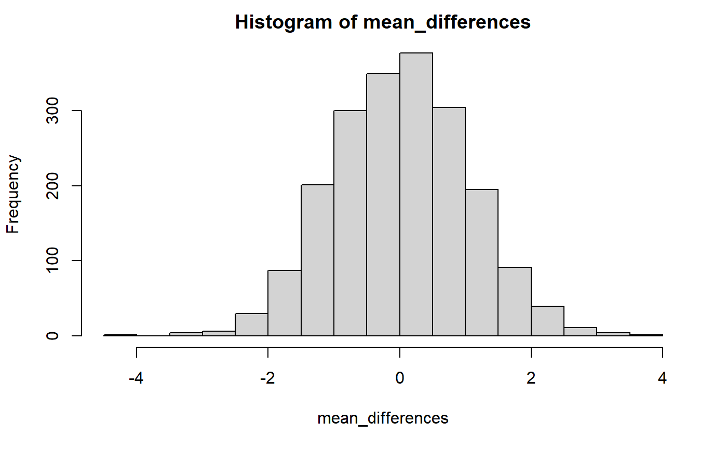
3. None had a magnitude greater than 5.8.  
   sum(abs(mean_differences) > diff_observed)
4. You would need to run over 10 million simulations until you would expect to see a value equal to or greater than 5.8mm.
5. 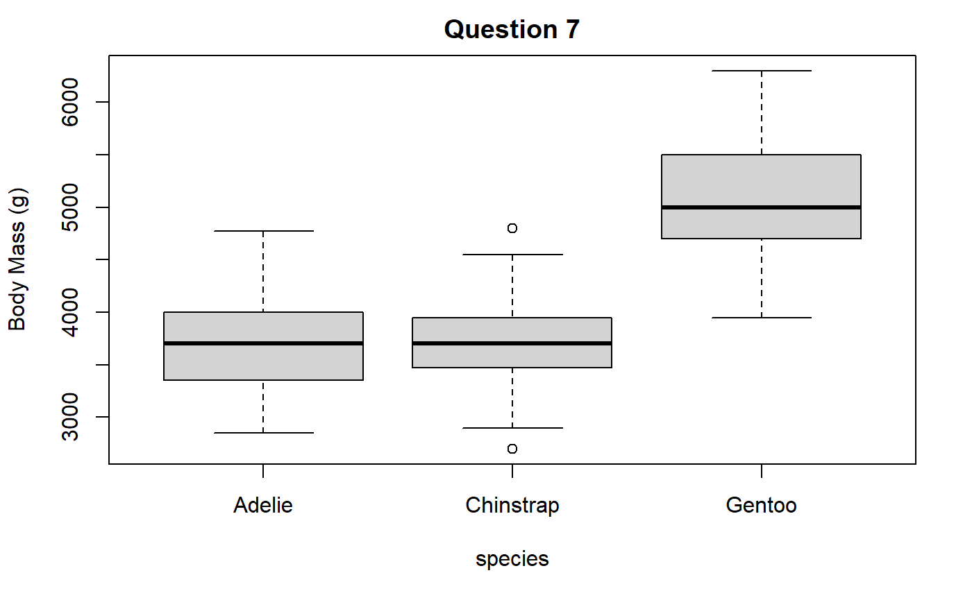
6. The mean for Adelie penguins is 3700.662g and the mean for Gentoo is 5076.016g.  
   The difference in means is 1375.354.
7. p-value = 2.2e-16. This p-value means that the chances of observing these results as pure chance and not an interaction between the predictor and outcome variables. A larger p-value means it is more likely there is no interaction and it was pure chance the results are how they appear. A smaller p-value means it is unlikely that this is random chance and that there is a relationship or interaction between the variables observed.
8. There are zero differences in mean greater than diff_crit.
9. 