Project 1: Pick and Place sorting with a fixed based manipulator
Description: A 7-DoF Jaco v2 manipulator welded to the world at its base is tasked to pick and place multiple objects from a table into color-coded bins. The end effector has 3 fingers. The goal is to pick and place each of the object to its respective bins.
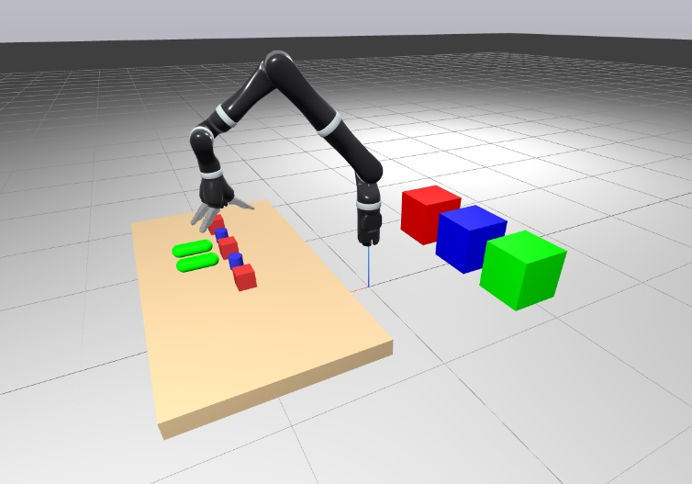.
Objective: Design and implement a control framework that enables the manipulator to autonomously grasp, and place each object in the correct bin as efficiently as possible. The solution should demonstrate consistent performance across different randomized initial object layouts.
Provided material: an SDF containing: 1) Jaco v2 manipulator, 2) One static table and seven dynamic objects, 3) Three sorting bins and a ground plane.
Expected Implementation
- Load and visualize the provided SDF world using Drake.
- Implement a control architecture (e.g., joint-space or task-space controller) so that the robot can reach a desired given pose.
- Compute feasible grasp and placement poses for each object using inverse kinematics.
- Generate joint-space trajectories for pick-and-place sequences.
Requirement: Show that the framework still works when the initial pose of the objects is randomized at startup.
Notes
- Do not modify the base pose of the robot.
Contact person: Mohayad.Abdelmonim.Mahmoud.Omer@vub.be

